## Ecosystem E2B1

#### Snowy midland tundra

Mainly occurring below 1200m, they may have gentle to quite steep slopes and typically exhibit thick snow cover. Maritime influence makes conditions mild and cloudy with the highest total precipitation in the typology, but they are in windier locations, span a greater climatic range, have a longer growing season (degree-days above -5 degrees C), and occur on average at the lowest elevations in the environmental unit. The biota is characterised by common lichens, mosses and springtails, with some incidence of antarctic hair grass. These systems appear to be unsuitable for rotifers and algaes.

### Photos (if available)

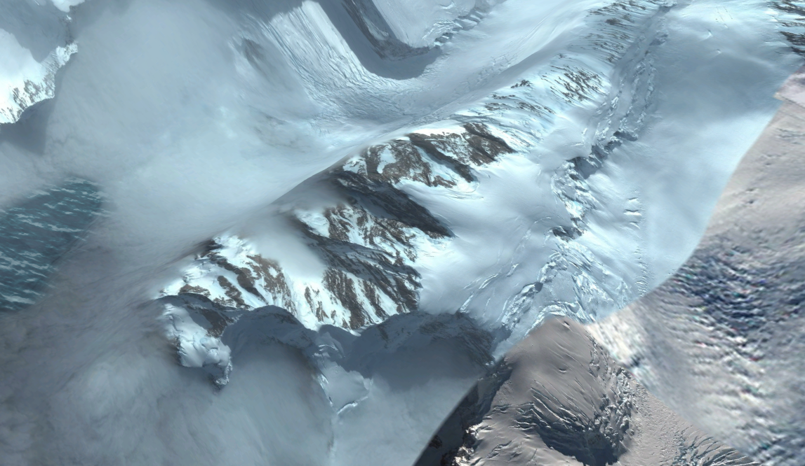

Ecosystem photos

### Distribution

Occurs mainly along the western/southwestern coast of the Northern and Central Antarctic Peninsula, with scattered occurrences in Marie Byrd Land, Enderby Land, Victoria Land and in the Transantarctic Mountains.

Full map

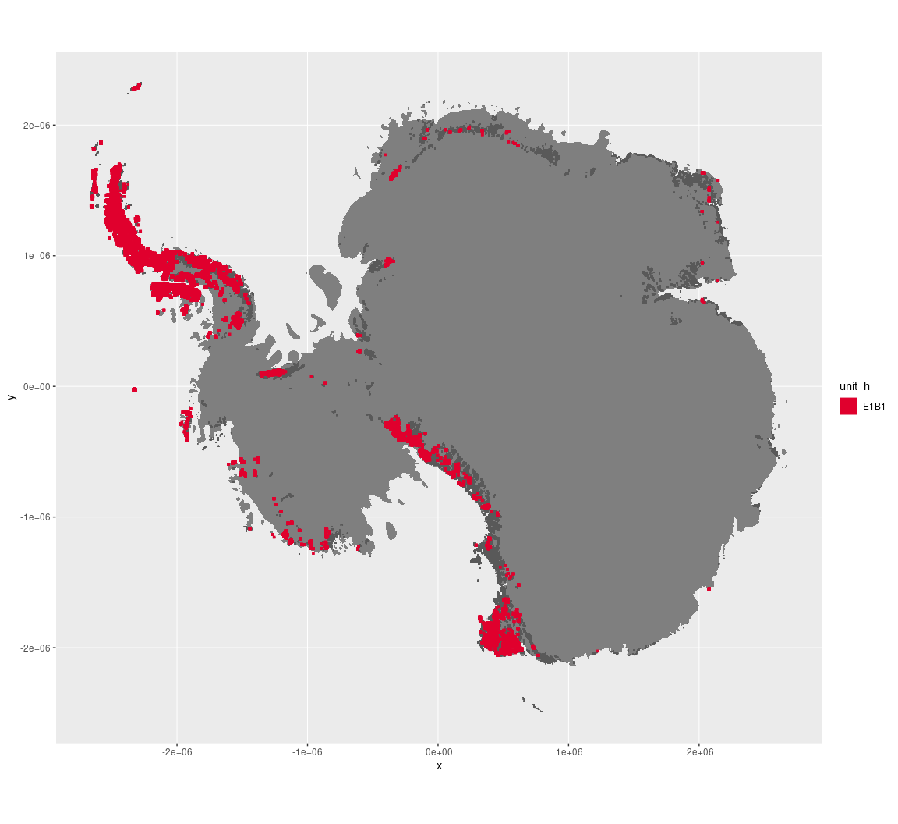

Regional maps

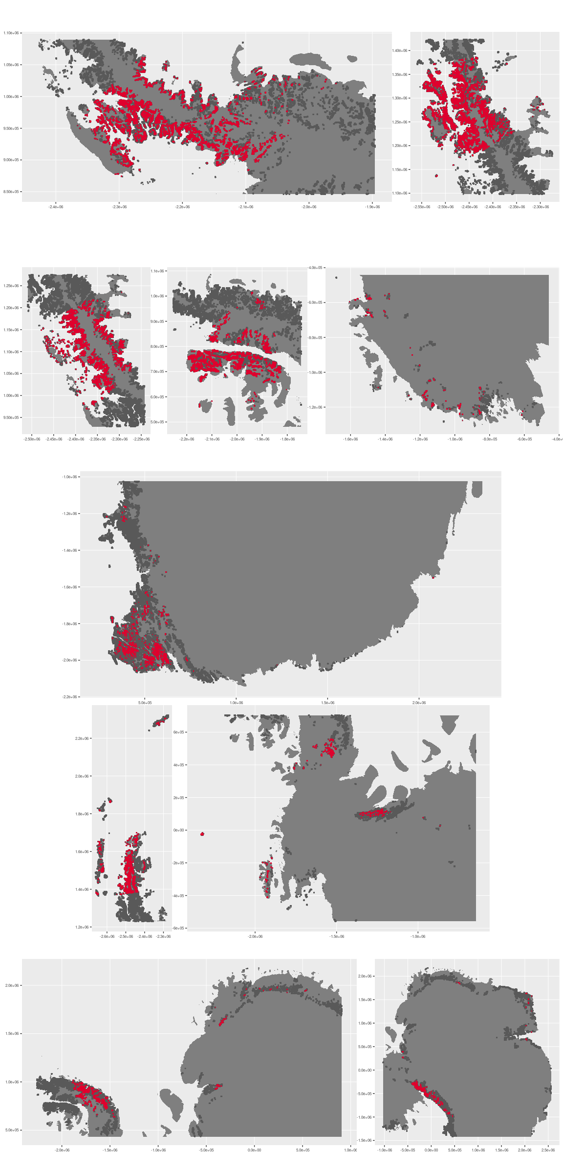



### Environment

The unit E1B1 is part of the environmental supergroup E1.

Supergroup E1 is, on average, substantially higher in cloud, DDm5, meanTemp, melt and totPrecip than continental Antarctica. It is substantially lower in no variables than the rest of the continent.

The elevation of unit E1B1 ranges from 0 to 4752 metres above sea level, but 90% of its pixels fall above 175 and below 1745 metres. Its average elevation is 886 metres.

The unit is higher in DDm5, meanTemp, rugosity, slope and totPrecip and lower in elevation than the rest of supergroup E1.

#### Distinctiveness of the assemblage from its group and the rest of Antarctica

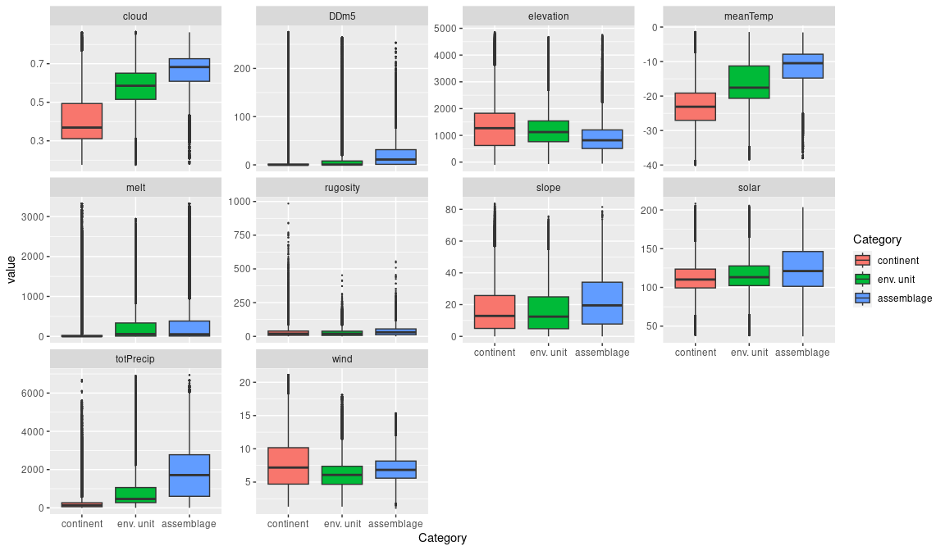

### Biota

Most widely sampled species in the unit (found in most pixels)

|  |  |  |  |  |  |
| --- | --- | --- | --- | --- | --- |
| scientific | functional group | phylum | restricted | count | percent of samples |
| Usnea sphacelata | Ascomycota_Lecanoromycetes_Lecanorales_Parmeliaceae | Ascomycota | TRUE | 38 | 1.8173 |
| Deschampsia antarctica | Tracheophyta | Tracheophyta | FALSE | 36 | 1.7217 |
| Pohlia nutans | Bryophyta_Bryopsida_Bryales | Bryophyta | FALSE | 34 | 1.6260 |
| Polytrichastrum alpinum | Bryophyta_Bryopsida_Polytrichales | Bryophyta | FALSE | 34 | 1.6260 |
| Usnea antarctica | Ascomycota_Lecanoromycetes_Lecanorales_Parmeliaceae | Ascomycota | FALSE | 29 | 1.3869 |
| Brachythecium austro-salebrosum | Bryophyta_Bryopsida_Hypnales | Bryophyta | TRUE | 26 | 1.2434 |
| Syntrichia princeps | Bryophyta_Bryopsida_Pottiales | Bryophyta | FALSE | 26 | 1.2434 |
| Umbilicaria decussata | Ascomycota_Lecanoromycetes_Umbilicariales_Umbilicariaceae | Ascomycota | FALSE | 26 | 1.2434 |
| Bryum pseudotriquetrum | Bryophyta_Bryopsida_Bryales | Bryophyta | FALSE | 25 | 1.1956 |
| Pohlia cruda | Bryophyta_Bryopsida_Bryales | Bryophyta | FALSE | 25 | 1.1956 |

Supergroup E1 is, on average, substantially higher in suitability for algae_Green, lichens_Lecideacid, Nematodes, penguins_Adelie and penguins_Chinstrap functional groups than continental Antarctica. It is substantially lower in suitability for no variables than the rest of the continent.

Unit E1B1 is higher in suitability for no variables and lower in suitability for no variables than the rest of supergroup E1.

#### Distinctiveness of the unit from the environmental group and the rest of Antarctica

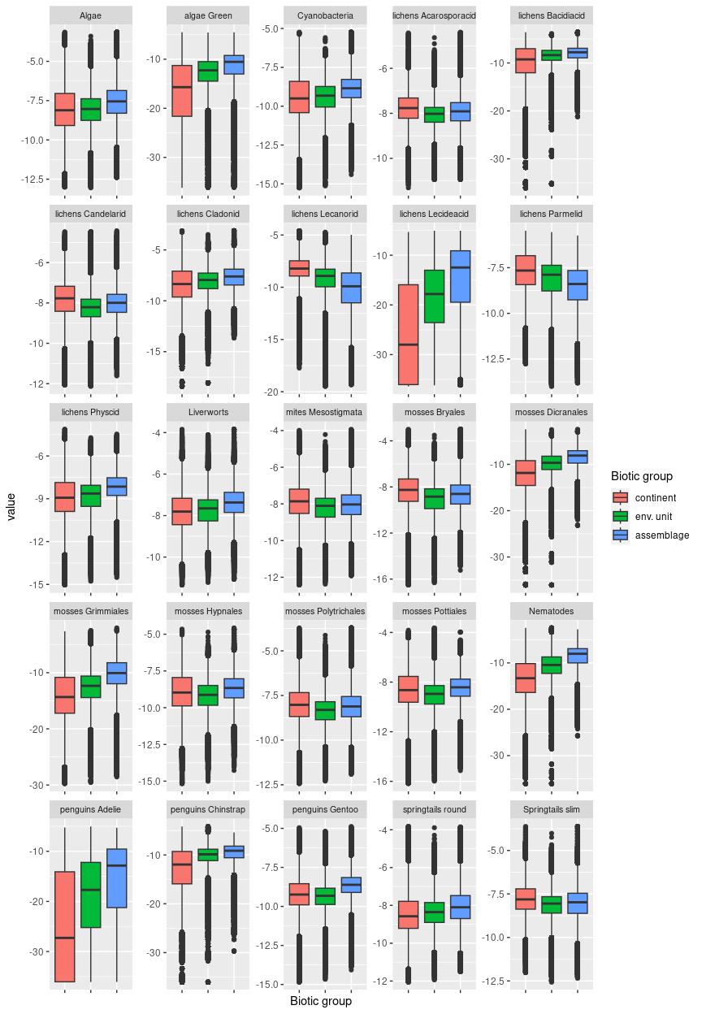

## Ecosystem E1B2

#### Meltwater-eroded midland tundra

Mainly occurring below 1700m, this assemblage encompasses a great variety of midland terrain types and is likely to exhibit seasonally thick snow cover. Relatively warm conditions and high snowfall are accompanied by especially high meltwater erosion, a long growing season, and slightly higher relief than average for the environmental unit. Meltwater erosion results in deep ridges/channels on the surfaces. A number of widespread moss species are accompanied by incidence of Antarctic hair grass and chinstrap penguin colonies. These systems are unsuitable for rotifers and algaes.

### Photos (if available)

### Ecosystem photo

Ecosystem photo

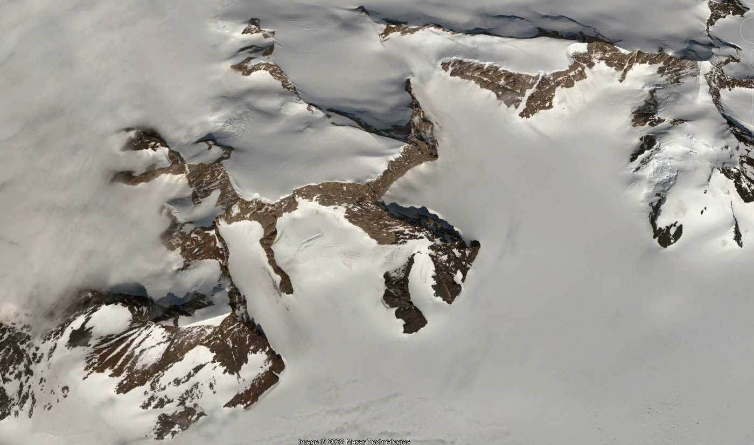

Ecosystem photo

### Distribution

Occurs mainly along the eastern coast of the northern Antarctic Peninsula, though a few notable occurrences are found in the Transantarctic mountains

Full map

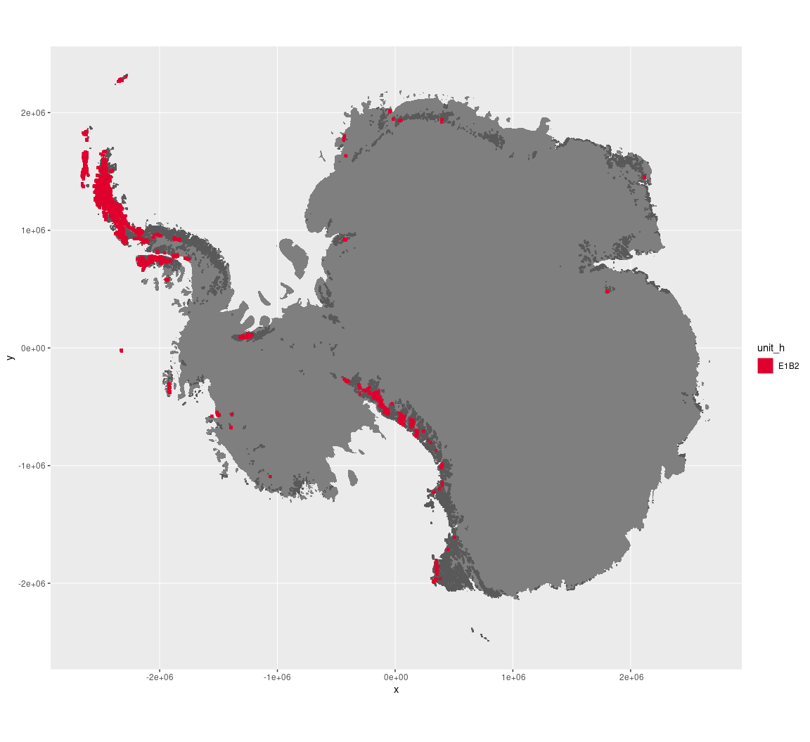

Regional maps

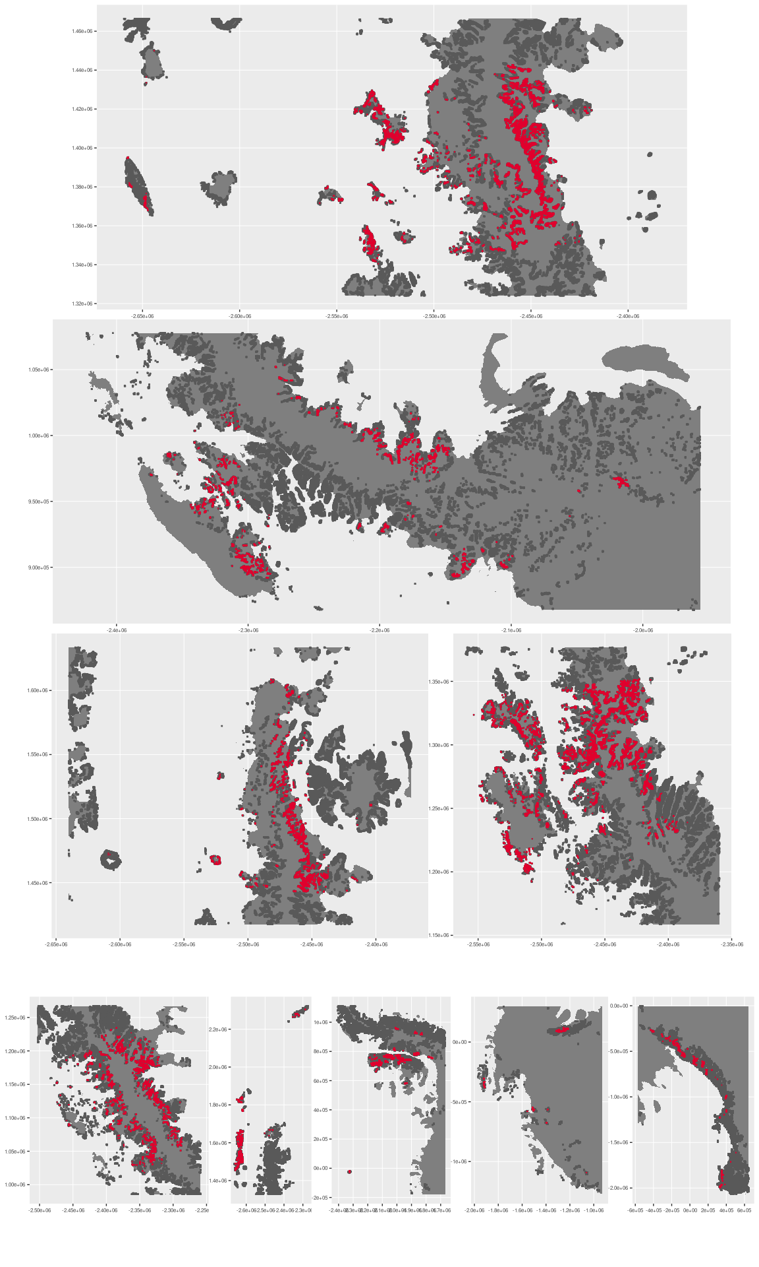



### Environment

The unit E1B2 is part of the environmental supergroup E1.

Supergroup E1 is, on average, substantially higher in cloud, DDm5, meanTemp, melt and totPrecip than continental Antarctica. It is substantially lower in no variables than the rest of the continent.

The elevation of unit E1B2 ranges from 0 to 4674 metres above sea level, but 90% of its pixels fall above 102 and below 3022 metres. Its average elevation is 1104 metres.

The unit is higher in DDm5, meanTemp, melt, rugosity, slope and totPrecip and lower in no variables than the rest of supergroup E1.

#### Distinctiveness of the assemblage from its group and the rest of Antarctica

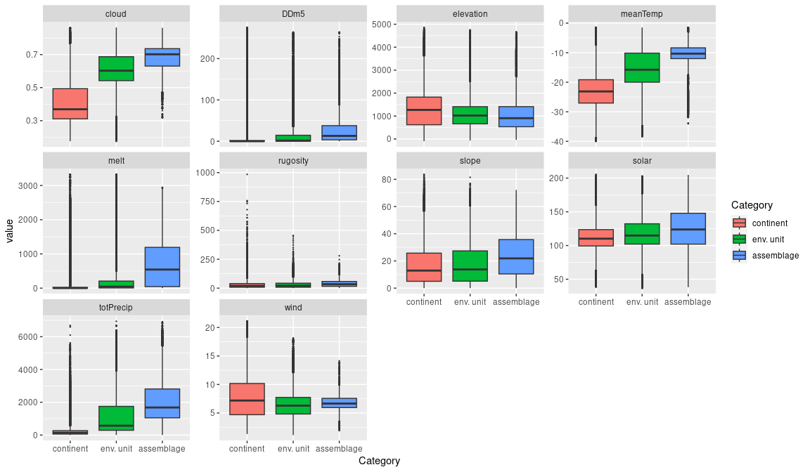

### Biota

Most widely sampled species in the unit (found in most pixels)

|  |  |  |  |  |  |
| --- | --- | --- | --- | --- | --- |
| scientific | Functional group | phylum | restricted | count | percent of samples |
| Syntrichia princeps | Bryophyta_Bryopsida_Pottiales | Bryophyta | FALSE | 22 | 1.8917 |
| Usnea antarctica | Ascomycota_Lecanoromycetes_Lecanorales_Parmeliaceae | Ascomycota | FALSE | 21 | 1.8057 |
| Polytrichastrum alpinum | Bryophyta_Bryopsida_Polytrichales | Bryophyta | FALSE | 20 | 1.7197 |
| Pygoscelis antarctica | Chordata_Aves_Sphenisciformes_Spheniscidae_Pygoscelis_antarctica | Chordata | TRUE | 20 | 1.7197 |
| Andreaea depressinervis | Bryophyta_Andreaeopsida_Andreaeales | Bryophyta | TRUE | 18 | 1.5477 |
| Deschampsia antarctica | Tracheophyta | Tracheophyta | FALSE | 17 | 1.4617 |
| Sanionia uncinata | Bryophyta_Bryopsida_Hypnales | Bryophyta | FALSE | 17 | 1.4617 |
| Andreaea gainii | Bryophyta_Andreaeopsida_Andreaeales | Bryophyta | TRUE | 15 | 1.2898 |
| Andreaea regularis | Bryophyta_Andreaeopsida_Andreaeales | Bryophyta | TRUE | 14 | 1.2038 |
| Bryum pseudotriquetrum | Bryophyta_Bryopsida_Bryales | Bryophyta | FALSE | 14 | 1.2038 |

Supergroup E1 is, on average, substantially higher in suitability for algae_Green, lichens_Lecideacid, mosses_Dicranales, Nematodes, penguins_Adelie and penguins_Chinstrap functional groups than continental Antarctica. It is substantially lower in suitability for no variables than the rest of the continent.

Unit E1B2 is higher in suitability for penguins_Adelie and lower in suitability for no variables than the rest of supergroup E1.

#### Distinctiveness of the unit from the environmental group and the rest of Antarctica

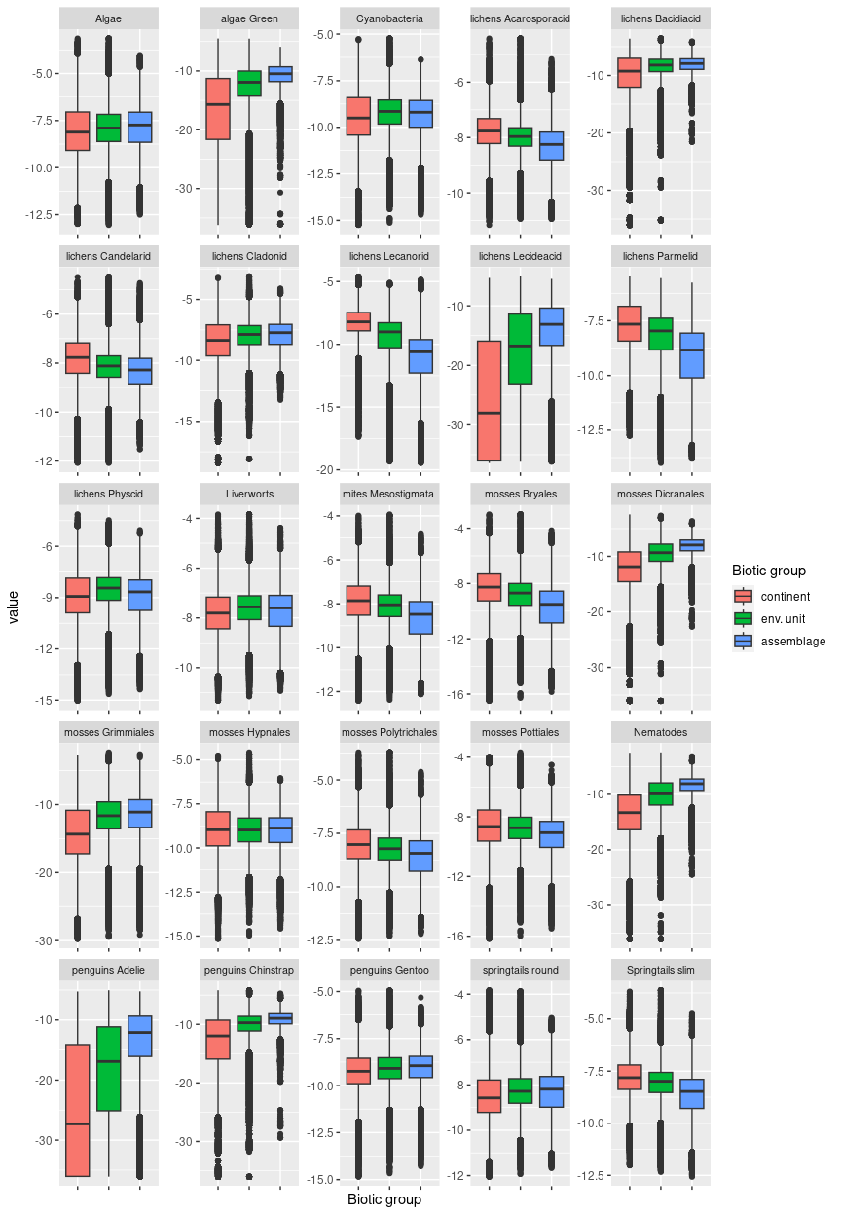

## Ecosystem E1B3

#### Cool dry midland inclines

Characterised by relatively gentle terrain though it may encompass low ridges. On the southern Peninsula, it dominates low-relief nunataks and occurs in association with E4B2 where slopes are sunnier or steeper. Unit is of midland elevations and the least steep and rugged in its group. Its terrain reminiscent of E5 units, the unit is dry relative to the rest of E1 assemblages, receiving the lowest snowfall, cloud cover and meltwater in the group. In some cases, temp and moisture variables drop below continental average. Sampled biota are dominated by lichens, but suitability is lower than continental average for Rotifers, algaes, and certain lichen groups.

### Photos (if available)

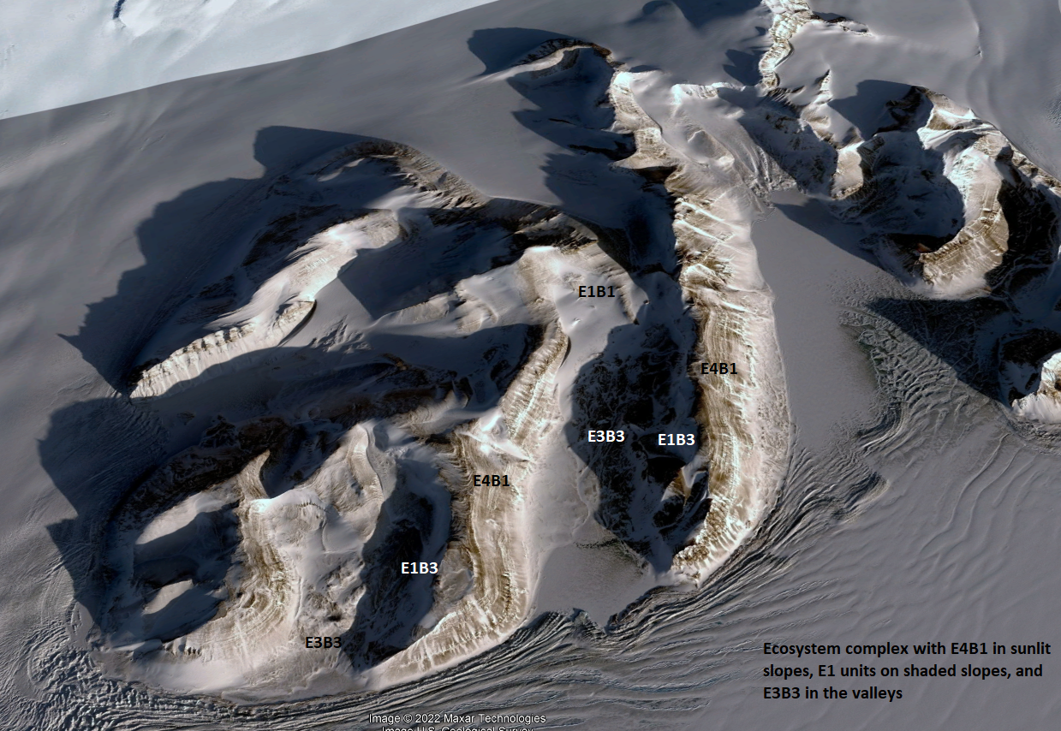

Ecosystem photo

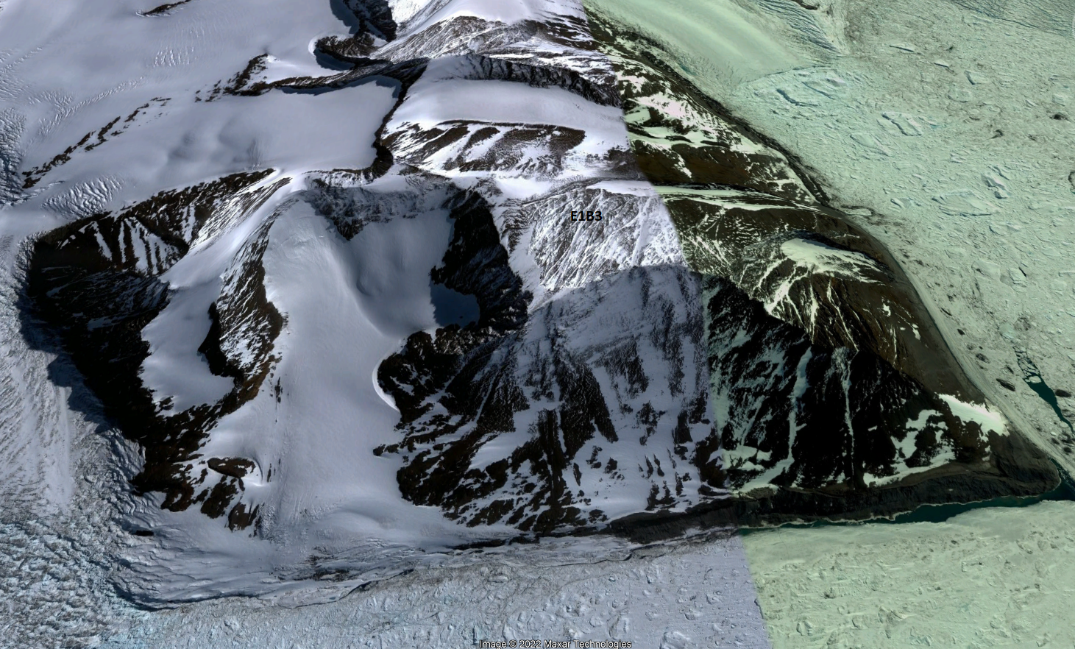

Ecosystem photo

### Distribution

Widespread in the southern Antarctic peninsula, Ellsworth mountains, and the Transantarctic mountains, Enderby Land and Victoria Land, with a scattering around the eastern edge of the continent.

Full map

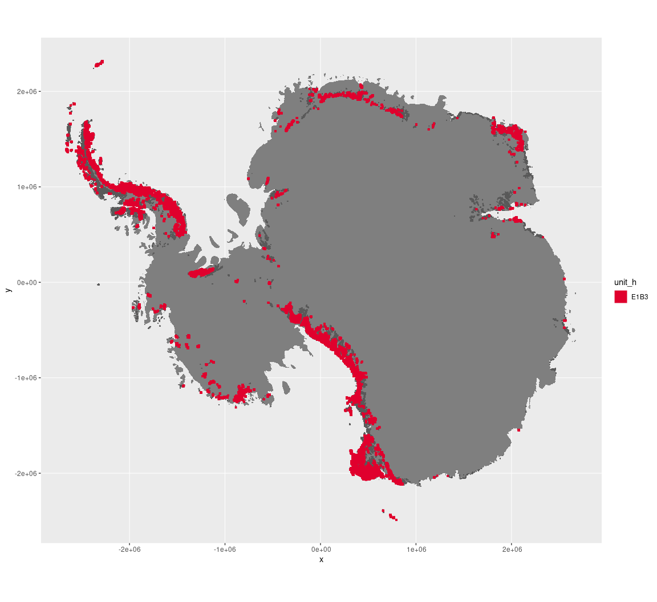

Regional maps

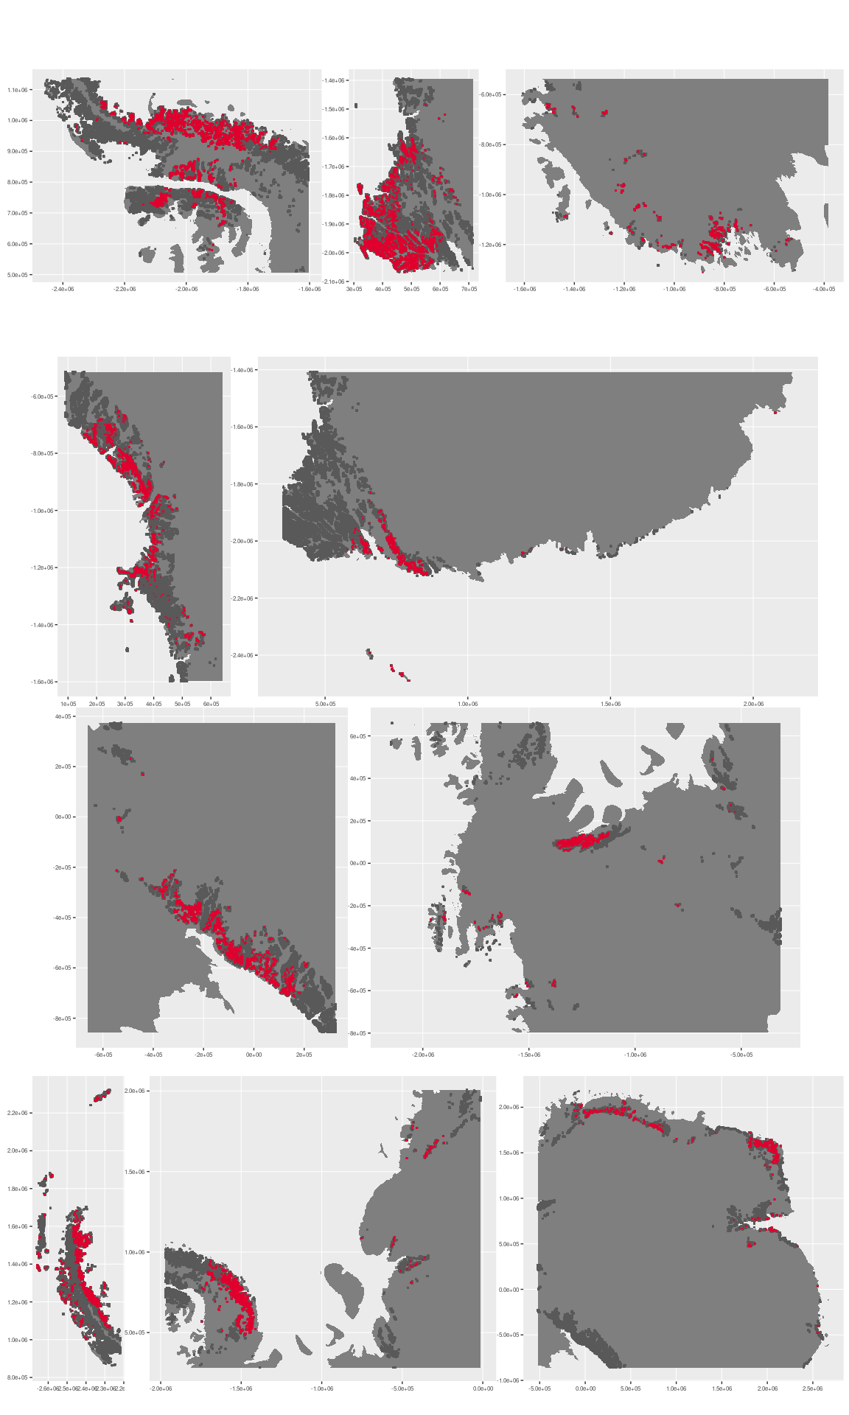

### Environment

The unit E1B3 is part of the environmental supergroup E1.

Supergroup E1 is, on average, substantially higher in cloud, DDm5, meanTemp, melt, rugosity, slope and totPrecip than continental Antarctica. It is substantially lower in no variables than the rest of the continent.

The elevation of unit E1B3 ranges from 0 to 4562 metres above sea level, but 90% of its pixels fall above 311 and below 2138 metres. Its average elevation is 1125 metres.

The unit is higher in no variables and lower in DDm5, meanTemp, melt, rugosity, slope and totPrecip than the rest of supergroup E1.

#### Distinctiveness of the assemblage from its group and the rest of Antarctica

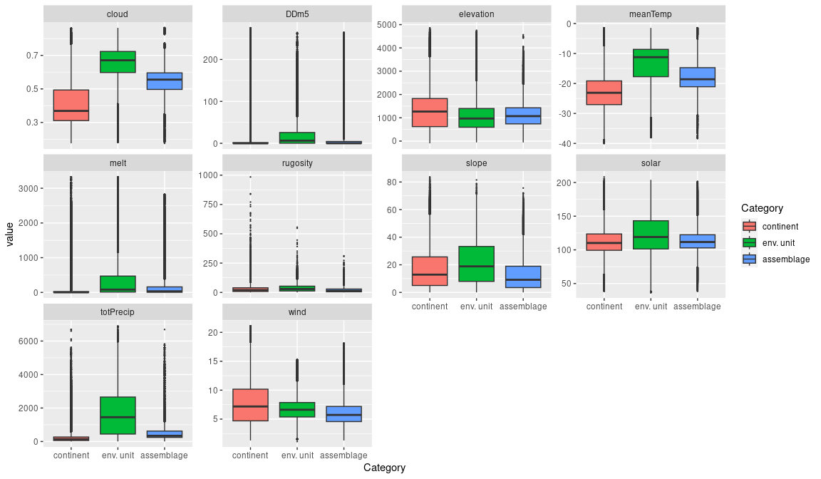

### Biota

Most widely sampled species in the unit (found in most pixels)

The top most widespread species in ecosystem E1B3

|  |  |  |  |  |  |
| --- | --- | --- | --- | --- | --- |
| scientific | Functional group | phylum | restricted | count | percent of samples |
| Pseudephebe minuscula | Ascomycota_Lecanoromycetes_Lecanorales_Parmeliaceae | Ascomycota | FALSE | 40 | 7.4074 |
| Usnea sphacelata | Ascomycota_Lecanoromycetes_Lecanorales_Parmeliaceae | Ascomycota | TRUE | 40 | 7.4074 |
| Umbilicaria decussata | Ascomycota_Lecanoromycetes_Umbilicariales_Umbilicariaceae | Ascomycota | FALSE | 21 | 3.8889 |
| Lecidea cf. cancriformis | Ascomycota_Lecanoromycetes_Lecanorales_Lecideaceae | Ascomycota | TRUE | 20 | 3.7037 |
| Pleopsidium chlorophanum | Ascomycota_Lecanoromycetes_Acarosporales_Acarosporaceae | Ascomycota | FALSE | 19 | 3.5185 |
| Lecidea cancriformis | Ascomycota_Lecanoromycetes_Lecanorales_Lecideaceae | Ascomycota | TRUE | 14 | 2.5926 |
| Acarospora gwynnii | Ascomycota_Lecanoromycetes_Acarosporales_Acarosporaceae | Ascomycota | TRUE | 13 | 2.4074 |
| Rhizoplaca melanophthalma | Ascomycota_Lecanoromycetes_Lecanorales_Lecanoraceae | Ascomycota | FALSE | 11 | 2.0370 |
| Xanthoria elegans | Ascomycota_Lecanoromycetes_Teloschistales_Teloschistaceae | Ascomycota | FALSE | 10 | 1.8519 |
| Carbonea vorticosa | Ascomycota_Lecanoromycetes_Lecanorales_Lecanoraceae | Ascomycota | FALSE | 9 | 1.6667 |
| Pohlia nutans | Bryophyta_Bryopsida_Bryales | Bryophyta | FALSE | 9 | 1.6667 |
| Usnea antarctica | Ascomycota_Lecanoromycetes_Lecanorales_Parmeliaceae | Ascomycota | FALSE | 9 | 1.6667 |

Supergroup E1 is, on average, substantially higher in suitability for algae_Green, lichens_Lecideacid, mosses_Dicranales, Nematodes, penguins_Adelie and penguins_Chinstrap functional groups than continental Antarctica. It is substantially lower in suitability for no variables than the rest of the continent.

Unit E1B3 is higher in suitability for no variables and lower in suitability for no variables than the rest of supergroup E1.

#### Distinctiveness of the unit from the environmental group and the rest of Antarctica

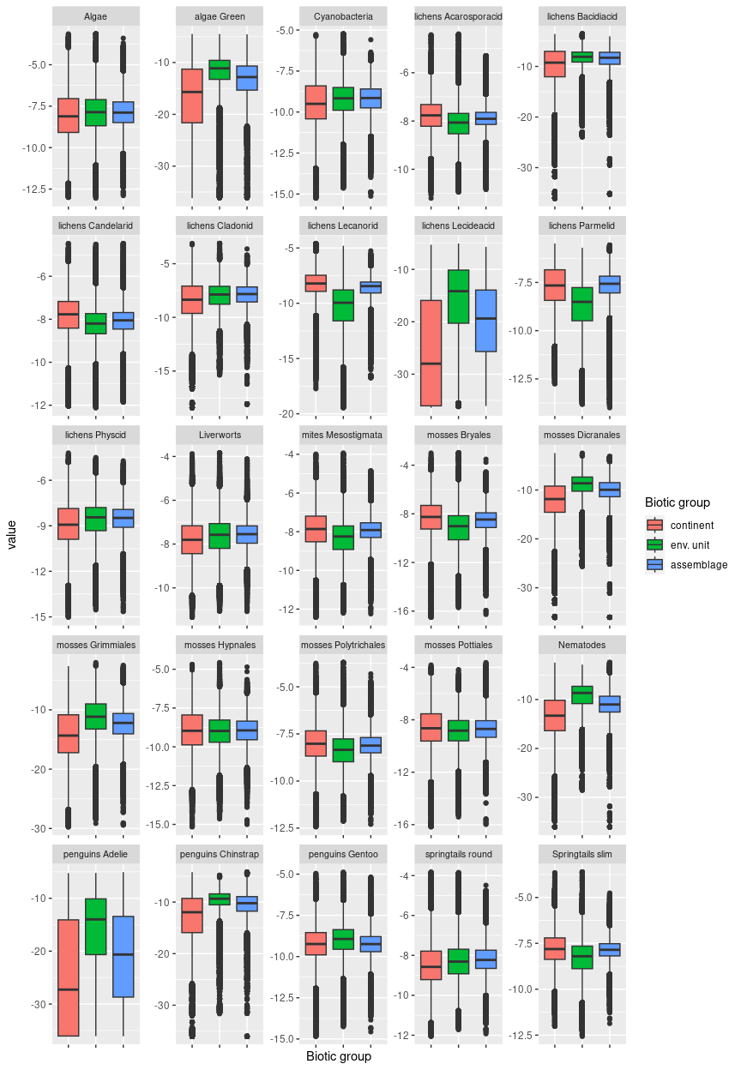

## Ecosystem E1B4

#### Inland Meltwater-eroded mid-highland mountain slopes

Terrain and elevation may be quite variable, but the unit is characterised by high snowfall, cloud cover, and melt. Usually farther removed from the coast than most E1 units, it is more sheltered from maritime winds, lower in moisture (except E1B3), and higher in elevation than its sister assemblages. Satellite imagery shows frequent deep lateral crevasses in adjacent glacier accumulation zones and rock falls where unit is transitional between E2 units and glacier below. Sampled biota includes mainly common lichens and occasional mosses. Suitability is low for most functional groups, but higher than the continental average of Bacidiacid, Cladonid, and Rhizocarpid lichens as well as most mosses and mites.

### Photos (if available)

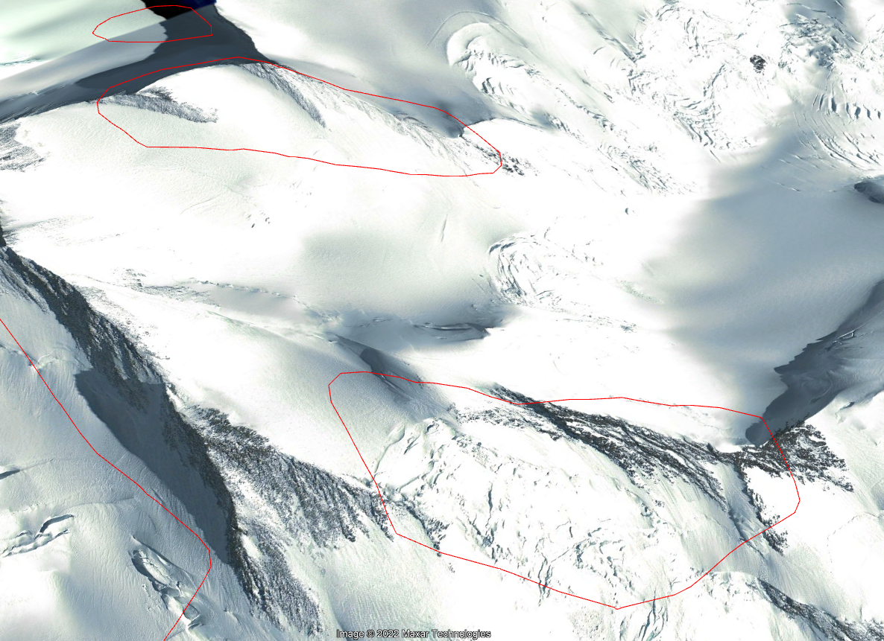

Ecosystem photo

### Distribution

Occurs mainly inland from the coast on the Antarctic Peninsula with a good representation in the Transantarctic Mountains and Victoria Land, again somewhat isolated from the coast.

Full map

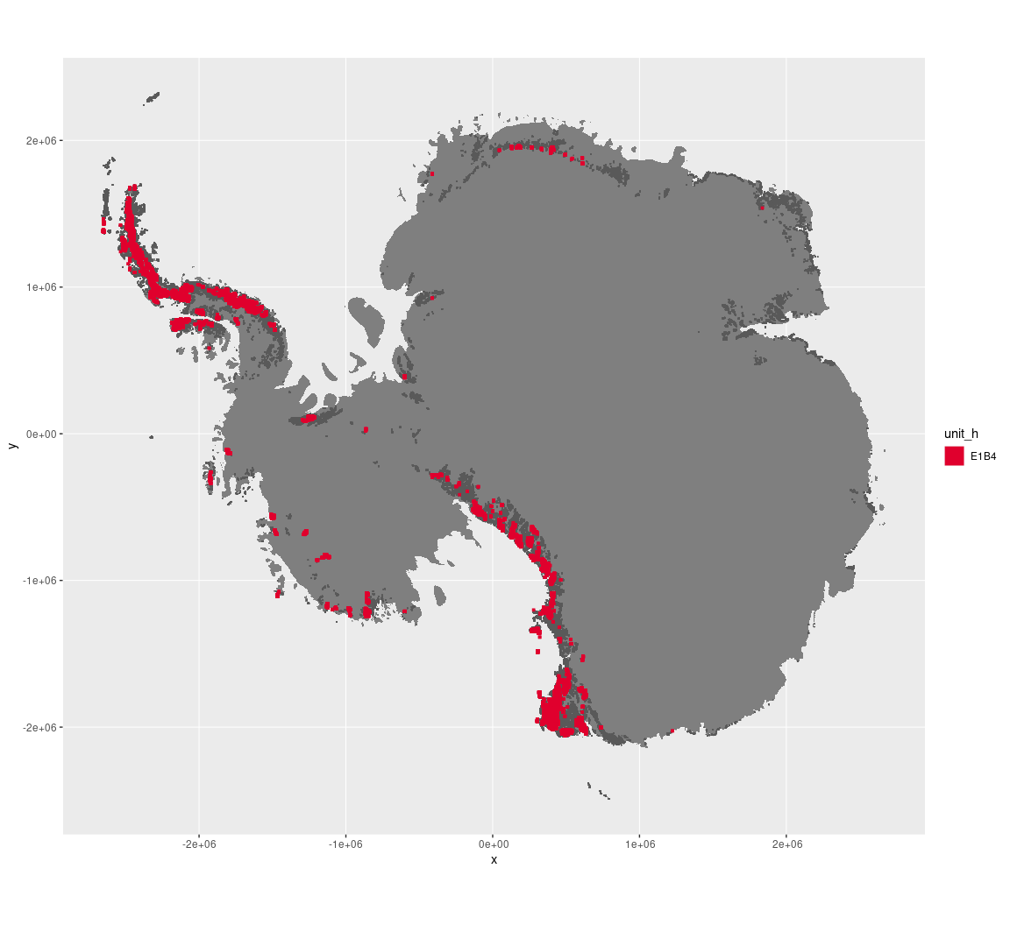

Regional maps

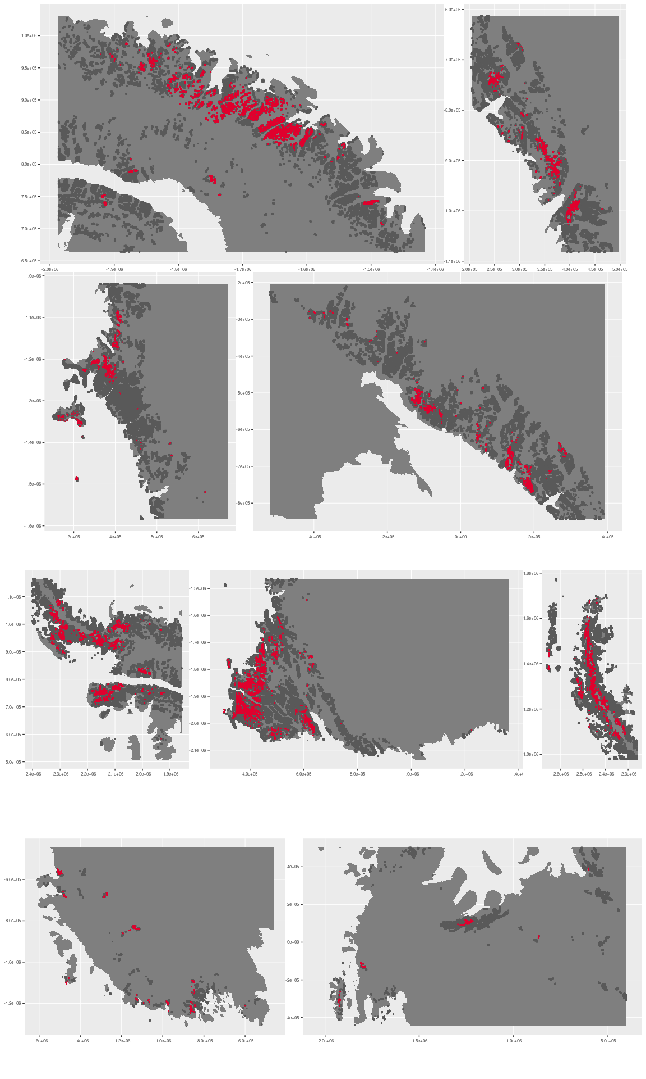

### Environment

The unit E1B4 is part of the environmental supergroup E1.

Supergroup E1 is, on average, substantially higher in cloud, DDm5, meanTemp, melt and totPrecip than continental Antarctica. It is substantially lower in no variables than the rest of the continent.

The elevation of unit E1B4 ranges from 0 to 4477 metres above sea level, but 90% of its pixels fall above 645 and below 2760 metres. Its average elevation is 1526 metres.

The unit is higher in elevation and lower in DDm5 and melt than the rest of supergroup E1.

#### Distinctiveness of the assemblage from its group and the rest of Antarctica

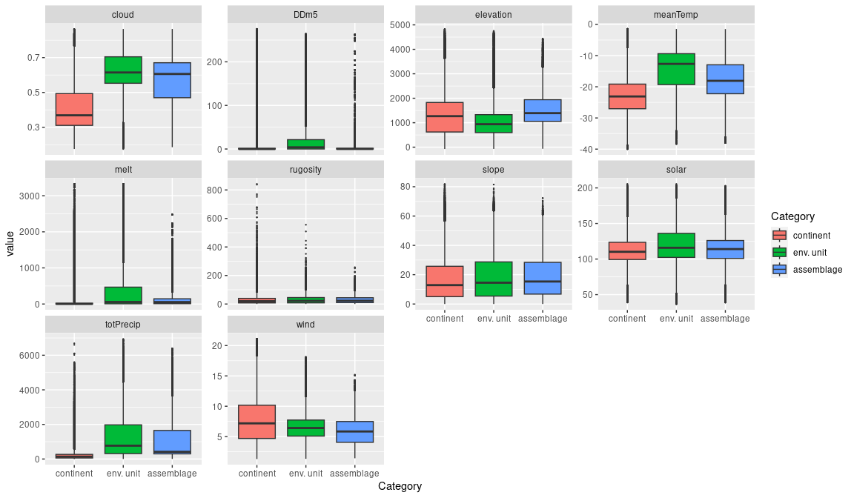

### Biota

Most widely sampled species in the unit (found in most pixels)

|  |  |  |  |  |  |
| --- | --- | --- | --- | --- | --- |
| scientific | Functional group | phylum | restricted | count | percent of samples |
| Usnea sphacelata | Ascomycota_Lecanoromycetes_Lecanorales_Parmeliaceae | Ascomycota | TRUE | 6 | 11.3208 |
| Pseudephebe minuscula | Ascomycota_Lecanoromycetes_Lecanorales_Parmeliaceae | Ascomycota | FALSE | 5 | 9.4340 |
| Buellia pallida | Ascomycota_Lecanoromycetes_Teloschistales_Physciaceae | Ascomycota | TRUE | 4 | 7.5472 |
| Pygoscelis adeliae | Chordata_Aves_Sphenisciformes_Spheniscidae_Pygoscelis_adeliae | Chordata | FALSE | 3 | 5.6604 |
| Acarospora gwynnii | Ascomycota_Lecanoromycetes_Acarosporales_Acarosporaceae | Ascomycota | TRUE | 2 | 3.7736 |
| Ceratodon purpureus | Bryophyta_Bryopsida_Dicranales | Bryophyta | FALSE | 2 | 3.7736 |
| Lecidea cf. cancriformis | Ascomycota_Lecanoromycetes_Lecanorales_Lecideaceae | Ascomycota | TRUE | 2 | 3.7736 |
| Umbilicaria decussata | Ascomycota_Lecanoromycetes_Umbilicariales_Umbilicariaceae | Ascomycota | FALSE | 2 | 3.7736 |

Supergroup E1 is, on average, substantially higher in suitability for algae_Green, lichens_Lecideacid, mosses_Dicranales, Nematodes, penguins_Adelie and penguins_Chinstrap functional groups than continental Antarctica. It is substantially lower in suitability for no variables than the rest of the continent.

Unit E1B4 is higher in suitability for no variables and lower in suitability for no variables than the rest of supergroup E1.

#### Distinctiveness of the unit from the environmental group and the rest of Antarctica

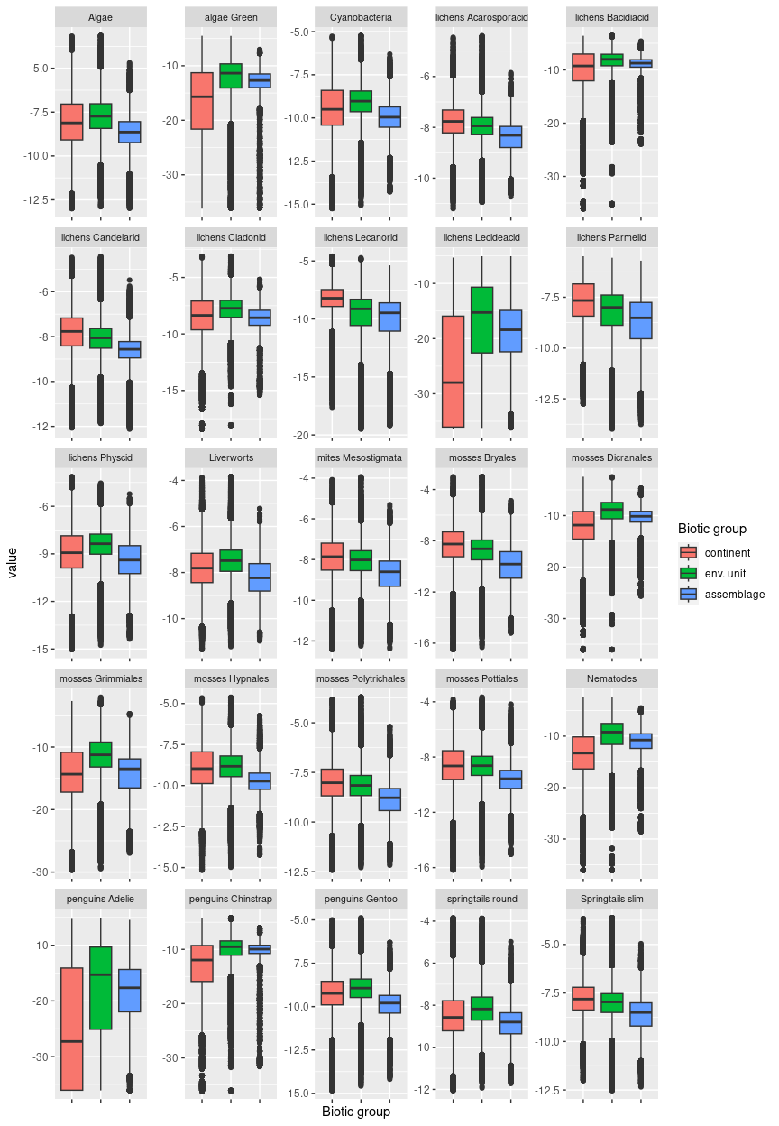

## Ecosystem E2B1

#### Exposed midland escarpments.

Characterised by steep, shadowed slopes, this unit may be found in close association with sunlit E4 units where light conditions vary due to aspect. Unit is the lowest elevation, warmest and windiest unit in E2 (which is the steepest and shadiest group), occurring where lower elevation or coastal mountains have sharp, high escarpments. Suitability is higher than the group for nearly all functional groups but still below continental average in most cases, excepting some lichen groups and Algae.

### Photos (if available)

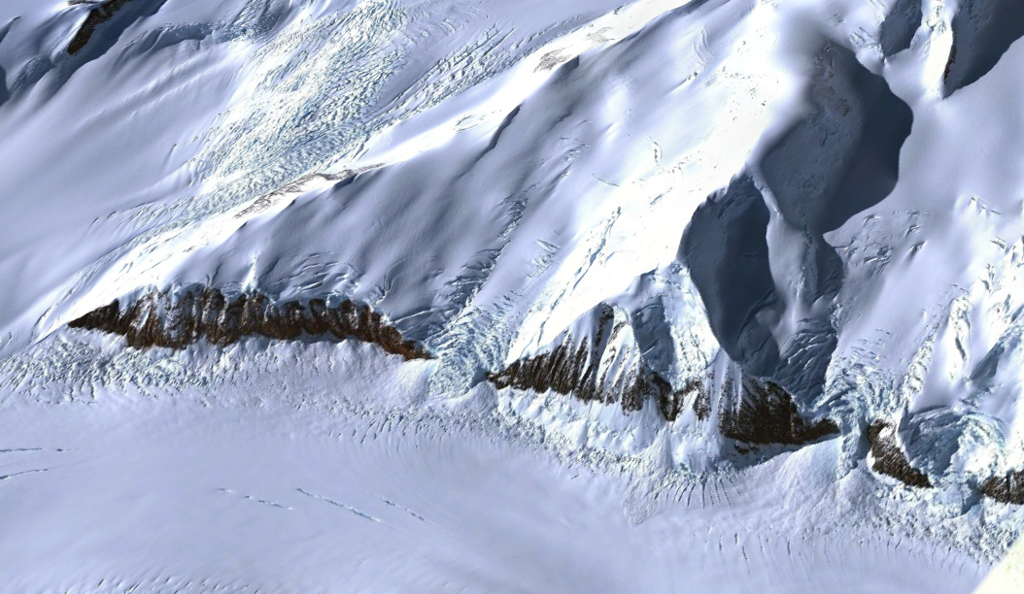

Ecosystem photo

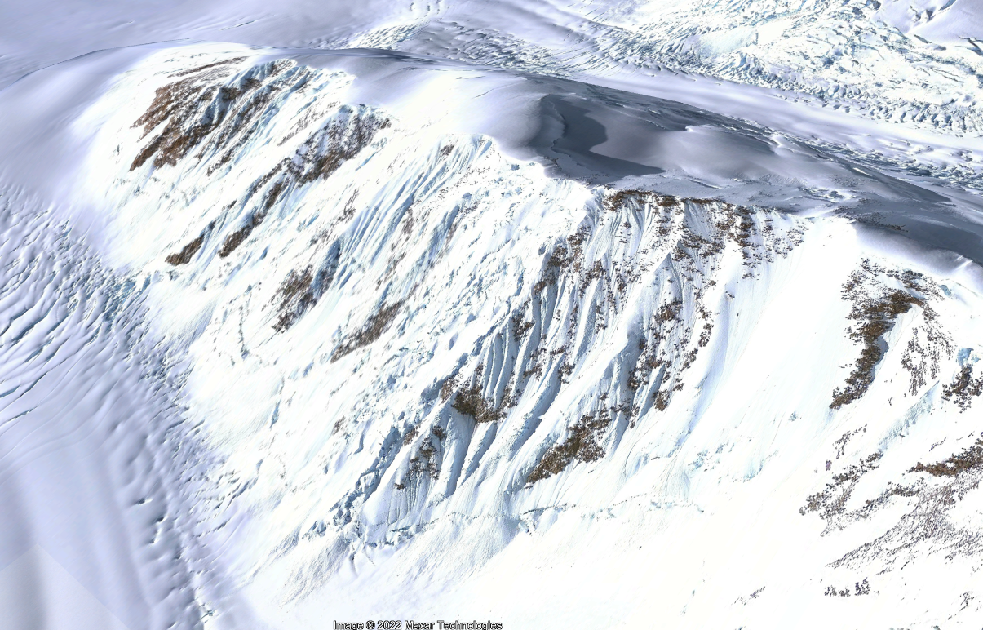

Ecosystem photo

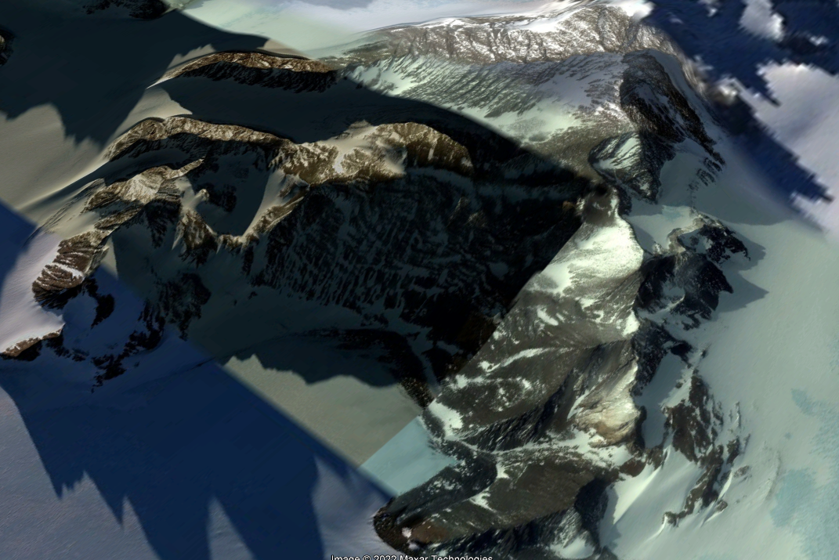

Ecosystem photo

### Distribution

Occurs all around Antarctica, with concentrations in South Victoria Land, Dronning Maud Land and the Transantarctic mountains.

Full map

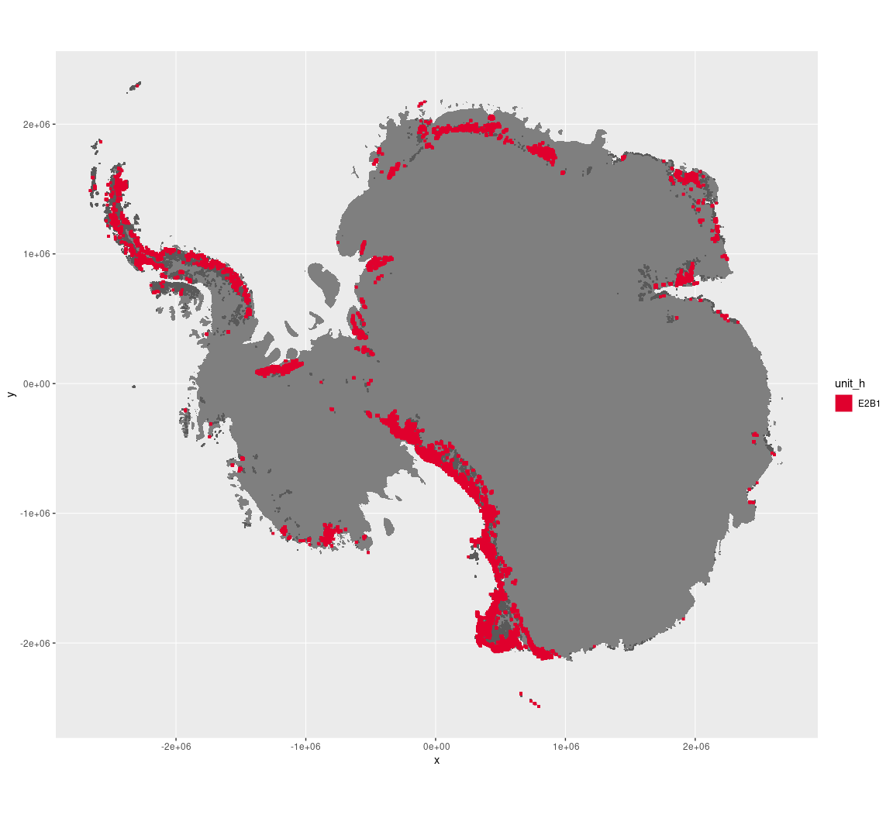

Regional maps

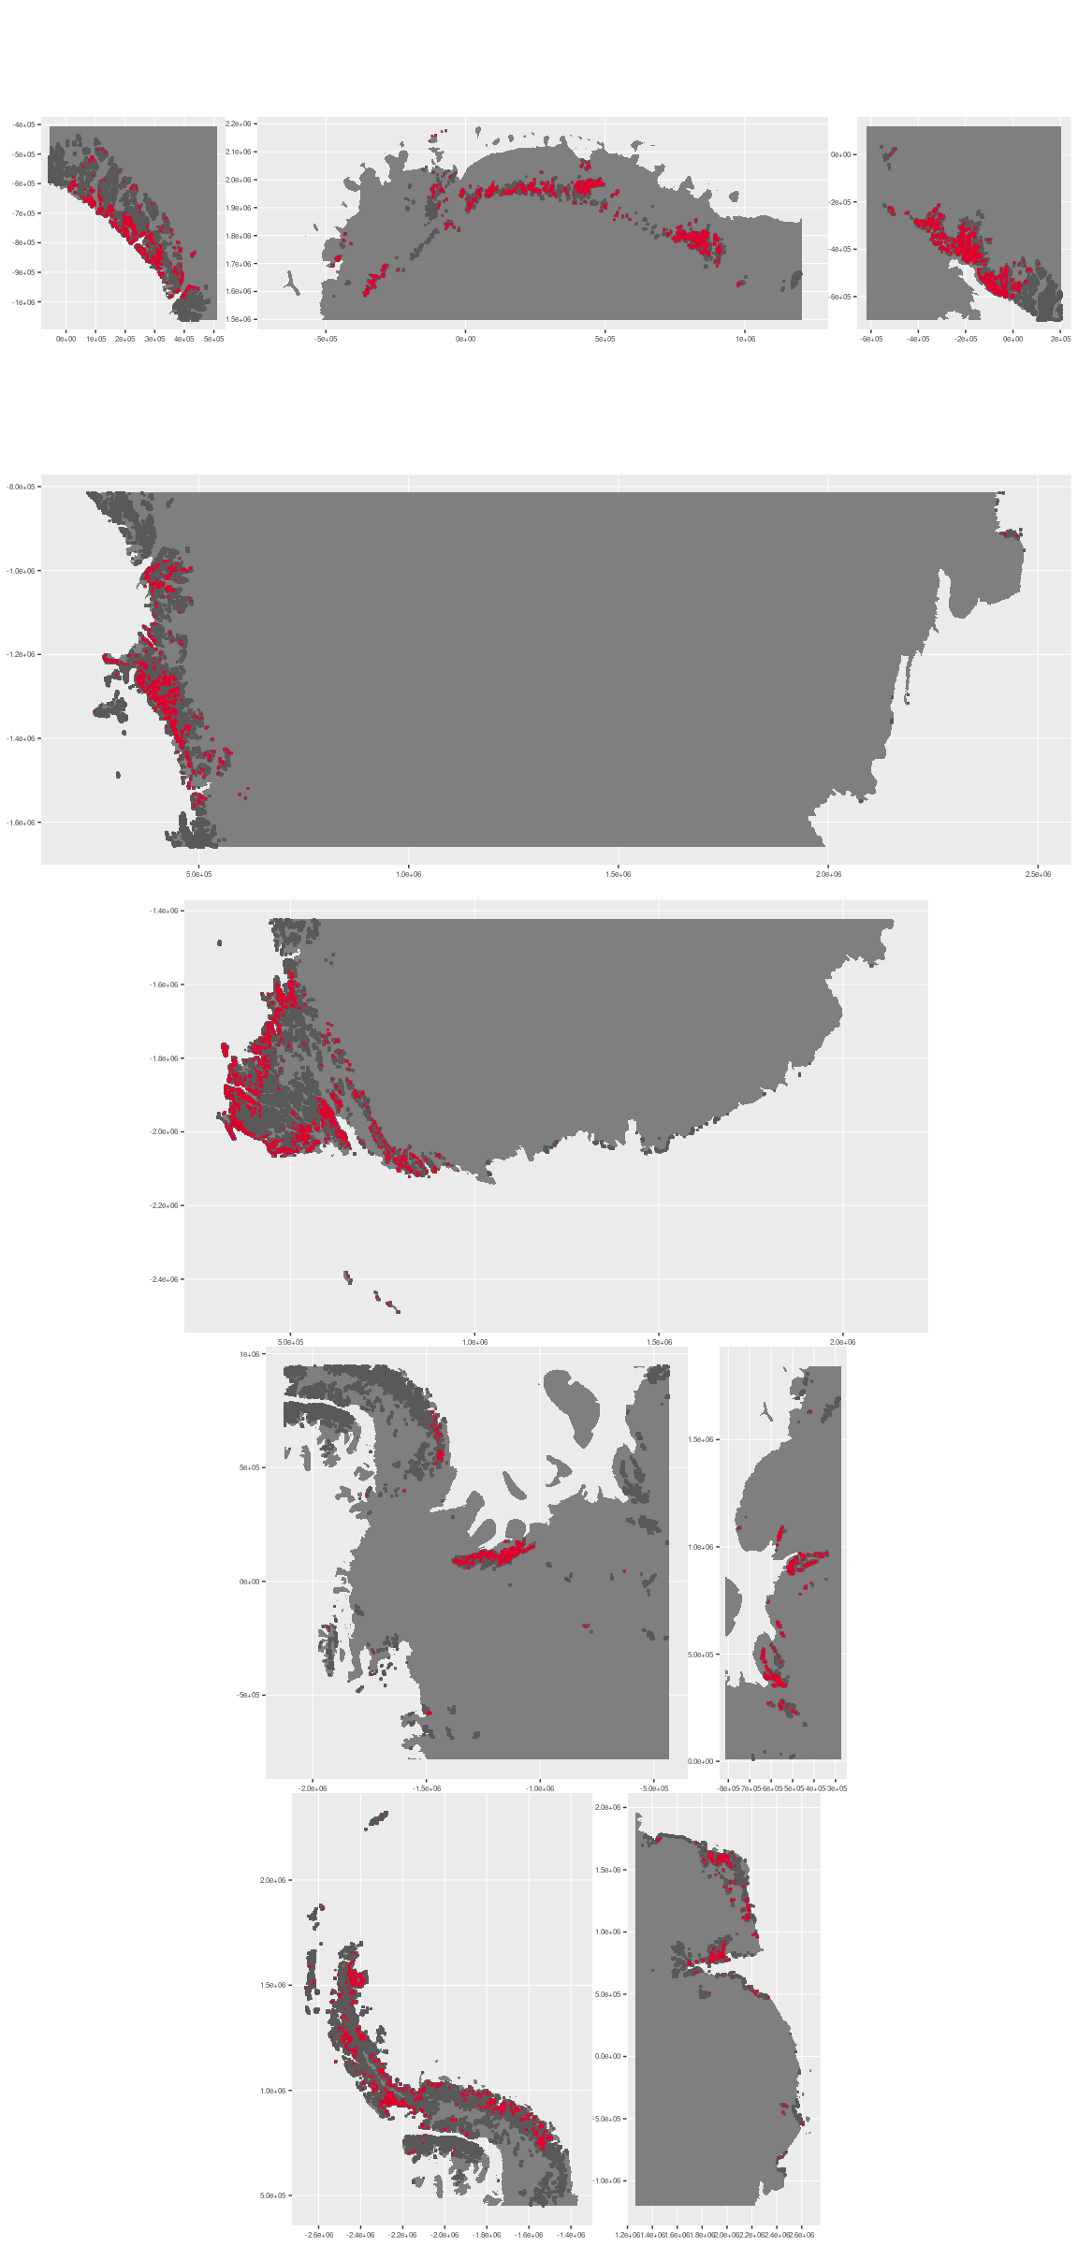







### Environment

The unit E2B1 is part of the environmental supergroup E2.

Supergroup E2 is, on average, substantially higher in elevation, rugosity and slope than continental Antarctica. It is substantially lower in DDm5, melt and totPrecip than the rest of the continent.

The elevation of unit E2B1 ranges from 0 to 3881 metres above sea level, but 90% of its pixels fall above 308 and below 2035 metres. Its average elevation is 1115 metres.

The unit is higher in DDm5 and wind and lower in elevation than the rest of supergroup E2.

#### Distinctiveness of the assemblage from its group and the rest of Antarctica

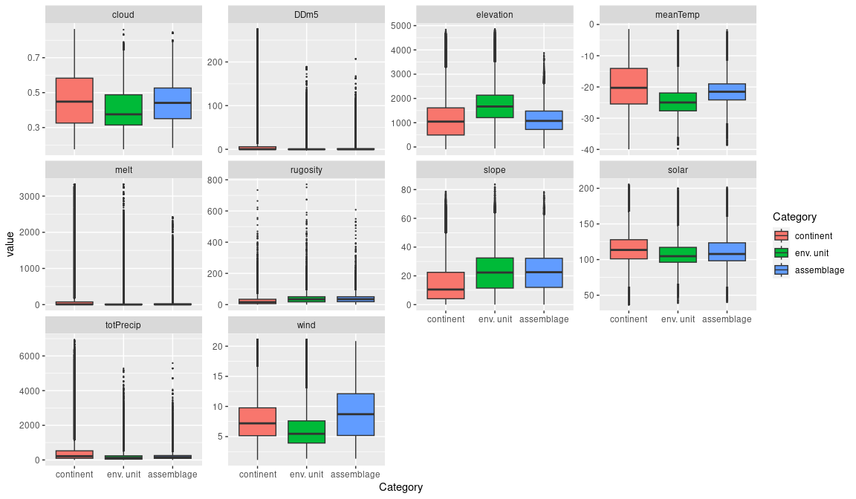

### Biota

Most widely sampled species in the unit (found in most pixels)

The top most widespread species in ecosystem E2B1

|  |  |  |  |  |  |
| --- | --- | --- | --- | --- | --- |
| scientific | Functional group | phylum | restricted | count | percent of samples |
| Xanthoria elegans | Ascomycota_Lecanoromycetes_Teloschistales_Teloschistaceae | Ascomycota | FALSE | 10 | 3.9370 |
| Lecidea cancriformis | Ascomycota_Lecanoromycetes_Lecanorales_Lecideaceae | Ascomycota | TRUE | 7 | 2.7559 |
| Pseudephebe minuscula | Ascomycota_Lecanoromycetes_Lecanorales_Parmeliaceae | Ascomycota | FALSE | 7 | 2.7559 |
| Gomphiocephalus hodgsoni | Arthropoda_Entognatha_Poduromorpha | Arthropoda | TRUE | 6 | 2.3622 |
| Rhizoplaca melanophthalma | Ascomycota_Lecanoromycetes_Lecanorales_Lecanoraceae | Ascomycota | FALSE | 6 | 2.3622 |
| Usnea sphacelata | Ascomycota_Lecanoromycetes_Lecanorales_Parmeliaceae | Ascomycota | TRUE | 6 | 2.3622 |
| Candelariella flava | Ascomycota_Lecanoromycetes_Candelariales_Candelariaceae | Ascomycota | TRUE | 5 | 1.9685 |
| Physcia caesia | Ascomycota_Lecanoromycetes_Teloschistales_Physciaceae | Ascomycota | FALSE | 5 | 1.9685 |
| Umbilicaria decussata | Ascomycota_Lecanoromycetes_Umbilicariales_Umbilicariaceae | Ascomycota | FALSE | 5 | 1.9685 |
| Acarospora gwynnii | Ascomycota_Lecanoromycetes_Acarosporales_Acarosporaceae | Ascomycota | TRUE | 4 | 1.5748 |
| Buellia frigida | Ascomycota_Lecanoromycetes_Teloschistales_Physciaceae | Ascomycota | TRUE | 4 | 1.5748 |
| Pleopsidium chlorophanum | Ascomycota_Lecanoromycetes_Acarosporales_Acarosporaceae | Ascomycota | FALSE | 4 | 1.5748 |

Supergroup E2 is, on average, substantially higher in suitability for no variables functional groups than continental Antarctica. It is substantially lower in suitability for no variables than the rest of the continent.

Unit E2B1 is higher in suitability for mosses_Grimmiales and lower in suitability for no variables than the rest of supergroup E2.

#### Distinctiveness of the unit from the environmental group and the rest of Antarctica

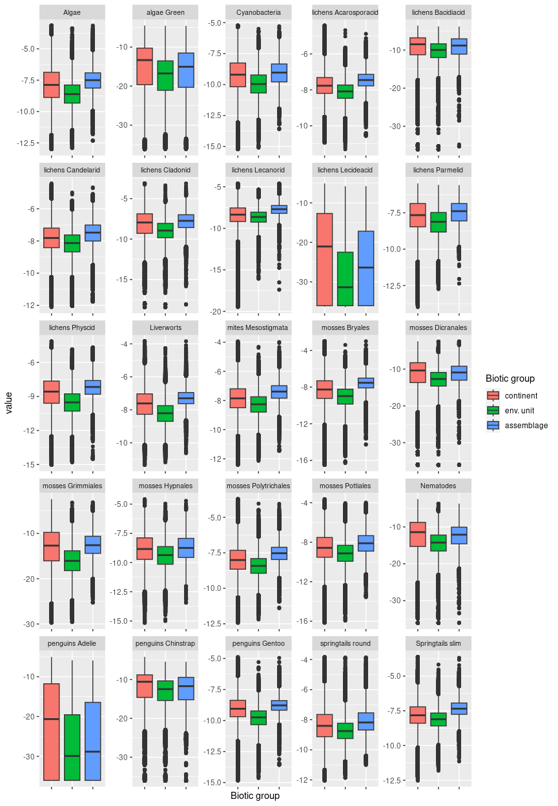

## Ecosystem E2B2

#### Cloudy escarpments

High, rugged escarpments with some water availability, high cloud cover and highest snowfall in the group. Some instances on the Peninsula have a short growing season. Very rare unit.

### Photos (if available)

### Distribution

Patchy, rare occurrences in the southern Transantarctic Mountains, Ellsworth Mountains, and the Antarctic Peninsula

Full map

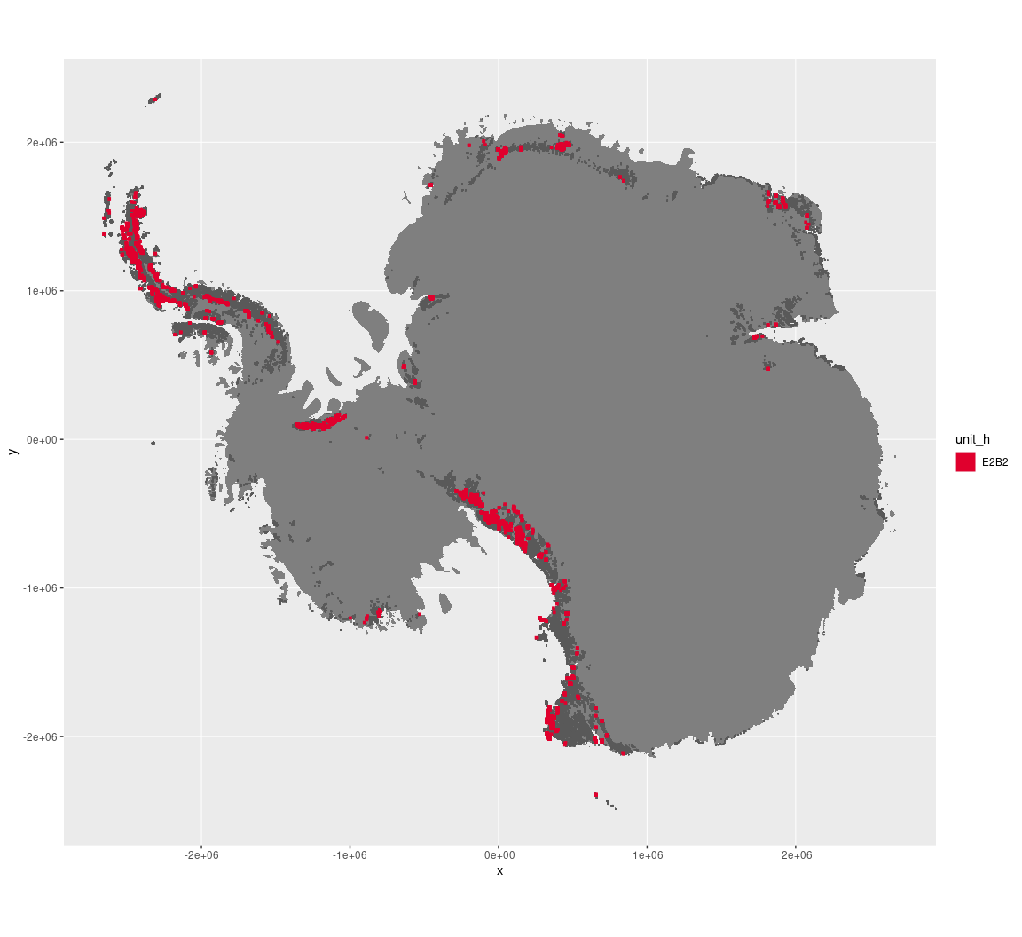

Regional maps

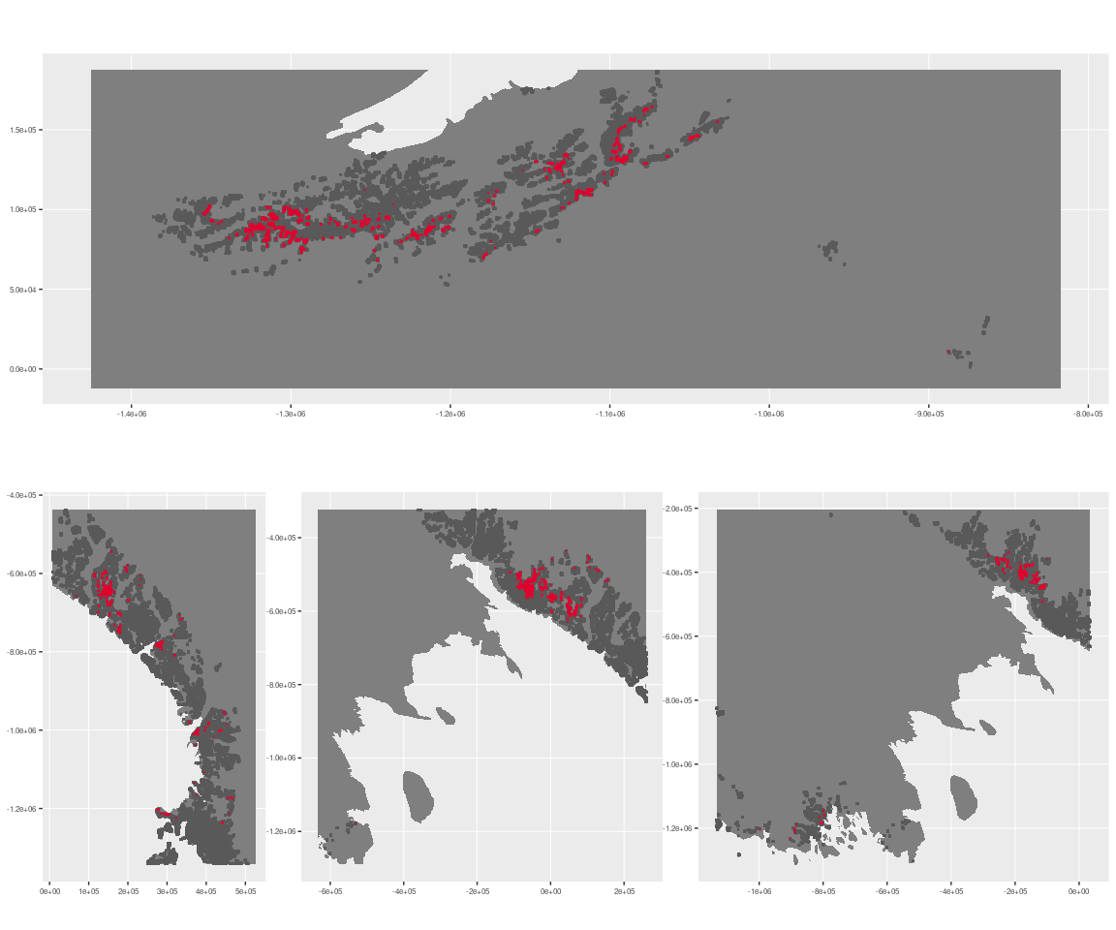

### Environment

The unit E2B2 is part of the environmental supergroup E2.

Supergroup E2 is, on average, substantially higher in elevation, rugosity and slope than continental Antarctica. It is substantially lower in DDm5, melt and totPrecip than the rest of the continent.

The elevation of unit E2B2 ranges from 0 to 4744 metres above sea level, but 90% of its pixels fall above 335 and below 3252 metres. Its average elevation is 1866 metres.

The unit is higher in DDm5 and totPrecip and lower in no variables than the rest of supergroup E2.

#### Distinctiveness of the assemblage from its group and the rest of Antarctica

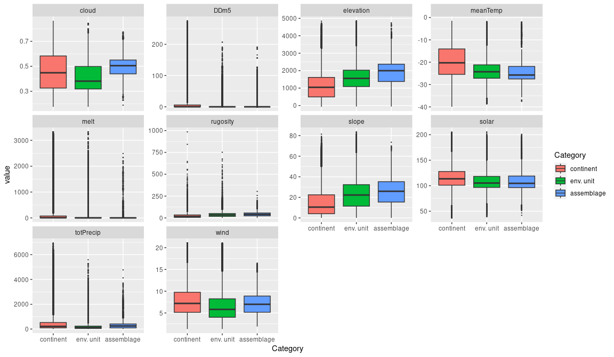

### Biota

Most widely sampled species in the unit (found in most pixels)

The top most widespread species in ecosystem E2B2

|  |  |  |  |  |  |
| --- | --- | --- | --- | --- | --- |
| scientific | Functional group | phylum | restricted | count | percent of samples |
| Pseudephebe minuscula | Ascomycota_Lecanoromycetes_Lecanorales_Parmeliaceae | Ascomycota | FALSE | 2 | 5.4054 |
| Acarospora macrocyclos | Ascomycota_Lecanoromycetes_Acarosporales_Acarosporaceae | Ascomycota | TRUE | 1 | 2.7027 |
| Andreaea gainii | Bryophyta_Andreaeopsida_Andreaeales | Bryophyta | TRUE | 1 | 2.7027 |
| Bryum argenteum | Bryophyta_Bryopsida_Bryales | Bryophyta | FALSE | 1 | 2.7027 |
| Buellia anisomera | Ascomycota_Lecanoromycetes_Teloschistales_Physciaceae | Ascomycota | TRUE | 1 | 2.7027 |
| Buellia sp. | Ascomycota_Lecanoromycetes_Teloschistales_Physciaceae | Ascomycota | TRUE | 1 | 2.7027 |
| Caloplaca sp. | Ascomycota_Lecanoromycetes_Teloschistales_Teloschistaceae | Ascomycota | TRUE | 1 | 2.7027 |
| Candelariella vitellina | Ascomycota_Lecanoromycetes_Candelariales_Candelariaceae | Ascomycota | FALSE | 1 | 2.7027 |
| Ceratodon purpureus | Bryophyta_Bryopsida_Dicranales | Bryophyta | FALSE | 1 | 2.7027 |
| Cladonia pocillum | Ascomycota_Lecanoromycetes_Lecanorales_Cladoniaceae | Ascomycota | FALSE | 1 | 2.7027 |
| Haematomma erythromma | Ascomycota_Lecanoromycetes_Lecanorales_Haematommataceae | Ascomycota | TRUE | 1 | 2.7027 |
| Hennediella heimii | Bryophyta_Bryopsida_Pottiales | Bryophyta | FALSE | 1 | 2.7027 |
| Larus dominicanus | Chordata_Aves_Charadriiformes | Chordata | TRUE | 1 | 2.7027 |
| Lecanora aspidophora | Ascomycota_Lecanoromycetes_Lecanorales_Lecanoraceae | Ascomycota | TRUE | 1 | 2.7027 |
| Nanorchestes antarcticus | Arthropoda_Arachnida_Sarcoptiformes | Arthropoda | TRUE | 1 | 2.7027 |
| Nanorchestes bellus | Arthropoda_Arachnida_Sarcoptiformes | Arthropoda | TRUE | 1 | 2.7027 |
| Physcia caesia | Ascomycota_Lecanoromycetes_Teloschistales_Physciaceae | Ascomycota | FALSE | 1 | 2.7027 |
| Pleopsidium chlorophanum | Ascomycota_Lecanoromycetes_Acarosporales_Acarosporaceae | Ascomycota | FALSE | 1 | 2.7027 |
| Pohlia nutans | Bryophyta_Bryopsida_Bryales | Bryophyta | FALSE | 1 | 2.7027 |
| Pygoscelis adeliae | Chordata_Aves_Sphenisciformes_Spheniscidae_Pygoscelis_adeliae | Chordata | FALSE | 1 | 2.7027 |
| Pygoscelis antarctica | Chordata_Aves_Sphenisciformes_Spheniscidae_Pygoscelis_antarctica | Chordata | TRUE | 1 | 2.7027 |
| Pygoscelis papua | Chordata_Aves_Sphenisciformes_Spheniscidae_Pygoscelis_papua | Chordata | FALSE | 1 | 2.7027 |
| Rhizocarpon geographicum | Ascomycota_Lecanoromycetes_Not assigned_Rhizocarpaceae | Ascomycota | FALSE | 1 | 2.7027 |
| Rhizoplaca melanophthalma | Ascomycota_Lecanoromycetes_Lecanorales_Lecanoraceae | Ascomycota | FALSE | 1 | 2.7027 |
| Sanionia uncinata | Bryophyta_Bryopsida_Hypnales | Bryophyta | FALSE | 1 | 2.7027 |
| Schistidium antarctici | Bryophyta_Bryopsida_Grimmiales | Bryophyta | TRUE | 1 | 2.7027 |
| Stereocaulon antarcticum | Ascomycota_Lecanoromycetes_Lecanorales_Stereocaulaceae | Ascomycota | TRUE | 1 | 2.7027 |
| Syntrichia princeps | Bryophyta_Bryopsida_Pottiales | Bryophyta | FALSE | 1 | 2.7027 |
| Tremolecia atrata | Ascomycota_Lecanoromycetes_Not assigned_Hymeneliaceae | Ascomycota | FALSE | 1 | 2.7027 |
| Umbilicaria antarctica | Ascomycota_Lecanoromycetes_Umbilicariales_Umbilicariaceae | Ascomycota | TRUE | 1 | 2.7027 |
| Umbilicaria decussata | Ascomycota_Lecanoromycetes_Umbilicariales_Umbilicariaceae | Ascomycota | FALSE | 1 | 2.7027 |
| Umbilicaria kappenii | Ascomycota_Lecanoromycetes_Umbilicariales_Umbilicariaceae | Ascomycota | TRUE | 1 | 2.7027 |
| Usnea antarctica | Ascomycota_Lecanoromycetes_Lecanorales_Parmeliaceae | Ascomycota | FALSE | 1 | 2.7027 |
| Usnea sphacelata | Ascomycota_Lecanoromycetes_Lecanorales_Parmeliaceae | Ascomycota | TRUE | 1 | 2.7027 |
| Xanthoria candelaria | Ascomycota_Lecanoromycetes_Teloschistales_Teloschistaceae | Ascomycota | FALSE | 1 | 2.7027 |
| Xanthoria elegans | Ascomycota_Lecanoromycetes_Teloschistales_Teloschistaceae | Ascomycota | FALSE | 1 | 2.7027 |

Supergroup E2 is, on average, substantially higher in suitability for no variables functional groups than continental Antarctica. It is substantially lower in suitability for no variables than the rest of the continent.

Unit E2B2 is higher in suitability for no variables and lower in suitability for no variables than the rest of supergroup E2.

#### Distinctiveness of the unit from the environmental group and the rest of Antarctica

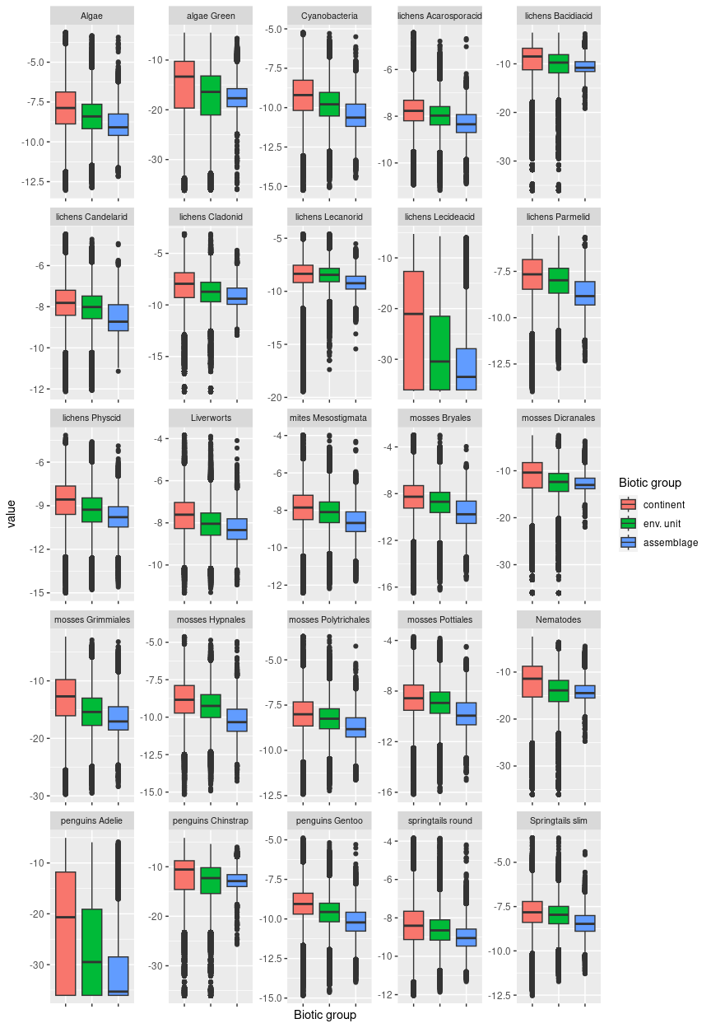

## Ecosystem E2B3

#### Sheltered dry highland escarpments

Its surfaces are usually quite steep, shadowed, and may be topped by sheer cliff, but sheltered from prevailing wind. May have some limited meltwater erosion. Sampling is nearly absent, with repeat samples only occurring in lichens, and suitability is low for nearly all functional groups, though it is above the group average for Bacidiacid and Cladonid lichens and several mosses.

### Photos (if available)

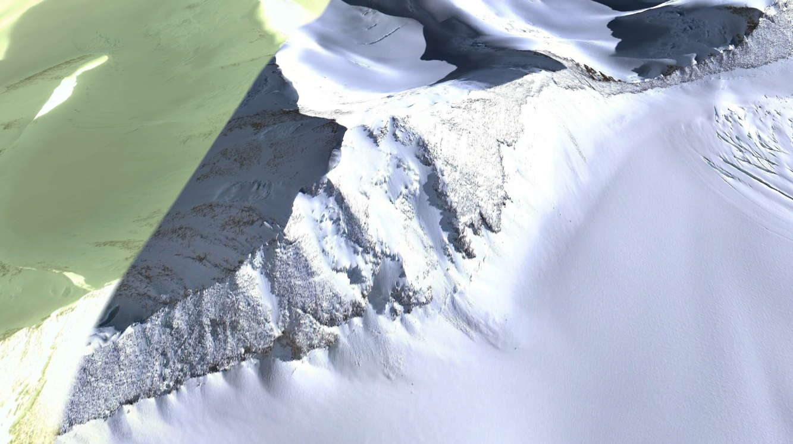

Ecosystem photo

### Distribution

Occurs mainly in the Transantarctic Mountains and Victoria Land, as well as the central and southern Antarctic Peninsula.

Full map

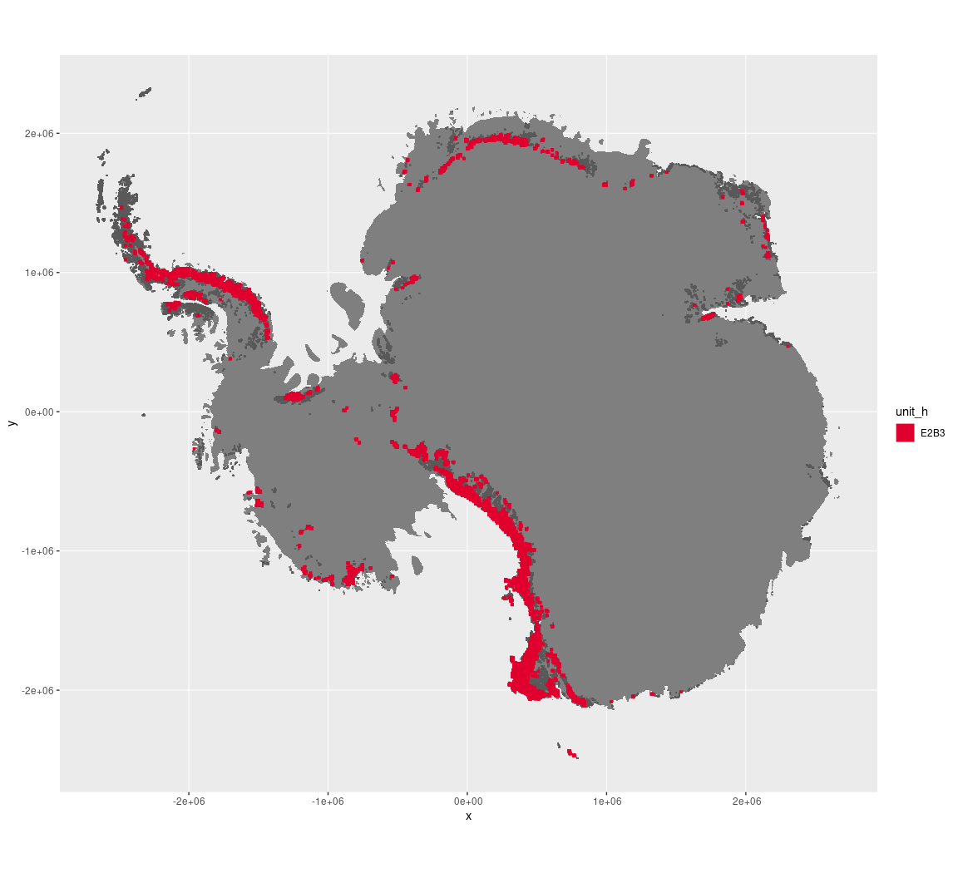

Regional maps

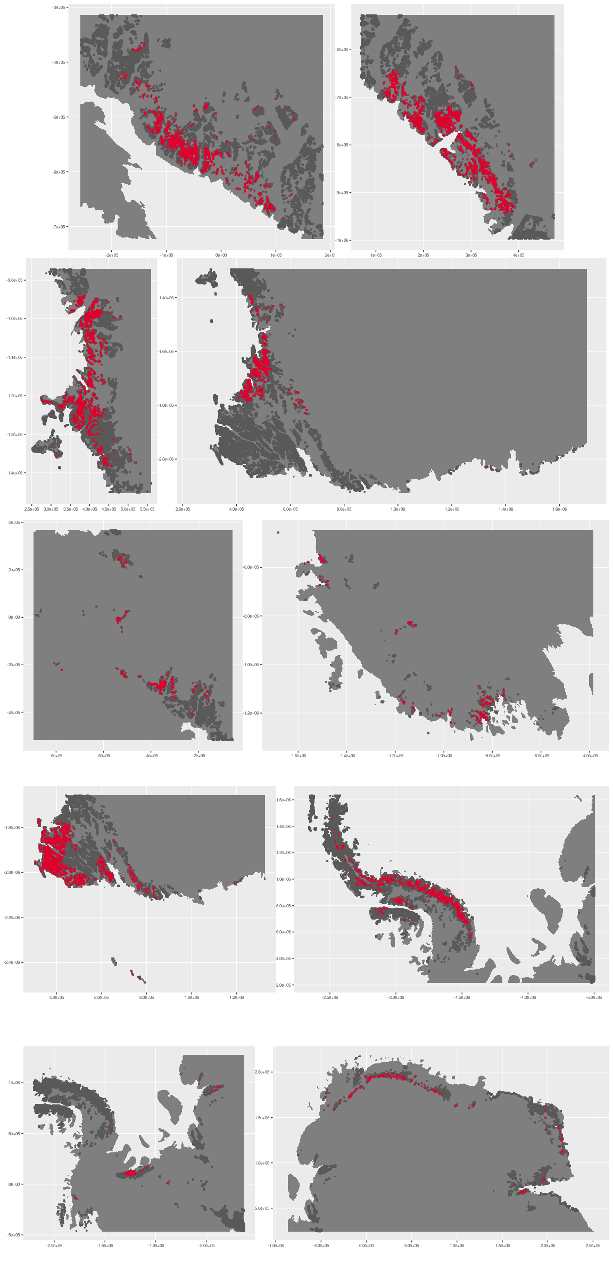



### Environment

The unit E2B3 is part of the environmental supergroup E2.

Supergroup E2 is, on average, substantially higher in elevation, rugosity and slope than continental Antarctica. It is substantially lower in DDm5, melt and totPrecip than the rest of the continent.

The elevation of unit E2B3 ranges from 0 to 4433 metres above sea level, but 90% of its pixels fall above 569 and below 2726 metres. Its average elevation is 1556 metres.

The unit is higher in totPrecip and lower in DDm5 and wind than the rest of supergroup E2.

#### Distinctiveness of the assemblage from its group and the rest of Antarctica

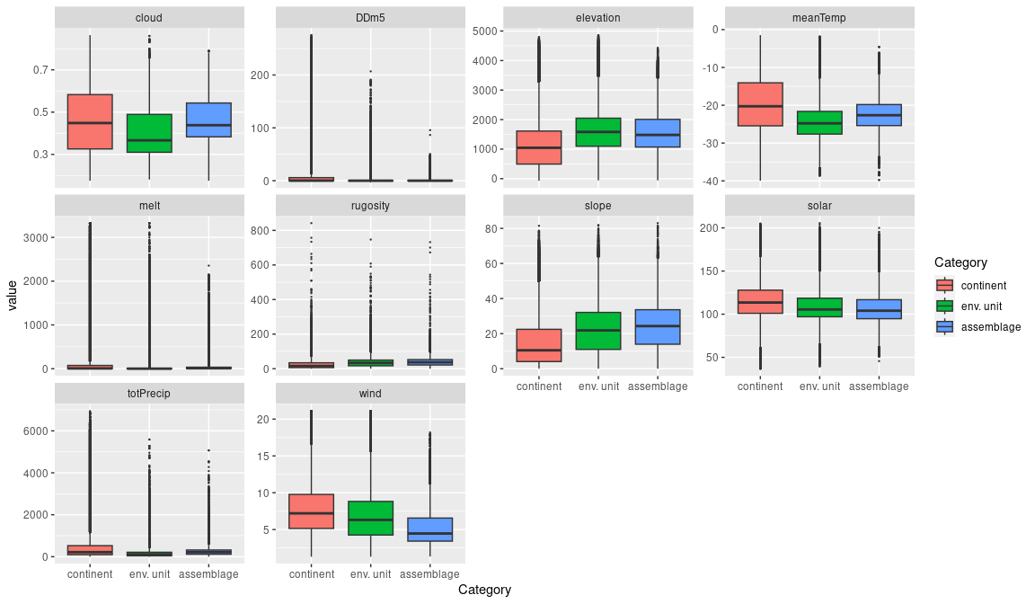

### Biota

Most widely sampled species in the unit (found in most pixels)

The top most widespread species in ecosystem E2B3

|  |  |  |  |  |  |
| --- | --- | --- | --- | --- | --- |
| scientific | Functional group | phylum | restricted | count | percent of samples |
| Xanthoria elegans | Ascomycota_Lecanoromycetes_Teloschistales_Teloschistaceae | Ascomycota | FALSE | 4 | 6.8966 |
| Acarospora gwynnii | Ascomycota_Lecanoromycetes_Acarosporales_Acarosporaceae | Ascomycota | TRUE | 2 | 3.4483 |
| Buellia frigida | Ascomycota_Lecanoromycetes_Teloschistales_Physciaceae | Ascomycota | TRUE | 2 | 3.4483 |
| Candelariella vitellina | Ascomycota_Lecanoromycetes_Candelariales_Candelariaceae | Ascomycota | FALSE | 2 | 3.4483 |
| Pseudephebe minuscula | Ascomycota_Lecanoromycetes_Lecanorales_Parmeliaceae | Ascomycota | FALSE | 2 | 3.4483 |
| Rhizoplaca melanophthalma | Ascomycota_Lecanoromycetes_Lecanorales_Lecanoraceae | Ascomycota | FALSE | 2 | 3.4483 |
| Amandinea coniops | Ascomycota_Lecanoromycetes_Teloschistales_Physciaceae | Ascomycota | FALSE | 1 | 1.7241 |
| Arthrorhaphis citrinella | Ascomycota_Lecanoromycetes_Not assigned_Arthrorhaphidaceae | Ascomycota | FALSE | 1 | 1.7241 |
| Biscoia sudpolaris | Arthropoda_Entognatha_Poduromorpha | Arthropoda | TRUE | 1 | 1.7241 |
| Buellia cladocarpiza | Ascomycota_Lecanoromycetes_Teloschistales_Physciaceae | Ascomycota | TRUE | 1 | 1.7241 |
| Buellia dendritica | Ascomycota_Lecanoromycetes_Teloschistales_Physciaceae | Ascomycota | TRUE | 1 | 1.7241 |
| Buellia grisea | Ascomycota_Lecanoromycetes_Teloschistales_Physciaceae | Ascomycota | FALSE | 1 | 1.7241 |
| Buellia muscicola | Ascomycota_Lecanoromycetes_Teloschistales_Physciaceae | Ascomycota | TRUE | 1 | 1.7241 |
| Caloplaca athallina | Ascomycota_Lecanoromycetes_Teloschistales_Teloschistaceae | Ascomycota | TRUE | 1 | 1.7241 |
| Caloplaca citrina | Ascomycota_Lecanoromycetes_Teloschistales_Teloschistaceae | Ascomycota | TRUE | 1 | 1.7241 |
| Caloplaca lewis-smithii | Ascomycota_Lecanoromycetes_Teloschistales_Teloschistaceae | Ascomycota | TRUE | 1 | 1.7241 |
| Caloplaca saxicola | Ascomycota_Lecanoromycetes_Teloschistales_Teloschistaceae | Ascomycota | FALSE | 1 | 1.7241 |
| Candelaria murrayi | Ascomycota_Lecanoromycetes_Candelariales_Candelariaceae | Ascomycota | TRUE | 1 | 1.7241 |
| Candelariella flava | Ascomycota_Lecanoromycetes_Candelariales_Candelariaceae | Ascomycota | TRUE | 1 | 1.7241 |
| Catillaria cremea | Ascomycota_Lecanoromycetes_Lecanorales_Catillariaceae | Ascomycota | TRUE | 1 | 1.7241 |
| Catillaria floccosa | Ascomycota_Lecanoromycetes_Lecanorales_Catillariaceae | Ascomycota | TRUE | 1 | 1.7241 |
| Coccorhagidia keithi | Arthropoda_Arachnida_Trombidiformes | Arthropoda | TRUE | 1 | 1.7241 |
| Gressittacantha terranova | Arthropoda_Entognatha_Entomobryomorpha | Arthropoda | TRUE | 1 | 1.7241 |
| Grimmia reflexidens | Bryophyta_Bryopsida_Grimmiales | Bryophyta | FALSE | 1 | 1.7241 |
| Lecanora cf. geophila | Ascomycota_Lecanoromycetes_Lecanorales_Lecanoraceae | Ascomycota | TRUE | 1 | 1.7241 |
| Lecanora expectans | Ascomycota_Lecanoromycetes_Lecanorales_Lecanoraceae | Ascomycota | TRUE | 1 | 1.7241 |
| Lecanora fuscobrunnea | Ascomycota_Lecanoromycetes_Lecanorales_Lecanoraceae | Ascomycota | TRUE | 1 | 1.7241 |
| Lecanora mons-nivis | Ascomycota_Lecanoromycetes_Lecanorales_Lecanoraceae | Ascomycota | TRUE | 1 | 1.7241 |
| Lecidea andersonii | Ascomycota_Lecanoromycetes_Lecanorales_Lecideaceae | Ascomycota | TRUE | 1 | 1.7241 |
| Lecidea cancriformis | Ascomycota_Lecanoromycetes_Lecanorales_Lecideaceae | Ascomycota | TRUE | 1 | 1.7241 |
| Lecidella siplei | Ascomycota_Lecanoromycetes_Lecanorales_Lecanoraceae | Ascomycota | TRUE | 1 | 1.7241 |
| Lepraria cacuminum | Ascomycota_Lecanoromycetes_Lecanorales_Stereocaulaceae | Ascomycota | FALSE | 1 | 1.7241 |
| Phoma sp. | Ascomycota_Dothideomycetes_Pleosporales_Not assigned | Ascomycota | TRUE | 1 | 1.7241 |
| Physcia caesia | Ascomycota_Lecanoromycetes_Teloschistales_Physciaceae | Ascomycota | FALSE | 1 | 1.7241 |
| Placopsis contortuplicata | Ascomycota_Lecanoromycetes_Baeomycetales_Trapeliaceae | Ascomycota | TRUE | 1 | 1.7241 |
| Plectus murrayi | Nematoda | Nematoda | TRUE | 1 | 1.7241 |
| Pleopsidium chlorophanum | Ascomycota_Lecanoromycetes_Acarosporales_Acarosporaceae | Ascomycota | FALSE | 1 | 1.7241 |
| Pohlia cruda | Bryophyta_Bryopsida_Bryales | Bryophyta | FALSE | 1 | 1.7241 |
| Pohlia nutans | Bryophyta_Bryopsida_Bryales | Bryophyta | FALSE | 1 | 1.7241 |
| Pseudogymnoascus pannorum | Ascomycota_Leotiomycetes_Not assigned_Myxotrichaceae | Ascomycota | FALSE | 1 | 1.7241 |
| Rhizocarpon sp. | Ascomycota_Lecanoromycetes_Not assigned_Rhizocarpaceae | Ascomycota | TRUE | 1 | 1.7241 |
| Rinodina olivaceobrunnea | Ascomycota_Lecanoromycetes_Teloschistales_Physciaceae | Ascomycota | FALSE | 1 | 1.7241 |
| Stereocaulon antarcticum | Ascomycota_Lecanoromycetes_Lecanorales_Stereocaulaceae | Ascomycota | TRUE | 1 | 1.7241 |
| Syntrichia princeps | Bryophyta_Bryopsida_Pottiales | Bryophyta | FALSE | 1 | 1.7241 |
| Syntrichia sarconeurum | Bryophyta_Bryopsida_Pottiales | Bryophyta | FALSE | 1 | 1.7241 |
| Tetramelas papillatus | Ascomycota_Lecanoromycetes_Teloschistales_Physciaceae | Ascomycota | FALSE | 1 | 1.7241 |
| Umbilicaria aprina | Ascomycota_Lecanoromycetes_Umbilicariales_Umbilicariaceae | Ascomycota | FALSE | 1 | 1.7241 |
| Usnea antarctica | Ascomycota_Lecanoromycetes_Lecanorales_Parmeliaceae | Ascomycota | FALSE | 1 | 1.7241 |
| Usnea sphacelata | Ascomycota_Lecanoromycetes_Lecanorales_Parmeliaceae | Ascomycota | TRUE | 1 | 1.7241 |
| Xanthoria mawsonii | Ascomycota_Lecanoromycetes_Teloschistales_Teloschistaceae | Ascomycota | TRUE | 1 | 1.7241 |

Supergroup E2 is, on average, substantially higher in suitability for no variables functional groups than continental Antarctica. It is substantially lower in suitability for no variables than the rest of the continent.

Unit E2B3 is higher in suitability for lichens_Lecideacid and penguins_Adelie and lower in suitability for no variables than the rest of supergroup E2.

#### Distinctiveness of the unit from the environmental group and the rest of Antarctica

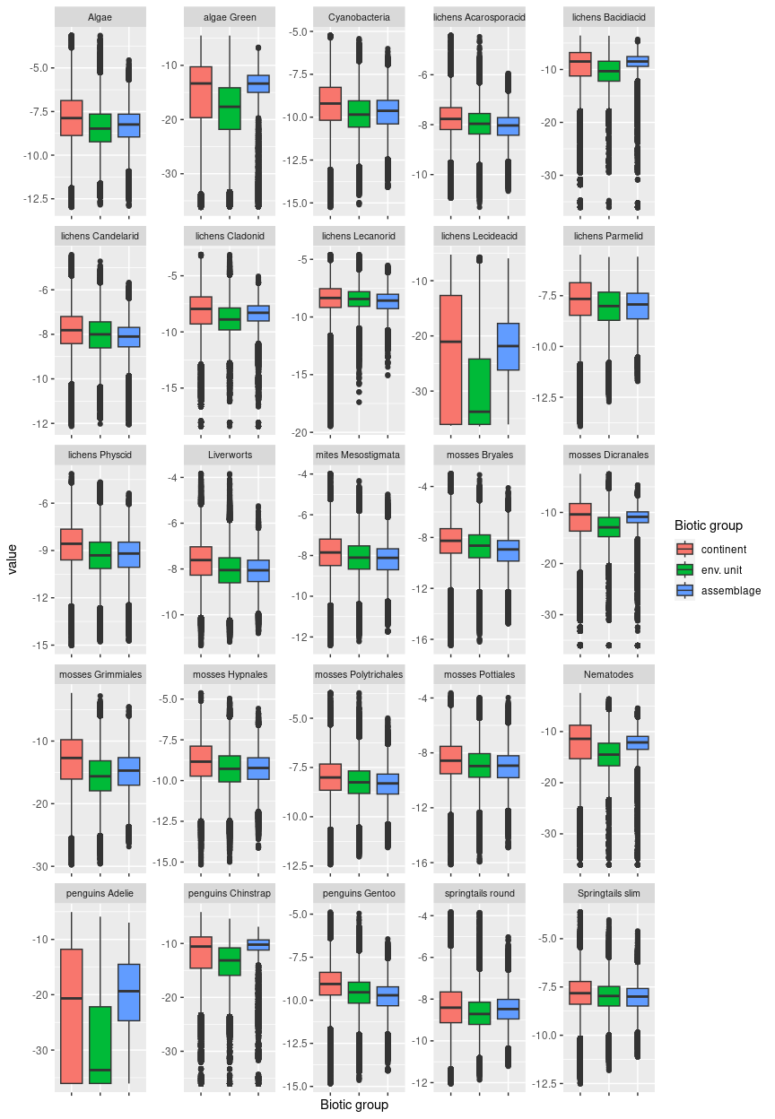

## Ecosystem E2B4

#### Highland clear arid mountain slopes

Usually set well back from the coast and removed from maritime influence, this cold (mean temperatures typically below -25 degrees), arid unit occurs mainly above 1500m and exhibits the lowest snowfall and cloud cover in its group. Terrain may be moderate to quite steep. Sampled biota are scarce but include mostly lichens and a species of Antarctic sprintail (Gomphiocephalus hodgsoni). Suitability is low for all functional groups.

### Photos (if available)

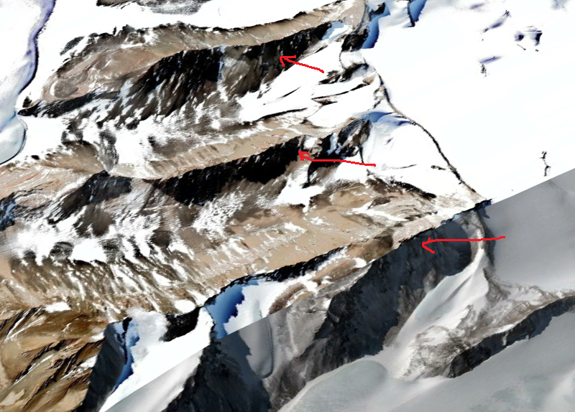

Ecosystem photo

### Distribution

Occurs mainly in Victoria Land, the Transantarctic Mountains and Dronning Maud Land. Prominent ecosystem in the escarpments above the McMurdo dry valleys, alternating with E4 units where aspect makes sunlight conditions variable

Full map

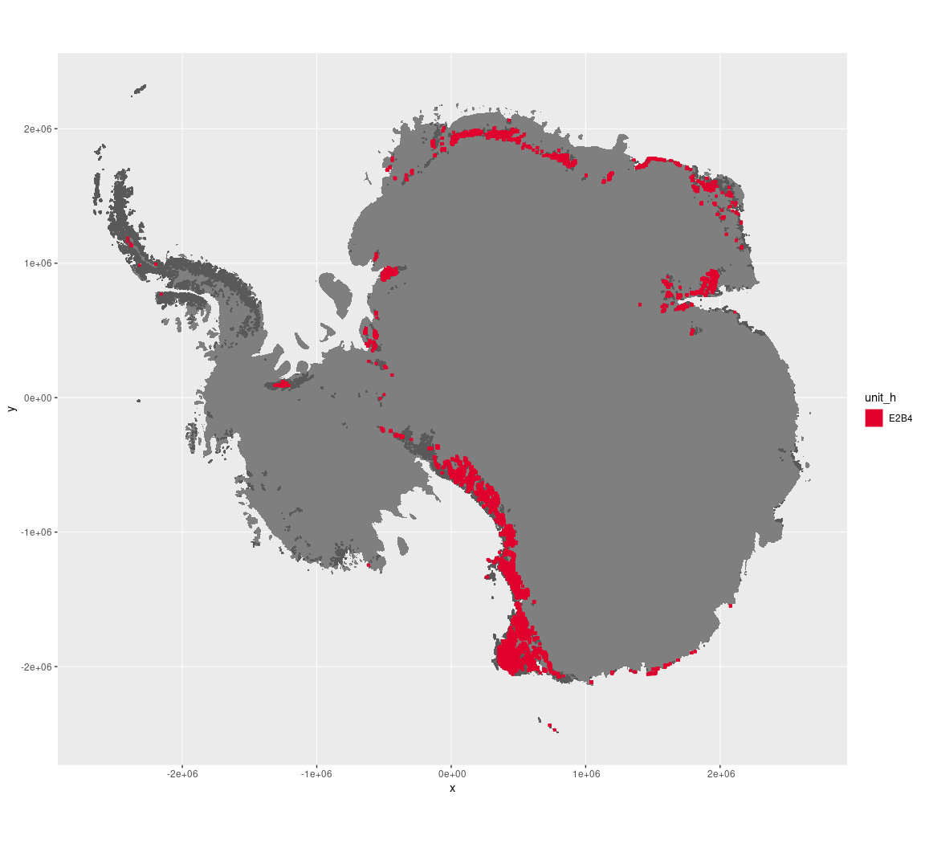

Regional maps

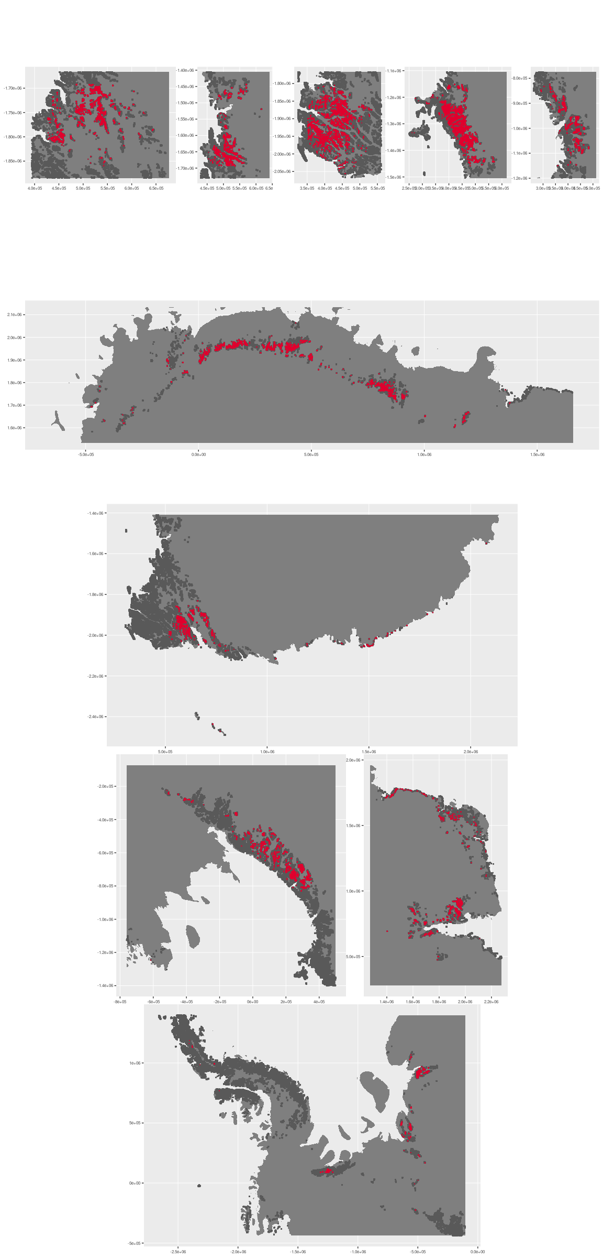





### Environment

The unit E2B4 is part of the environmental supergroup E2.

Supergroup E2 is, on average, substantially higher in elevation, rugosity and slope than continental Antarctica. It is substantially lower in DDm5, melt and totPrecip than the rest of the continent.

The elevation of unit E2B4 ranges from 0 to 4860 metres above sea level, but 90% of its pixels fall above 1024 and below 2925 metres. Its average elevation is 1885 metres.

The unit is higher in no variables and lower in DDm5, melt and totPrecip than the rest of supergroup E2.

#### Distinctiveness of the assemblage from its group and the rest of Antarctica

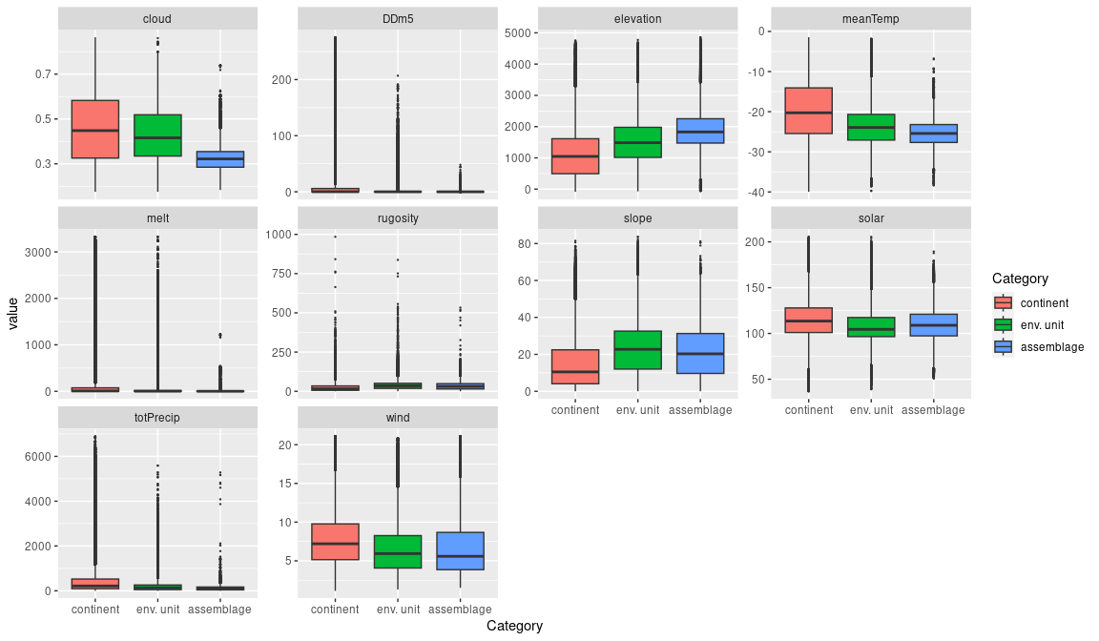

### Biota

Most widely sampled species in the unit (found in most pixels)

|  |  |  |  |  |  |
| --- | --- | --- | --- | --- | --- |
| scientific | Functional group | phylum | restricted | count | percent of samples |
| Gomphiocephalus hodgsoni | Arthropoda_Entognatha_Poduromorpha | Arthropoda | TRUE | 5 | 4.8544 |
| Acarospora gwynnii | Ascomycota_Lecanoromycetes_Acarosporales_Acarosporaceae | Ascomycota | TRUE | 4 | 3.8835 |
| Buellia frigida | Ascomycota_Lecanoromycetes_Teloschistales_Physciaceae | Ascomycota | TRUE | 4 | 3.8835 |
| Buellia pallida | Ascomycota_Lecanoromycetes_Teloschistales_Physciaceae | Ascomycota | TRUE | 3 | 2.9126 |
| Carbonea capsulata | Ascomycota_Lecanoromycetes_Lecanorales_Lecanoraceae | Ascomycota | TRUE | 3 | 2.9126 |
| Eudorylaimus antarcticus | Nematoda | Nematoda | TRUE | 3 | 2.9126 |
| Lecanora fuscobrunnea | Ascomycota_Lecanoromycetes_Lecanorales_Lecanoraceae | Ascomycota | TRUE | 3 | 2.9126 |
| Pleopsidium chlorophanum | Ascomycota_Lecanoromycetes_Acarosporales_Acarosporaceae | Ascomycota | FALSE | 3 | 2.9126 |

Supergroup E2 is, on average, substantially higher in suitability for no variables functional groups than continental Antarctica. It is substantially lower in suitability for no variables than the rest of the continent.

Unit E2B4 is higher in suitability for no variables and lower in suitability for no variables than the rest of supergroup E2.

#### Distinctiveness of the unit from the environmental group and the rest of Antarctica

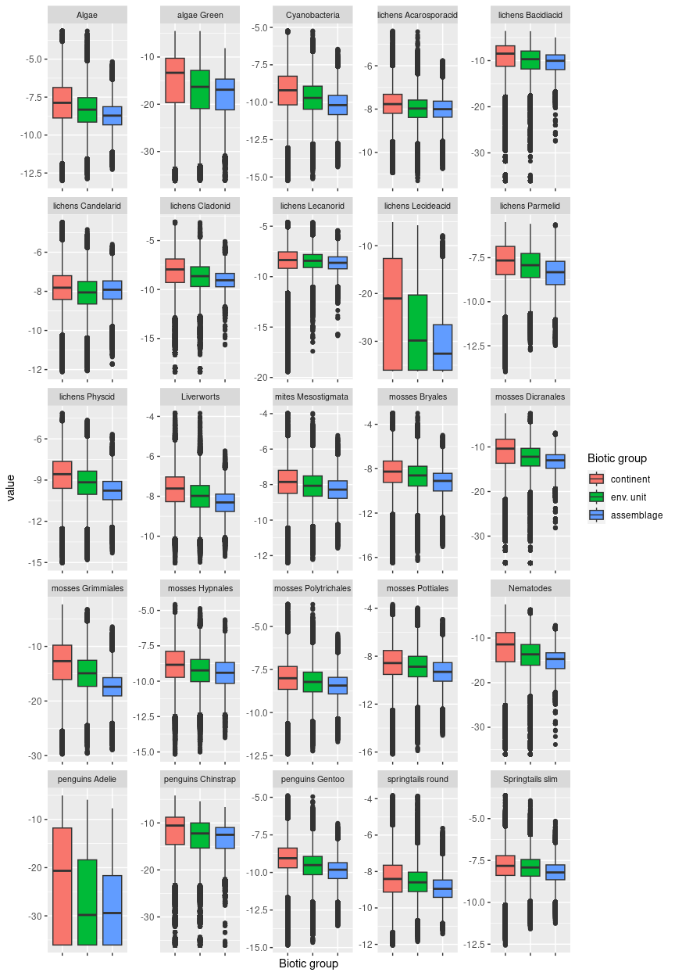

## Ecosystem E2B5

#### Highland clear transitional mountain slopes

Assemblage has relatively low elevation and gentlest topography in this rugged and high-elevation group. Sampled biota contains several repeat incidences of nematodes, mites, and springtails in addition to common lichens.

### Photos (if available)

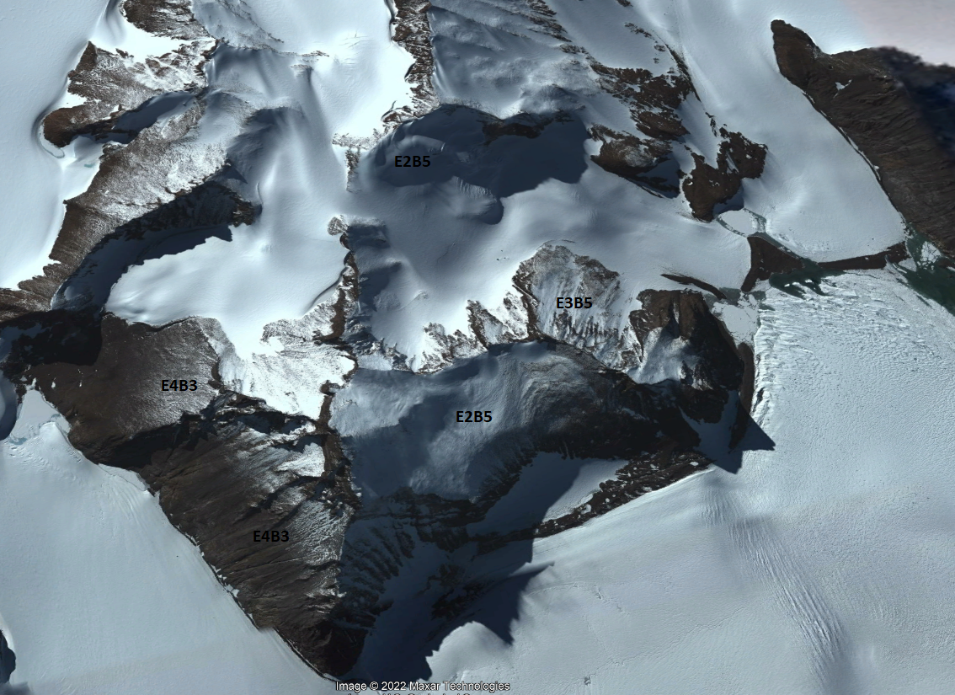

Ecosystem photo

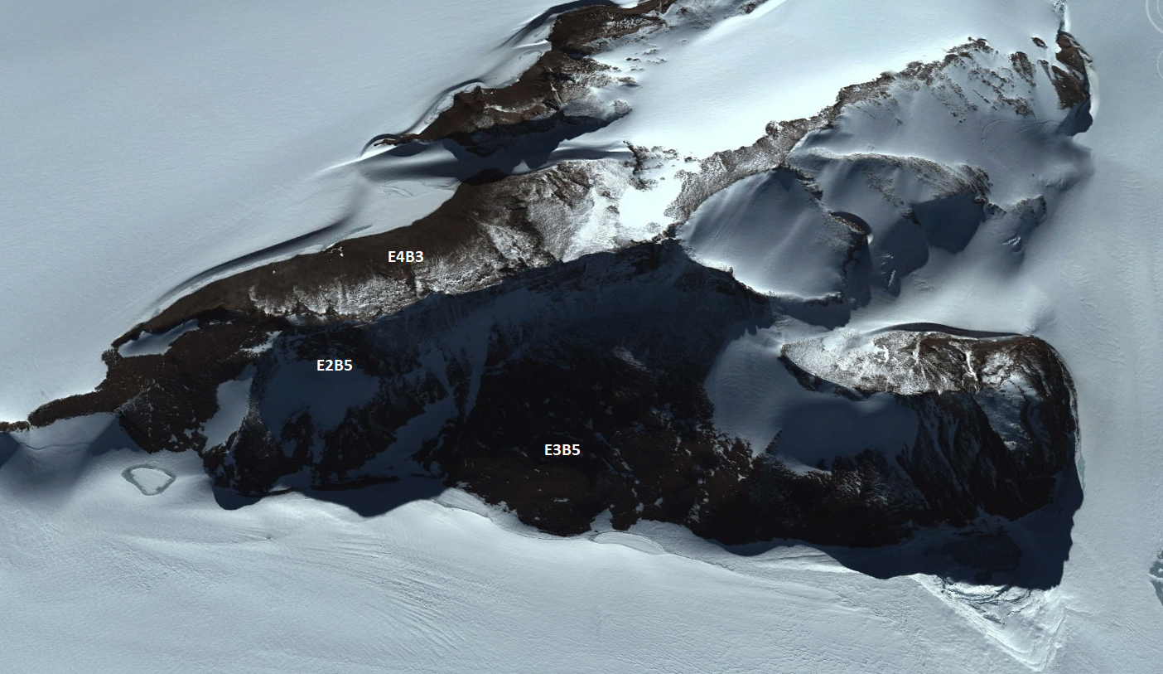

Ecosystem photo

### Distribution

Patchy occurrences distributed around the continent, with concentrations in the Prince Charles Mountains, Victoria Land, and Enderby Land

Full map

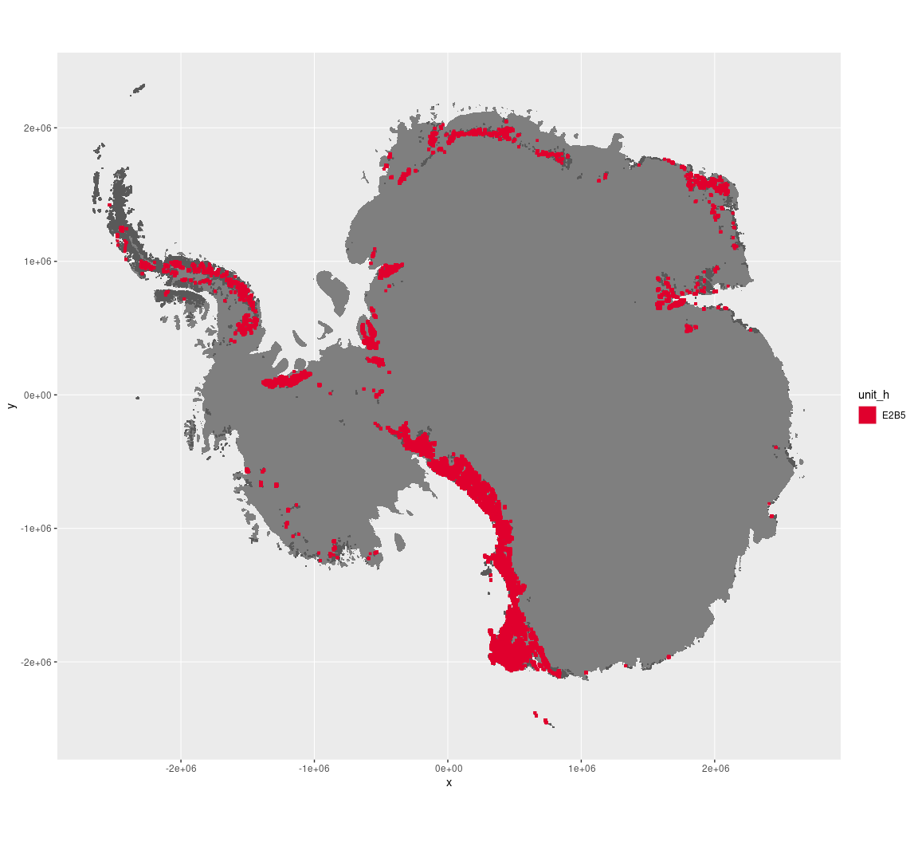

Regional maps

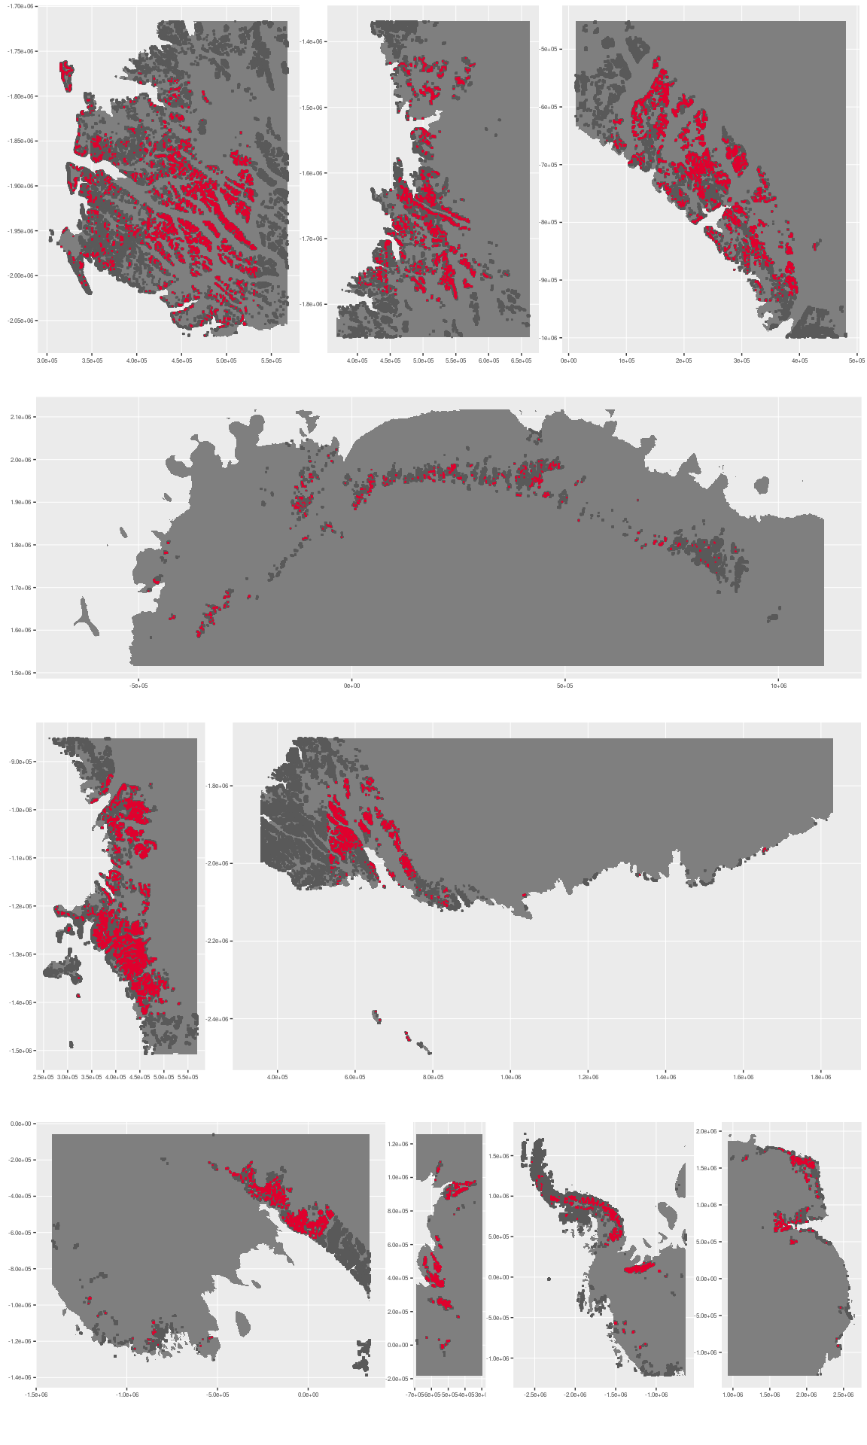

### Environment

The unit E2B5 is part of the environmental supergroup E2.

Supergroup E2 is, on average, substantially higher in elevation, rugosity and slope than continental Antarctica. It is substantially lower in DDm5, melt and totPrecip than the rest of the continent.

The elevation of unit E2B5 ranges from 0 to 4318 metres above sea level, but 90% of its pixels fall above 542 and below 2496 metres. Its average elevation is 1486 metres.

The unit is higher in no variables and lower in DDm5, melt and totPrecip than the rest of supergroup E2.

#### Distinctiveness of the assemblage from its group and the rest of Antarctica

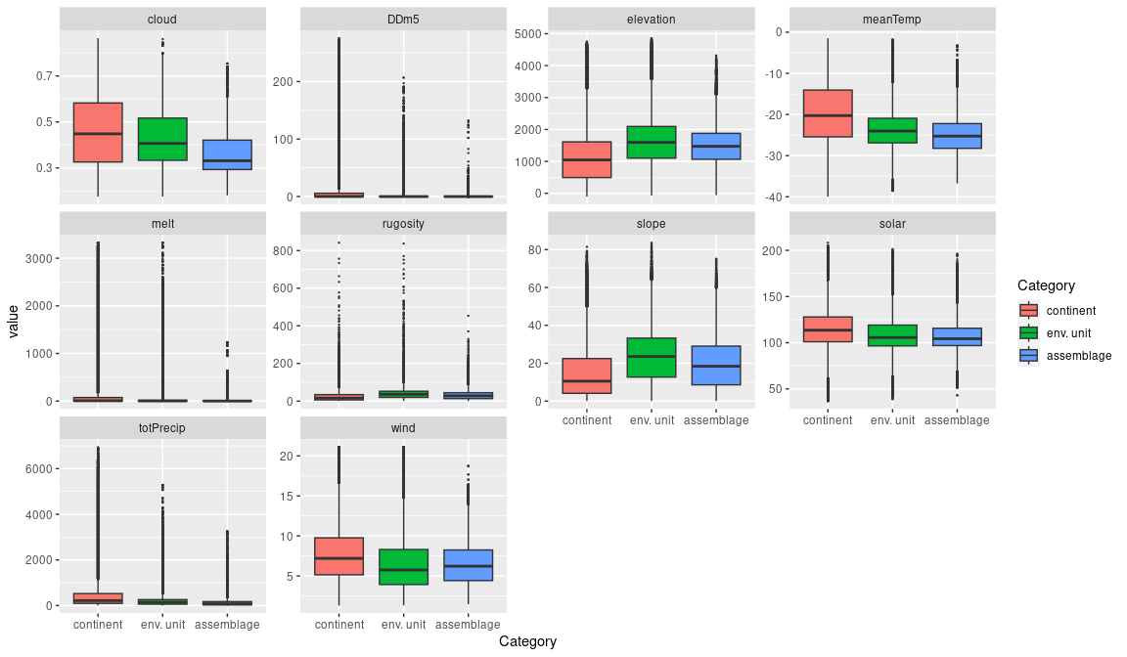

### Biota

Most widely sampled species in the unit (found in most pixels)

|  |  |  |  |  |  |
| --- | --- | --- | --- | --- | --- |
| scientific | Functional group | phylum | restricted | count | percent of samples |
| Pseudephebe minuscula | Ascomycota_Lecanoromycetes_Lecanorales_Parmeliaceae | Ascomycota | FALSE | 5 | 3.2680 |
| Scottnema lindsayae | Nematoda | Nematoda | TRUE | 5 | 3.2680 |
| Eudorylaimus antarcticus | Nematoda | Nematoda | TRUE | 4 | 2.6144 |
| Gomphiocephalus hodgsoni | Arthropoda_Entognatha_Poduromorpha | Arthropoda | TRUE | 4 | 2.6144 |
| Nanorchestes antarcticus | Arthropoda_Arachnida_Sarcoptiformes | Arthropoda | TRUE | 4 | 2.6144 |
| Acarospora gwynnii | Ascomycota_Lecanoromycetes_Acarosporales_Acarosporaceae | Ascomycota | TRUE | 3 | 1.9608 |
| Lecidea cf. cancriformis | Ascomycota_Lecanoromycetes_Lecanorales_Lecideaceae | Ascomycota | TRUE | 3 | 1.9608 |
| Plectus murrayi | Nematoda | Nematoda | TRUE | 3 | 1.9608 |
| Stereotydeus mollis | Arthropoda_Arachnida_Trombidiformes | Arthropoda | TRUE | 3 | 1.9608 |
| Umbilicaria aprina | Ascomycota_Lecanoromycetes_Umbilicariales_Umbilicariaceae | Ascomycota | FALSE | 3 | 1.9608 |
| Usnea sphacelata | Ascomycota_Lecanoromycetes_Lecanorales_Parmeliaceae | Ascomycota | TRUE | 3 | 1.9608 |

Supergroup E2 is, on average, substantially higher in suitability for no variables functional groups than continental Antarctica. It is substantially lower in suitability for no variables than the rest of the continent.

Unit E2B5 is higher in suitability for no variables and lower in suitability for no variables than the rest of supergroup E2.

#### Distinctiveness of the unit from the environmental group and the rest of Antarctica

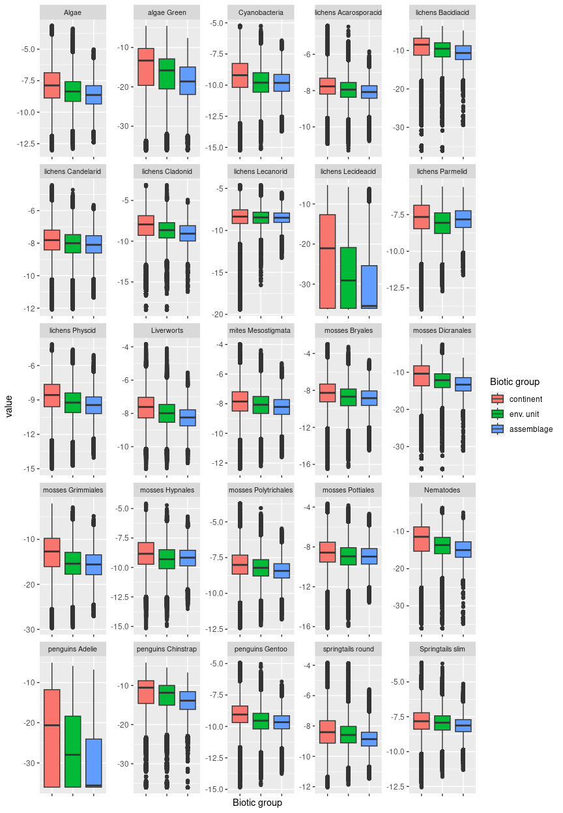

## Ecosystem E2B6

#### Highland sheltered escarpments

Steepest, most rugged and on average coldest unit in the group, usually remote from the coast or occurring coastally inland from permanent ice sheet. Sampled biota rare and dominated by lichens.

### Photos (if available)

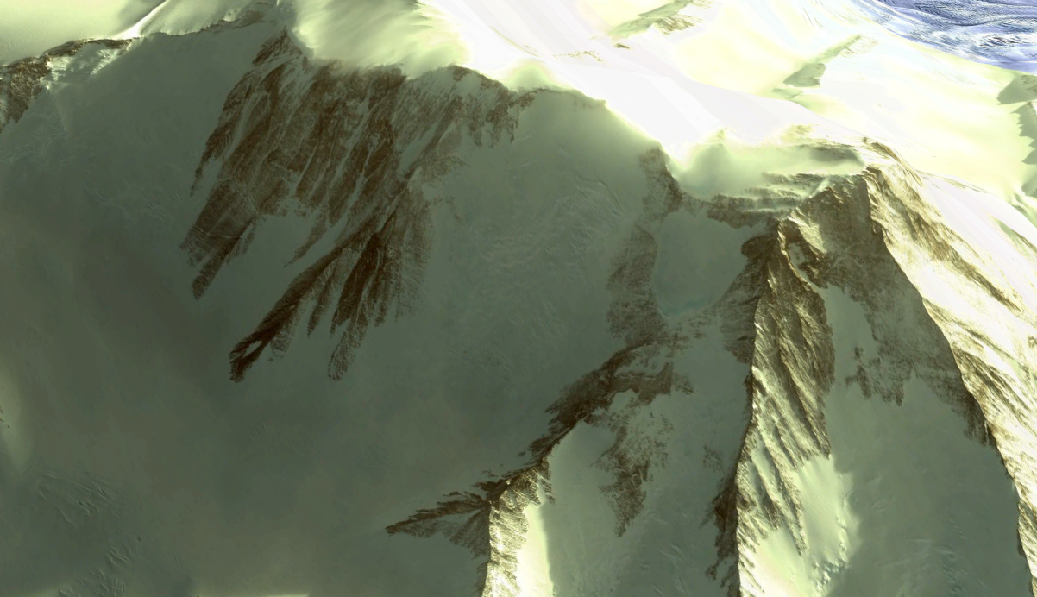

Ecosystem photo: Vinson Massif

### Distribution

Most common unit in the Transantarctic Mountains. Patchy occurrences on the Antarctic Peninsula particularly inland from permanent ocean ice sheet and Victoria Land. Unit represents E2 almost exclusively on Alexander Island. In the Ellsworth Mountains, unit covers ice-free areas of the Vinson Massif, Antarctica’s tallest peak.

Full map

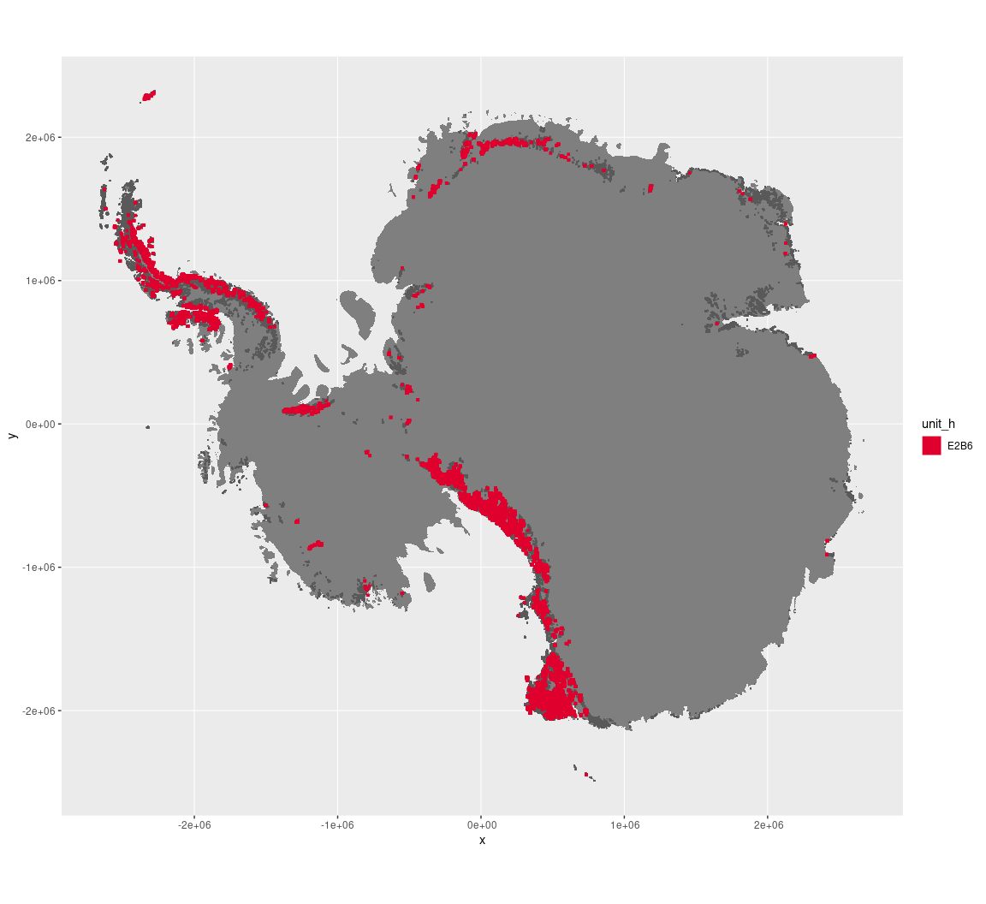

Regional maps

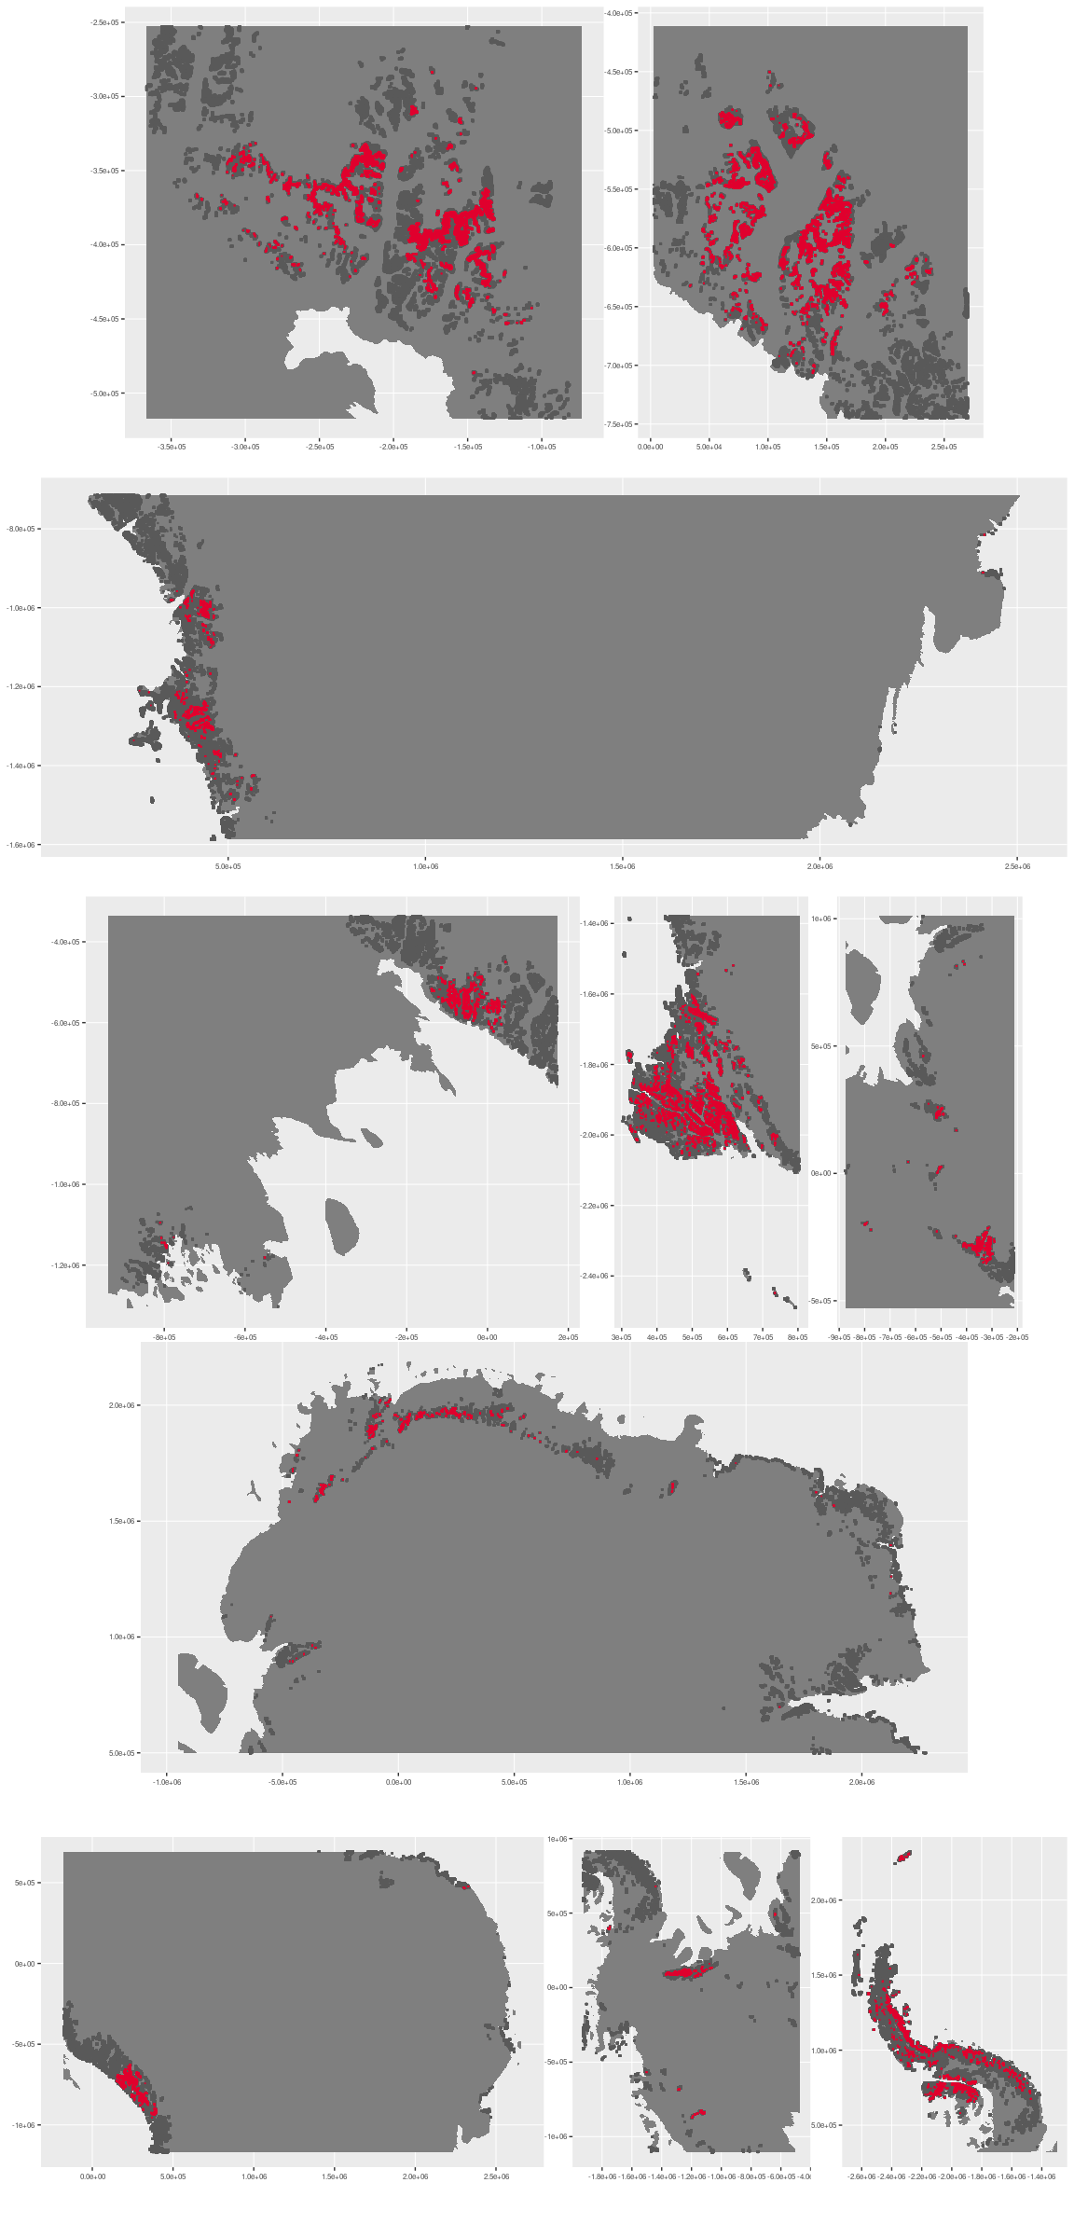





### Environment

The unit E2B6 is part of the environmental supergroup E2.

Supergroup E2 is, on average, substantially higher in elevation, rugosity and slope than continental Antarctica. It is substantially lower in DDm5, melt and totPrecip than the rest of the continent.

The elevation of unit E2B6 ranges from 0 to 4785 metres above sea level, but 90% of its pixels fall above 594 and below 3201 metres. Its average elevation is 1876 metres.

The unit is higher in melt and lower in no variables than the rest of supergroup E2.

#### Distinctiveness of the assemblage from its group and the rest of Antarctica

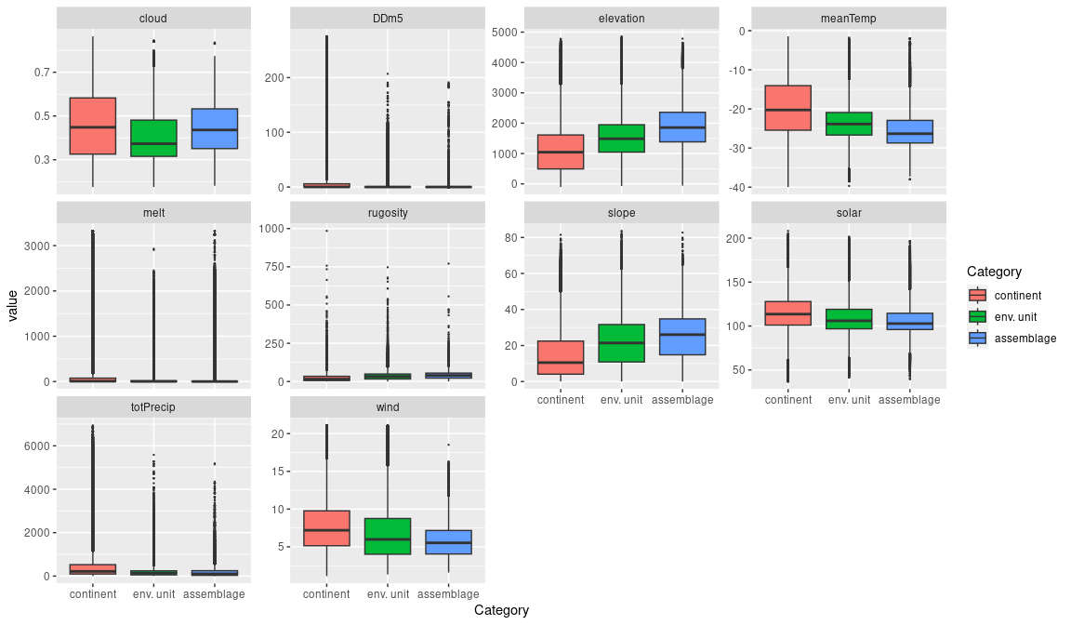

### Biota

Most widely sampled species in the unit (found in most pixels)

|  |  |  |  |  |  |
| --- | --- | --- | --- | --- | --- |
| scientific | Functional group | phylum | restricted | count | percent of samples |
| Pseudephebe minuscula | Ascomycota_Lecanoromycetes_Lecanorales_Parmeliaceae | Ascomycota | FALSE | 4 | 5.2632 |
| Usnea sphacelata | Ascomycota_Lecanoromycetes_Lecanorales_Parmeliaceae | Ascomycota | TRUE | 4 | 5.2632 |
| Lecidea cancriformis | Ascomycota_Lecanoromycetes_Lecanorales_Lecideaceae | Ascomycota | TRUE | 3 | 3.9474 |
| Acarospora gwynnii | Ascomycota_Lecanoromycetes_Acarosporales_Acarosporaceae | Ascomycota | TRUE | 2 | 2.6316 |
| Buellia frigida | Ascomycota_Lecanoromycetes_Teloschistales_Physciaceae | Ascomycota | TRUE | 2 | 2.6316 |
| Gomphiocephalus hodgsoni | Arthropoda_Entognatha_Poduromorpha | Arthropoda | TRUE | 2 | 2.6316 |
| Lecidea cf. cancriformis | Ascomycota_Lecanoromycetes_Lecanorales_Lecideaceae | Ascomycota | TRUE | 2 | 2.6316 |
| Physcia caesia | Ascomycota_Lecanoromycetes_Teloschistales_Physciaceae | Ascomycota | FALSE | 2 | 2.6316 |
| Rhizocarpon adarense | Ascomycota_Lecanoromycetes_Not assigned_Rhizocarpaceae | Ascomycota | TRUE | 2 | 2.6316 |
| Umbilicaria decussata | Ascomycota_Lecanoromycetes_Umbilicariales_Umbilicariaceae | Ascomycota | FALSE | 2 | 2.6316 |

Supergroup E2 is, on average, substantially higher in suitability for no variables functional groups than continental Antarctica. It is substantially lower in suitability for no variables than the rest of the continent.

Unit E2B6 is higher in suitability for no variables and lower in suitability for no variables than the rest of supergroup E2.

#### Distinctiveness of the unit from the environmental group and the rest of Antarctica

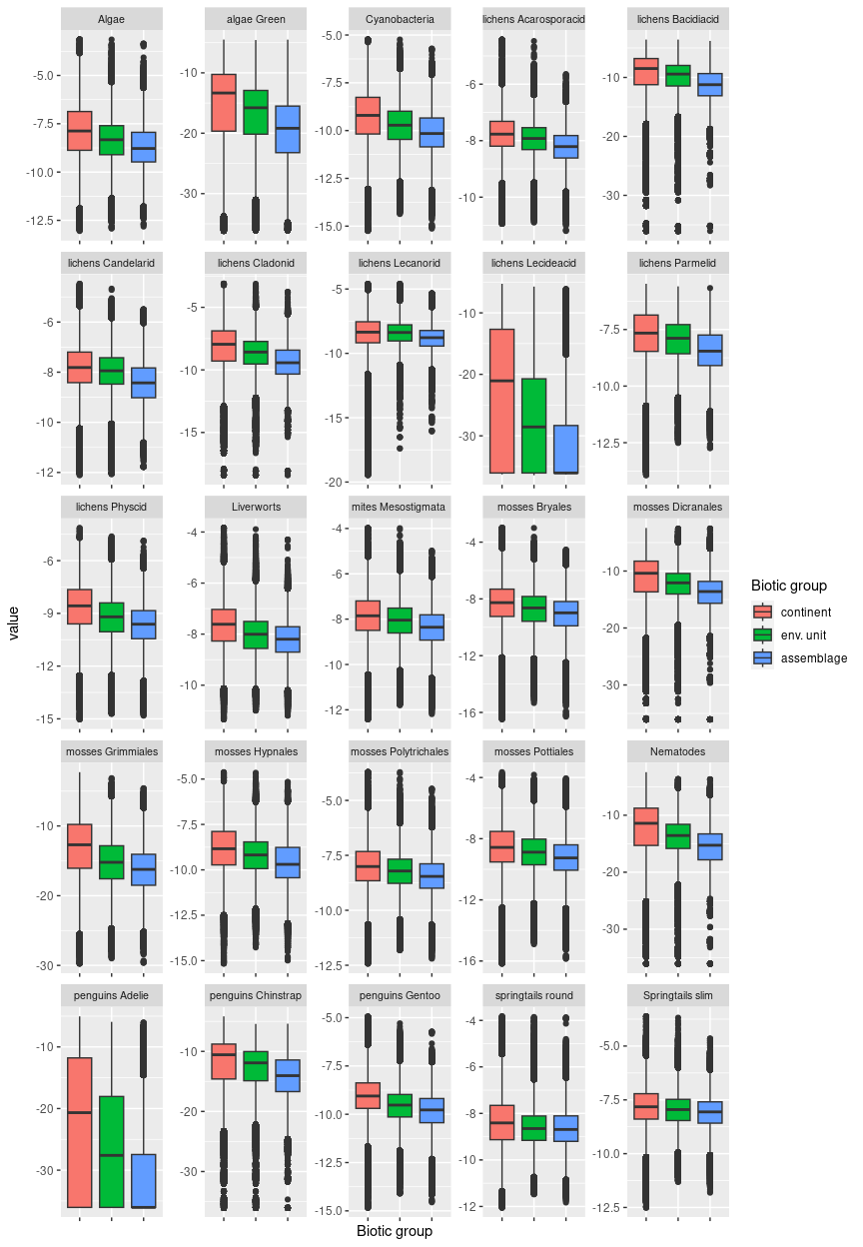

## Ecosystem E3B1

#### Mild coastal inclines and beaches

Rocky, gently sloping lowlands in warm, cloudy mesic (high snowfall) areas has seasonal snow cover and usually exhibits meltwater erosion channels. This unit supports a rich biota dominated mainly by lichens, mosses and seabirds. Colonies of penguins on the lower slopes and nesting seabirds influence moss beds upslope enriched by nutrients via updrafts. Grasses occur occasionally within this system at low elevations on the Antarctic Peninsula and associated islands, but not in other areas. The microbiota is likely to exhibit strong regional variation within this unit around the continent. Based on sampling, appears to be the most favoured ecosystem for several species of seabirds (terns, gulls, petrels), lichens, mosses, mites, and springtails. A favoured nesting environment on the Peninsula for the Southern Giant Petrel, which has been sampled in large numbers. This unit has the highest sampling of 102 relatively common species (at least 10 occurrences), and 20 of these are found in this unit for more than 50% of their samples.

### Photos (if available)

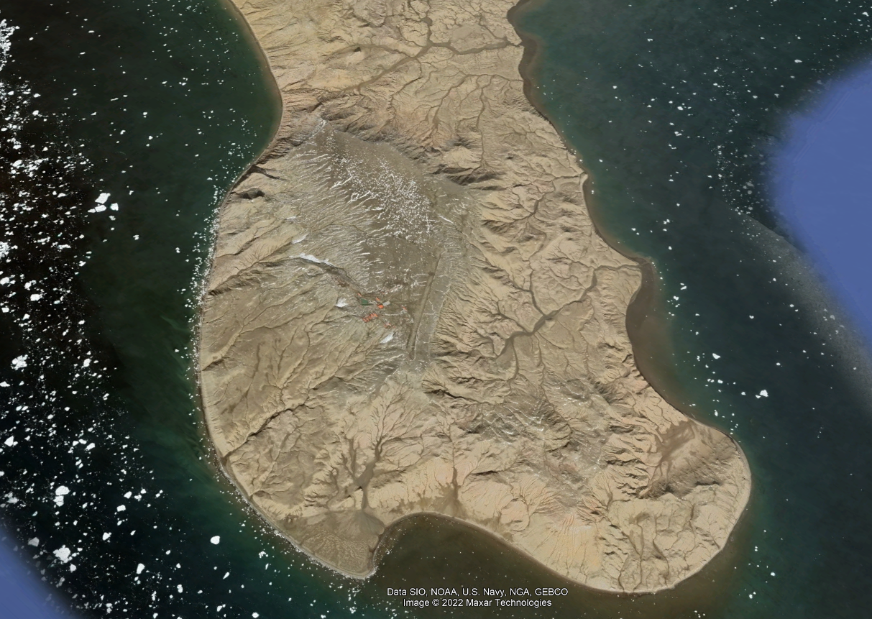

Ecosystem photo

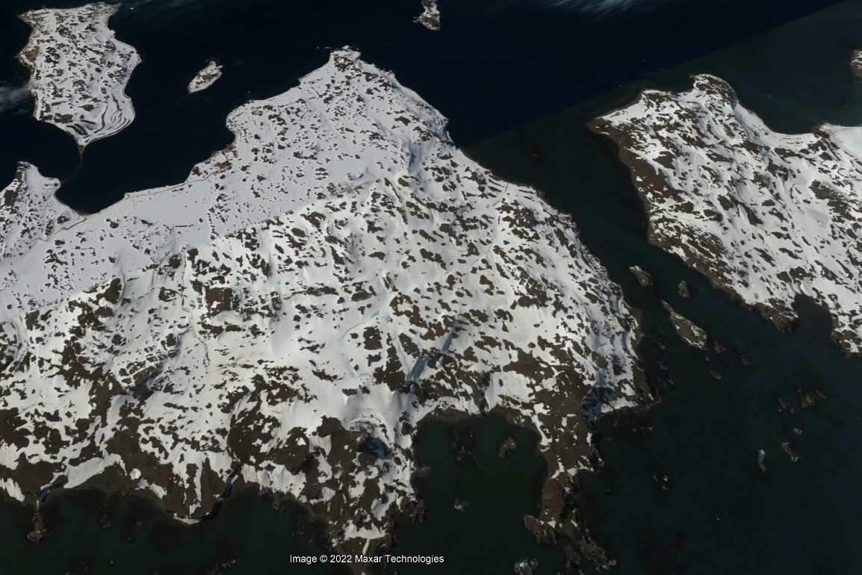

Ecosystem photo

### Distribution

Occurs mainly in the coastal Antarctic peninsula and Marie Byrd land. Very common on beaches of coastal islands off the Peninsla

Full map

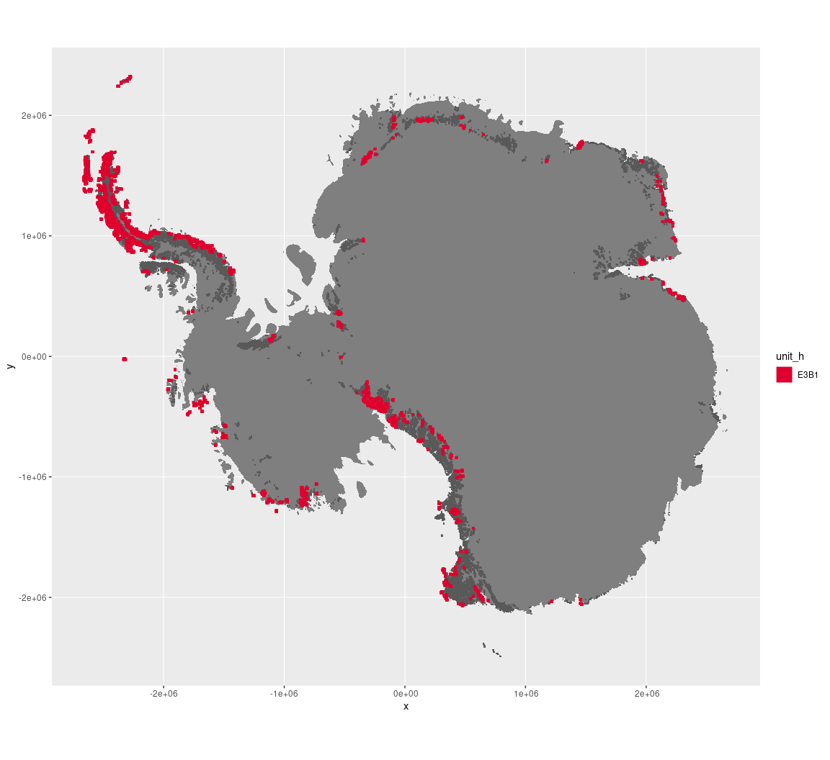

Regional maps

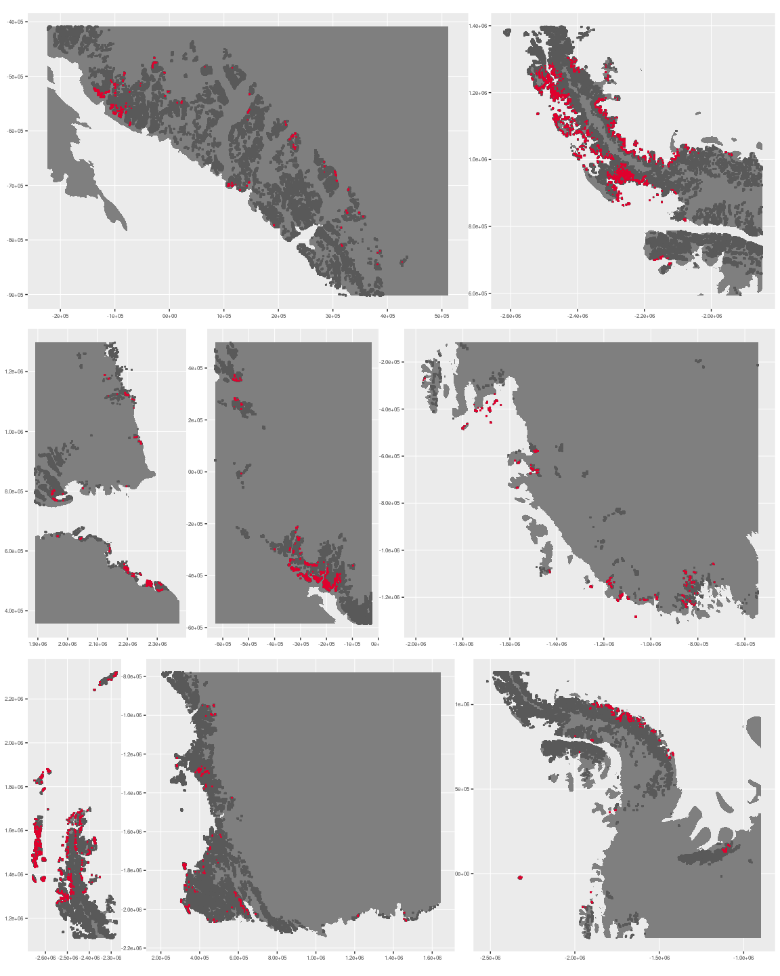

### Environment

The unit E3B1 is part of the environmental supergroup E3.

Supergroup E3 is, on average, substantially higher in DDm5 and melt than continental Antarctica. It is substantially lower in elevation, rugosity and totPrecip than the rest of the continent.

The elevation of unit E3B1 ranges from 0 to 3732 metres above sea level, but 90% of its pixels fall above 5 and below 1192 metres. Its average elevation is 314 metres.

The unit is higher in cloud, DDm5, meanTemp and totPrecip and lower in elevation than the rest of supergroup E3.

#### Distinctiveness of the assemblage from its group and the rest of Antarctica

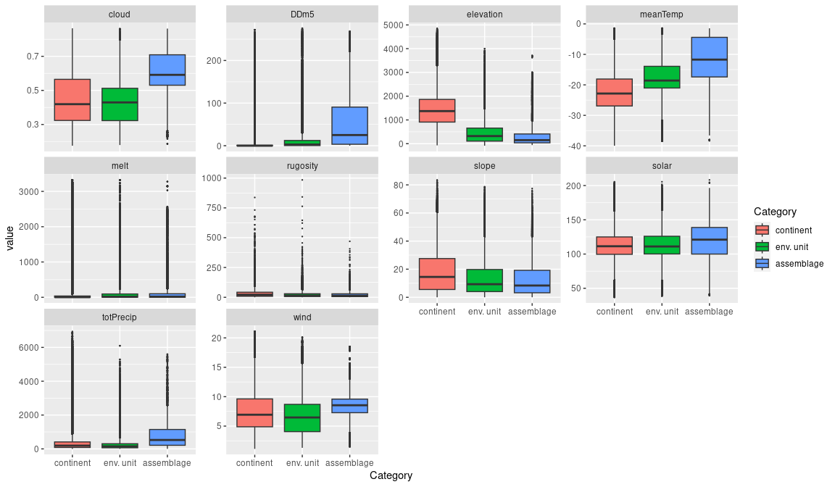

### Biota

Most widely sampled species in the unit (found in most pixels)

|  |  |  |  |  |  |
| --- | --- | --- | --- | --- | --- |
| scientific | Functional group | phylum | restricted | count | percent of samples |
| Polytrichastrum alpinum | Bryophyta_Bryopsida_Polytrichales | Bryophyta | FALSE | 44 | 1.5157 |
| Bryum pseudotriquetrum | Bryophyta_Bryopsida_Bryales | Bryophyta | FALSE | 38 | 1.3090 |
| Pygoscelis antarctica | Chordata_Aves_Sphenisciformes_Spheniscidae_Pygoscelis_antarctica | Chordata | TRUE | 38 | 1.3090 |
| Ceratodon purpureus | Bryophyta_Bryopsida_Dicranales | Bryophyta | FALSE | 37 | 1.2745 |
| Cryptopygus antarcticus | Arthropoda_Entognatha_Entomobryomorpha | Arthropoda | TRUE | 37 | 1.2745 |
| Pygoscelis adeliae | Chordata_Aves_Sphenisciformes_Spheniscidae_Pygoscelis_adeliae | Chordata | FALSE | 37 | 1.2745 |
| Andreaea regularis | Bryophyta_Andreaeopsida_Andreaeales | Bryophyta | TRUE | 33 | 1.1368 |
| Larus dominicanus | Chordata_Aves_Charadriiformes | Chordata | TRUE | 33 | 1.1368 |
| Sanionia uncinata | Bryophyta_Bryopsida_Hypnales | Bryophyta | FALSE | 32 | 1.1023 |
| Usnea antarctica | Ascomycota_Lecanoromycetes_Lecanorales_Parmeliaceae | Ascomycota | FALSE | 32 | 1.1023 |

Supergroup E3 is, on average, substantially higher in suitability for algae_Green, lichens_Bacidiacid, lichens_Cladonid, lichens_Lecideacid, mosses_Dicranales, mosses_Grimmiales, Nematodes, penguins_Adelie and penguins_Chinstrap functional groups than continental Antarctica. It is substantially lower in suitability for no variables than the rest of the continent.

Unit E3B1 is higher in suitability for mosses_Grimmiales and lower in suitability for no variables than the rest of supergroup E3.

#### Distinctiveness of the unit from the environmental group and the rest of Antarctica

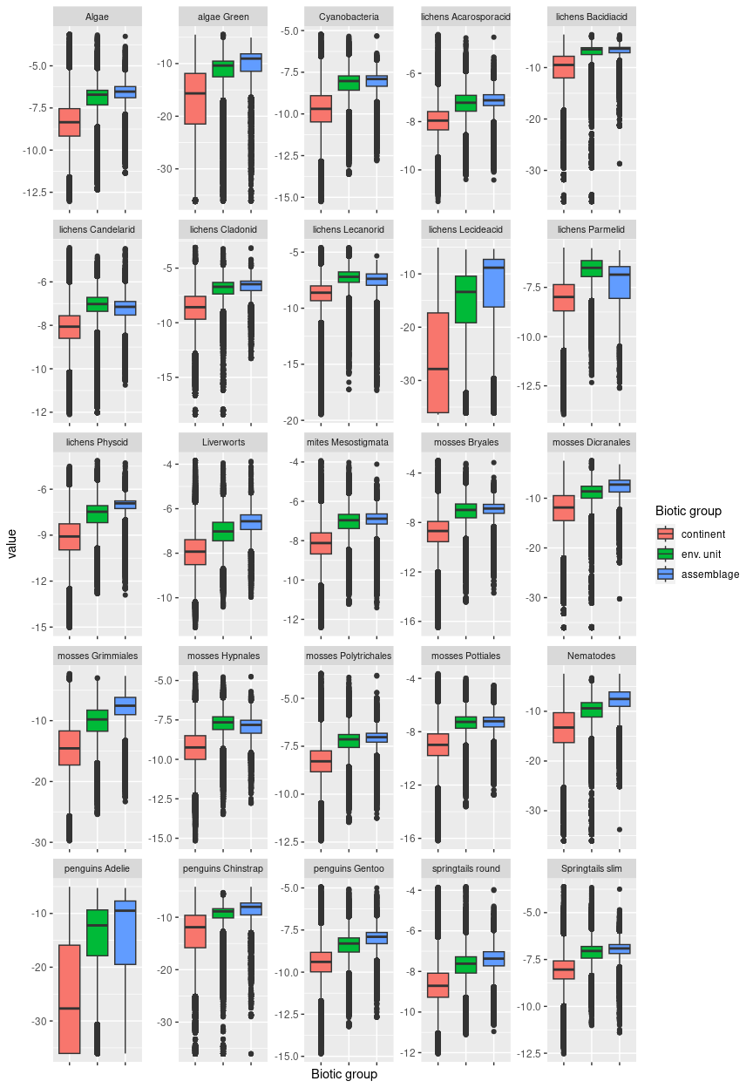

## Ecosystem E3B2

#### Meltwater-eroded flatlands

Rocky, gently sloping lowlands characterised by high seasonal melt and meltwater erosion, creating a complex, dynamic terrestrial surface, and higher rugosity than is usual for the group. Satellite imagery suggests a layer of loose, crumbling soils. Common mosses and lichens are its dominant biota, but the unit may host chinstrap penguin colonies.

### Photos (if available)

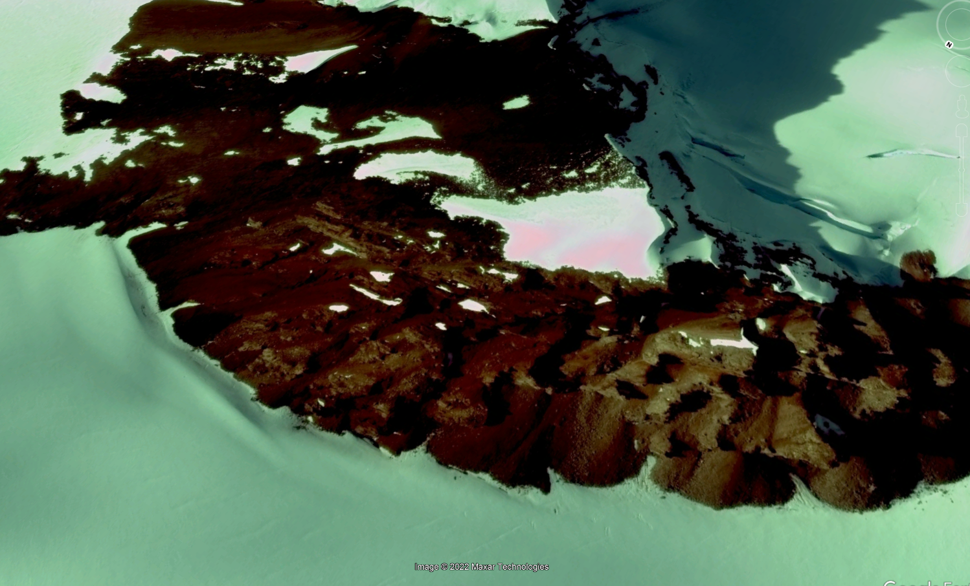

Ecosystem photo

### Distribution

Occurs mainly on the Antarctic Peninsula, but a scattering of this unit can also be found coastally in the Transantarctic Mountains, Victoria Land, Marie Byrd Land, and Enderby Land.

Full map

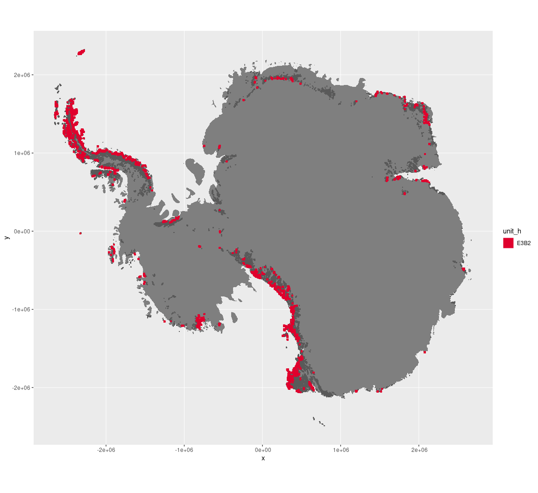

Regional maps

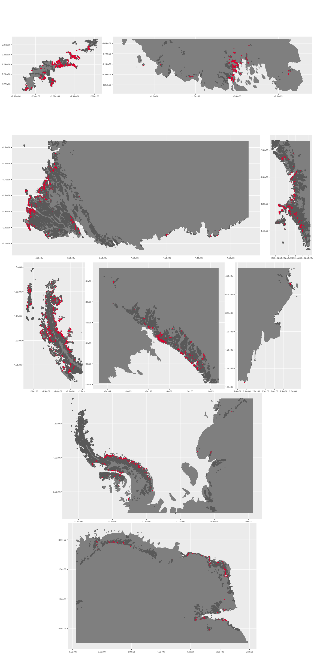





### Environment

The unit E3B2 is part of the environmental supergroup E3.

Supergroup E3 is, on average, substantially higher in DDm5 and meanTemp than continental Antarctica. It is substantially lower in elevation, rugosity, slope and totPrecip than the rest of the continent.

The elevation of unit E3B2 ranges from 0 to 3913 metres above sea level, but 90% of its pixels fall above 23 and below 1149 metres. Its average elevation is 419 metres.

The unit is higher in melt, rugosity, slope and totPrecip and lower in no variables than the rest of supergroup E3.

#### Distinctiveness of the assemblage from its group and the rest of Antarctica

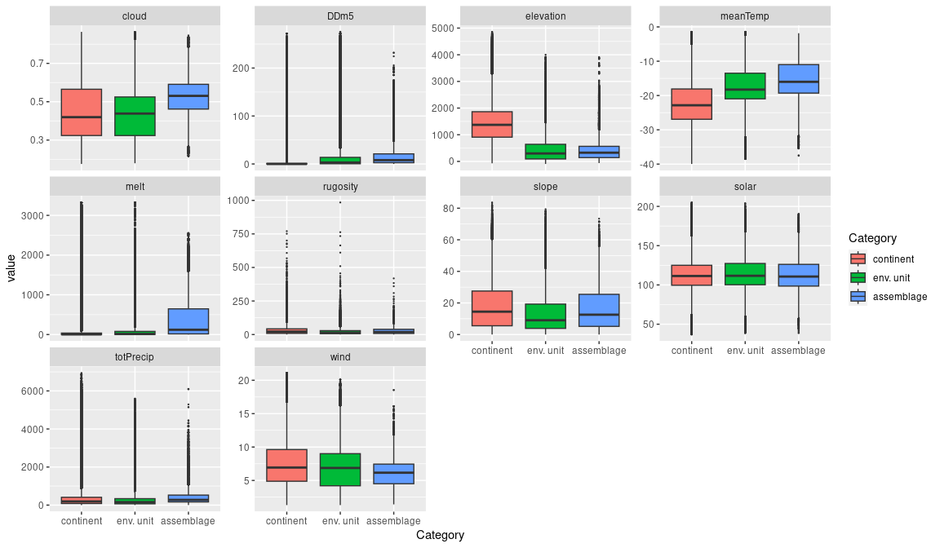

### Biota

Most widely sampled species in the unit (found in most pixels)

|  |  |  |  |  |  |
| --- | --- | --- | --- | --- | --- |
| scientific | Functional group | phylum | restricted | count | percent of samples |
| Pseudephebe minuscula | Ascomycota_Lecanoromycetes_Lecanorales_Parmeliaceae | Ascomycota | FALSE | 13 | 1.5205 |
| Umbilicaria decussata | Ascomycota_Lecanoromycetes_Umbilicariales_Umbilicariaceae | Ascomycota | FALSE | 13 | 1.5205 |
| Ceratodon purpureus | Bryophyta_Bryopsida_Dicranales | Bryophyta | FALSE | 12 | 1.4035 |
| Usnea sphacelata | Ascomycota_Lecanoromycetes_Lecanorales_Parmeliaceae | Ascomycota | TRUE | 12 | 1.4035 |
| Schistidium antarctici | Bryophyta_Bryopsida_Grimmiales | Bryophyta | TRUE | 11 | 1.2865 |
| Usnea antarctica | Ascomycota_Lecanoromycetes_Lecanorales_Parmeliaceae | Ascomycota | FALSE | 11 | 1.2865 |
| Usnea aurantiaco-atra | Ascomycota_Lecanoromycetes_Lecanorales_Parmeliaceae | Ascomycota | FALSE | 9 | 1.0526 |
| Bryum pseudotriquetrum | Bryophyta_Bryopsida_Bryales | Bryophyta | FALSE | 8 | 0.9357 |
| Andreaea regularis | Bryophyta_Andreaeopsida_Andreaeales | Bryophyta | TRUE | 7 | 0.8187 |
| Cryptopygus antarcticus | Arthropoda_Entognatha_Entomobryomorpha | Arthropoda | TRUE | 7 | 0.8187 |
| Pohlia nutans | Bryophyta_Bryopsida_Bryales | Bryophyta | FALSE | 7 | 0.8187 |
| Pygoscelis antarctica | Chordata_Aves_Sphenisciformes_Spheniscidae_Pygoscelis_antarctica | Chordata | TRUE | 7 | 0.8187 |
| Rhizocarpon geographicum | Ascomycota_Lecanoromycetes_Not assigned_Rhizocarpaceae | Ascomycota | FALSE | 7 | 0.8187 |
| Rhizoplaca melanophthalma | Ascomycota_Lecanoromycetes_Lecanorales_Lecanoraceae | Ascomycota | FALSE | 7 | 0.8187 |
| Sanionia uncinata | Bryophyta_Bryopsida_Hypnales | Bryophyta | FALSE | 7 | 0.8187 |

Supergroup E3 is, on average, substantially higher in suitability for algae_Green, lichens_Bacidiacid, lichens_Cladonid, lichens_Lecideacid, mosses_Dicranales, mosses_Grimmiales, Nematodes, penguins_Adelie and penguins_Chinstrap functional groups than continental Antarctica. It is substantially lower in suitability for no variables than the rest of the continent.

Unit E3B2 is higher in suitability for lichens_Lecideacid and penguins_Adelie and lower in suitability for no variables than the rest of supergroup E3.

#### Distinctiveness of the unit from the environmental group and the rest of Antarctica

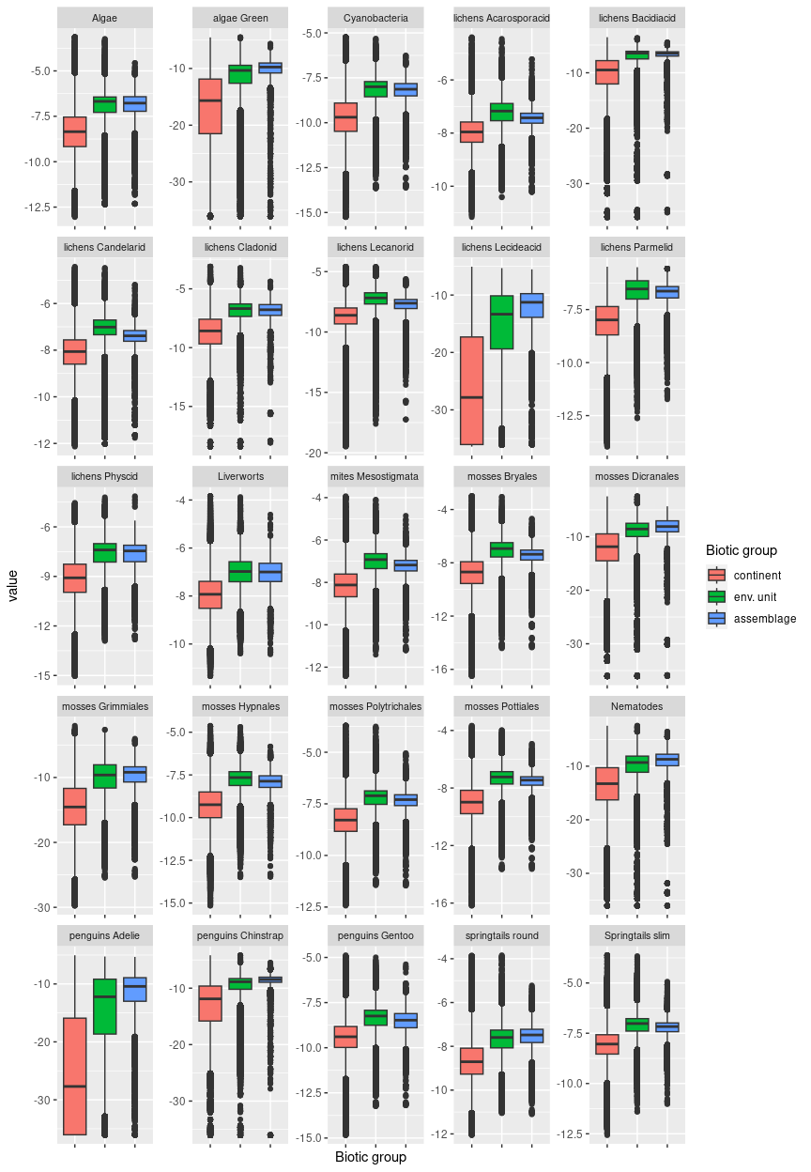

## Ecosystem E3B3

#### Xeric valley floors

Sloped or rolling valley sides or low outcrops in valleys typically carved by antecedent glaciers and transitioning to steeper cliffs and high peaks. The valleys may extend many kilometres inland and are strongly sheltered from the wind and sun and extremely dry. Some incidence of this unit is also seen between the edge of existing glaciers and steeper mountain slopes. These systems are colder than the rest of the lowlands, but still warmer than the continental average. The vegetation is sparse due to extremely dry conditions, characterised mainly by Lecanorid and Teloschistid lichens with high suitability for Stereocaulid lichens, nematodes, trombidiformid mites, rotifers, green algae, and springtails. Highly characteristic moss Encaplypta procera found primarily in this assemblage.

### Photos (if available)



Ecosystem photo

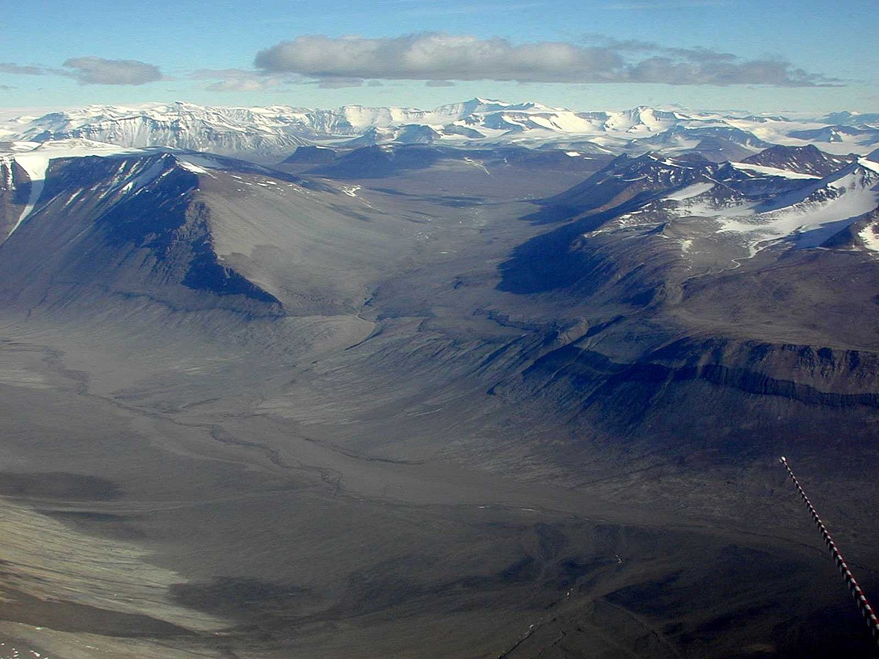

Bull Pass, McMurdo Dry valleys

### Distribution

Occurs primarily in South Victoria Land, covering much of the McMurdo Dry Valleys. Minor occurrences also exist on the Northern shore of Alexander Island, in Dronning Maud Land and the Transantarctic Mountains.

Full map

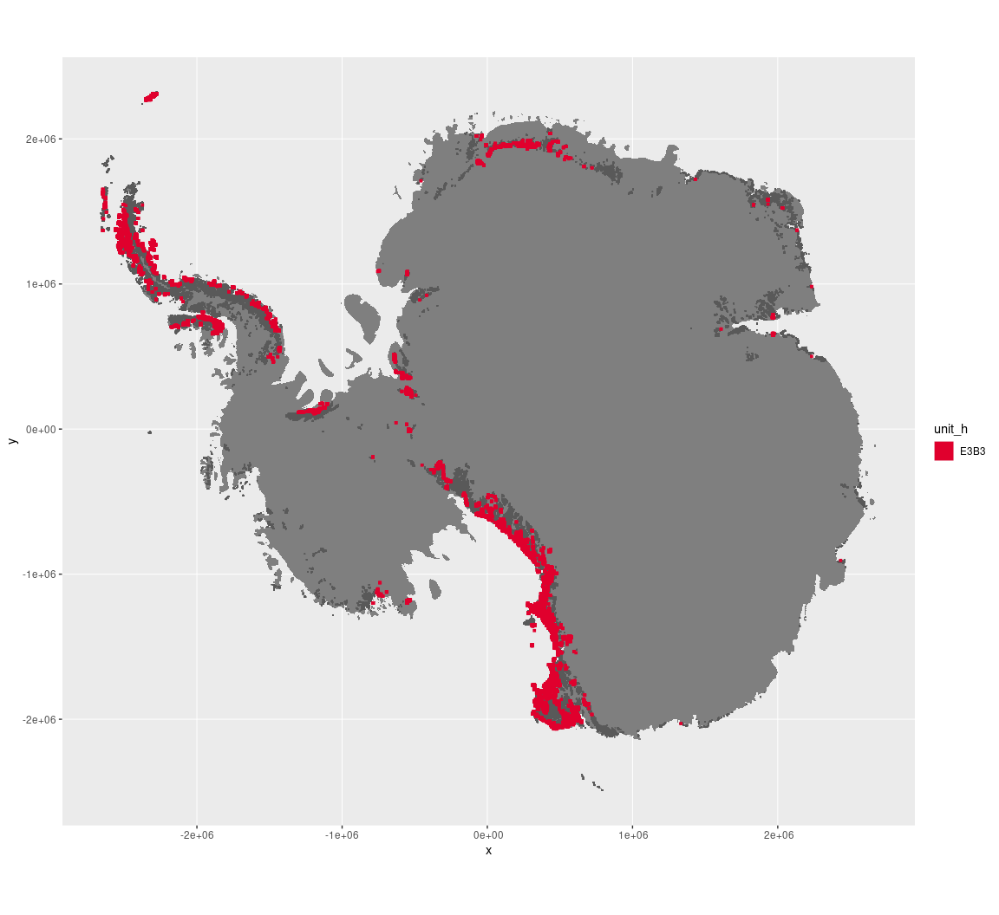

Regional maps

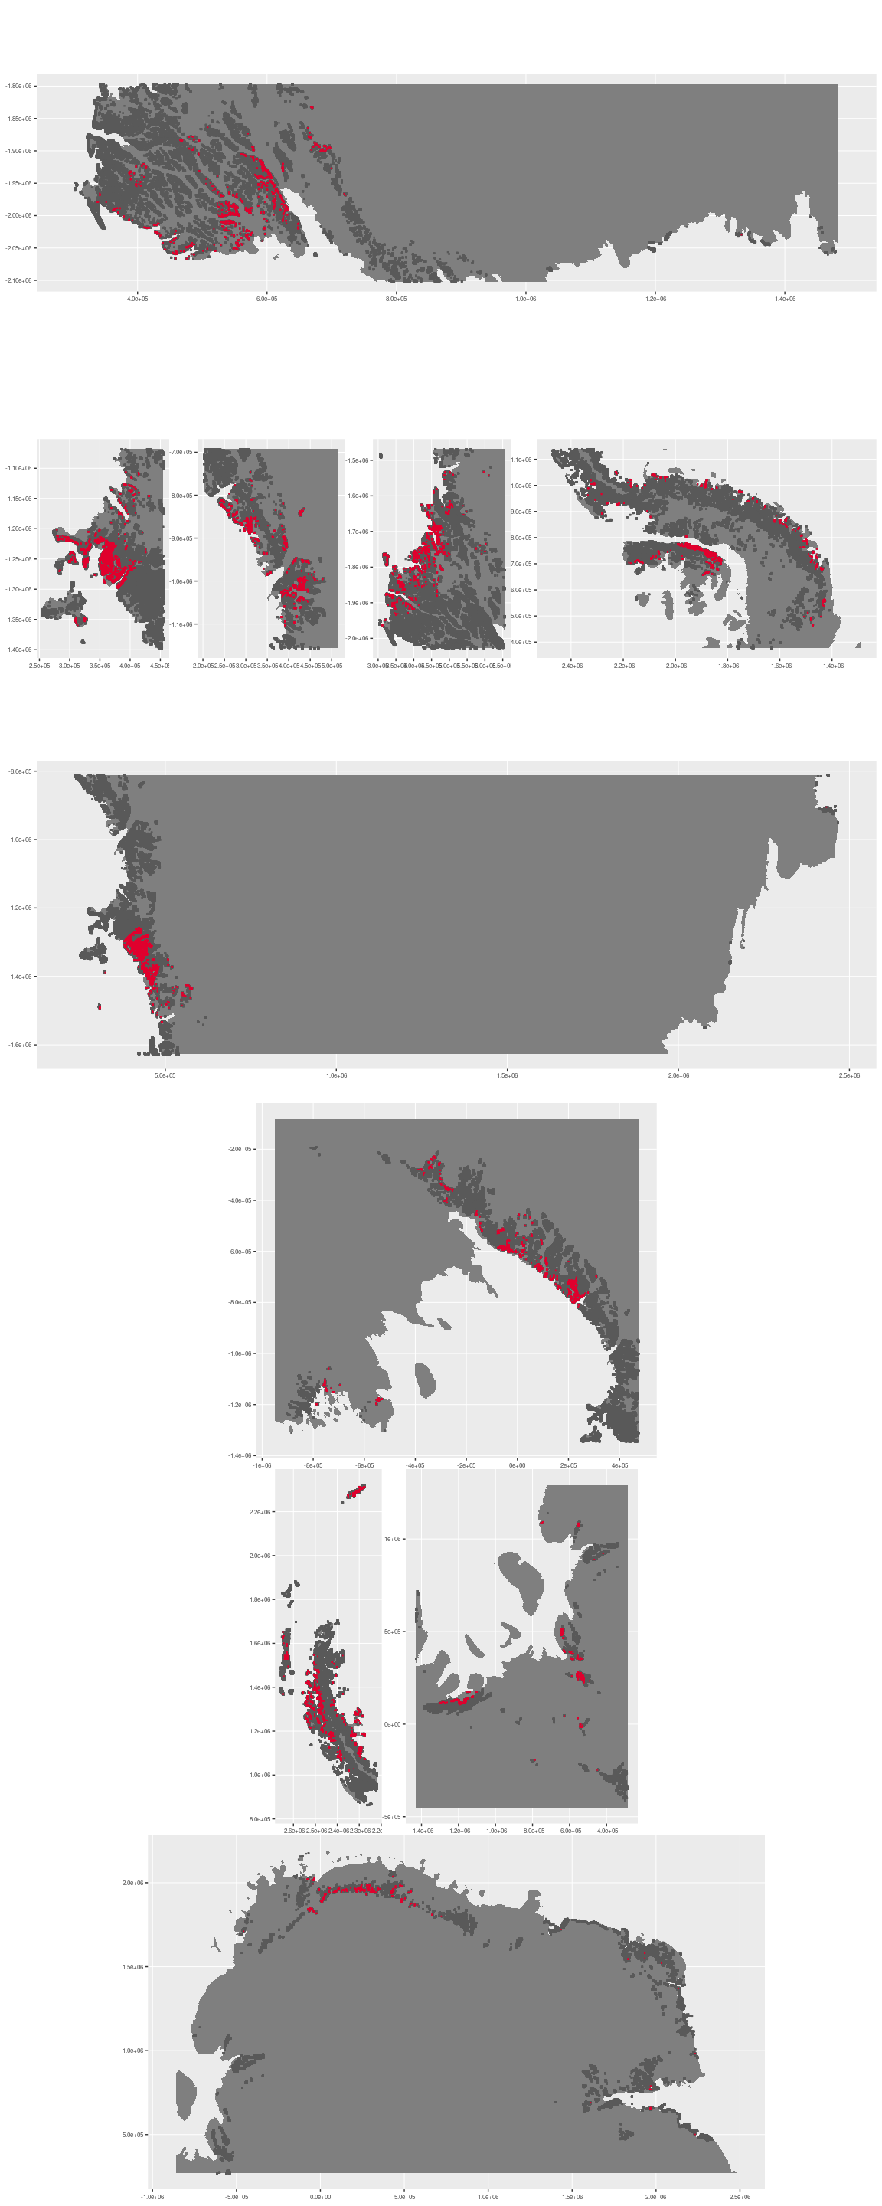

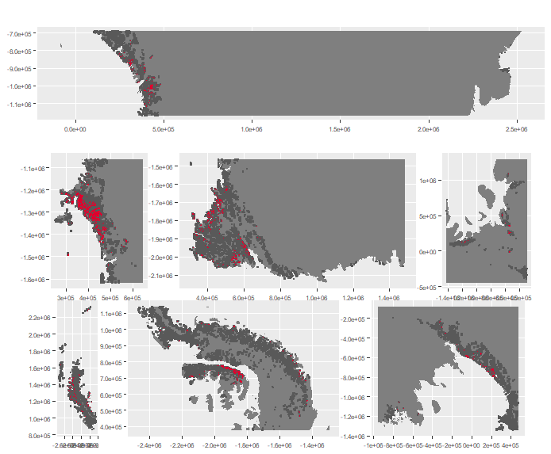

### Environment

The unit E3B3 is part of the environmental supergroup E3.

Supergroup E3 is, on average, substantially higher in DDm5 and meanTemp than continental Antarctica. It is substantially lower in elevation, rugosity, slope and totPrecip than the rest of the continent.

The elevation of unit E3B3 ranges from 0 to 3866 metres above sea level, but 90% of its pixels fall above 40 and below 1301 metres. Its average elevation is 552 metres.

The unit is higher in elevation and melt and lower in DDm5, totPrecip and wind than the rest of supergroup E3.

#### Distinctiveness of the assemblage from its group and the rest of Antarctica

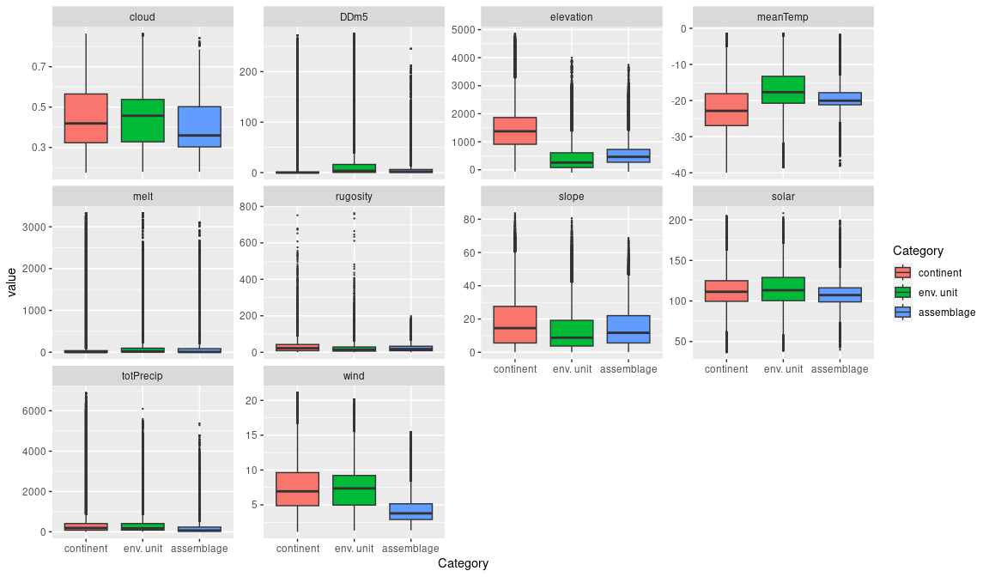

### Biota

Most widely sampled species in the unit (found in most pixels)

|  |  |  |  |  |  |
| --- | --- | --- | --- | --- | --- |
| scientific | Functional group | phylum | restricted | count | percent of samples |
| Gomphiocephalus hodgsoni | Arthropoda_Entognatha_Poduromorpha | Arthropoda | TRUE | 30 | 1.9934 |
| Usnea sphacelata | Ascomycota_Lecanoromycetes_Lecanorales_Parmeliaceae | Ascomycota | TRUE | 27 | 1.7940 |
| Stereotydeus mollis | Arthropoda_Arachnida_Trombidiformes | Arthropoda | TRUE | 24 | 1.5947 |
| Eudorylaimus antarcticus | Nematoda | Nematoda | TRUE | 23 | 1.5282 |
| Scottnema lindsayae | Nematoda | Nematoda | TRUE | 23 | 1.5282 |
| Encalypta procera | Bryophyta_Bryopsida_Pottiales | Bryophyta | FALSE | 22 | 1.4618 |
| Bryum pseudotriquetrum | Bryophyta_Bryopsida_Bryales | Bryophyta | FALSE | 21 | 1.3953 |
| Distichium capillaceum | Bryophyta_Bryopsida_Dicranales | Bryophyta | FALSE | 19 | 1.2625 |
| Syntrichia princeps | Bryophyta_Bryopsida_Pottiales | Bryophyta | FALSE | 18 | 1.1960 |
| Bryum amblyodon | Bryophyta_Bryopsida_Bryales | Bryophyta | FALSE | 13 | 0.8638 |
| Friesea topo | Arthropoda_Entognatha_Poduromorpha | Arthropoda | TRUE | 13 | 0.8638 |
| Pseudephebe minuscula | Ascomycota_Lecanoromycetes_Lecanorales_Parmeliaceae | Ascomycota | FALSE | 13 | 0.8638 |
| Umbilicaria decussata | Ascomycota_Lecanoromycetes_Umbilicariales_Umbilicariaceae | Ascomycota | FALSE | 13 | 0.8638 |

Supergroup E3 is, on average, substantially higher in suitability for algae_Green, lichens_Bacidiacid, lichens_Cladonid, lichens_Lecideacid, mosses_Dicranales, mosses_Grimmiales, Nematodes, penguins_Adelie and penguins_Chinstrap functional groups than continental Antarctica. It is substantially lower in suitability for no variables than the rest of the continent.

Unit E3B3 is higher in suitability for no variables and lower in suitability for no variables than the rest of supergroup E3.

#### Distinctiveness of the unit from the environmental group and the rest of Antarctica

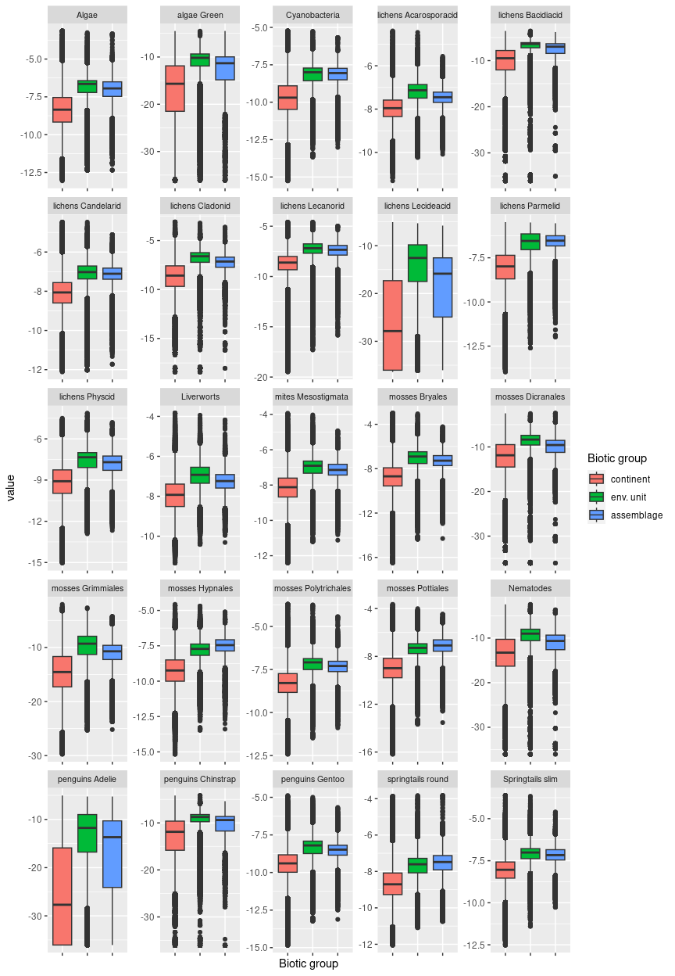

## Ecosystem E3B4

#### Exposed Rocky flatlands

Cold despite low elevations, little snowfall but often contains lakes maintained by meltwater streams. Terrain especially low and flat. Wind tends to be high as this unit is not sheltered by topographic features. Sampled mainly lichens and mosses, and also several species of diatoms. Suitability also high for rotifers.

### Photos (if available)

Ecosystem photo

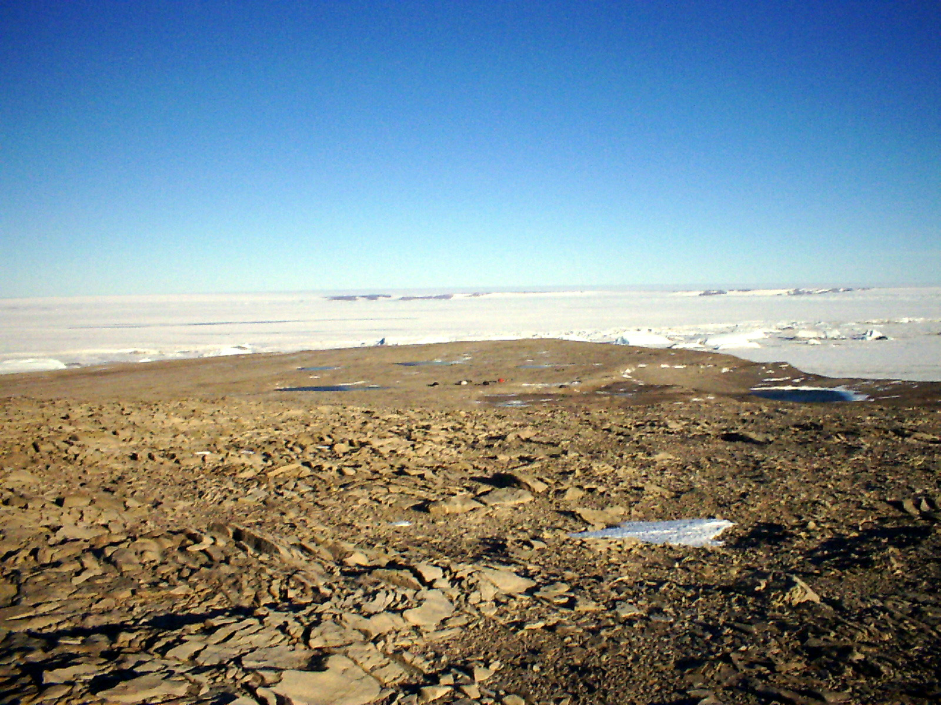

Ecosystem photo

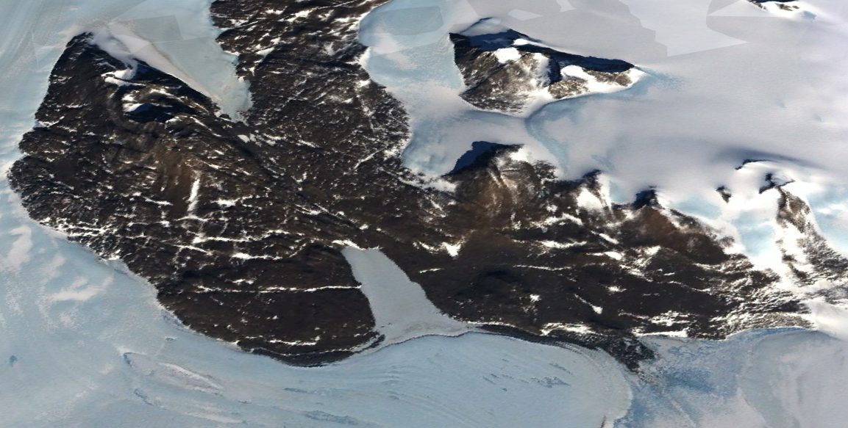

### Distribution

Occurs mainly in Enderby Land, East Antarctica, and the Prince Charles Mountains with a scattering of sites on the Antarctic Peninsula, Marie Byrd land, Victoria Land and the Transantarctic Mountains. A large swathe of E3B4 occurs in the McMurdo Dry Valleys

Full map

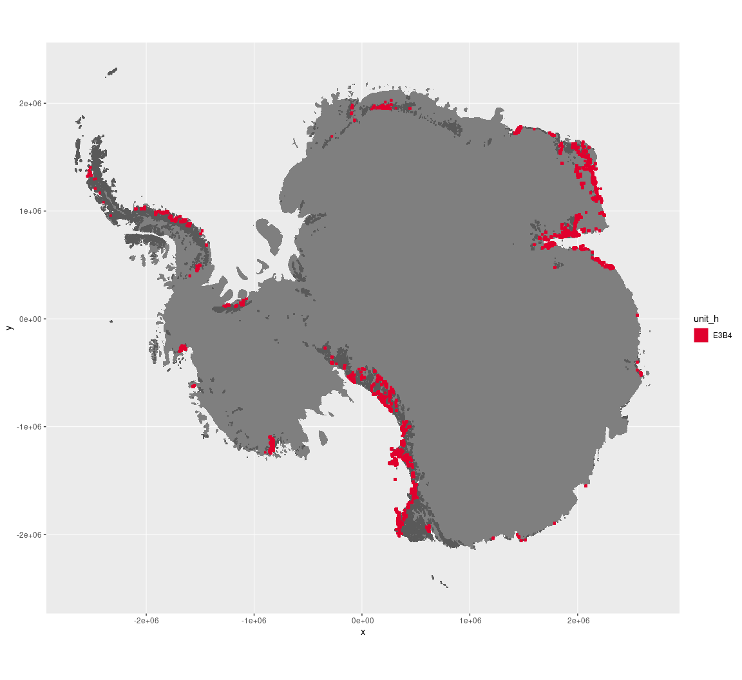

Regional maps

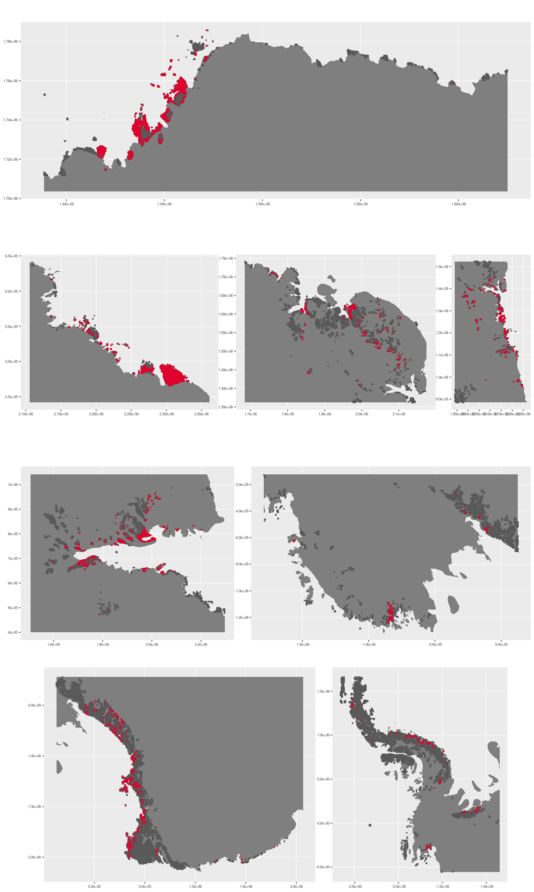



### Environment

The unit E3B4 is part of the environmental supergroup E3.

Supergroup E3 is, on average, substantially higher in DDm5, meanTemp and melt than continental Antarctica. It is substantially lower in elevation and totPrecip than the rest of the continent.

The elevation of unit E3B4 ranges from 0 to 3869 metres above sea level, but 90% of its pixels fall above 15 and below 1089 metres. Its average elevation is 316 metres.

The unit is higher in wind and lower in DDm5, elevation, melt, rugosity, slope and totPrecip than the rest of supergroup E3.

#### Distinctiveness of the assemblage from its group and the rest of Antarctica

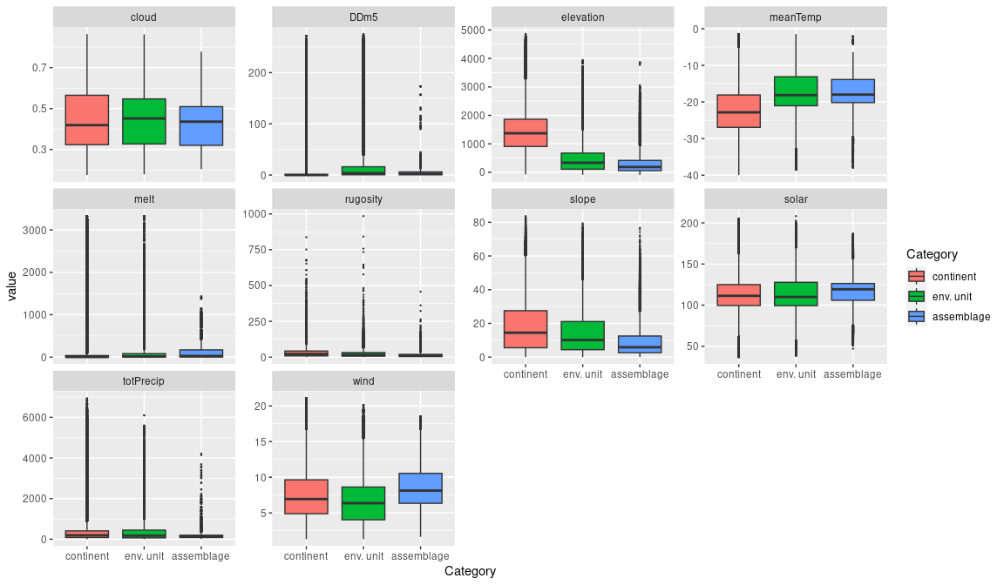

### Biota

Most widely sampled species in the unit (found in most pixels)

|  |  |  |  |  |  |
| --- | --- | --- | --- | --- | --- |
| scientific | Functional group | phylum | restricted | count | percent of samples |
| Bryum pseudotriquetrum | Bryophyta_Bryopsida_Bryales | Bryophyta | FALSE | 61 | 3.4817 |
| Buellia frigida | Ascomycota_Lecanoromycetes_Teloschistales_Physciaceae | Ascomycota | TRUE | 42 | 2.3973 |
| Umbilicaria aprina | Ascomycota_Lecanoromycetes_Umbilicariales_Umbilicariaceae | Ascomycota | FALSE | 34 | 1.9406 |
| Acarospora gwynnii | Ascomycota_Lecanoromycetes_Acarosporales_Acarosporaceae | Ascomycota | TRUE | 31 | 1.7694 |
| Ceratodon purpureus | Bryophyta_Bryopsida_Dicranales | Bryophyta | FALSE | 31 | 1.7694 |
| Caloplaca citrina | Ascomycota_Lecanoromycetes_Teloschistales_Teloschistaceae | Ascomycota | TRUE | 29 | 1.6553 |
| Lecanora expectans | Ascomycota_Lecanoromycetes_Lecanorales_Lecanoraceae | Ascomycota | TRUE | 28 | 1.5982 |
| Rhizoplaca melanophthalma | Ascomycota_Lecanoromycetes_Lecanorales_Lecanoraceae | Ascomycota | FALSE | 28 | 1.5982 |
| Navicula salinarum | Ochrophyta | Ochrophyta | FALSE | 27 | 1.5411 |
| Candelariella flava | Ascomycota_Lecanoromycetes_Candelariales_Candelariaceae | Ascomycota | TRUE | 26 | 1.4840 |
| Chaetoceros sp. | Ochrophyta | Ochrophyta | TRUE | 26 | 1.4840 |
| Navicula directa | Ochrophyta | Ochrophyta | FALSE | 26 | 1.4840 |

Supergroup E3 is, on average, substantially higher in suitability for algae_Green, lichens_Bacidiacid, lichens_Lecideacid, mosses_Dicranales, mosses_Grimmiales, Nematodes, penguins_Adelie and penguins_Chinstrap functional groups than continental Antarctica. It is substantially lower in suitability for no variables than the rest of the continent.

Unit E3B4 is higher in suitability for no variables and lower in suitability for no variables than the rest of supergroup E3.

#### Distinctiveness of the unit from the environmental group and the rest of Antarctica

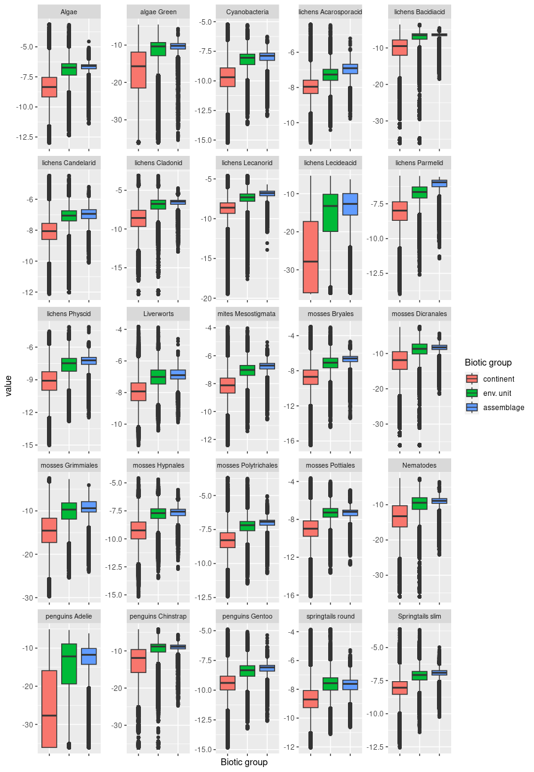

## Ecosystem E3B5

#### Subcoastal exposed mossy outcrops

These mossy ecosystems occupy low-relief rocky outcrops in the subcoastal hinterlands or directly on the coastline. Conditions are sufficiently warm and sunny to promote moss growth, but windier than other coastal systems in E3, leading to presence of aeolian (wind-eroded) contours. Several processes are likely to enhance habitat suitability for mosses by promoting nutrient enrichment. Many occurrences coincide with current or abandoned penguin colonies that were active earlier in the Holocene when sea levels were higher than at present. Toxic nitrogen levels associated with active colonies have since been leached, while residual levels of N and other nutrients promote moss growth. Alternatively, more elevated sites receive nutrient influxes from nesting seabirds or aerosol inputs via updrafts from extant penguin colonies below. While mosses are often conspicuous features of these systems, lichens and some nematodes are also widespread, they are popular with snow petrels, Wilson’s storm petrels, and several cyanobacteria species are characteristic of occurrences in different regions of the continent.

### Photos (if available)

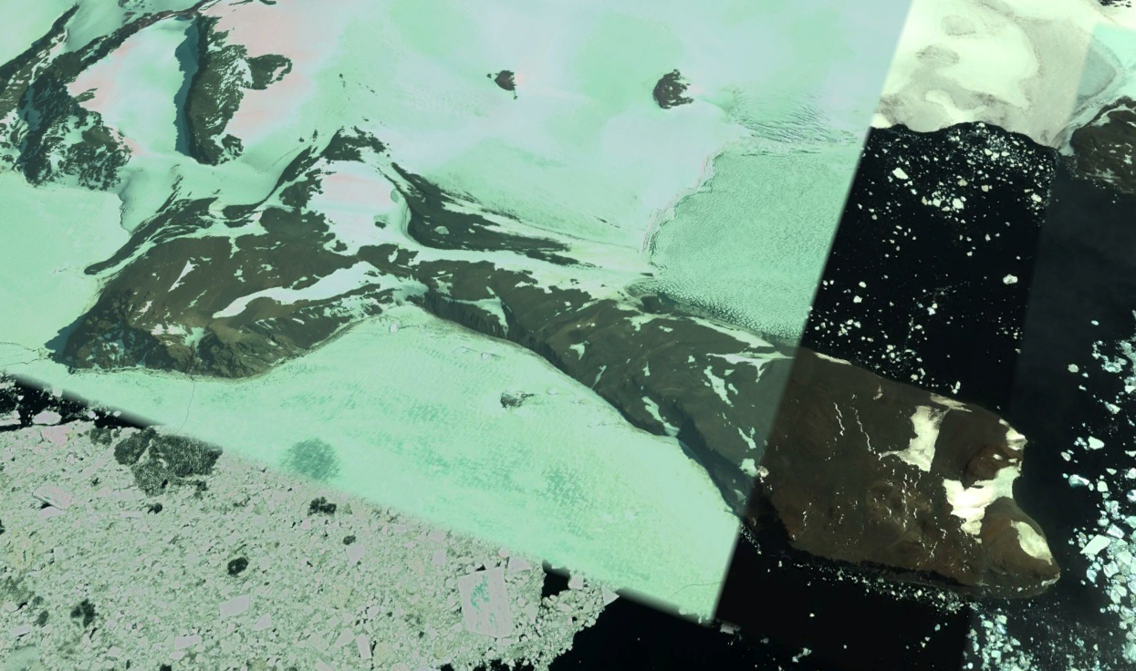

Ecosystem photo

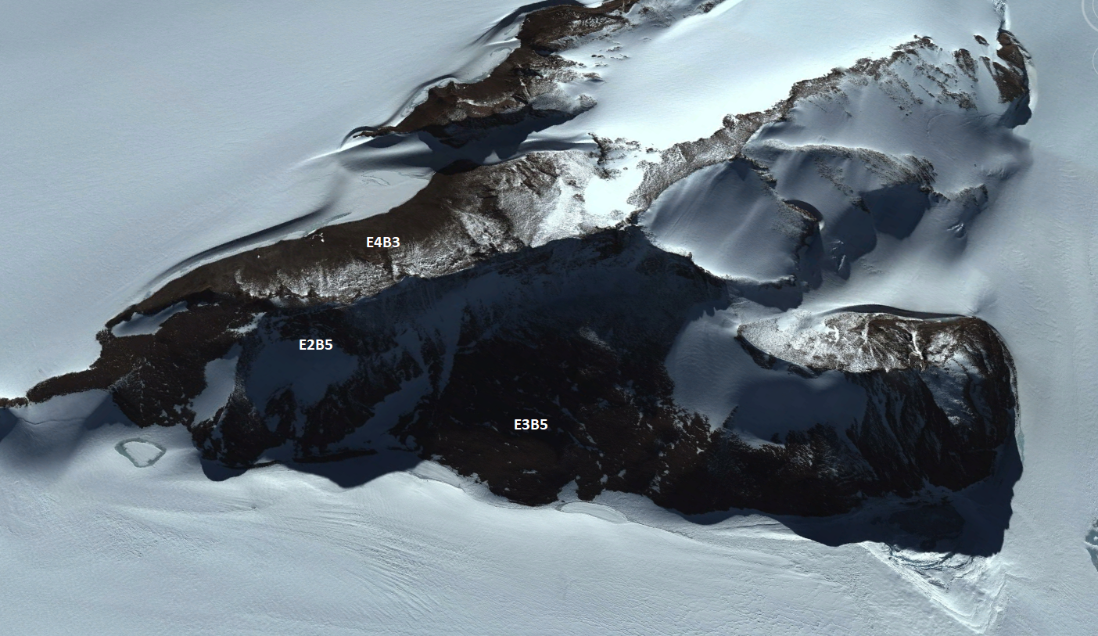

Ecosystem photo

### Distribution

Dominates Adelie Land, Enderby Land and East Antarctica

Full map

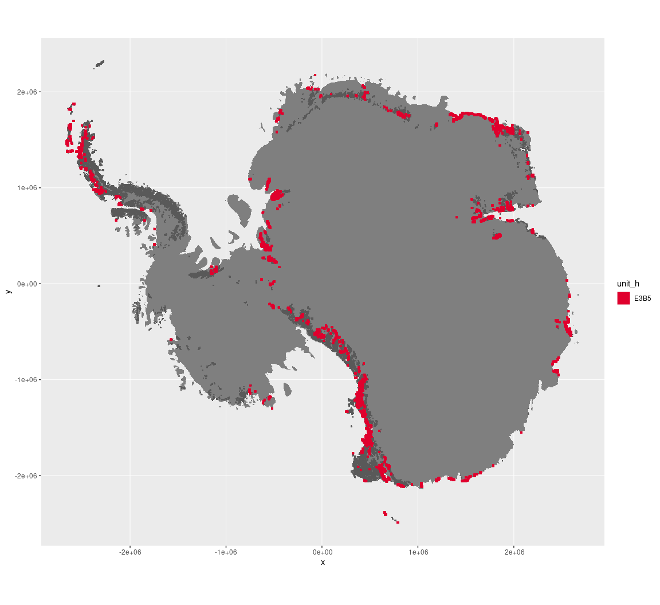

Regional maps

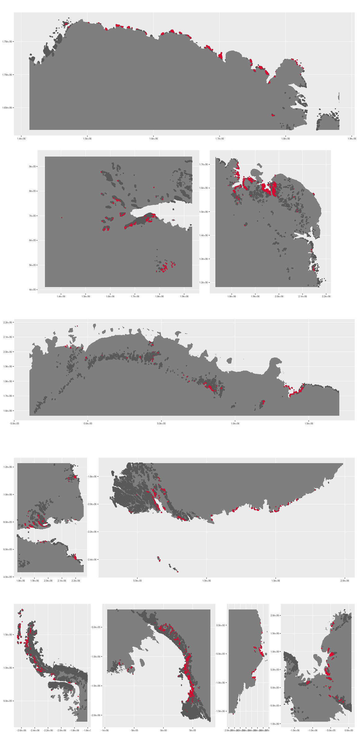



### Environment

The unit E3B5 is part of the environmental supergroup E3.

Supergroup E3 is, on average, substantially higher in DDm5, meanTemp and melt than continental Antarctica. It is substantially lower in elevation and totPrecip than the rest of the continent.

The elevation of unit E3B5 ranges from 0 to 3845 metres above sea level, but 90% of its pixels fall above 10 and below 1475 metres. Its average elevation is 429 metres.

The unit is higher in wind and lower in DDm5, melt, rugosity and slope than the rest of supergroup E3.

#### Distinctiveness of the assemblage from its group and the rest of Antarctica

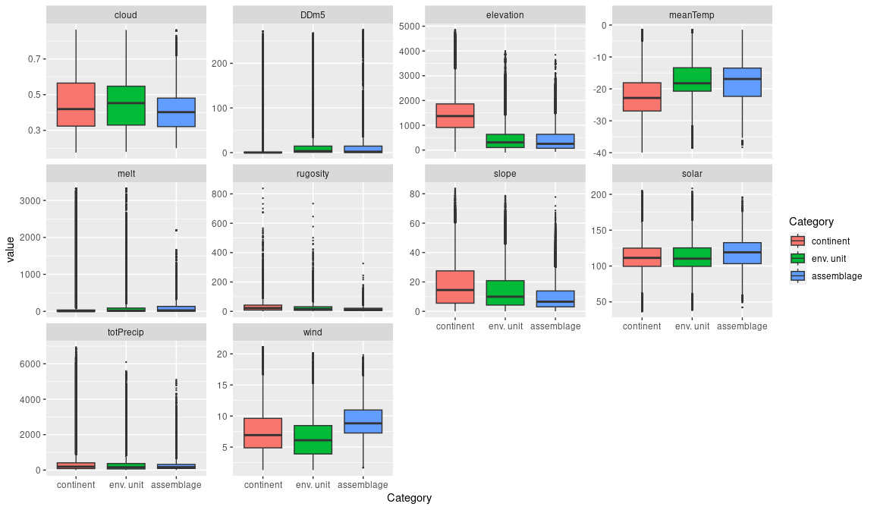

### Biota

Most widely sampled species in the unit (found in most pixels)

|  |  |  |  |  |  |
| --- | --- | --- | --- | --- | --- |
| scientific | Functional group | phylum | restricted | count | percent of samples |
| Ceratodon purpureus | Bryophyta_Bryopsida_Dicranales | Bryophyta | FALSE | 77 | 4.0526 |
| Bryum pseudotriquetrum | Bryophyta_Bryopsida_Bryales | Bryophyta | FALSE | 62 | 3.2632 |
| Umbilicaria decussata | Ascomycota_Lecanoromycetes_Umbilicariales_Umbilicariaceae | Ascomycota | FALSE | 62 | 3.2632 |
| Buellia frigida | Ascomycota_Lecanoromycetes_Teloschistales_Physciaceae | Ascomycota | TRUE | 45 | 2.3684 |
| Pagodroma nivea | Chordata_Aves_Procellariiformes | Chordata | FALSE | 44 | 2.3158 |
| Usnea sphacelata | Ascomycota_Lecanoromycetes_Lecanorales_Parmeliaceae | Ascomycota | TRUE | 35 | 1.8421 |
| Candelariella flava | Ascomycota_Lecanoromycetes_Candelariales_Candelariaceae | Ascomycota | TRUE | 34 | 1.7895 |
| Oceanites oceanicus | Chordata_Aves_Procellariiformes | Chordata | TRUE | 31 | 1.6316 |
| Usnea antarctica | Ascomycota_Lecanoromycetes_Lecanorales_Parmeliaceae | Ascomycota | FALSE | 31 | 1.6316 |
| Pseudephebe minuscula | Ascomycota_Lecanoromycetes_Lecanorales_Parmeliaceae | Ascomycota | FALSE | 30 | 1.5789 |
| Xanthoria elegans | Ascomycota_Lecanoromycetes_Teloschistales_Teloschistaceae | Ascomycota | FALSE | 30 | 1.5789 |

Supergroup E3 is, on average, substantially higher in suitability for algae_Green, lichens_Bacidiacid, lichens_Lecideacid, mosses_Dicranales, mosses_Grimmiales, Nematodes, penguins_Adelie and penguins_Chinstrap functional groups than continental Antarctica. It is substantially lower in suitability for no variables than the rest of the continent.

Unit E3B5 is higher in suitability for no variables and lower in suitability for no variables than the rest of supergroup E3.

#### Distinctiveness of the unit from the environmental group and the rest of Antarctica

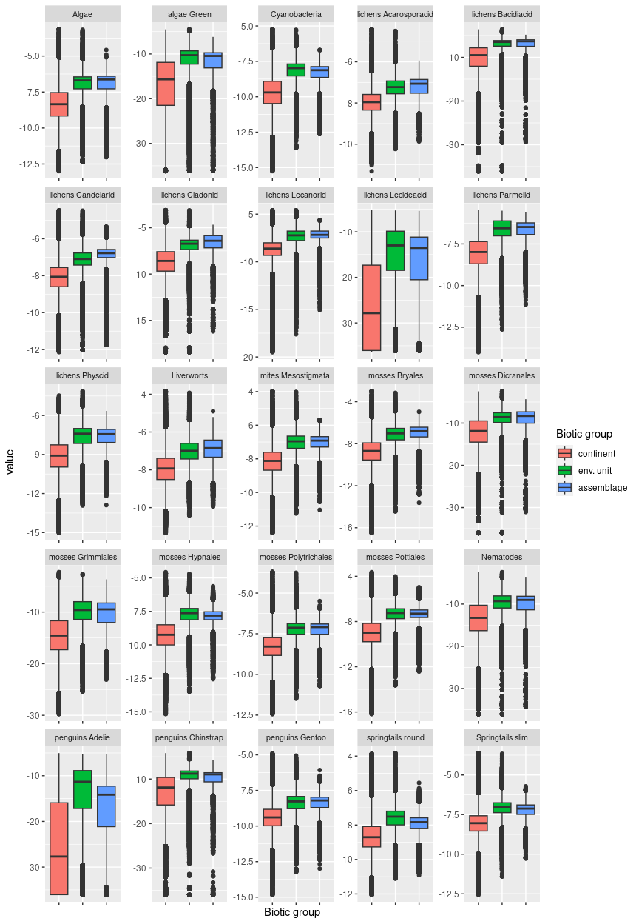

## Ecosystem E3B6

#### Glacial outwash plains

Located primarily at the terminus of glaciers, outwash plains contain debris and sediment from meltwater outflow that is often sorted by size, with larger rocks and boulders nearer to the glacier and smaller particles such as silt farther away. In Taylor valley, the outwash plain is a part of the Ross Sea 1 Drift (Perotti et al. 2018, Hawes et al. 2021) and contains a variety of interbedded substrates including gravel, silt, and sand. The unit often contains an abundance of kettle lakes and may be crisscrossed by meltwater streams.

### Photos (if available)

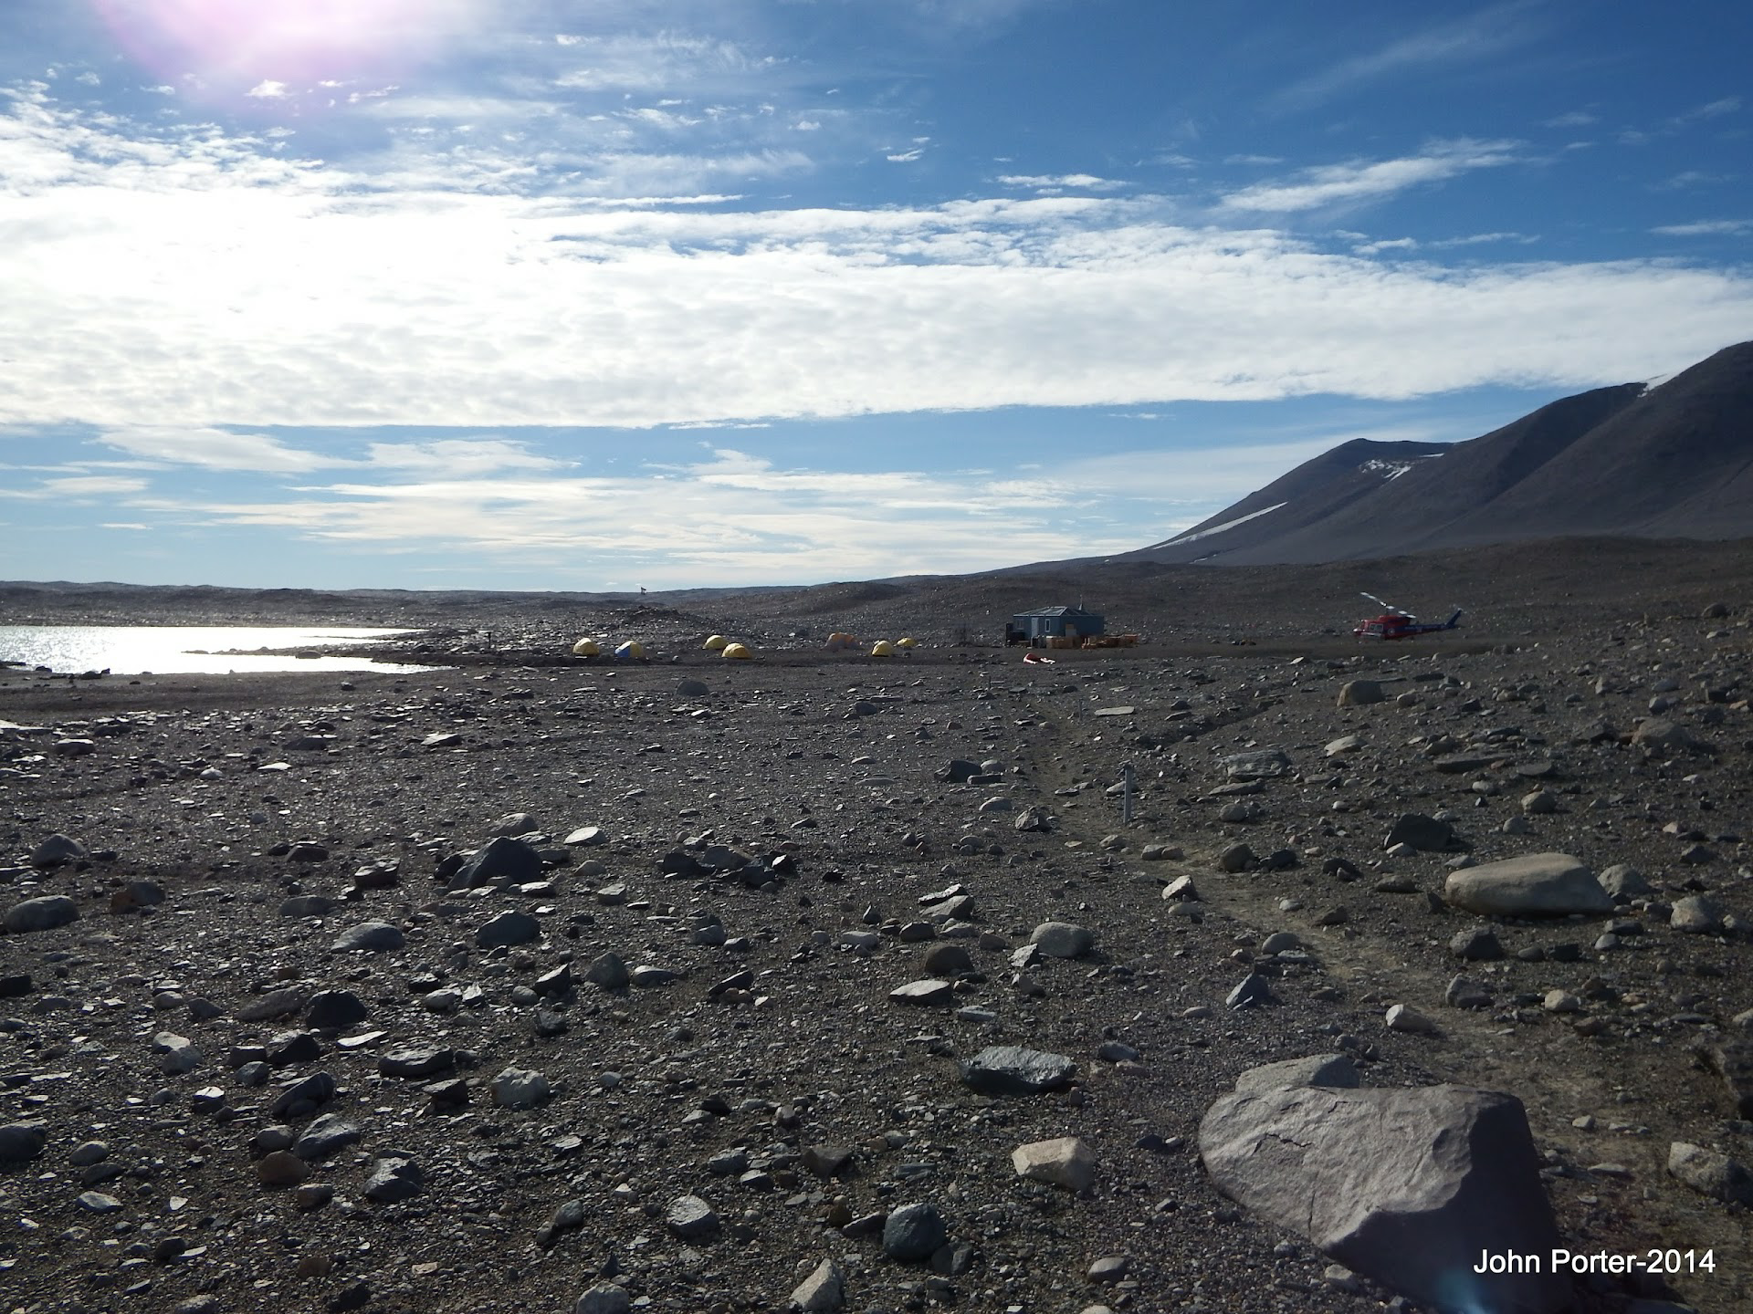

*Ecosystem E3B6 at the mouth of Taylor Valley*

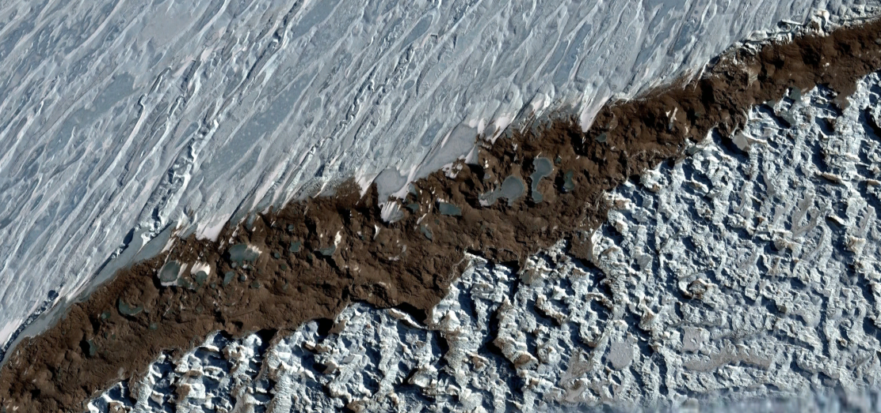

Ecosystem photo from the PCM

### Distribution

Aside from patchy relatively minor occurrences (< 100 km2 per bioregion) in the Antarctic Peninsula, the Transantarctic Mountains, Enderby Land and the Prince Charles Mountains, this assemblage is found primarily in Victoria Land, particularly in the McMurdo dry valleys (~800 km2), which constitutes over half of its total area.

Full map

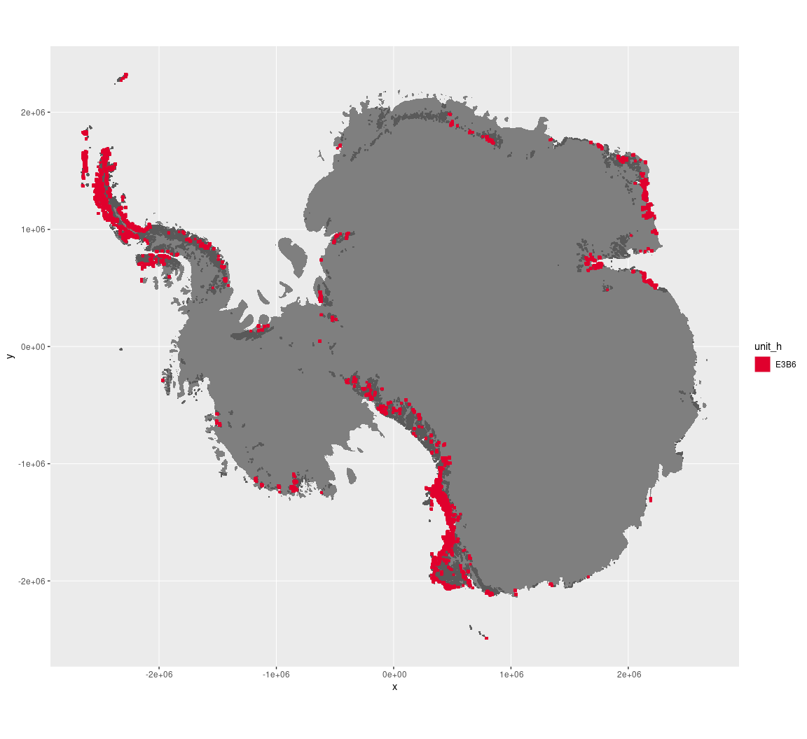

Regional maps

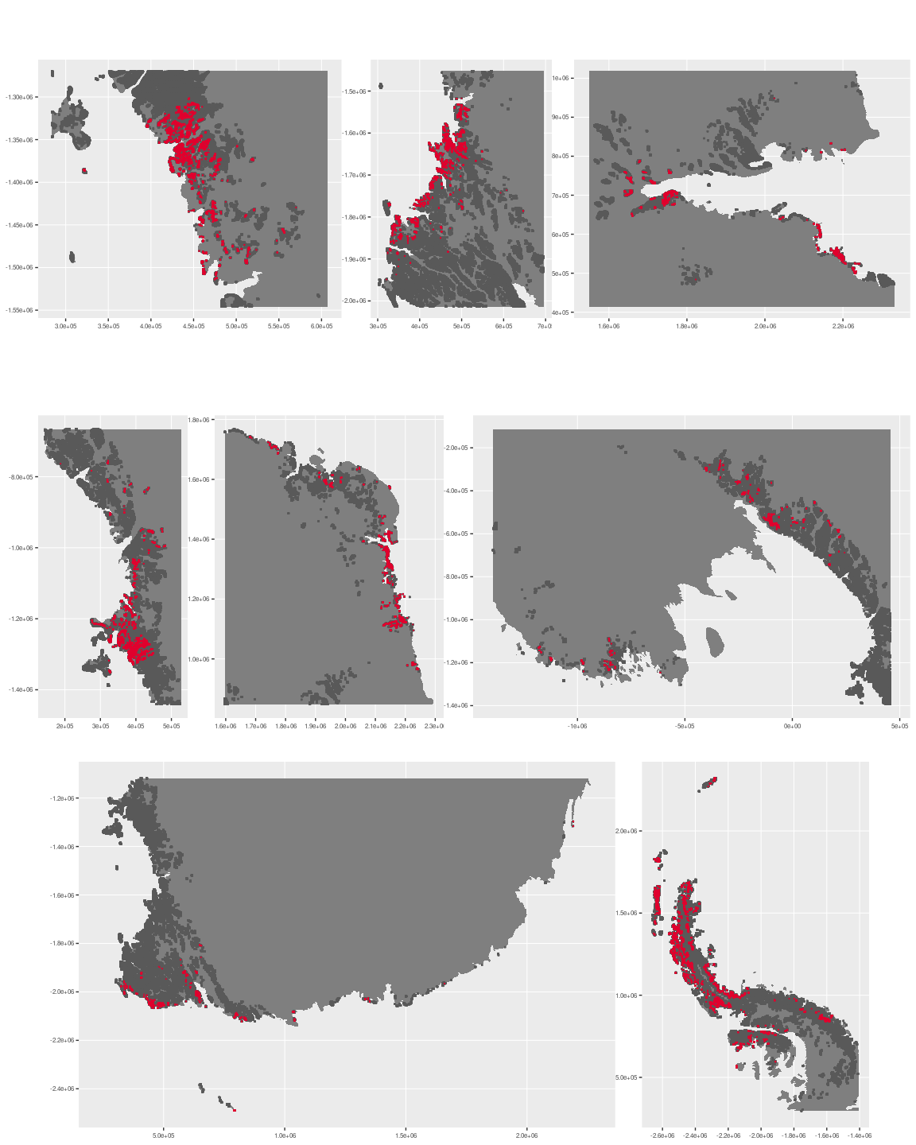



### Environment

The unit E3B6 is part of the environmental supergroup E3.

Supergroup E3 is, on average, substantially higher in DDm5, meanTemp and melt than continental Antarctica. It is substantially lower in elevation, rugosity, slope and totPrecip than the rest of the continent.

The elevation of unit E3B6 ranges from 0 to 3294 metres above sea level, but 90% of its pixels fall above -17 and below 1234 metres. Its average elevation is 451 metres.

The unit is higher in no variables and lower in melt than the rest of supergroup E3.

#### Distinctiveness of the assemblage from its group and the rest of Antarctica

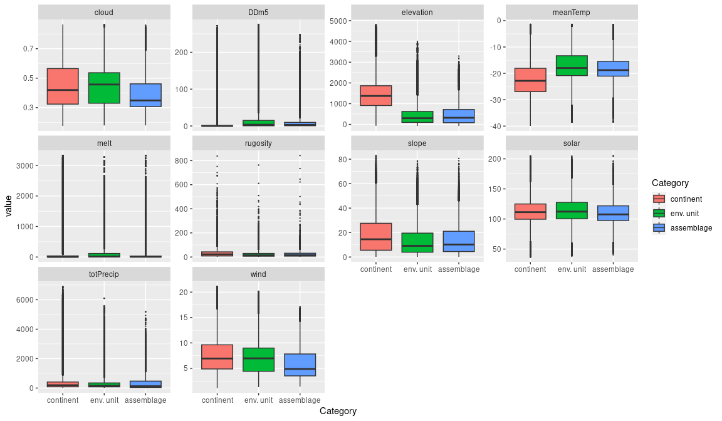

### Biota

Most widely sampled species in the unit (found in most pixels)

|  |  |  |  |  |  |
| --- | --- | --- | --- | --- | --- |
| scientific | Functional group | phylum | restricted | count | percent of samples |
| Scottnema lindsayae | Nematoda | Nematoda | TRUE | 32 | 1.8338 |
| Bryum pseudotriquetrum | Bryophyta_Bryopsida_Bryales | Bryophyta | FALSE | 31 | 1.7765 |
| Buellia frigida | Ascomycota_Lecanoromycetes_Teloschistales_Physciaceae | Ascomycota | TRUE | 26 | 1.4900 |
| Eudorylaimus antarcticus | Nematoda | Nematoda | TRUE | 23 | 1.3181 |
| Gomphiocephalus hodgsoni | Arthropoda_Entognatha_Poduromorpha | Arthropoda | TRUE | 23 | 1.3181 |
| Stereotydeus mollis | Arthropoda_Arachnida_Trombidiformes | Arthropoda | TRUE | 22 | 1.2607 |
| Xanthoria elegans | Ascomycota_Lecanoromycetes_Teloschistales_Teloschistaceae | Ascomycota | FALSE | 21 | 1.2034 |
| Pygoscelis adeliae | Chordata_Aves_Sphenisciformes_Spheniscidae_Pygoscelis_adeliae | Chordata | FALSE | 20 | 1.1461 |
| Plectus murrayi | Nematoda | Nematoda | TRUE | 19 | 1.0888 |
| Prasiola crispa | Chlorophyta | Chlorophyta | FALSE | 18 | 1.0315 |
| Umbilicaria decussata | Ascomycota_Lecanoromycetes_Umbilicariales_Umbilicariaceae | Ascomycota | FALSE | 18 | 1.0315 |

Supergroup E3 is, on average, substantially higher in suitability for algae_Green, lichens_Bacidiacid, lichens_Cladonid, lichens_Lecideacid, mosses_Dicranales, mosses_Grimmiales, Nematodes, penguins_Adelie and penguins_Chinstrap functional groups than continental Antarctica. It is substantially lower in suitability for no variables than the rest of the continent.

Unit E3B6 is higher in suitability for no variables and lower in suitability for no variables than the rest of supergroup E3.

#### Distinctiveness of the unit from the environmental group and the rest of Antarctica

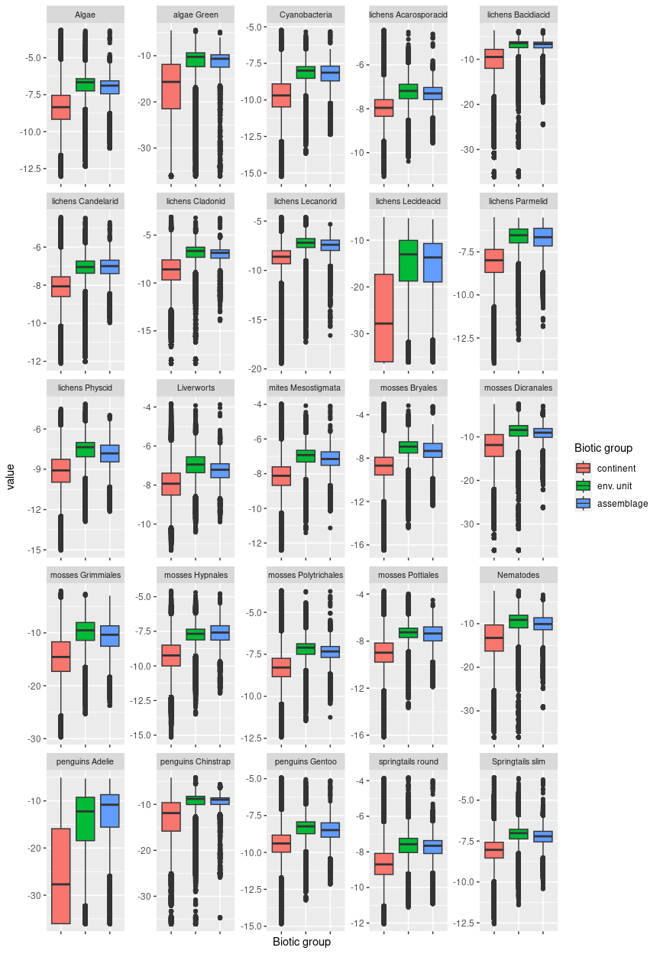

## Ecosystem E3B7

#### Dry lowland lichen fields

Primarily occurs on flat, rocky terrain or low outcrops on cold, dry and windy coastlines (though there are occasional occurrences inland), commonly (but not exclusively) adjacent to ice shelves. Characteristic biota includes several common moss and lichen recorded primarily from this unit (note this is biased due to extensive sampling throughout the Vestfold Hills), though penguins and seabirds are also commonly sampled. Nutrient fluxes potentially influenced by Emperor penguin colonies on adjacent ice sheets. Suitability is high for all functional groups.

### Photos (if available)

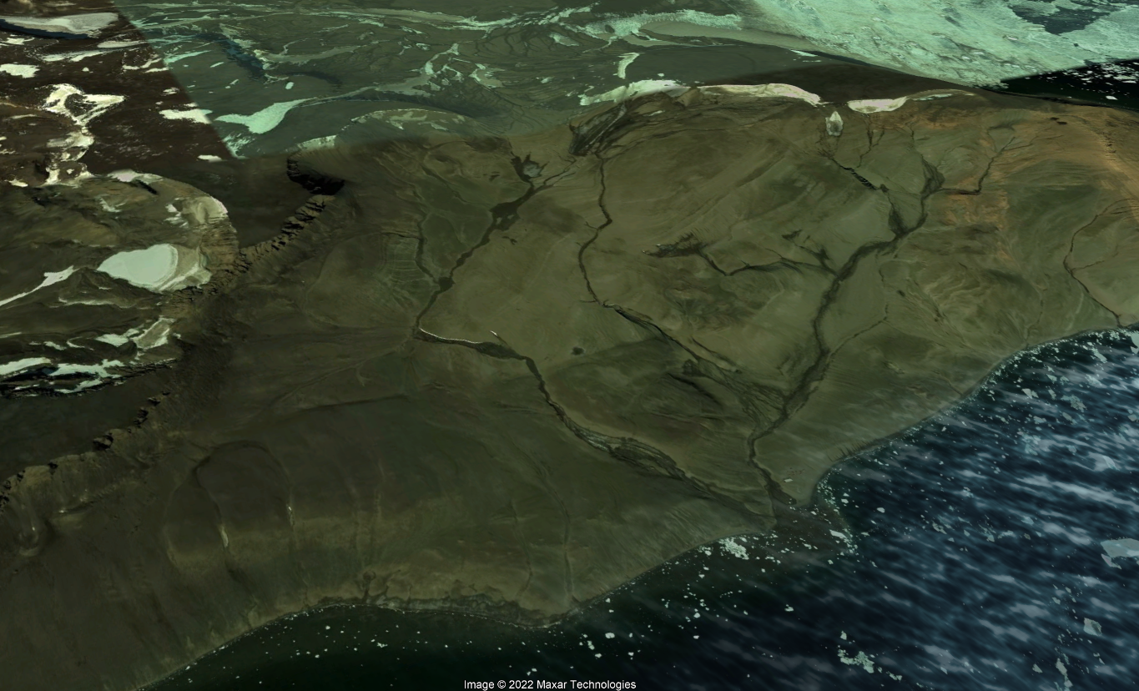

Ecosystem photo

### Distribution

Patchy occurrences all around Antarctica. Found most commonly in the Transantarctic Mountains and Victoria Land but also on the Antarctic Peninsula. Also encompasses Seymour Island.

Full map

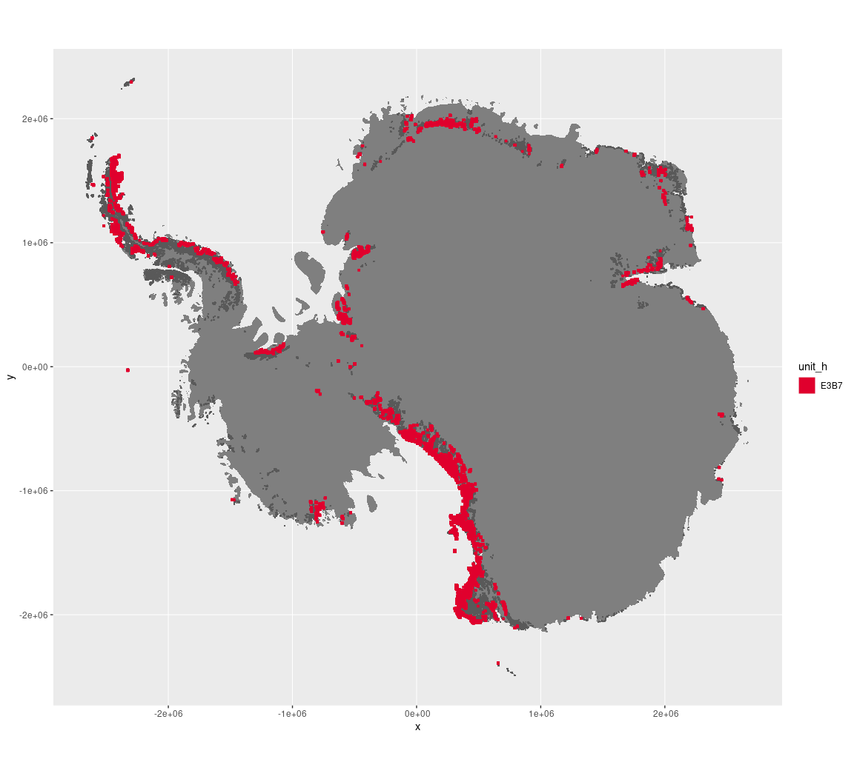

Regional maps

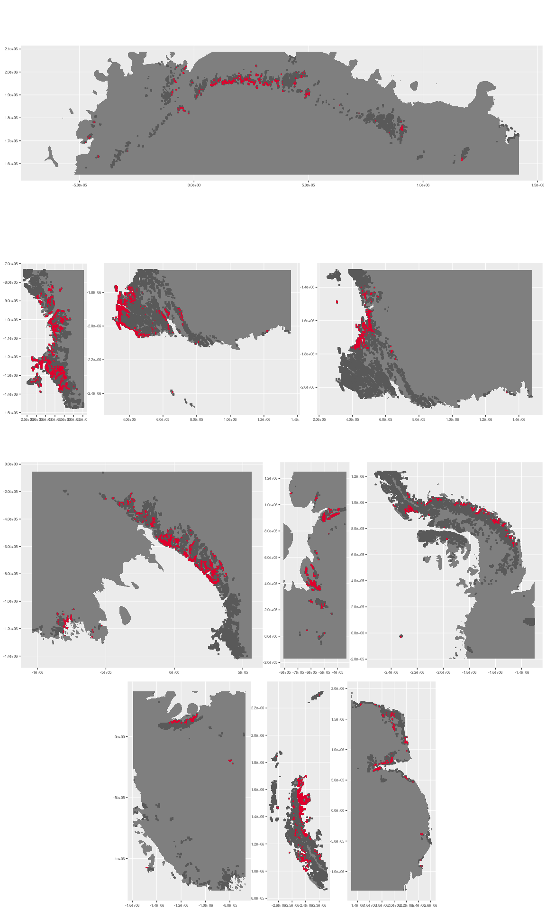

### Environment

The unit E3B7 is part of the environmental supergroup E3.

Supergroup E3 is, on average, substantially higher in DDm5, meanTemp and melt than continental Antarctica. It is substantially lower in elevation, rugosity, slope and totPrecip than the rest of the continent.

The elevation of unit E3B7 ranges from 0 to 4000 metres above sea level, but 90% of its pixels fall above 17 and below 1774 metres. Its average elevation is 549 metres.

The unit is higher in DDm5, elevation, rugosity and slope and lower in melt than the rest of supergroup E3.

#### Distinctiveness of the assemblage from its group and the rest of Antarctica

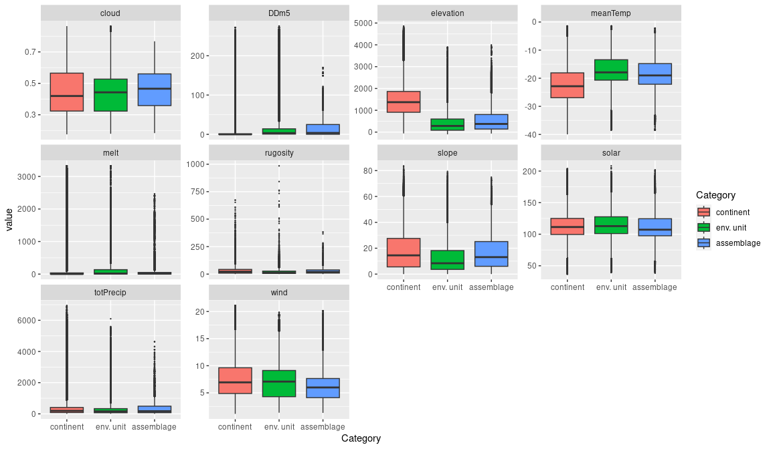

### Biota

Most widely sampled species in the unit (found in most pixels)

|  |  |  |  |  |  |
| --- | --- | --- | --- | --- | --- |
| scientific | Functional group | phylum | restricted | count | percent of samples |
| Xanthoria elegans | Ascomycota_Lecanoromycetes_Teloschistales_Teloschistaceae | Ascomycota | FALSE | 38 | 2.9945 |
| Rhizoplaca melanophthalma | Ascomycota_Lecanoromycetes_Lecanorales_Lecanoraceae | Ascomycota | FALSE | 29 | 2.2853 |
| Usnea sphacelata | Ascomycota_Lecanoromycetes_Lecanorales_Parmeliaceae | Ascomycota | TRUE | 28 | 2.2065 |
| Buellia frigida | Ascomycota_Lecanoromycetes_Teloschistales_Physciaceae | Ascomycota | TRUE | 27 | 2.1277 |
| Bryum subrotundifolium | Bryophyta_Bryopsida_Bryales | Bryophyta | TRUE | 26 | 2.0489 |
| Bryum pseudotriquetrum | Bryophyta_Bryopsida_Bryales | Bryophyta | FALSE | 24 | 1.8913 |
| Umbilicaria decussata | Ascomycota_Lecanoromycetes_Umbilicariales_Umbilicariaceae | Ascomycota | FALSE | 24 | 1.8913 |
| Sarconeurum glaciale | Bryophyta_Bryopsida_Pottiales | Bryophyta | TRUE | 23 | 1.8125 |
| Lecanora expectans | Ascomycota_Lecanoromycetes_Lecanorales_Lecanoraceae | Ascomycota | TRUE | 21 | 1.6548 |
| Syntrichia princeps | Bryophyta_Bryopsida_Pottiales | Bryophyta | FALSE | 19 | 1.4972 |

Supergroup E3 is, on average, substantially higher in suitability for algae_Green, lichens_Bacidiacid, lichens_Cladonid, lichens_Lecideacid, mosses_Dicranales, mosses_Grimmiales, Nematodes, penguins_Adelie and penguins_Chinstrap functional groups than continental Antarctica. It is substantially lower in suitability for no variables than the rest of the continent.

Unit E3B7 is higher in suitability for no variables and lower in suitability for no variables than the rest of supergroup E3.

#### Distinctiveness of the unit from the environmental group and the rest of Antarctica

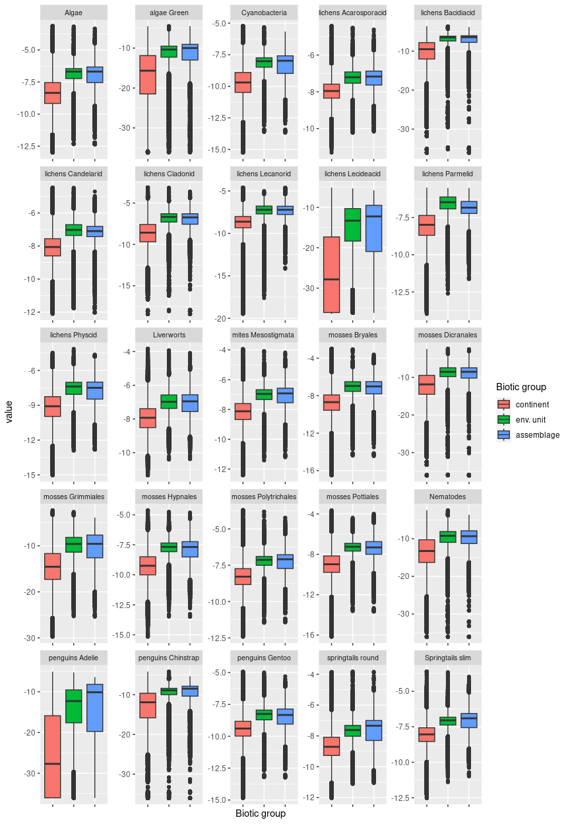

## Ecosystem E3B8

#### Large rookeries

This assemblage is distinguished by large nesting colonies of adelie, chinstrap and gentoo penguins. They select ice-free shorelines (< 300m from coast) with gentle topography, low elevation (usually no more than a few metres above sea level), and high insolation. Nesting sites also tend to have high cloud cover, snowfall, and long growing season even relative to other E3 units, but may be exposed to prevailing winds. Favourability of these sites also makes them attractive to other nesting seabirds, including gulls, giant petrels, and the imperial shag, among others. Guano from nesting birds represents major nutrient influx and supports unique trophic network of mosses, lichens, mites/springtails etc.

### Photos (if available)

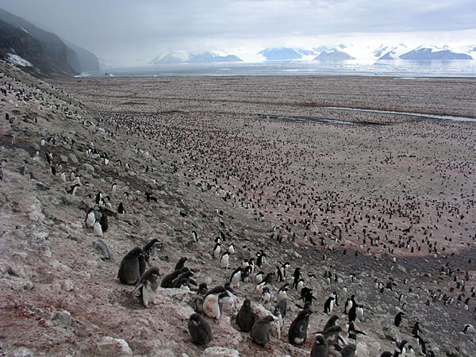

*Photo Credit: Steve Emslie. The adelie penguin colony on Cape Adare, the largest rookery in Antarctica.*

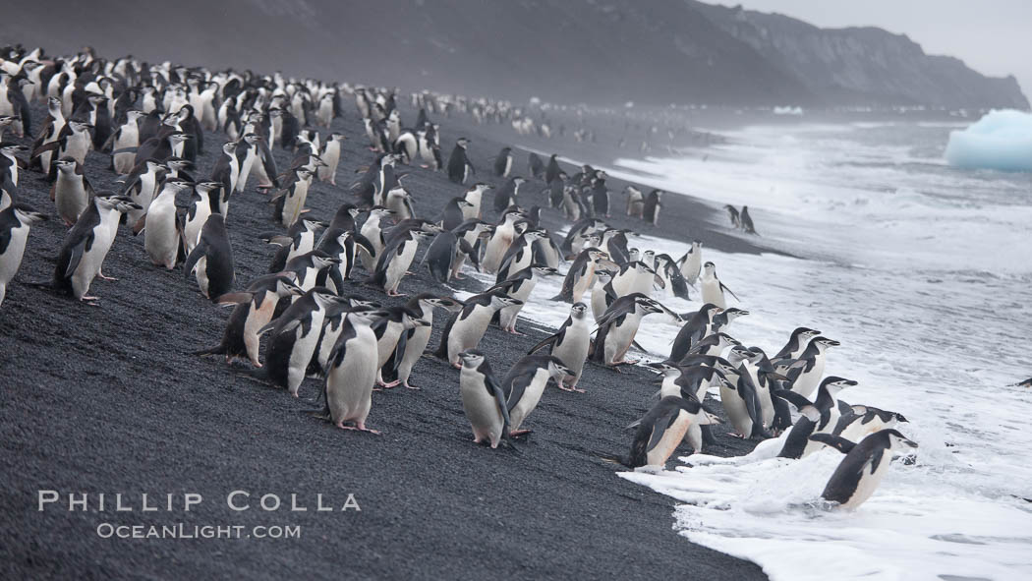

*Chinstrap penguin colony on Deception Island*

### Distribution

Coastal outcrops all around the edge of the continent and peninsula, and on coastal islands

Full map

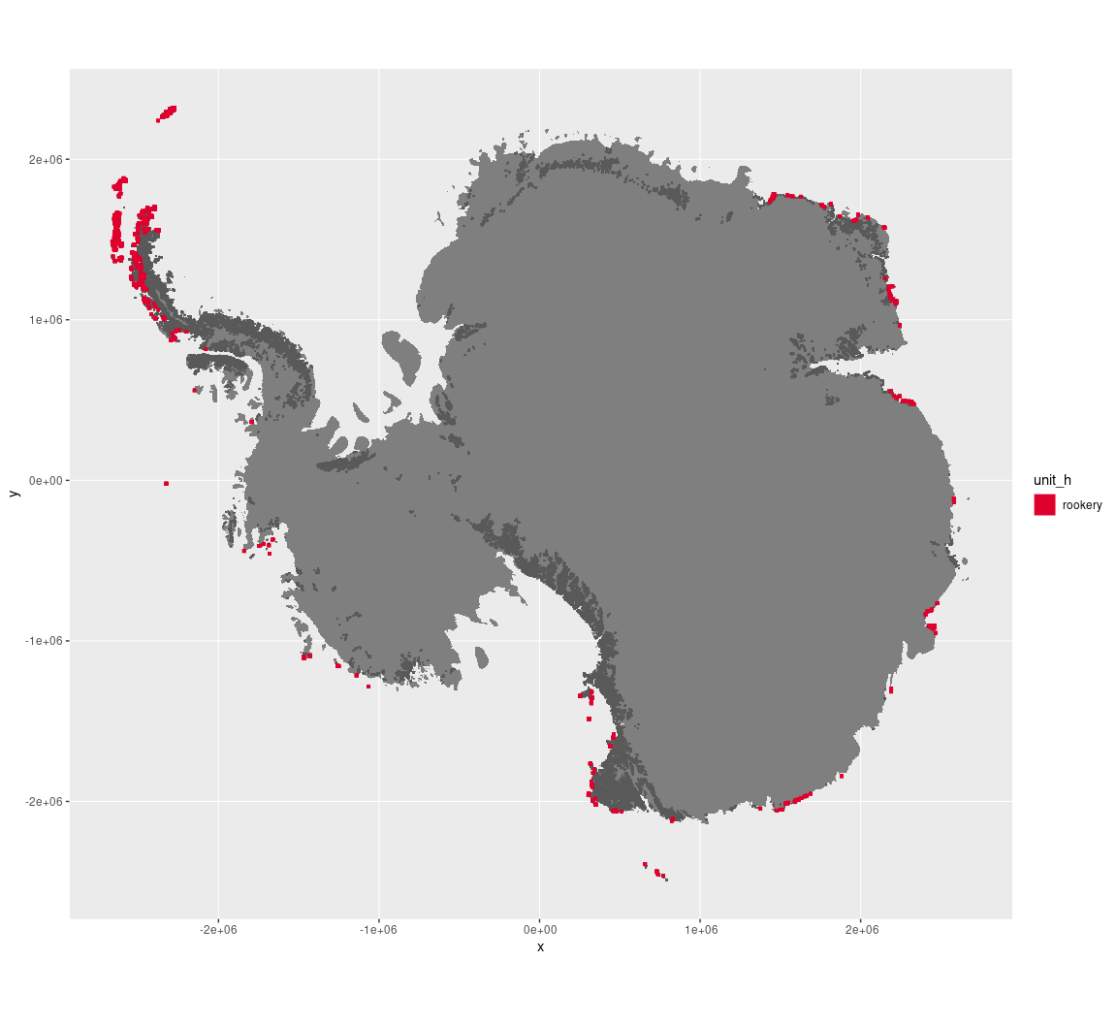

Regional maps

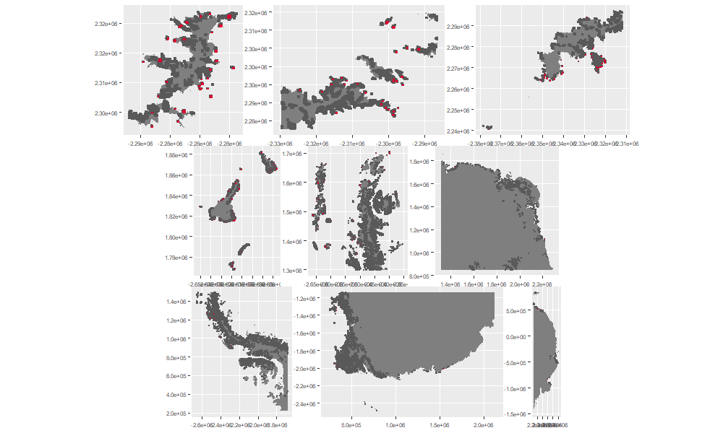

### Environment

Rookeries are part of the environmental supergroup E3.

Supergroup E3 is, on average, substantially higher in DDm5, meanTemp and melt than continental Antarctica. It is substantially lower in elevation, rugosity and totPrecip than the rest of the continent.

The elevation of rookeries ranges from 0 to 1029 metres above sea level, but 90% of its pixels are below 172 metres. Its average elevation is 37 metres.

The unit is higher in cloud, DDm5, meanTemp and totPrecip and lower in elevation, rugosity and slope than the rest of supergroup E3.

#### Distinctiveness of the assemblage from its group and the rest of Antarctica

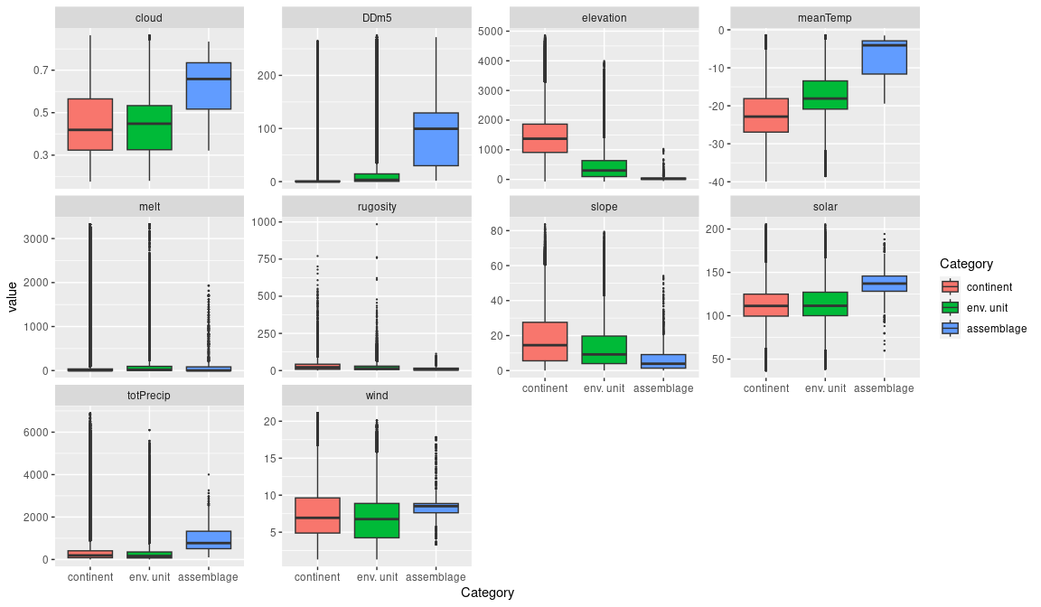

### Biota

Most widely sampled species in the unit (found in most pixels)

|  |  |  |  |  |  |
| --- | --- | --- | --- | --- | --- |
| scientific | Functional group | phylum | restricted | count | percent of samples |
| Pygoscelis antarctica | Chordata_Aves_Sphenisciformes_Spheniscidae_Pygoscelis_antarctica | Chordata | TRUE | 218 | 16.8731 |
| Pygoscelis adeliae | Chordata_Aves_Sphenisciformes_Spheniscidae_Pygoscelis_adeliae | Chordata | FALSE | 203 | 15.7121 |
| Pygoscelis papua | Chordata_Aves_Sphenisciformes_Spheniscidae_Pygoscelis_papua | Chordata | FALSE | 65 | 5.0310 |
| Larus dominicanus | Chordata_Aves_Charadriiformes | Chordata | TRUE | 25 | 1.9350 |
| Macronectes giganteus | Chordata_Aves_Procellariiformes | Chordata | FALSE | 25 | 1.9350 |
| Leucocarbo atriceps | Chordata_Aves_Suliformes | Chordata | FALSE | 17 | 1.3158 |
| Bryum pseudotriquetrum | Bryophyta_Bryopsida_Bryales | Bryophyta | FALSE | 12 | 0.9288 |
| Cryptopygus antarcticus | Arthropoda_Entognatha_Entomobryomorpha | Arthropoda | TRUE | 12 | 0.9288 |
| Prasiola crispa | Chlorophyta | Chlorophyta | FALSE | 12 | 0.9288 |
| Usnea antarctica | Ascomycota_Lecanoromycetes_Lecanorales_Parmeliaceae | Ascomycota | FALSE | 11 | 0.8514 |

Supergroup E3 is, on average, substantially higher in suitability for algae_Green, lichens_Bacidiacid, lichens_Cladonid, lichens_Lecideacid, mosses_Dicranales, mosses_Grimmiales, Nematodes, penguins_Adelie and penguins_Chinstrap functional groups than continental Antarctica. It is substantially lower in suitability for no variables than the rest of the continent.

Rookeries are higher in suitability for algae_Green, lichens_Lecideacid, mosses_Dicranales, mosses_Grimmiales, Nematodes, penguins_Adelie and penguins_Chinstrap and lower in suitability for no variables than the rest of supergroup E3.

#### Distinctiveness of the unit from the environmental group and the rest of Antarctica

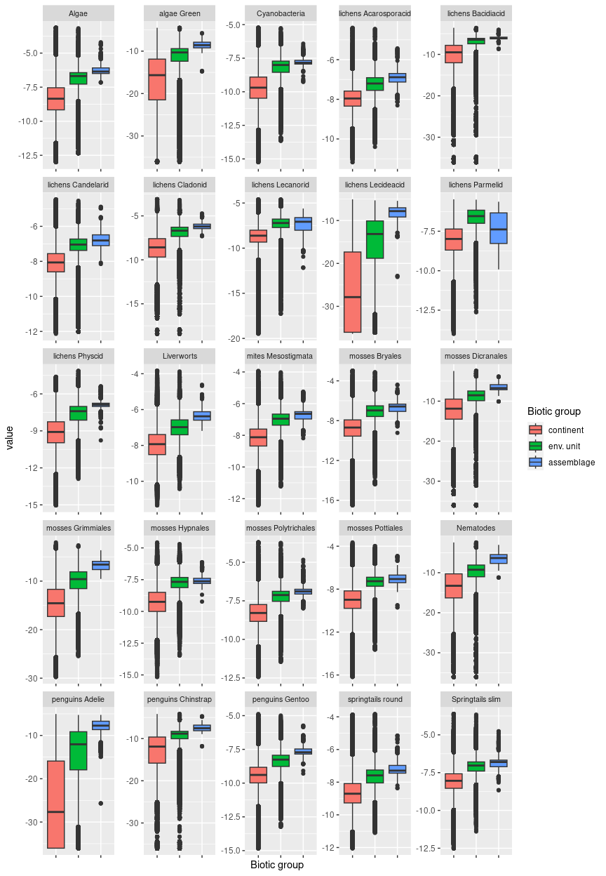

## Ecosystem E4B1

#### Sunny exposed low-midland hillslopes/screes

### One of the sunniest units on the continent, this relatively mild north-facing ecosystem exhibits mainly medium but occasionally steeper craggy slopes and may be exposed to prevailing wind. It is primarily coastal except in DM Land. It is relatively mild but the windiest unit in E4. In DM Land, the unit often occurs alternating with E2B1 or E5B6 (depending on elevation and ruggedness) where light conditions are variable due to topography and aspect, with this unit representing well-lit inclines and slopes. On the Peninsula, it may alternate similarly with lowland E3 and snowy E1 units and is prominently free of snow in summer (see photos). Primary sampled biota are lichens and mosses. Suitability is higher than the rest of E4 for algae, Acarosporacid, Candelarid, and Lecanorid lichens, Liverworts, Bryales mosses and slim Springtails.

### Photos (if available)

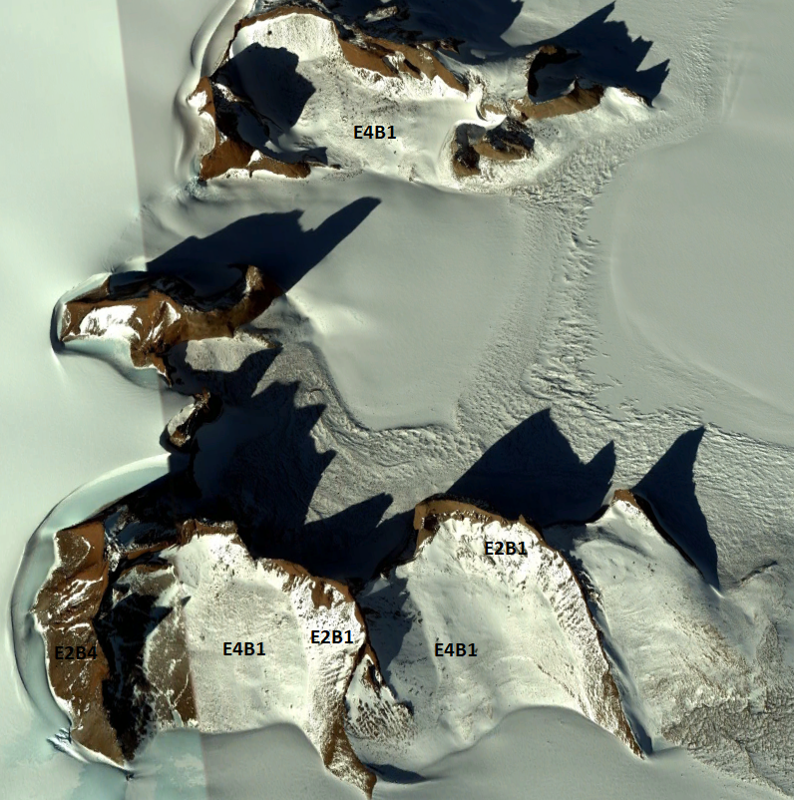

*Ecosystem complex with E4B1 in Dronning Maud Land (Google Earth)*

### 

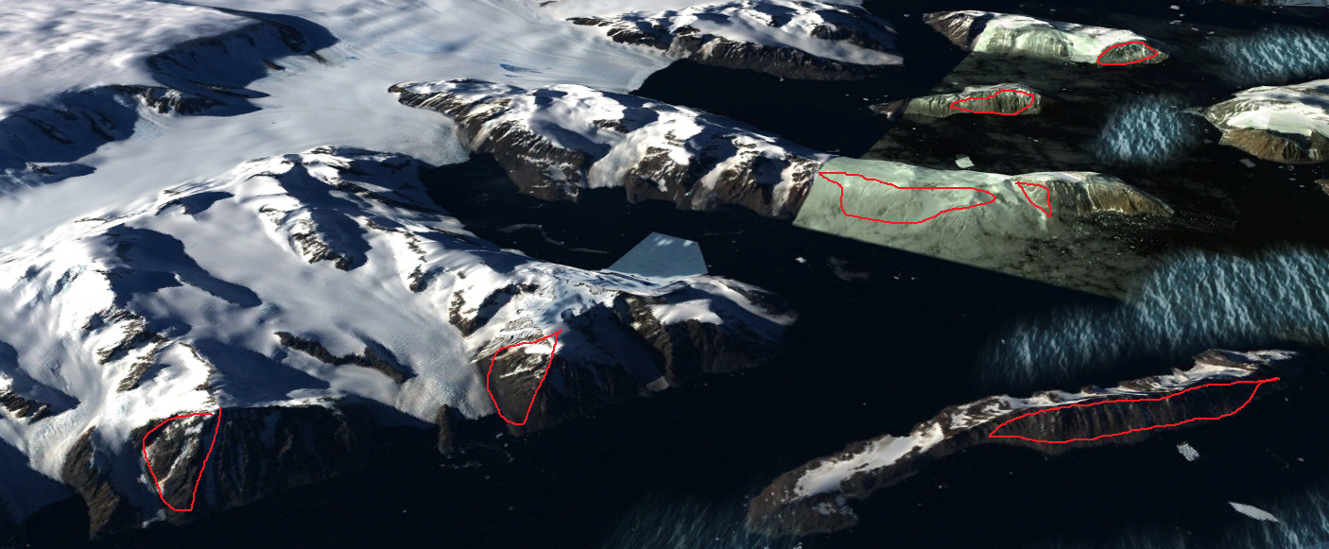

*E4B1 on north-facing slopes in the North-east Antarctic Peninsula (Google Earth)*



Ecosystem complex containing E4B1 on Alexander Island (Google Earth)

### Distribution

Concentrated in Dronning Maud Land, with relatively minor occurrences on the Antarctic Peninsula and in North Victoria Land.

Full map

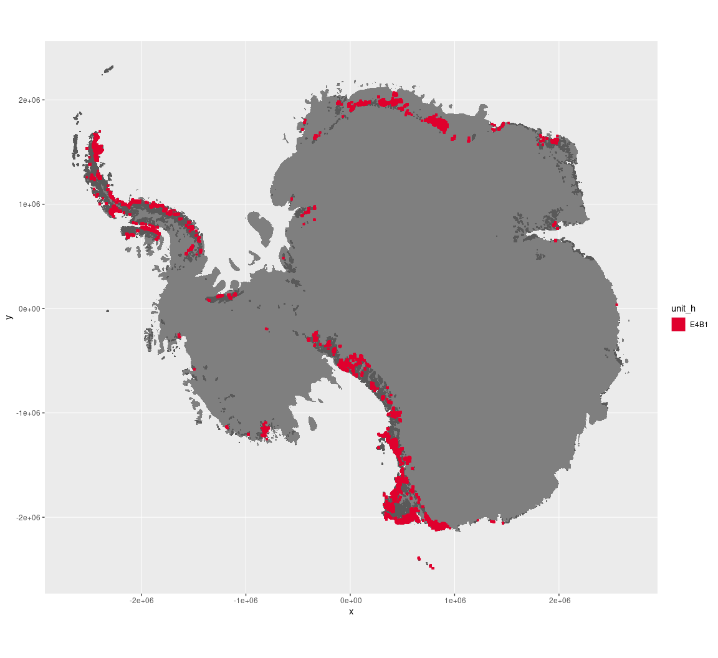

Regional maps

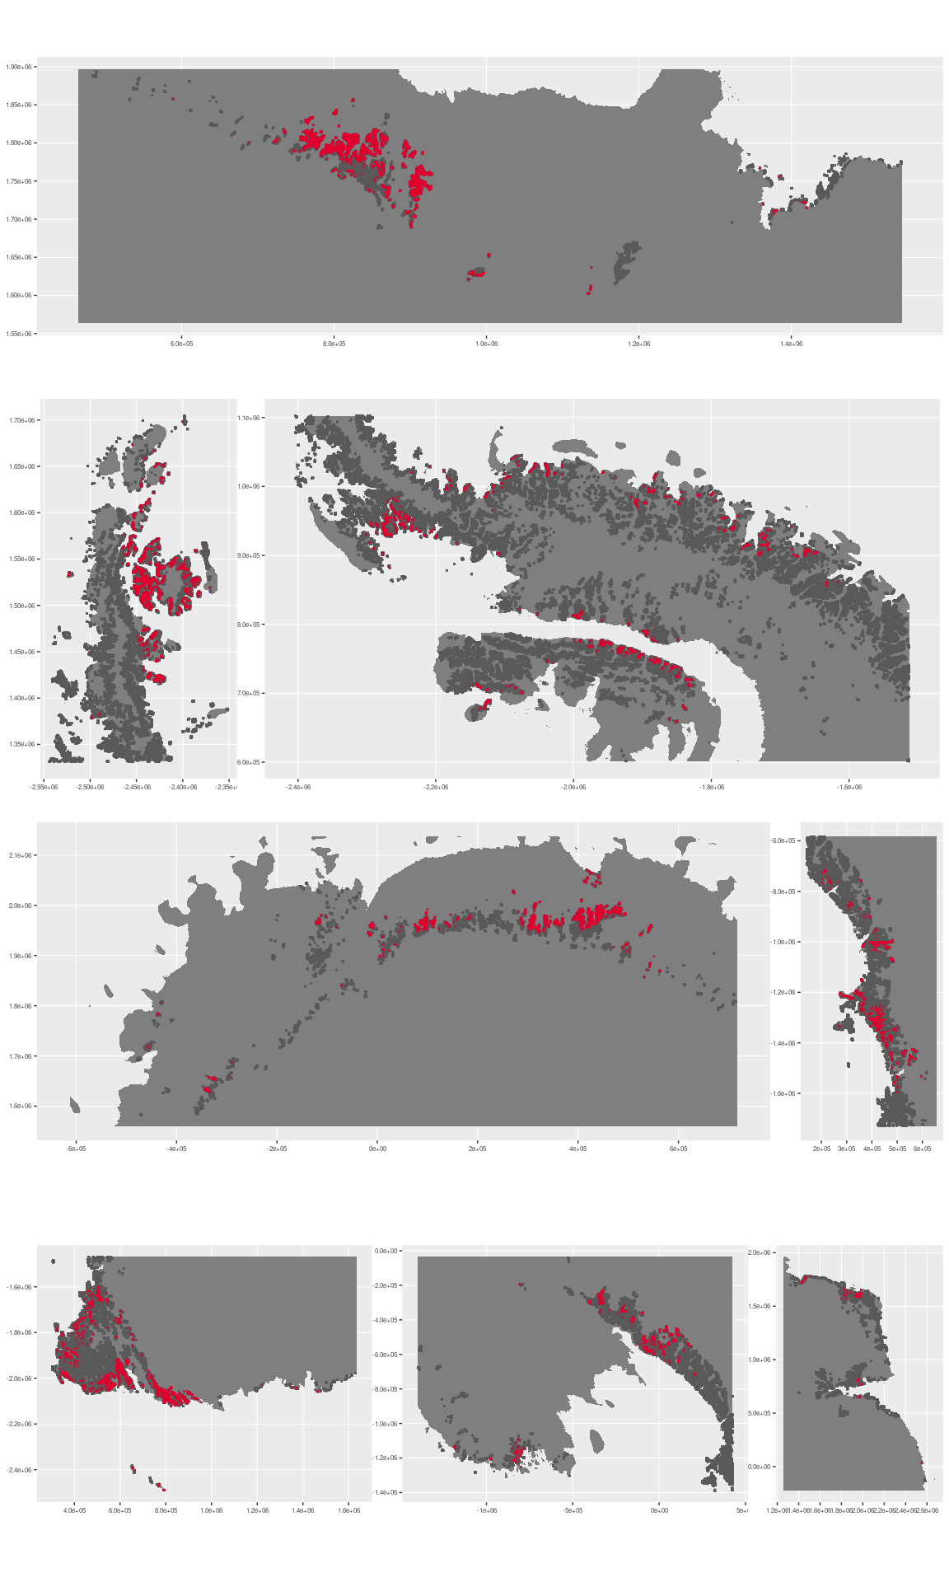

### Environment

The unit E4B1 is part of the environmental supergroup E4.

Supergroup E4 is, on average, substantially higher in no variables than continental Antarctica. It is substantially lower in DDm5 and totPrecip than the rest of the continent.

The elevation of unit E4B1 ranges from 0 to 3975 metres above sea level, but 90% of its pixels fall above 209 and below 1950 metres. Its average elevation is 1142 metres.

The unit is higher in DDm5, totPrecip and wind and lower in melt than the rest of supergroup E4.

#### Distinctiveness of the assemblage from its group and the rest of Antarctica

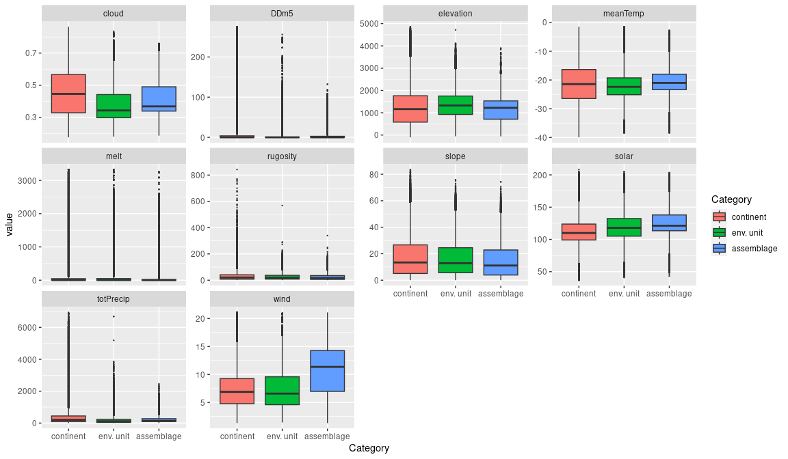

### Biota

Most widely sampled species in the unit (found in most pixels)

|  |  |  |  |  |  |
| --- | --- | --- | --- | --- | --- |
| scientific | Functional group | phylum | restricted | count | percent of samples |
| Candelariella flava | Ascomycota_Lecanoromycetes_Candelariales_Candelariaceae | Ascomycota | TRUE | 6 | 3.1579 |
| Rhizoplaca melanophthalma | Ascomycota_Lecanoromycetes_Lecanorales_Lecanoraceae | Ascomycota | FALSE | 6 | 3.1579 |
| Xanthoria elegans | Ascomycota_Lecanoromycetes_Teloschistales_Teloschistaceae | Ascomycota | FALSE | 6 | 3.1579 |
| Umbilicaria aprina | Ascomycota_Lecanoromycetes_Umbilicariales_Umbilicariaceae | Ascomycota | FALSE | 5 | 2.6316 |
| Bartramia patens | Bryophyta_Bryopsida_Bryales | Bryophyta | FALSE | 4 | 2.1053 |
| Bryum pseudotriquetrum | Bryophyta_Bryopsida_Bryales | Bryophyta | FALSE | 4 | 2.1053 |
| Physcia caesia | Ascomycota_Lecanoromycetes_Teloschistales_Physciaceae | Ascomycota | FALSE | 4 | 2.1053 |
| Pohlia cruda | Bryophyta_Bryopsida_Bryales | Bryophyta | FALSE | 4 | 2.1053 |
| Syntrichia sarconeurum | Bryophyta_Bryopsida_Pottiales | Bryophyta | FALSE | 4 | 2.1053 |
| Umbilicaria decussata | Ascomycota_Lecanoromycetes_Umbilicariales_Umbilicariaceae | Ascomycota | FALSE | 4 | 2.1053 |
| Xanthoria cf. elegans | Ascomycota_Lecanoromycetes_Teloschistales_Teloschistaceae | Ascomycota | TRUE | 4 | 2.1053 |
| Xanthoria mawsonii | Ascomycota_Lecanoromycetes_Teloschistales_Teloschistaceae | Ascomycota | TRUE | 4 | 2.1053 |

Supergroup E4 is, on average, substantially higher in suitability for no variables functional groups than continental Antarctica. It is substantially lower in suitability for no variables than the rest of the continent.

Unit E4B1 is higher in suitability for no variables and lower in suitability for no variables than the rest of supergroup E4.

#### Distinctiveness of the unit from the environmental group and the rest of Antarctica

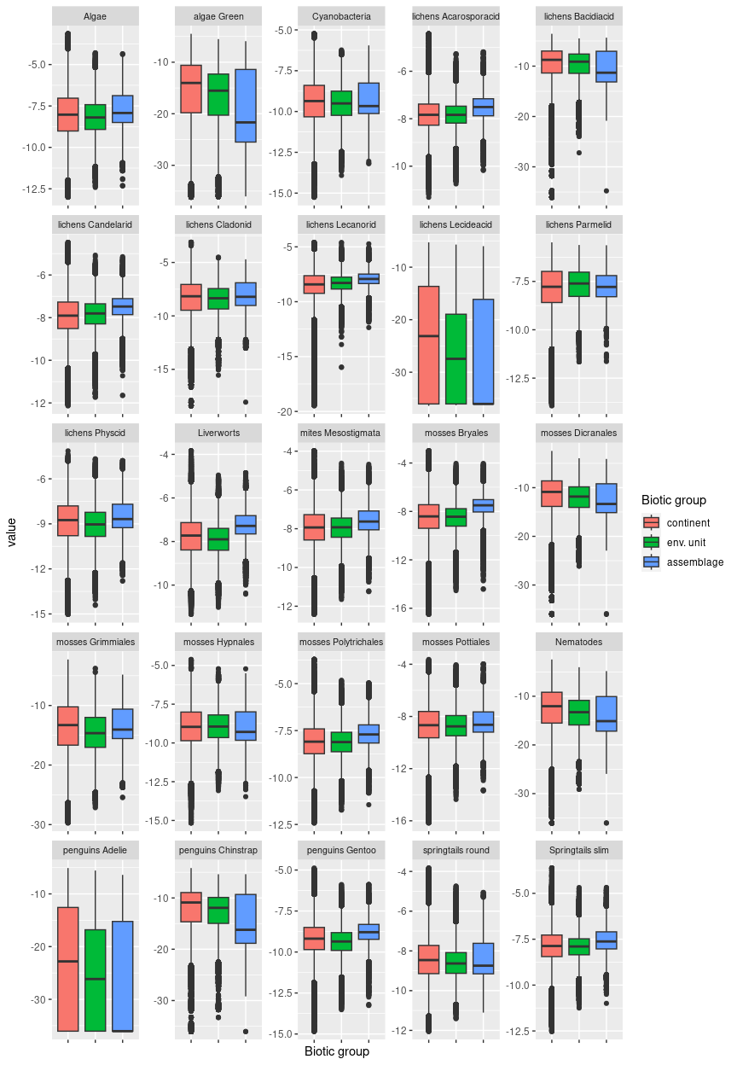

## Ecosystem E4B2

#### Sunny mesic midland hillslopes/screes

Typically exhibiting medium to steep rocky slopes that are visibly eroded by meltwater channels, this mild low-midland unit is often found in association with E1B1 on the Peninsula, with this unit facing north with meltwater channels in evidence and E1B1 facing south with thick snow cover. The wettest (high snowfall, cloud, and melt) and warmest in E4, with the highest solar radiation. Terrain is similar to E4B1 but sheltered from the prevailing wind. Sampled biota are scarce but suitability is high for Bacidiacid and Cladonid lichens, most mosses, mites, and springtails. The sampled biota appears to be dominated by mosses, likely due to water availability.

### Photos (if available)

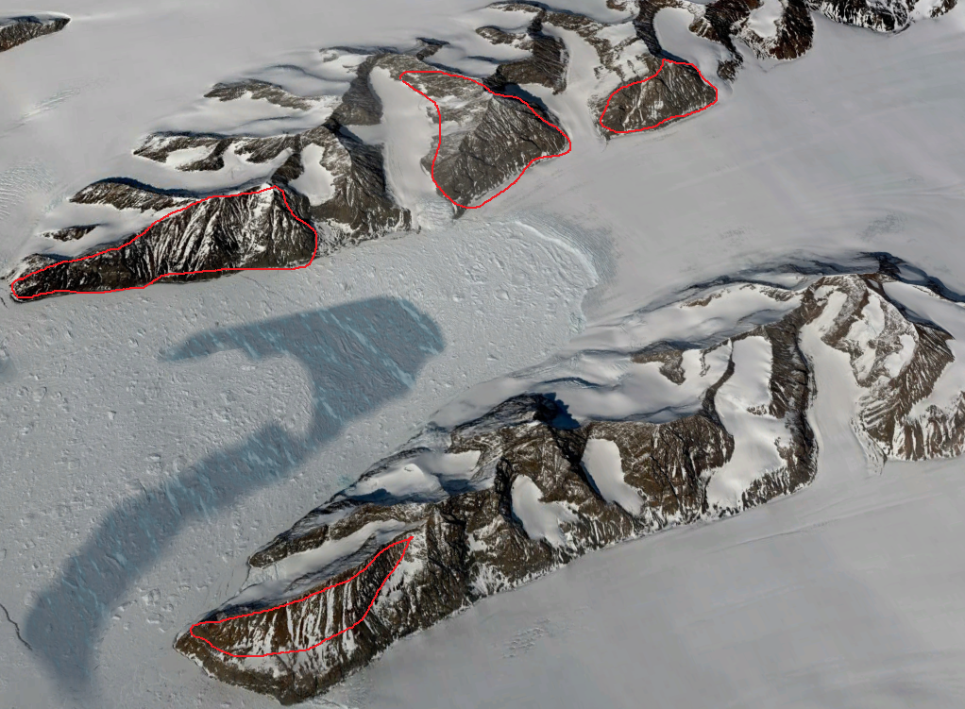

### Distribution

A relatively rare unit that is sprinkled across the Antarctic Peninsula, North Victoria Land, Dronning Maud Land and the Transantarctic Mountains.

Full map

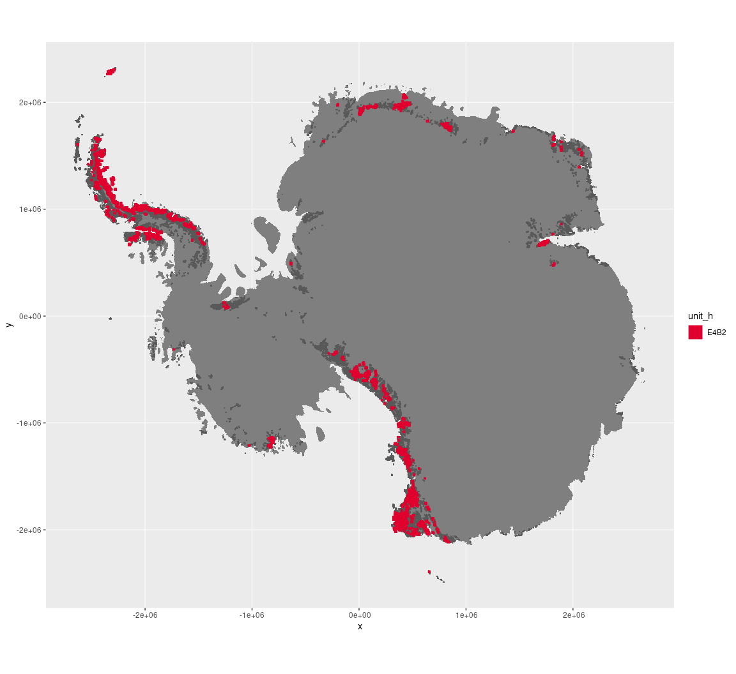

Regional maps

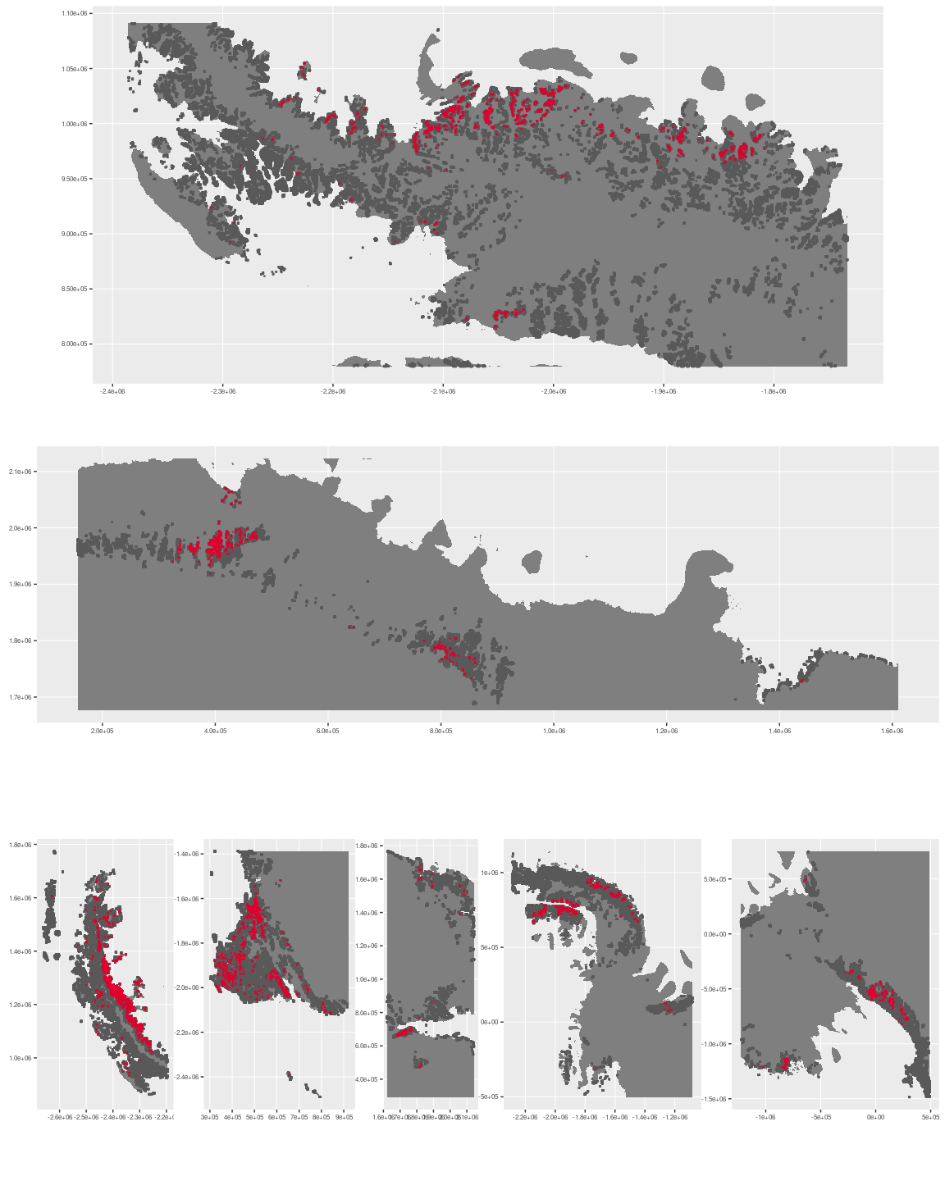



### Environment

The unit E4B2 is part of the environmental supergroup E4.

Supergroup E4 is, on average, substantially higher in no variables than continental Antarctica. It is substantially lower in DDm5, melt and totPrecip than the rest of the continent.

The elevation of unit E4B2 ranges from 0 to 4170 metres above sea level, but 90% of its pixels fall above 263 and below 2367 metres. Its average elevation is 1101 metres.

The unit is higher in cloud, DDm5, meanTemp, melt, rugosity, slope and totPrecip and lower in no variables than the rest of supergroup E4.

#### Distinctiveness of the assemblage from its group and the rest of Antarctica

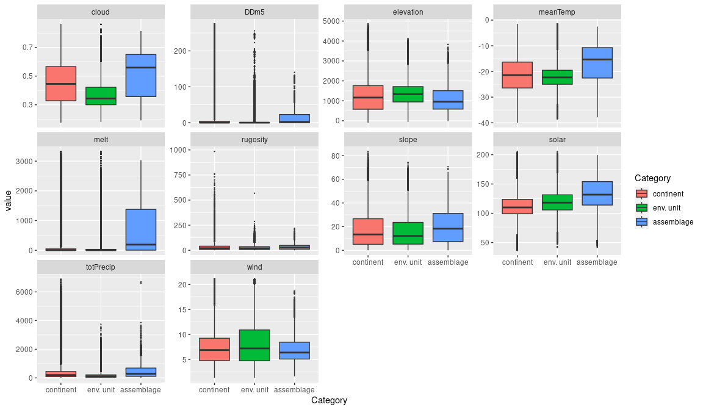

### Biota

Most widely sampled species in the unit (found in most pixels)

|  |  |  |  |  |  |
| --- | --- | --- | --- | --- | --- |
| scientific | Functional group | phylum | restricted | count | percent of samples |
| Usnea sphacelata | Ascomycota_Lecanoromycetes_Lecanorales_Parmeliaceae | Ascomycota | TRUE | 7 | 2.5180 |
| Sanionia uncinata | Bryophyta_Bryopsida_Hypnales | Bryophyta | FALSE | 6 | 2.1583 |
| Andreaea depressinervis | Bryophyta_Andreaeopsida_Andreaeales | Bryophyta | TRUE | 5 | 1.7986 |
| Pseudephebe minuscula | Ascomycota_Lecanoromycetes_Lecanorales_Parmeliaceae | Ascomycota | FALSE | 5 | 1.7986 |
| Schistidium antarctici | Bryophyta_Bryopsida_Grimmiales | Bryophyta | TRUE | 5 | 1.7986 |
| Umbilicaria decussata | Ascomycota_Lecanoromycetes_Umbilicariales_Umbilicariaceae | Ascomycota | FALSE | 5 | 1.7986 |
| Pohlia cruda | Bryophyta_Bryopsida_Bryales | Bryophyta | FALSE | 4 | 1.4388 |
| Polytrichastrum alpinum | Bryophyta_Bryopsida_Polytrichales | Bryophyta | FALSE | 4 | 1.4388 |
| Pygoscelis adeliae | Chordata_Aves_Sphenisciformes_Spheniscidae_Pygoscelis_adeliae | Chordata | FALSE | 4 | 1.4388 |
| Syntrichia princeps | Bryophyta_Bryopsida_Pottiales | Bryophyta | FALSE | 4 | 1.4388 |
| Usnea antarctica | Ascomycota_Lecanoromycetes_Lecanorales_Parmeliaceae | Ascomycota | FALSE | 4 | 1.4388 |
| Warnstorfia laculosa | Bryophyta_Bryopsida_Hypnales | Bryophyta | TRUE | 4 | 1.4388 |

Supergroup E4 is, on average, substantially higher in suitability for no variables functional groups than continental Antarctica. It is substantially lower in suitability for no variables than the rest of the continent.

Unit E4B2 is higher in suitability for algae_Green, lichens_Lecideacid, mosses_Dicranales, Nematodes, penguins_Adelie and penguins_Chinstrap and lower in suitability for no variables than the rest of supergroup E4.

#### Distinctiveness of the unit from the environmental group and the rest of Antarctica

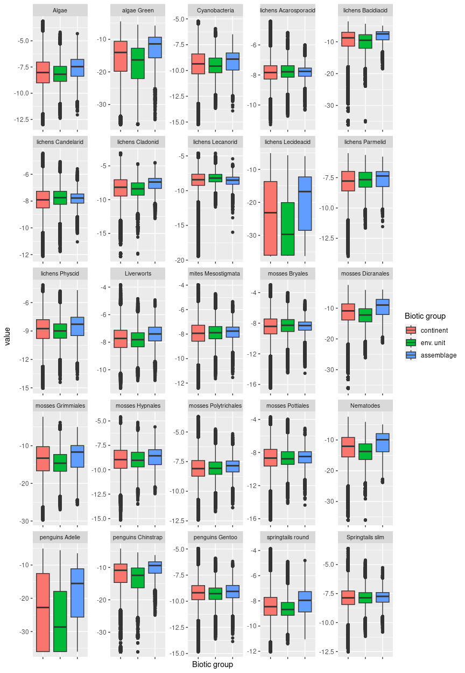

## Ecosystem E4B3

#### Freeze-Thaw slopes

Exhibiting mid- to steep-grade slopes, this unit is usually sheltered from prevailing wind. In the McMurdo dry valleys, large swathes of this unit are soil covered and exhibit glacial patterned ground (see photo) due to freeze-thaw cycles. Sampled biota are common lichens (Parmeliaceae dominant) and mosses (Bryales). Suitability is generally low for most functional groups.

### Photos (if available)

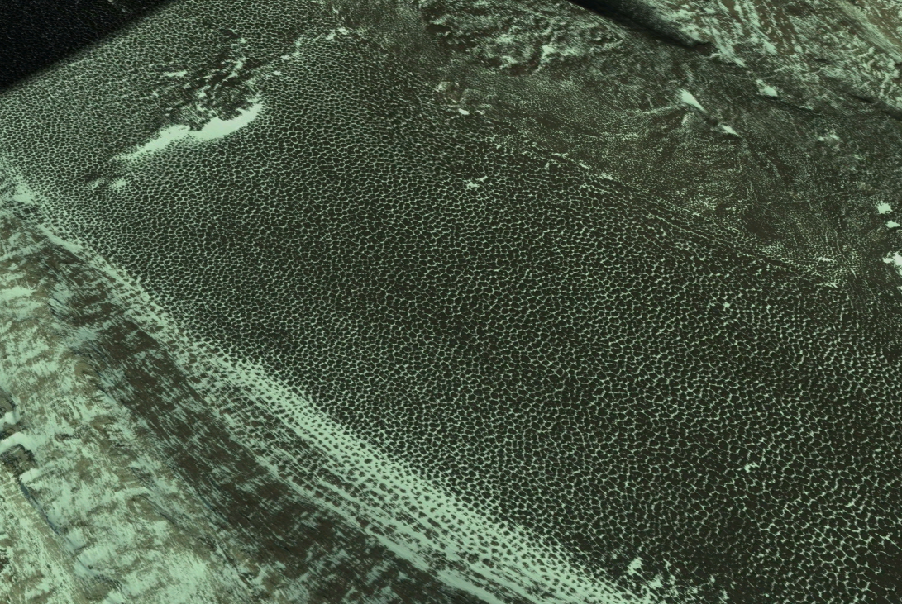

Glacial freeze-thaw patterned ground above Wright Valley in McMurdo.

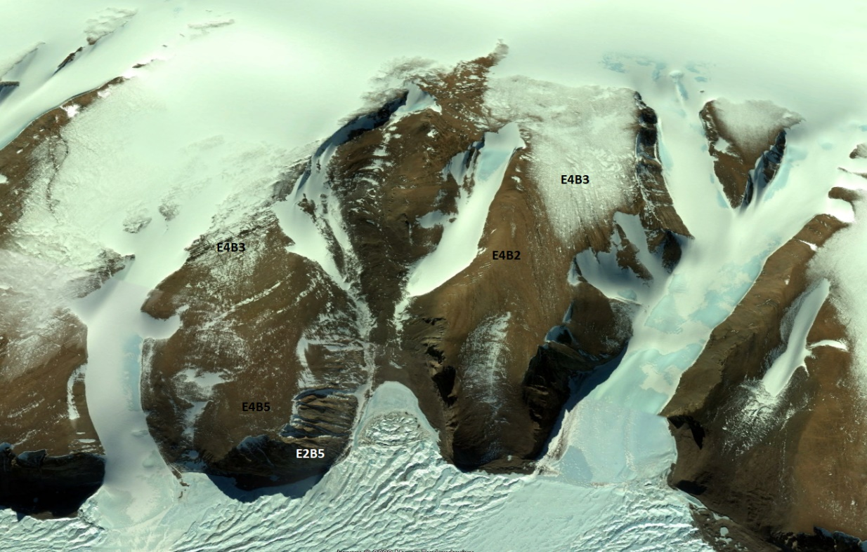

E4 Ecosystem complex in the Prince Charles Mountains

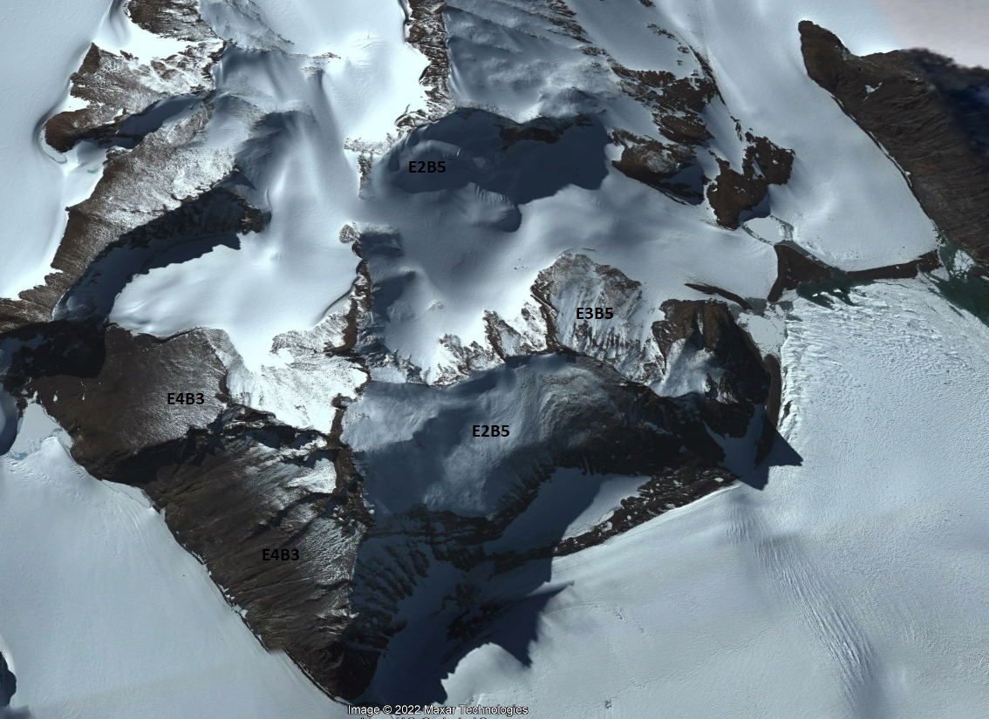

Ecosystem photo

### Distribution

Predominantly found in North and South Victoria land, with notable incidences in the Transantarctic Mountains, Prince Charles Mountains, Enderby Land (this is the most common E4 unit in Enderby Land), Dronning Maud Land, and the southern Antarctic Peninsula.

Full map

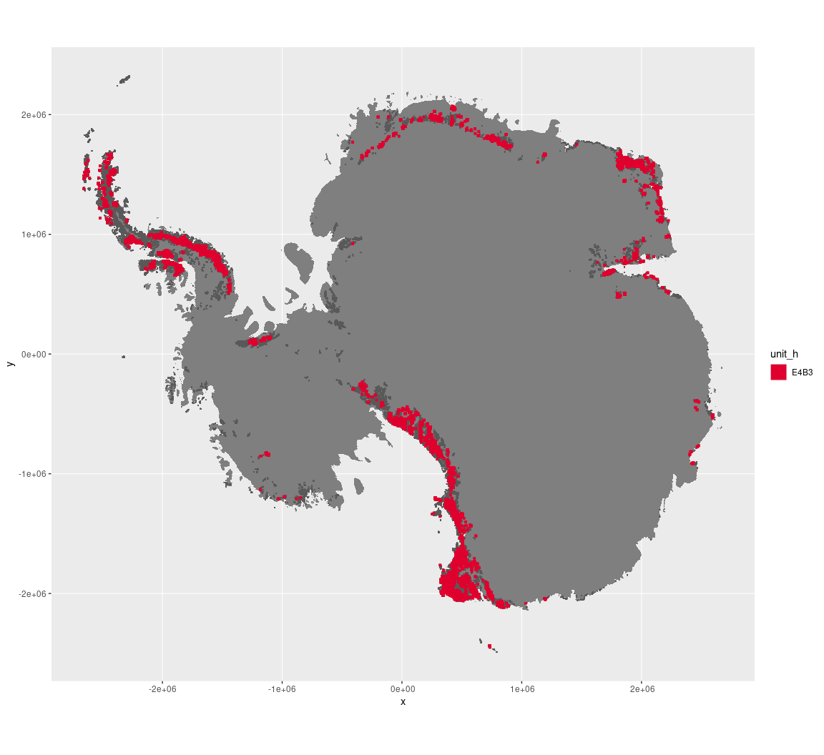

Regional maps

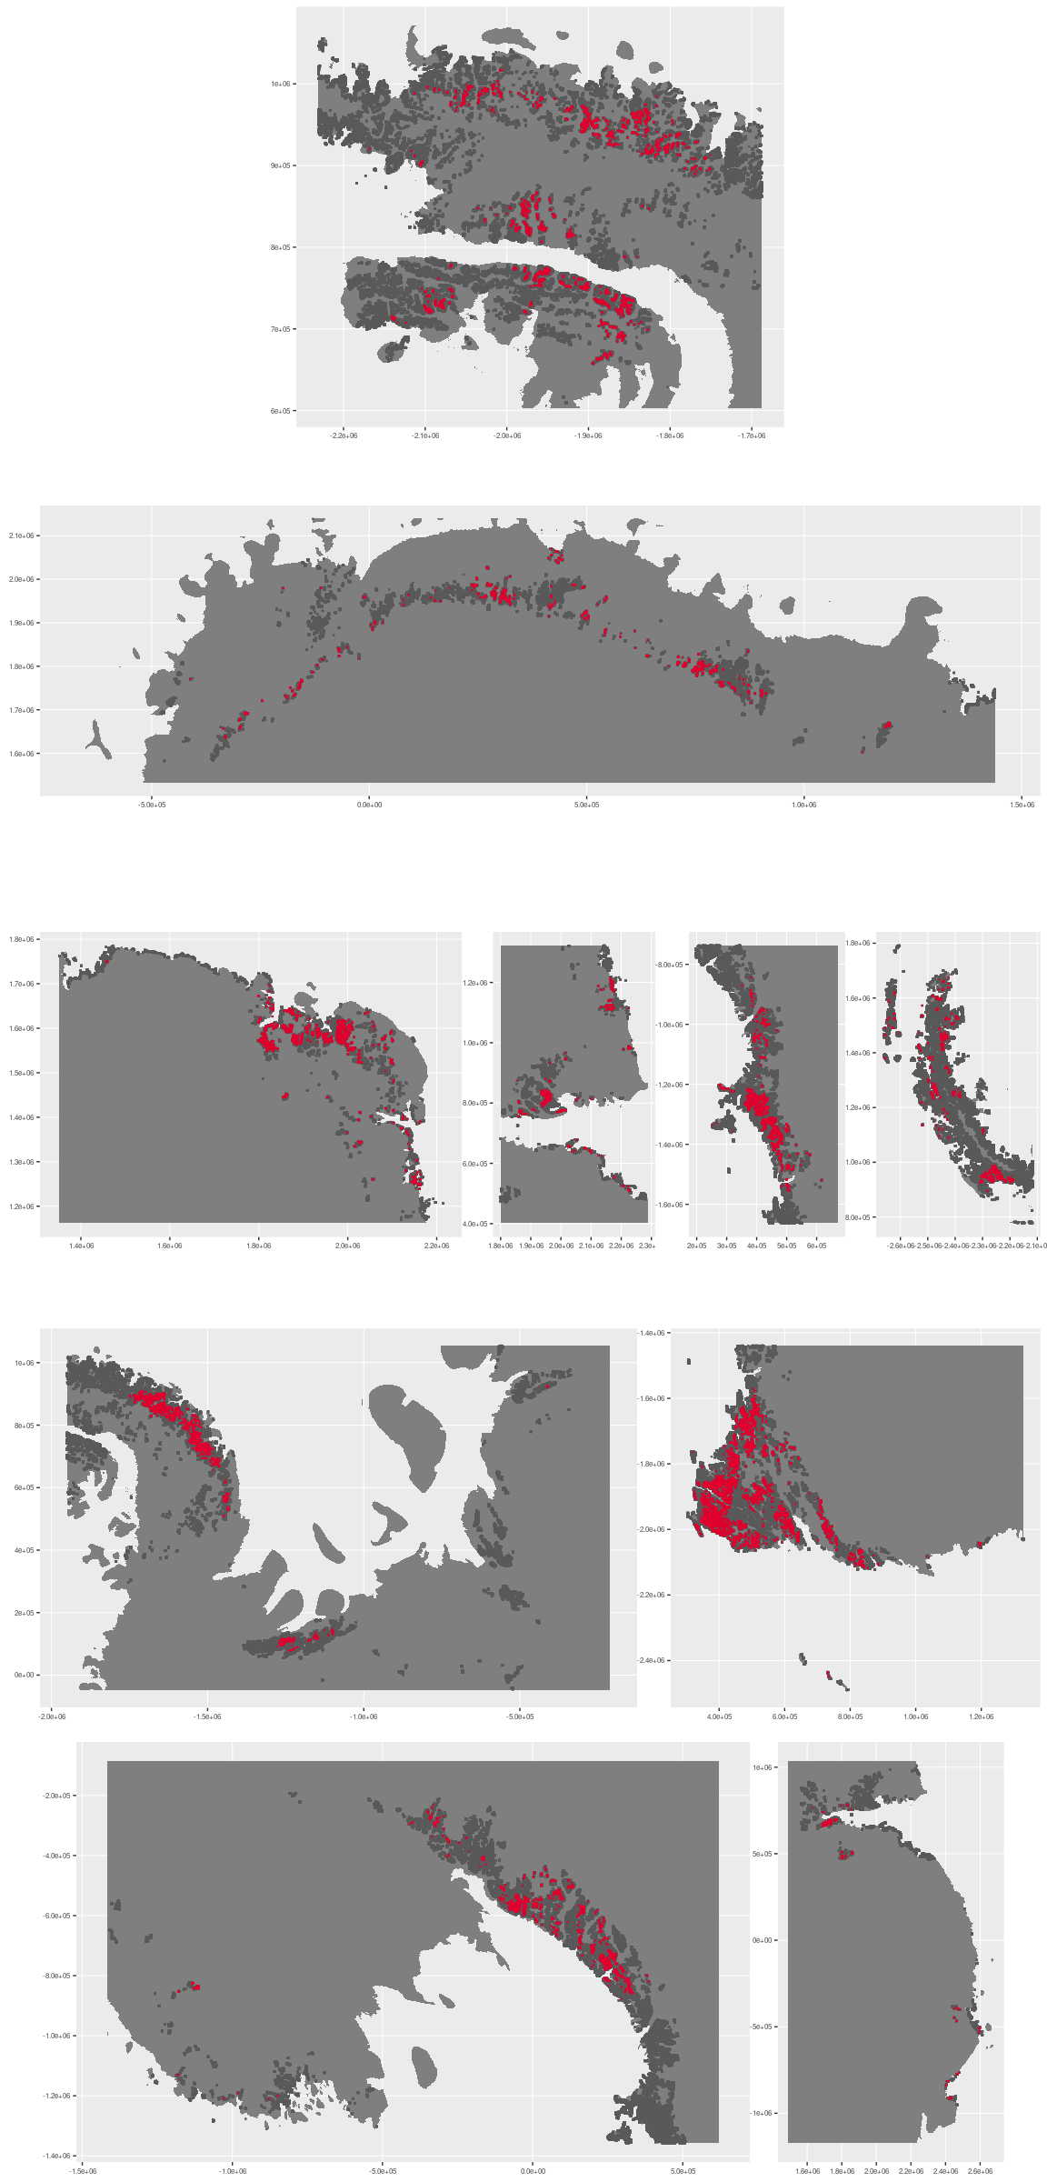



### Environment

The unit E4B3 is part of the environmental supergroup E4.

Supergroup E4 is, on average, substantially higher in no variables than continental Antarctica. It is substantially lower in DDm5 and totPrecip than the rest of the continent.

The elevation of unit E4B3 ranges from 0 to 3875 metres above sea level, but 90% of its pixels fall above 395 and below 2283 metres. Its average elevation is 1301 metres.

The unit is higher in no variables and lower in DDm5 than the rest of supergroup E4.

#### Distinctiveness of the assemblage from its group and the rest of Antarctica

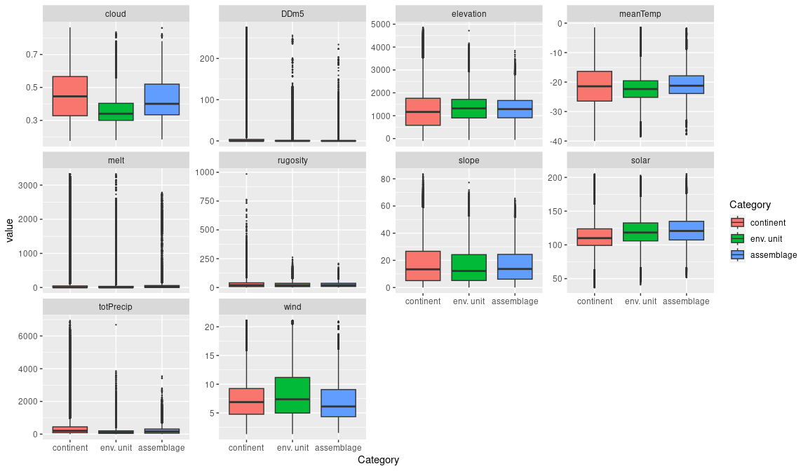

### Biota

Most widely sampled species in the unit (found in most pixels)

|  |  |  |  |  |  |
| --- | --- | --- | --- | --- | --- |
| scientific | Functional group | phylum | restricted | count | percent of samples |
| Usnea sphacelata | Ascomycota_Lecanoromycetes_Lecanorales_Parmeliaceae | Ascomycota | TRUE | 10 | 3.8462 |
| Umbilicaria decussata | Ascomycota_Lecanoromycetes_Umbilicariales_Umbilicariaceae | Ascomycota | FALSE | 9 | 3.4615 |
| Xanthoria elegans | Ascomycota_Lecanoromycetes_Teloschistales_Teloschistaceae | Ascomycota | FALSE | 9 | 3.4615 |
| Pseudephebe minuscula | Ascomycota_Lecanoromycetes_Lecanorales_Parmeliaceae | Ascomycota | FALSE | 6 | 2.3077 |
| Bryum pseudotriquetrum | Bryophyta_Bryopsida_Bryales | Bryophyta | FALSE | 5 | 1.9231 |
| Ceratodon purpureus | Bryophyta_Bryopsida_Dicranales | Bryophyta | FALSE | 5 | 1.9231 |
| Pohlia nutans | Bryophyta_Bryopsida_Bryales | Bryophyta | FALSE | 5 | 1.9231 |
| Schistidium antarctici | Bryophyta_Bryopsida_Grimmiales | Bryophyta | TRUE | 5 | 1.9231 |
| Syntrichia princeps | Bryophyta_Bryopsida_Pottiales | Bryophyta | FALSE | 5 | 1.9231 |
| Usnea antarctica | Ascomycota_Lecanoromycetes_Lecanorales_Parmeliaceae | Ascomycota | FALSE | 5 | 1.9231 |

Supergroup E4 is, on average, substantially higher in suitability for no variables functional groups than continental Antarctica. It is substantially lower in suitability for no variables than the rest of the continent.

Unit E4B3 is higher in suitability for no variables and lower in suitability for no variables than the rest of supergroup E4.

#### Distinctiveness of the unit from the environmental group and the rest of Antarctica

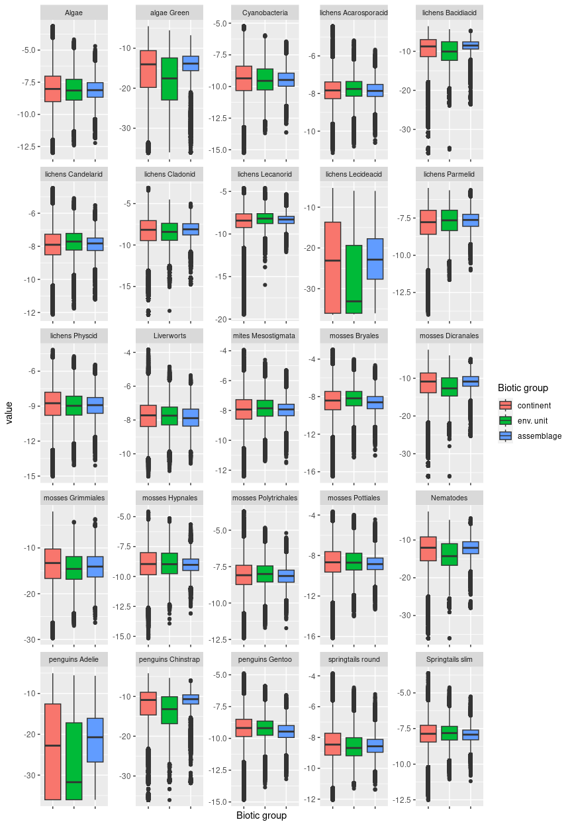

## Ecosystem E4B4

#### Sunny dry highland sheltered mountain slopes

Typically exhibiting smooth mid- to steep-grade slopes that may nonetheless hold some soil or screes, this unit has low snowfall, but also lowest solar radiation (still above average), lowest wind, lowest temperatures, and highest elevation in E4. This unit may also exhibit patterned ground due to freeze-thaw cycles. It is frequently found in association with E2B5 where topography and aspect result in varying light conditions. It is prominent on the north-facing mountainsides above the McMurdo dry valleys. Sampled biota are mainly lichens. Suitability generally average or low for all functional groups.

### Photos (if available)

### Distribution

Predominantly found in North and South Victoria Land, with notable incidences in the Transantarctic Mountains and the northern Antarctic Peninsula.

Full map

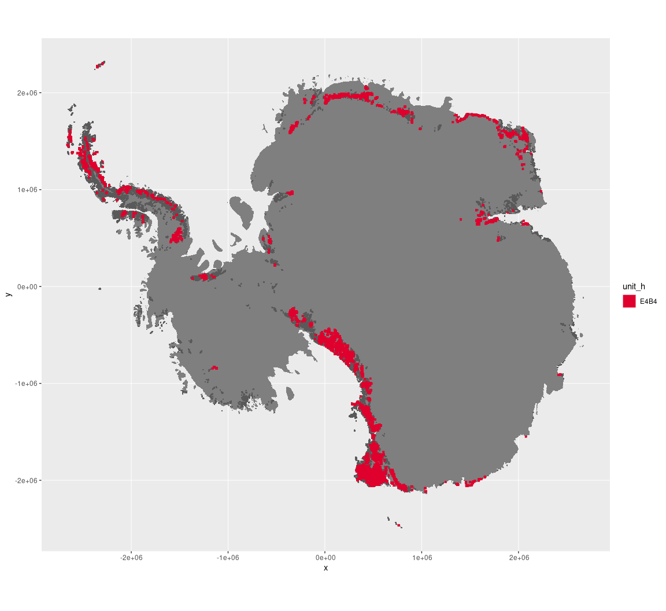

Regional maps

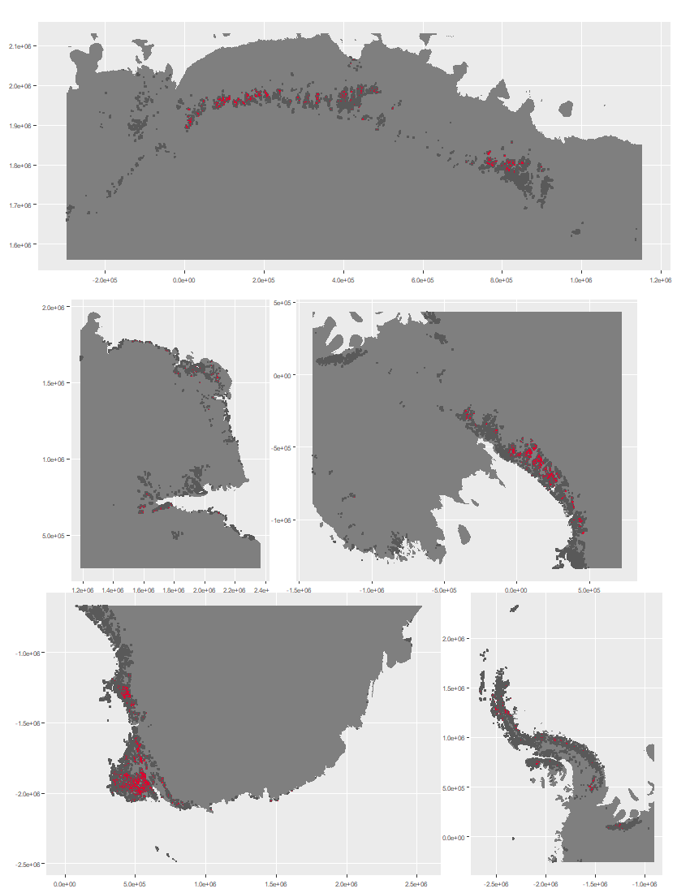

### Environment

The unit E4B4 is part of the environmental supergroup E4.

Supergroup E4 is, on average, substantially higher in no variables than continental Antarctica. It is substantially lower in DDm5 and totPrecip than the rest of the continent.

The elevation of unit E4B4 ranges from 0 to 4718 metres above sea level, but 90% of its pixels fall above 646 and below 2433 metres. Its average elevation is 1574 metres.

The unit is higher in no variables and lower in DDm5, melt and wind than the rest of supergroup E4.

#### Distinctiveness of the assemblage from its group and the rest of Antarctica

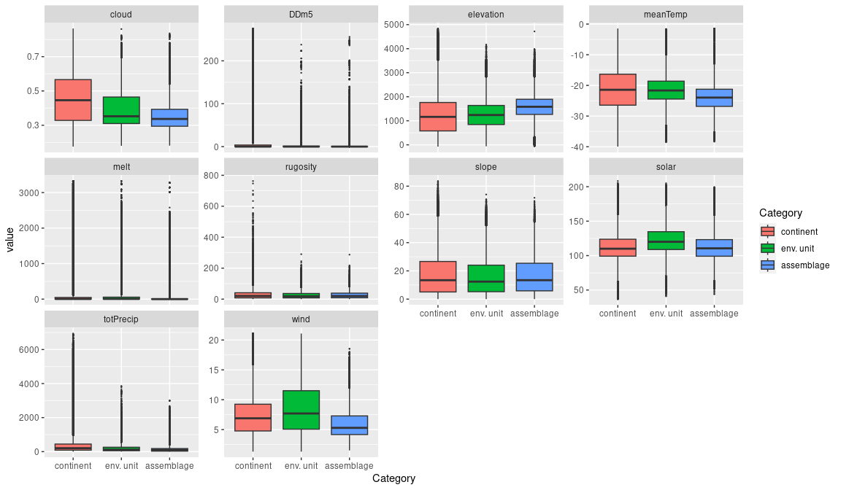

### Biota

Most widely sampled species in the unit (found in most pixels)

|  |  |  |  |  |  |
| --- | --- | --- | --- | --- | --- |
| scientific | Functional group | phylum | restricted | count | percent of samples |
| Lecidea cancriformis | Ascomycota_Lecanoromycetes_Lecanorales_Lecideaceae | Ascomycota | TRUE | 6 | 2.6201 |
| Buellia pallida | Ascomycota_Lecanoromycetes_Teloschistales_Physciaceae | Ascomycota | TRUE | 5 | 2.1834 |
| Bryum pseudotriquetrum | Bryophyta_Bryopsida_Bryales | Bryophyta | FALSE | 4 | 1.7467 |
| Pseudephebe minuscula | Ascomycota_Lecanoromycetes_Lecanorales_Parmeliaceae | Ascomycota | FALSE | 4 | 1.7467 |
| Buellia grisea | Ascomycota_Lecanoromycetes_Teloschistales_Physciaceae | Ascomycota | FALSE | 3 | 1.3100 |
| Carbonea vorticosa | Ascomycota_Lecanoromycetes_Lecanorales_Lecanoraceae | Ascomycota | FALSE | 3 | 1.3100 |
| Ceratodon purpureus | Bryophyta_Bryopsida_Dicranales | Bryophyta | FALSE | 3 | 1.3100 |
| Pohlia nutans | Bryophyta_Bryopsida_Bryales | Bryophyta | FALSE | 3 | 1.3100 |
| Usnea sphacelata | Ascomycota_Lecanoromycetes_Lecanorales_Parmeliaceae | Ascomycota | TRUE | 3 | 1.3100 |
| Xanthoria elegans | Ascomycota_Lecanoromycetes_Teloschistales_Teloschistaceae | Ascomycota | FALSE | 3 | 1.3100 |

Supergroup E4 is, on average, substantially higher in suitability for no variables functional groups than continental Antarctica. It is substantially lower in suitability for no variables than the rest of the continent.

Unit E4B4 is higher in suitability for no variables and lower in suitability for no variables than the rest of supergroup E4.

#### Distinctiveness of the unit from the environmental group and the rest of Antarctica

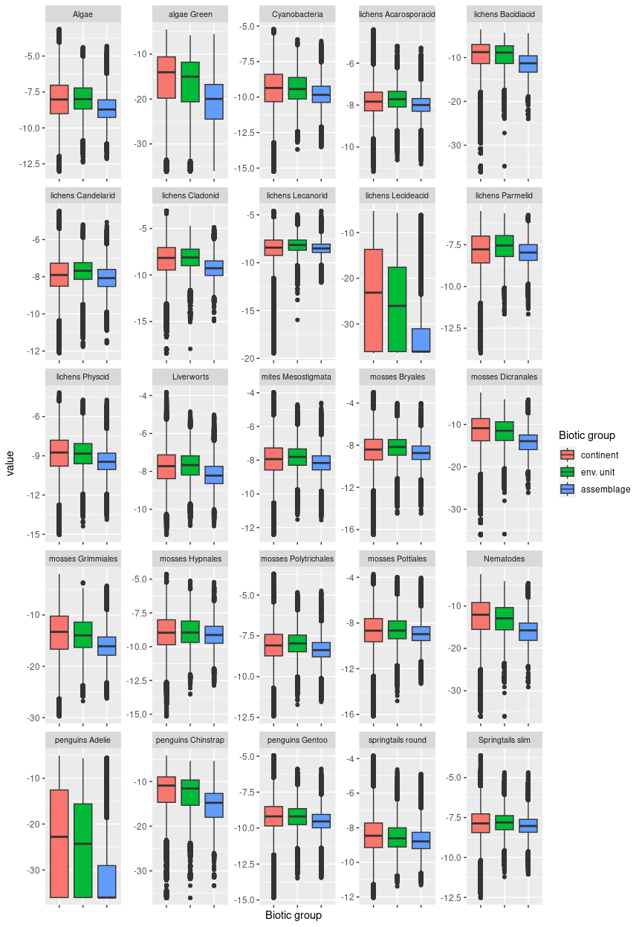

## Ecosystem E4B5

#### Sunny mid-highland arid exposed nunatak faces and mountain slopes

Typically exhibiting mid- to steep-grade slopes, this unit is otherwise similar in terrain to E4B3 (e.g. smoother surfaces with little evidence of meltwater erosion). It is often found in complexes with other E4 units. This unit is the least cloudy and driest unit in E4 and has the gentlest relief along with E4B1. Scarce samples are dominated by Arthropods (mites, springtails) and Nematodes, but also contain common lichens.

### Photos (if available)

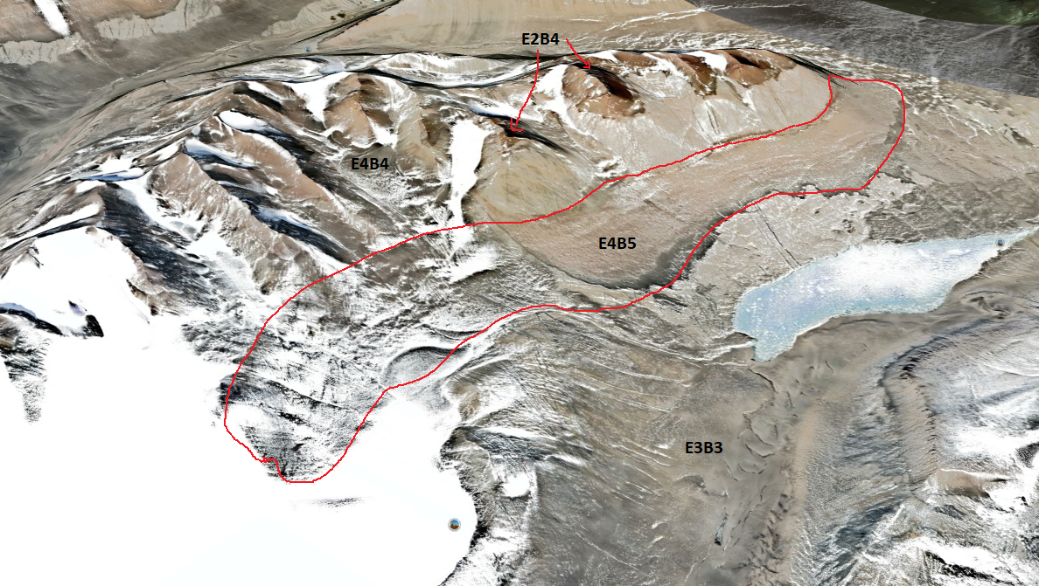

*Ecosystem complex with E4B5 above Lake Vida, McMurdo Dry Valleys.*

### Distribution

Occurrences concentrated in the Prince Charles Mountains (this is the most common E4 unit in the PCM), Dronning Maud Land, and Victoria Land.

Full map

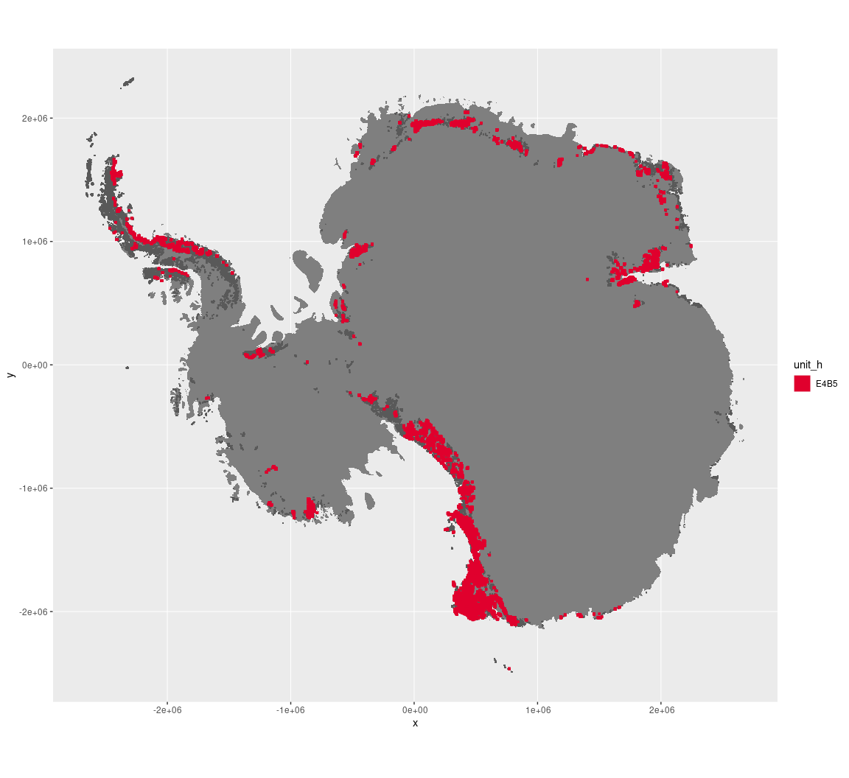

Regional maps

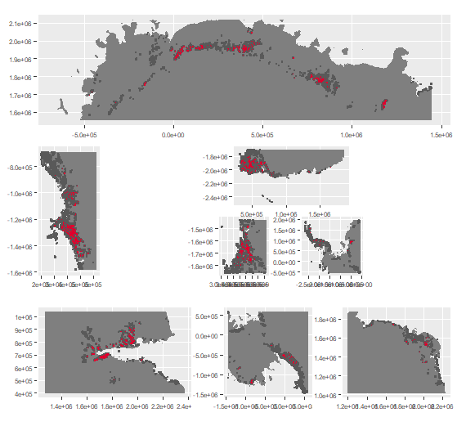





### Environment

The unit E4B5 is part of the environmental supergroup E4.

Supergroup E4 is, on average, substantially higher in melt than continental Antarctica. It is substantially lower in totPrecip than the rest of the continent.

The elevation of unit E4B5 ranges from 0 to 4159 metres above sea level, but 90% of its pixels fall above 483 and below 2432 metres. Its average elevation is 1348 metres.

The unit is higher in no variables and lower in DDm5, melt and totPrecip than the rest of supergroup E4.

#### Distinctiveness of the assemblage from its group and the rest of Antarctica

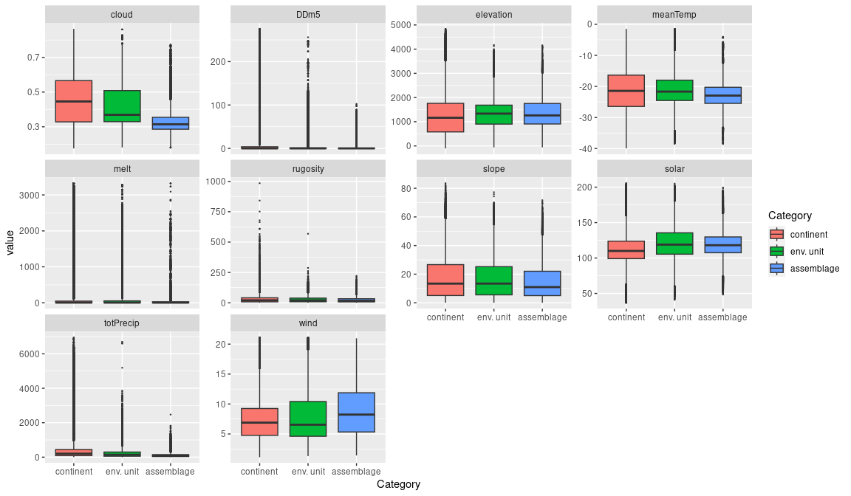

### Biota

Most widely sampled species in the unit (found in most pixels)

|  |  |  |  |  |  |  |
| --- | --- | --- | --- | --- | --- | --- |
| scientific | Functional group | phylum | restricted |  | count | percent of samples |
| Gomphiocephalus hodgsoni | Arthropoda_Entognatha_Poduromorpha | Arthropoda | TRUE |  | 12 | 13.6364 |
| Stereotydeus mollis | Arthropoda_Arachnida_Trombidiformes | Arthropoda | TRUE |  | 9 | 10.2273 |
| Scottnema lindsayae | Nematoda | Nematoda | TRUE |  | 4 | 4.5455 |
| Usnea sphacelata | Ascomycota_Lecanoromycetes_Lecanorales_Parmeliaceae | Ascomycota | TRUE |  | 4 | 4.5455 |
| Xanthoria elegans | Ascomycota_Lecanoromycetes_Teloschistales_Teloschistaceae | Ascomycota | FALSE |  | 3 | 3.4091 |
| Cryptopygus sverdrupi | Arthropoda_Entognatha_Entomobryomorpha | Arthropoda | TRUE |  | 2 | 2.2727 |
| Eudorylaimus antarcticus | Nematoda | Nematoda | TRUE |  | 2 | 2.2727 |
| Geomonhystera antarcticola | Nematoda | Nematoda | TRUE |  | 2 | 2.2727 |
| Kuttlingeria rutilans | Ascomycota_Unknown_Unknown_Unknown | Ascomycota | TRUE |  | 2 | 2.2727 |
| Lecidea cancriformis | Ascomycota_Lecanoromycetes_Lecanorales_Lecideaceae | Ascomycota | TRUE |  | 2 | 2.2727 |
| Nanorchestes antarcticus | Arthropoda_Arachnida_Sarcoptiformes | Arthropoda | TRUE |  | 2 | 2.2727 |
| Neocryptopygus nivicolus | Arthropoda_Entognatha_Entomobryomorpha | Arthropoda | TRUE |  | 2 | 2.2727 |
| Pleopsidium chlorophanum | Ascomycota_Lecanoromycetes_Acarosporales_Acarosporaceae | Ascomycota | FALSE |  | 2 | 2.2727 |
| Pseudephebe minuscula | Ascomycota_Lecanoromycetes_Lecanorales_Parmeliaceae | Ascomycota | FALSE |  | 2 | 2.2727 |
| Usnea antarctica | Ascomycota_Lecanoromycetes_Lecanorales_Parmeliaceae | Ascomycota | FALSE |  | 2 | 2.2727 |

Supergroup E4 is, on average, substantially higher in suitability for no variables functional groups than continental Antarctica. It is substantially lower in suitability for no variables than the rest of the continent.

Unit E4B5 is higher in suitability for no variables and lower in suitability for no variables than the rest of supergroup E4.

#### Distinctiveness of the unit from the environmental group and the rest of Antarctica

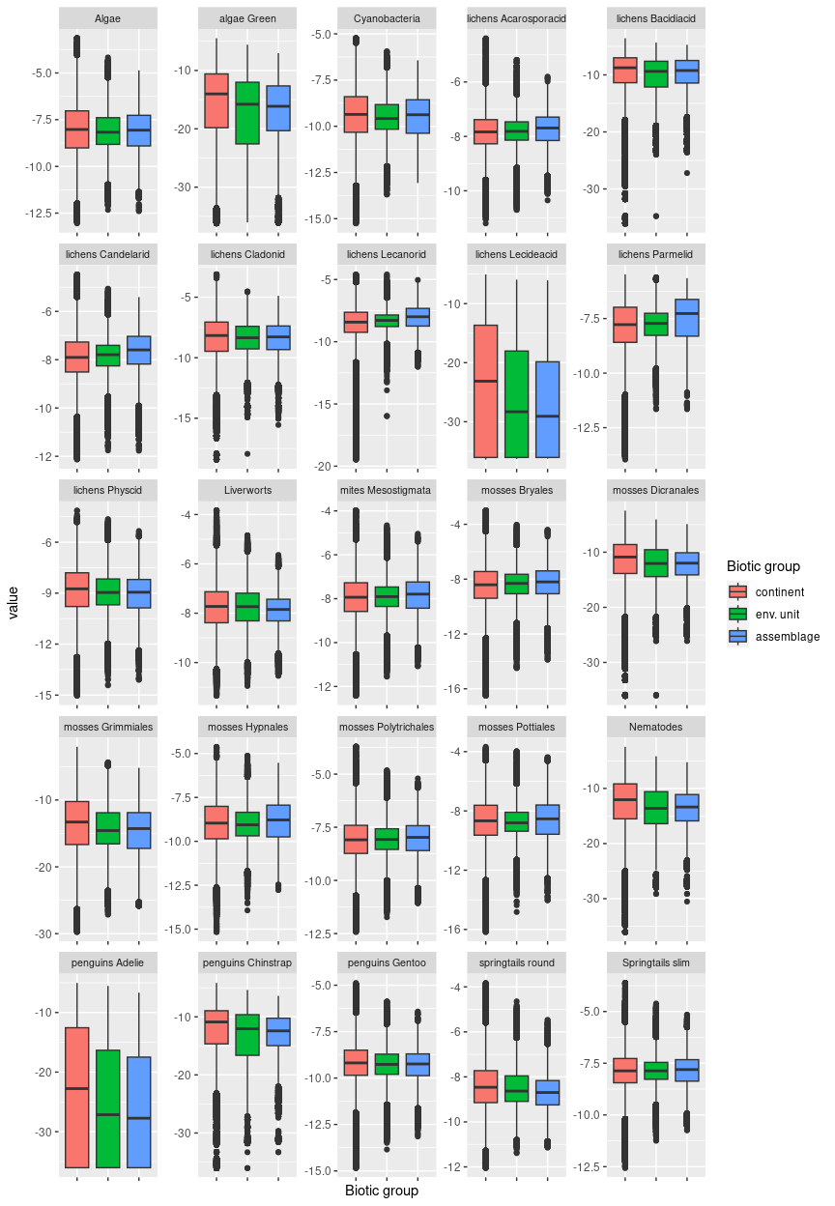

## Ecosystem E5B1

#### Windy high plains/flatlands

### This dry unit generally occurs around the low-relief fringes of rugged nunataks, or as isolated rock outcrops rising slightly above the ice sheet. Often unprotected by terrain features, this unit is barren and the windiest unit in the typology. It often occurs in association with E5B4. Sampled biota are dominated by seabirds that nest many km inland, notably several species of petrels. Several species of Rotifers, Nematodes, Tardigrades, Chlorophytes, Ochrophytes, and Cyanobacteria have been collected as singletons.

### Photos (if available)

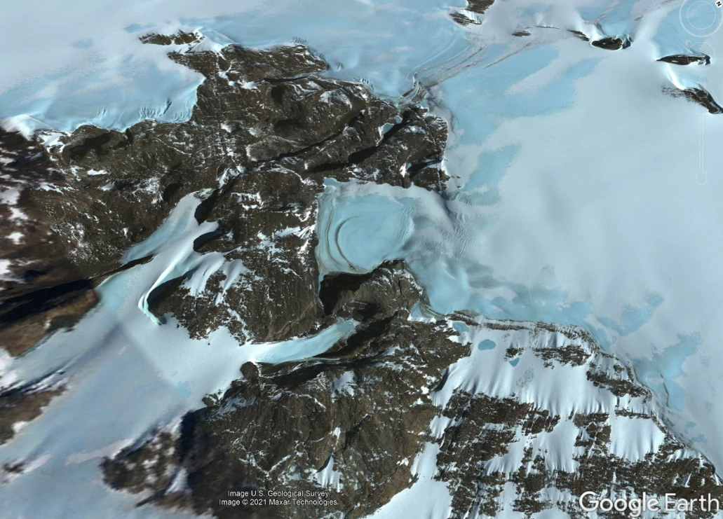

Ecosystem photo

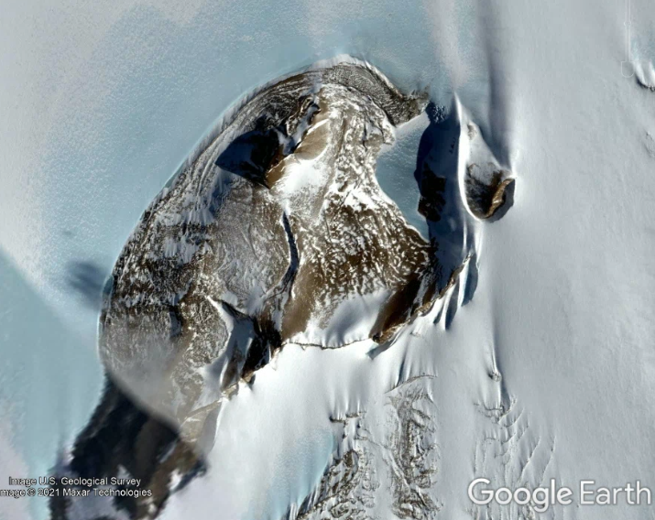

### Distribution

Relatively uncommon assemblage that occurs across the Transantarctic Mountains, Ellsworth Mountains, Dronning Maud Land, and the Prince Charles Mountains. Occurrences in other bioregions amount to less than 50 km2 per region.

Full map

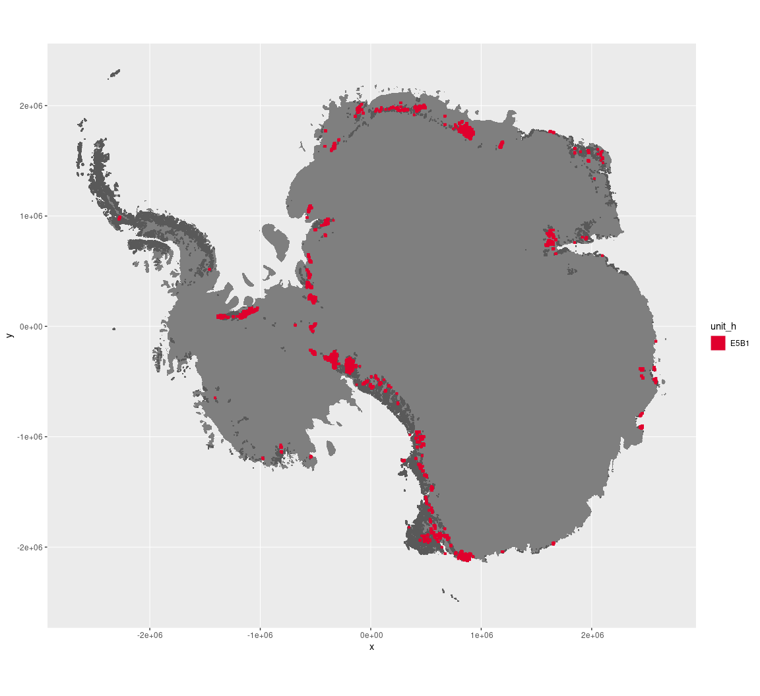

Regional maps

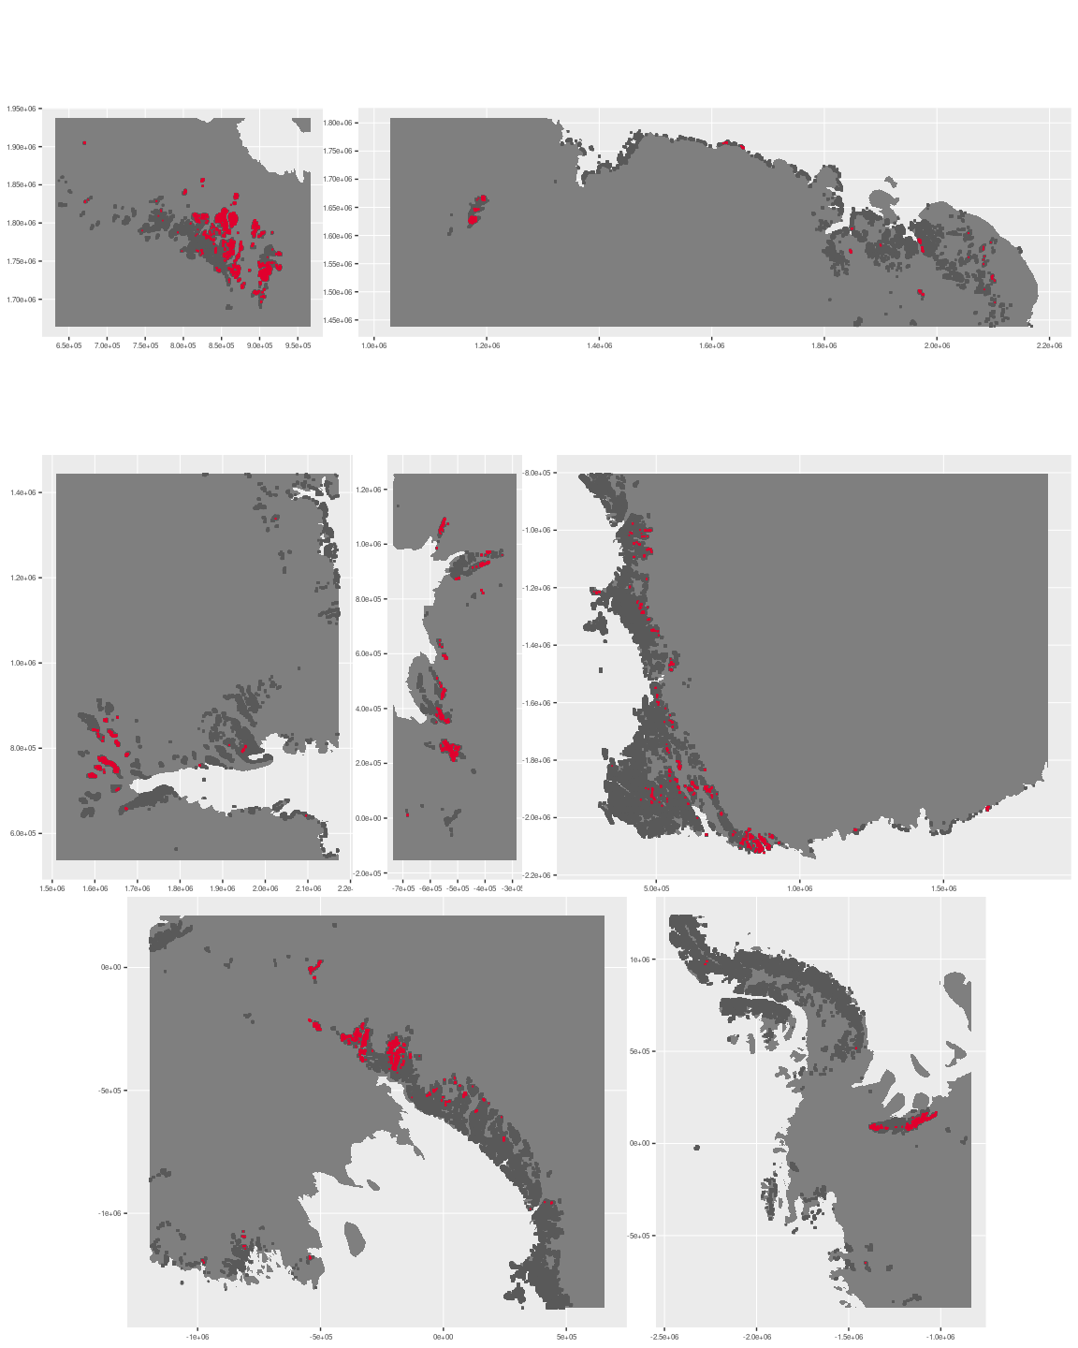

### Environment

The unit E5B1 is part of the environmental supergroup E5.

Supergroup E5 is, on average, substantially higher in elevation and wind than continental Antarctica. It is substantially lower in cloud, DDm5, meanTemp, melt, rugosity, slope and totPrecip than the rest of the continent.

The elevation of unit E5B1 ranges from 0 to 3640 metres above sea level, but 90% of its pixels fall above 620 and below 2036 metres. Its average elevation is 1337 metres.

The unit is higher in DDm5 and lower in melt than the rest of supergroup E5.

#### Distinctiveness of the assemblage from its group and the rest of Antarctica

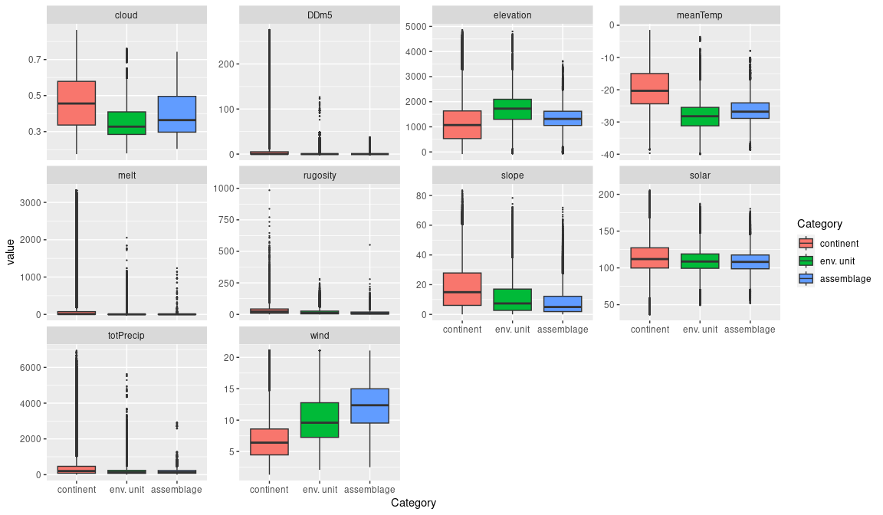

### Biota

Most widely sampled species in the unit (found in most pixels)

|  |  |  |  |  |  |
| --- | --- | --- | --- | --- | --- |
| scientific | Functional group | phylum | restricted | count | percent of samples |
| Daption capense | Chordata_Aves_Procellariiformes | Chordata | FALSE | 5 | 9.2593 |
| Pygoscelis adeliae | Chordata_Aves_Sphenisciformes_Spheniscidae_Pygoscelis_adeliae | Chordata | FALSE | 5 | 9.2593 |
| Pagodroma nivea | Chordata_Aves_Procellariiformes | Chordata | FALSE | 4 | 7.4074 |
| Aptenodytes forsteri | Chordata_Aves_Sphenisciformes_Spheniscidae_Aptenodytes_forsteri | Chordata | FALSE | 2 | 3.7037 |
| Macronectes giganteus | Chordata_Aves_Procellariiformes | Chordata | FALSE | 2 | 3.7037 |
| Oceanites oceanicus | Chordata_Aves_Procellariiformes | Chordata | TRUE | 2 | 3.7037 |
| Acarospora gwynnii | Ascomycota_Lecanoromycetes_Acarosporales_Acarosporaceae | Ascomycota | TRUE | 1 | 1.8519 |
| Adineta barbata | Rotifera | Rotifera | FALSE | 1 | 1.8519 |
| Adineta steineri | Rotifera | Rotifera | TRUE | 1 | 1.8519 |
| Adineta vaga | Rotifera | Rotifera | FALSE | 1 | 1.8519 |
| Aphelenchoides sp. | Nematoda | Nematoda | TRUE | 1 | 1.8519 |
| Candelariella hallettensis | Ascomycota_Lecanoromycetes_Candelariales_Candelariaceae | Ascomycota | TRUE | 1 | 1.8519 |
| Chlamydomonas sp. | Chlorophyta | Chlorophyta | TRUE | 1 | 1.8519 |
| Chlorococcum sp. | Chlorophyta | Chlorophyta | TRUE | 1 | 1.8519 |
| Diphascon chilenense langhovdensis | Tardigrada | Tardigrada | TRUE | 1 | 1.8519 |
| Diphascon schusteri | Tardigrada | Tardigrada | TRUE | 1 | 1.8519 |
| Fulmarus glacialoides | Chordata_Aves_Procellariiformes | Chordata | FALSE | 1 | 1.8519 |
| Gloeocapsa sp. | Cyanobacteria | Cyanobacteria | TRUE | 1 | 1.8519 |
| Habrotrocha constricta | Rotifera | Rotifera | TRUE | 1 | 1.8519 |
| Luticola muticopsis | Ochrophyta | Ochrophyta | FALSE | 1 | 1.8519 |
| Luticola sp. | Ochrophyta | Ochrophyta | TRUE | 1 | 1.8519 |
| Macrobiotus ?fuciger | Tardigrada | Tardigrada | TRUE | 1 | 1.8519 |
| Macrobiotus blocki | Tardigrada | Tardigrada | TRUE | 1 | 1.8519 |
| Macrobiotus furciger | Tardigrada | Tardigrada | FALSE | 1 | 1.8519 |
| Macrobiotus sp. | Tardigrada | Tardigrada | TRUE | 1 | 1.8519 |
| Macrotrachela nixa | Rotifera | Rotifera | TRUE | 1 | 1.8519 |
| Mniobia sp. | Rotifera | Rotifera | TRUE | 1 | 1.8519 |
| Monhystera sp. | Nematoda | Nematoda | TRUE | 1 | 1.8519 |
| Panagrolaimus sp. | Nematoda | Nematoda | TRUE | 1 | 1.8519 |
| Phormidium autumnale | Cyanobacteria | Cyanobacteria | TRUE | 1 | 1.8519 |
| Plectus sp. | Nematoda | Nematoda | TRUE | 1 | 1.8519 |
| Prasiola crispa | Chlorophyta | Chlorophyta | FALSE | 1 | 1.8519 |
| Pseudephebe minuscula | Ascomycota_Lecanoromycetes_Lecanorales_Parmeliaceae | Ascomycota | FALSE | 1 | 1.8519 |
| Stercorarius maccormicki | Chordata_Aves_Charadriiformes | Chordata | FALSE | 1 | 1.8519 |
| Stichococcus bacillaris | Chlorophyta | Chlorophyta | FALSE | 1 | 1.8519 |
| Teratocephalus sp. | Nematoda | Nematoda | TRUE | 1 | 1.8519 |
| Tetracystis cf. fissurata | Chlorophyta | Chlorophyta | TRUE | 1 | 1.8519 |
| Tetramelas papillatus | Ascomycota_Lecanoromycetes_Teloschistales_Physciaceae | Ascomycota | FALSE | 1 | 1.8519 |
| Thalassoica antarctica | Chordata_Aves_Procellariiformes | Chordata | FALSE | 1 | 1.8519 |
| Umbilicaria decussata | Ascomycota_Lecanoromycetes_Umbilicariales_Umbilicariaceae | Ascomycota | FALSE | 1 | 1.8519 |

Supergroup E5 is, on average, substantially higher in suitability for no variables functional groups than continental Antarctica. It is substantially lower in suitability for algae_Green, lichens_Bacidiacid, lichens_Lecideacid, mosses_Dicranales, Nematodes, penguins_Adelie and penguins_Chinstrap than the rest of the continent.

Unit E5B1 is higher in suitability for no variables and lower in suitability for no variables than the rest of supergroup E5.

#### Distinctiveness of the unit from the environmental group and the rest of Antarctica

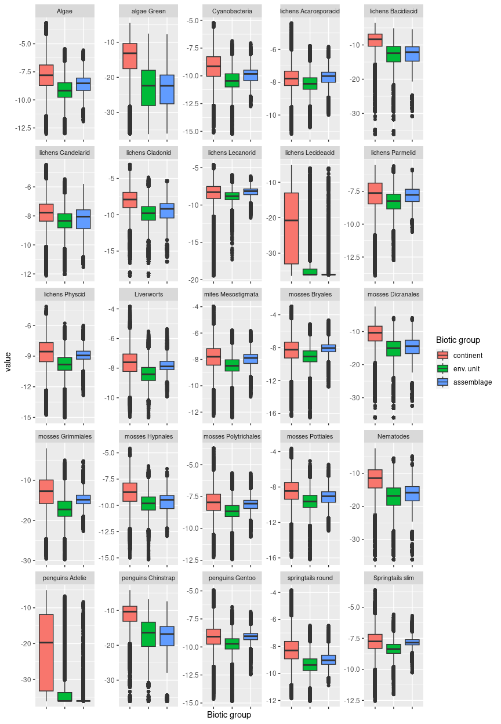

## Ecosystem E5B2

#### Windy clear remote plateaus and nunatak fringes

### This unit is situated on an uncommon juxtaposition of abiotic conditions, where gentle highland terrain encounters modest water availability. Snowfall and cloud cover is relatively high compared to the group despite remoteness from coast, which may improve suitability for some species by increasing water availability. Primarily associated with windy, flat to rolling dry terrain at high elevations removed from maritime influence, and may be sloping gently. Scarce samples are dominated by diatoms, though this may be a function of sampling patchiness. Suitability in this unit is generally low for all taxa.

### Photos (if available)

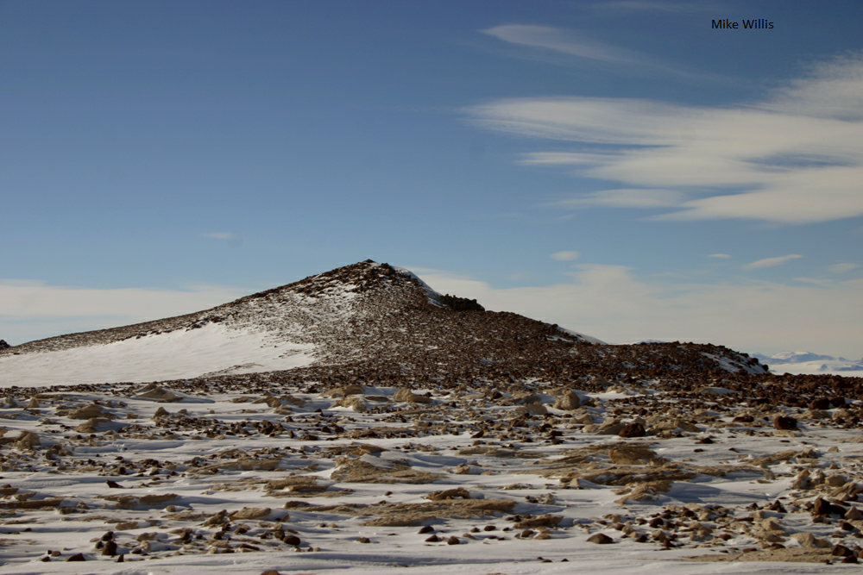

Ecosystem photo

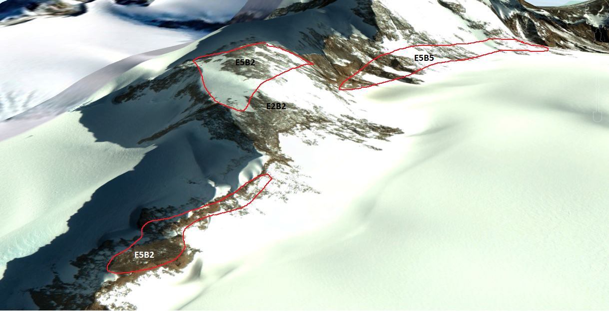

### Distribution

Rare unit that occurs in the Ellsworth Mountains, Dronning Maud Land, Enderby Land, and the Transantarctic Mountains

Full map

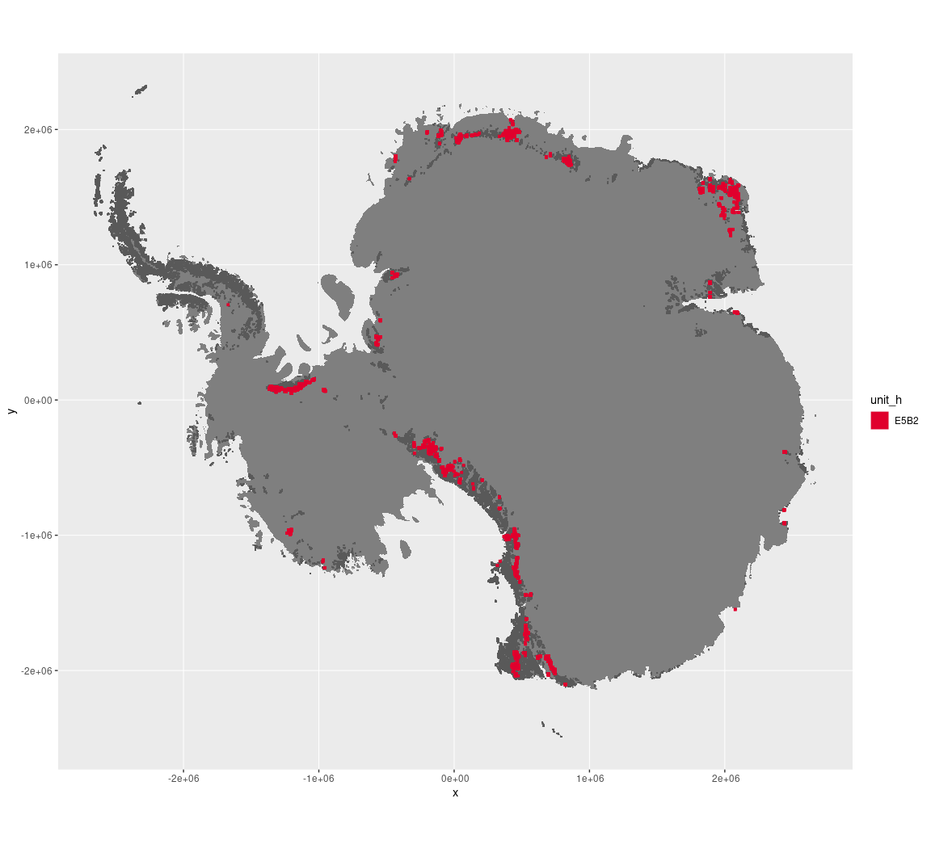

Regional maps

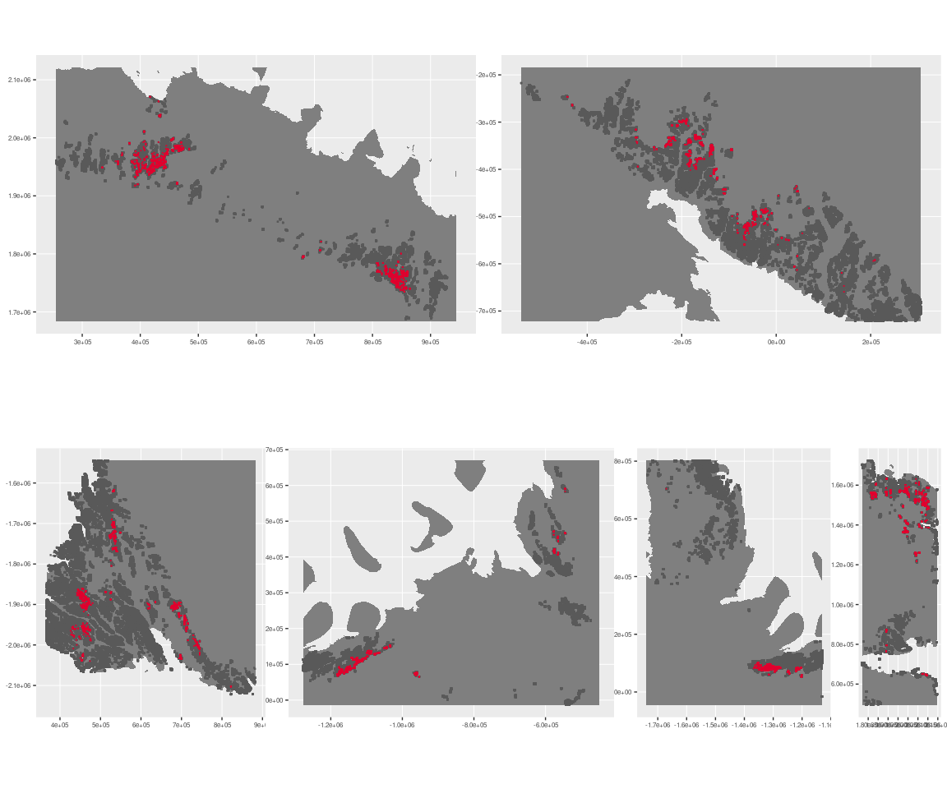

### Environment

The unit E5B2 is part of the environmental supergroup E5.

Supergroup E5 is, on average, substantially higher in elevation and wind than continental Antarctica. It is substantially lower in DDm5, meanTemp, melt, rugosity, slope and totPrecip than the rest of the continent.

The elevation of unit E5B2 ranges from 0 to 3975 metres above sea level, but 90% of its pixels fall above 929 and below 2576 metres. Its average elevation is 1817 metres.

The unit is higher in melt and totPrecip and lower in no variables than the rest of supergroup E5.

#### Distinctiveness of the assemblage from its group and the rest of Antarctica

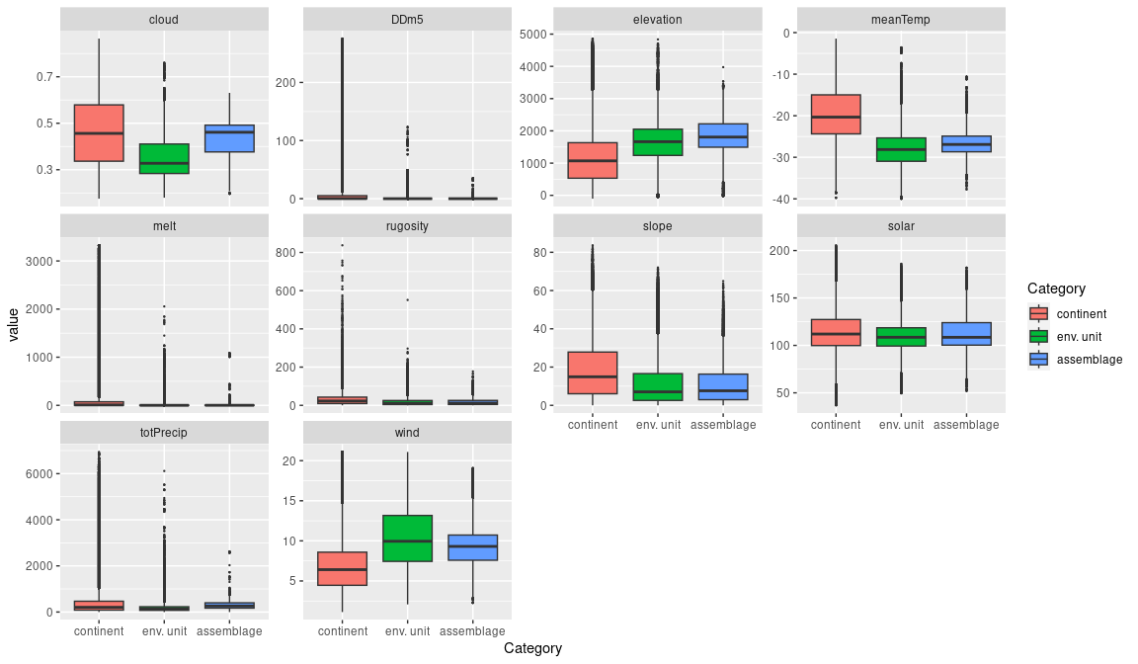

### Biota

Most widely sampled species in the unit (found in most pixels)

|  |  |  |  |  |  |
| --- | --- | --- | --- | --- | --- |
| scientific | Functional group | phylum | restricted | count | percent of samples |
| Pagodroma nivea | Chordata_Aves_Procellariiformes | Chordata | FALSE | 2 | 20 |
| Achnanthes sp. | Ochrophyta | Ochrophyta | TRUE | 1 | 10 |
| Aulacoseira sp. | Ochrophyta | Ochrophyta | TRUE | 1 | 10 |
| Caloneis tenuis | Ochrophyta | Ochrophyta | FALSE | 1 | 10 |
| Cyclotella ocellata | Ochrophyta | Ochrophyta | FALSE | 1 | 10 |
| Daption capense | Chordata_Aves_Procellariiformes | Chordata | FALSE | 1 | 10 |
| Fragilaria berolinensis | Ochrophyta | Ochrophyta | TRUE | 1 | 10 |
| Fragilaria sp. | Ochrophyta | Ochrophyta | TRUE | 1 | 10 |
| Pinnularia maior | Ochrophyta | Ochrophyta | FALSE | 1 | 10 |

Supergroup E5 is, on average, substantially higher in suitability for no variables functional groups than continental Antarctica. It is substantially lower in suitability for algae_Green, lichens_Bacidiacid, lichens_Lecideacid, mosses_Dicranales, Nematodes, penguins_Adelie and penguins_Chinstrap than the rest of the continent.

Unit E5B2 is higher in suitability for no variables and lower in suitability for no variables than the rest of supergroup E5.

#### Distinctiveness of the unit from the environmental group and the rest of Antarctica

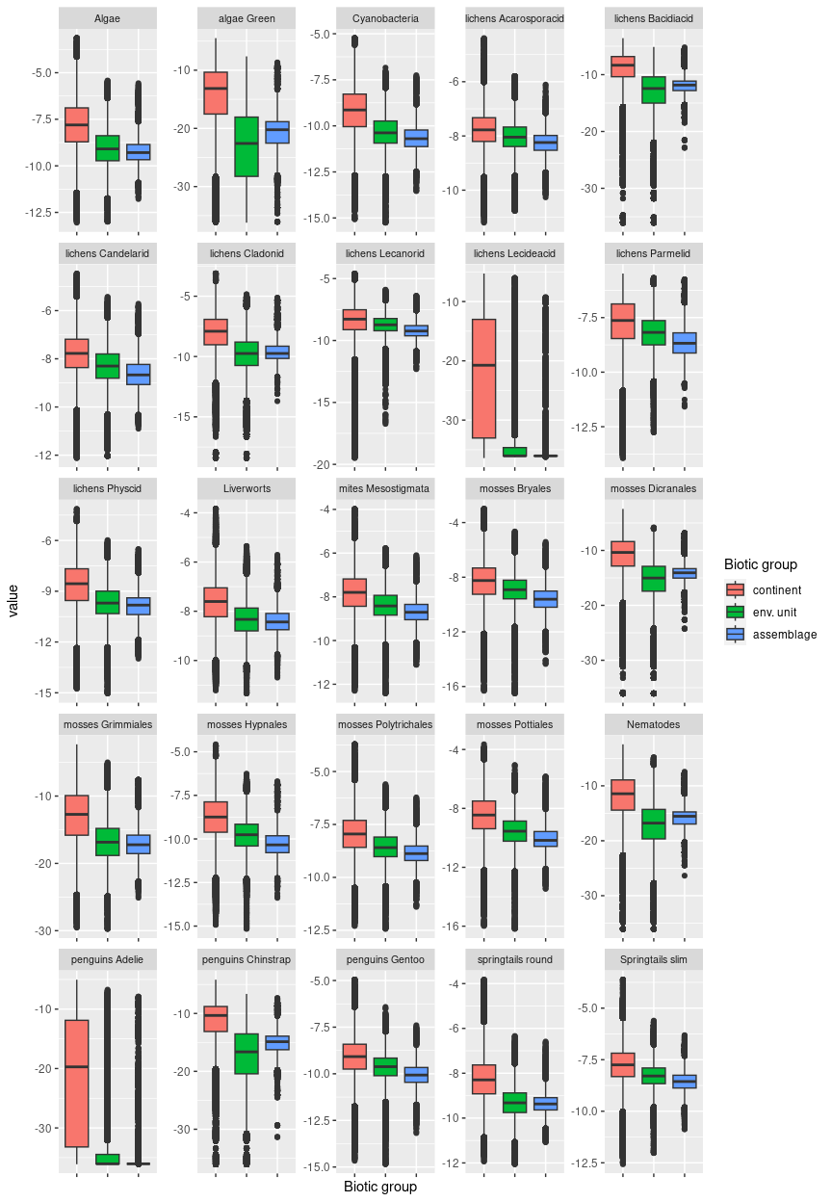

## Ecosystem E5B3

#### Exposed midland meltwater plateaus

Primarily associated with windy, flat to rolling terrain at a mid-range of elevations, sometimes near to the coast, and may be sloping gently. May include both the top of plateaus and the gentle slopes under any escarpments. Though this unit is dry, it has the highest melt and lowest elevation in E5 and is likely to be eroded by limited seasonal meltwater flow, unlike the rest of its group. Scarce sampled biota are mainly lichens. Suitability is below continental average for all functional groups, but substantially higher than the group average for nearly all groups, particularly Bacidiacid lichens and all moss groups.

### Photos (if available)

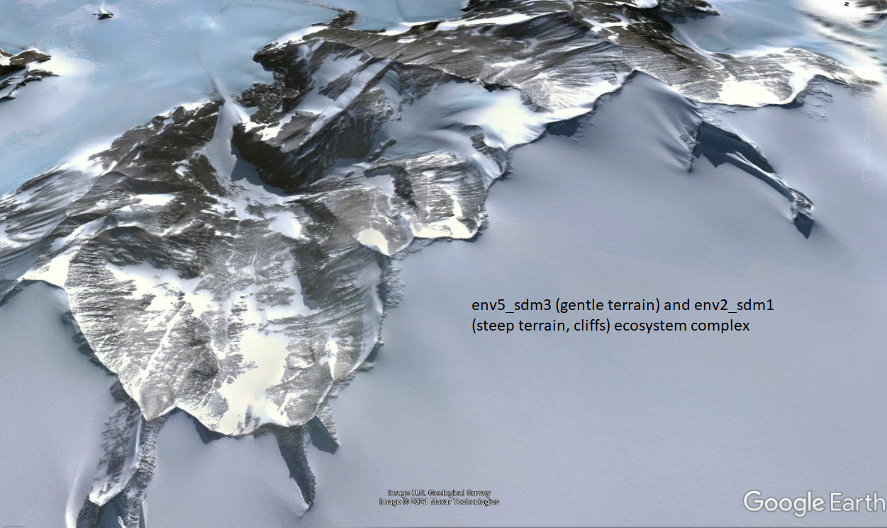

Ecosystem photo

### Distribution

Modest occurrences are found across the Transantarctic Mountains and Victoria Land, Prince Charles Mountains, Enderby Land, and the Ellsworth Mountains

Full map

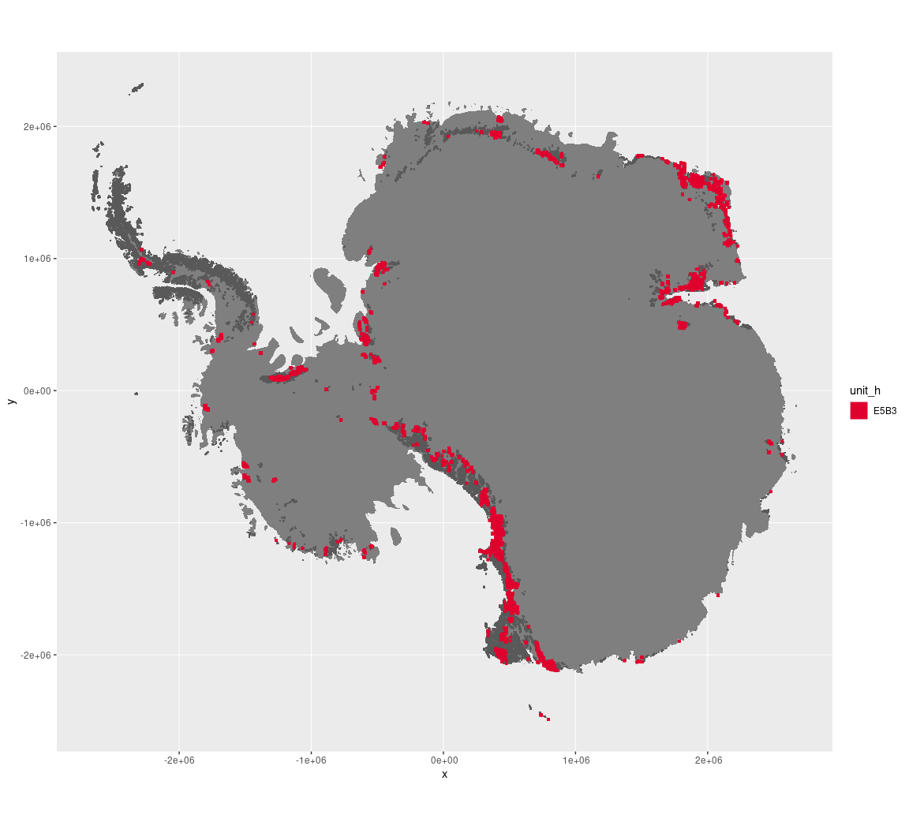

Regional maps

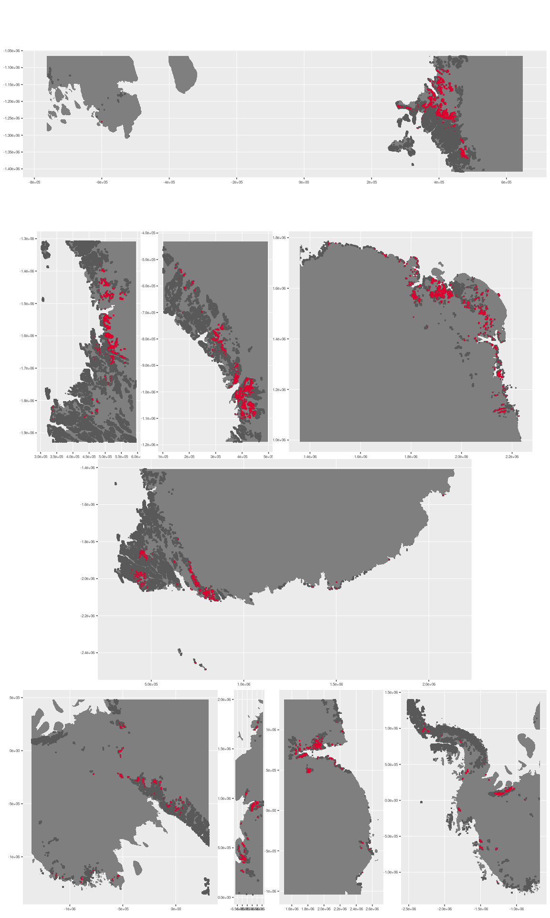

### Environment

The unit E5B3 is part of the environmental supergroup E5.

Supergroup E5 is, on average, substantially higher in elevation and wind than continental Antarctica. It is substantially lower in cloud, DDm5, meanTemp, melt, rugosity, slope and totPrecip than the rest of the continent.

The elevation of unit E5B3 ranges from 0 to 4519 metres above sea level, but 90% of its pixels fall above 404 and below 2334 metres. Its average elevation is 1215 metres.

The unit is higher in melt and totPrecip and lower in elevation than the rest of supergroup E5.

#### Distinctiveness of the assemblage from its group and the rest of Antarctica

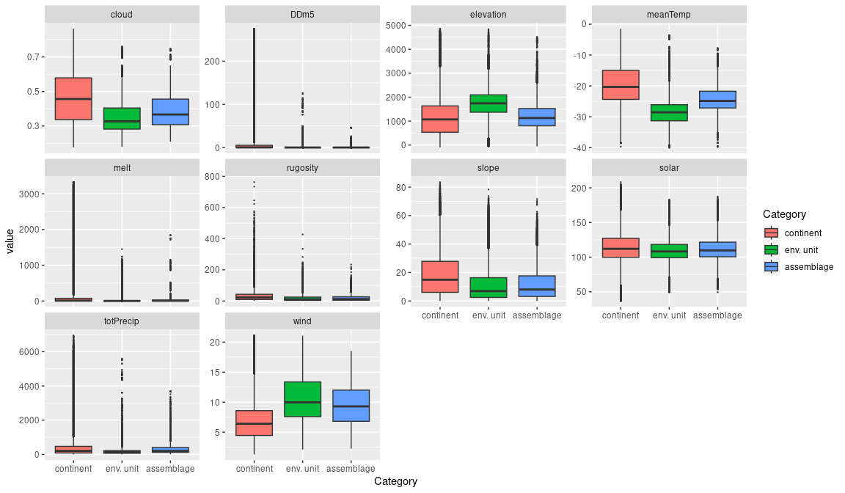

### Biota

Most widely sampled species in the unit (found in most pixels)

The top most widespread species in ecosystem E5B3

|  |  |  |  |  |  |
| --- | --- | --- | --- | --- | --- |
| scientific | Functional group | phylum | restricted | count | percent of samples |
| Candelariella flava | Ascomycota_Lecanoromycetes_Candelariales_Candelariaceae | Ascomycota | TRUE | 3 | 7.8947 |
| Xanthoria elegans | Ascomycota_Lecanoromycetes_Teloschistales_Teloschistaceae | Ascomycota | FALSE | 3 | 7.8947 |
| Acarospora gwynnii | Ascomycota_Lecanoromycetes_Acarosporales_Acarosporaceae | Ascomycota | TRUE | 2 | 5.2632 |
| Bryum pseudotriquetrum | Bryophyta_Bryopsida_Bryales | Bryophyta | FALSE | 2 | 5.2632 |
| Buellia frigida | Ascomycota_Lecanoromycetes_Teloschistales_Physciaceae | Ascomycota | TRUE | 2 | 5.2632 |
| Lecidea cancriformis | Ascomycota_Lecanoromycetes_Lecanorales_Lecideaceae | Ascomycota | TRUE | 2 | 5.2632 |
| Pleopsidium chlorophanum | Ascomycota_Lecanoromycetes_Acarosporales_Acarosporaceae | Ascomycota | FALSE | 2 | 5.2632 |
| Pseudephebe minuscula | Ascomycota_Lecanoromycetes_Lecanorales_Parmeliaceae | Ascomycota | FALSE | 2 | 5.2632 |
| Rhizoplaca melanophthalma | Ascomycota_Lecanoromycetes_Lecanorales_Lecanoraceae | Ascomycota | FALSE | 2 | 5.2632 |
| Umbilicaria decussata | Ascomycota_Lecanoromycetes_Umbilicariales_Umbilicariaceae | Ascomycota | FALSE | 2 | 5.2632 |

Supergroup E5 is, on average, substantially higher in suitability for no variables functional groups than continental Antarctica. It is substantially lower in suitability for algae_Green, lichens_Bacidiacid, lichens_Lecideacid, mosses_Dicranales, Nematodes, penguins_Adelie and penguins_Chinstrap than the rest of the continent.

Unit E5B3 is higher in suitability for algae_Green, lichens_Bacidiacid, lichens_Lecideacid, mosses_Dicranales, Nematodes, penguins_Adelie and penguins_Chinstrap and lower in suitability for no variables than the rest of supergroup E5.

#### Distinctiveness of the unit from the environmental group and the rest of Antarctica

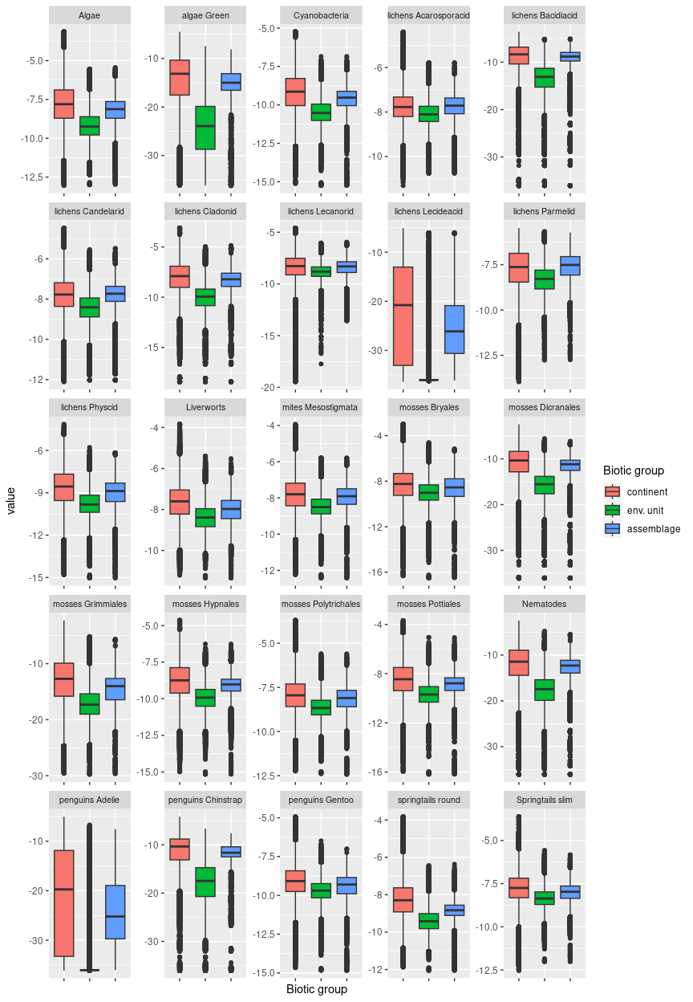

## Ecosystem E5B4

#### Exposed remote arid highlands

### Primarily associated with windy, flat to rolling terrain at a mid-range of elevations, sometimes near to the coast, and may be sloping gently. Though this unit is dry, it has the lowest elevation and highest average temperatures in E5 and is thus likely to be eroded by limited seasonal meltwater flow, unlike the rest of its group. With less insolation than the rest of E5, the unit may be periodically overshadowed by surrounding nunataks. Scarce sampled biota are mainly lichens. Suitability is below continental average for all functional groups, but substantially higher than the group average for nearly all groups, particularly Bacidiacid lichens and all moss groups.

### Photos (if available)

### 

### Distribution

Predominantly occurs far from the coast in the Transantarctic Mountains, with modest occurrences sprinkled across Victoria Land, Dronning Maud Land, the Prince Charles Mountains, Enderby Land, and the Ellsworth Mountains

Full map

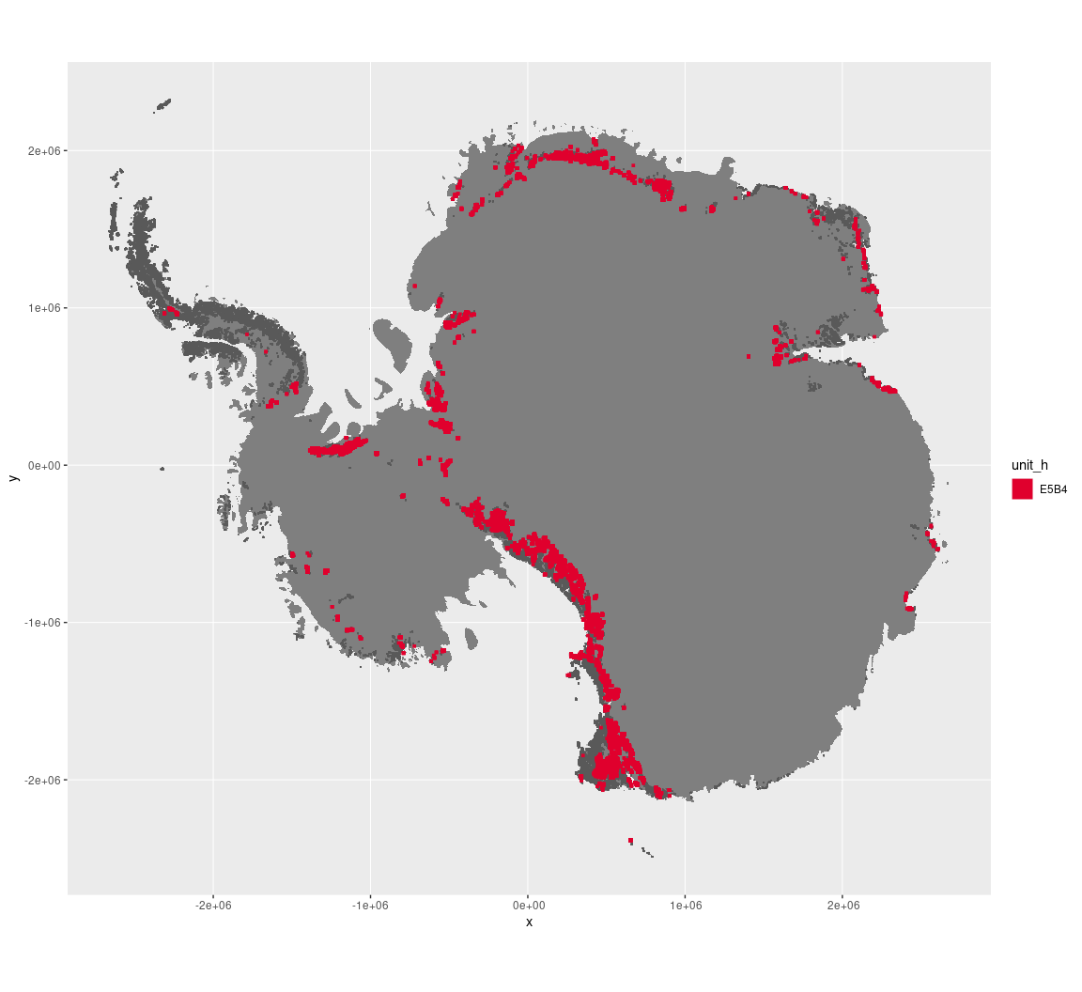

Regional maps

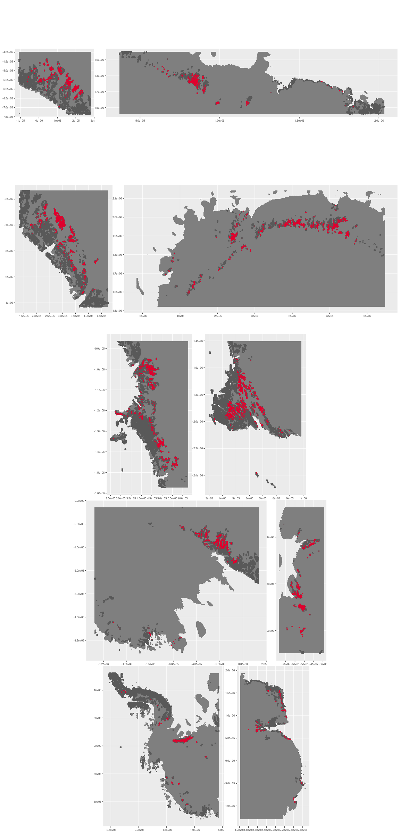







### Environment

The unit E5B4 is part of the environmental supergroup E5.

Supergroup E5 is, on average, substantially higher in elevation and wind than continental Antarctica. It is substantially lower in DDm5, meanTemp, melt, rugosity, slope and totPrecip than the rest of the continent.

The elevation of unit E5B4 ranges from 0 to 4836 metres above sea level, but 90% of its pixels fall above 709 and below 2590 metres. Its average elevation is 1688 metres.

The unit is higher in no variables and lower in DDm5 and melt than the rest of supergroup E5.

#### Distinctiveness of the assemblage from its group and the rest of Antarctica

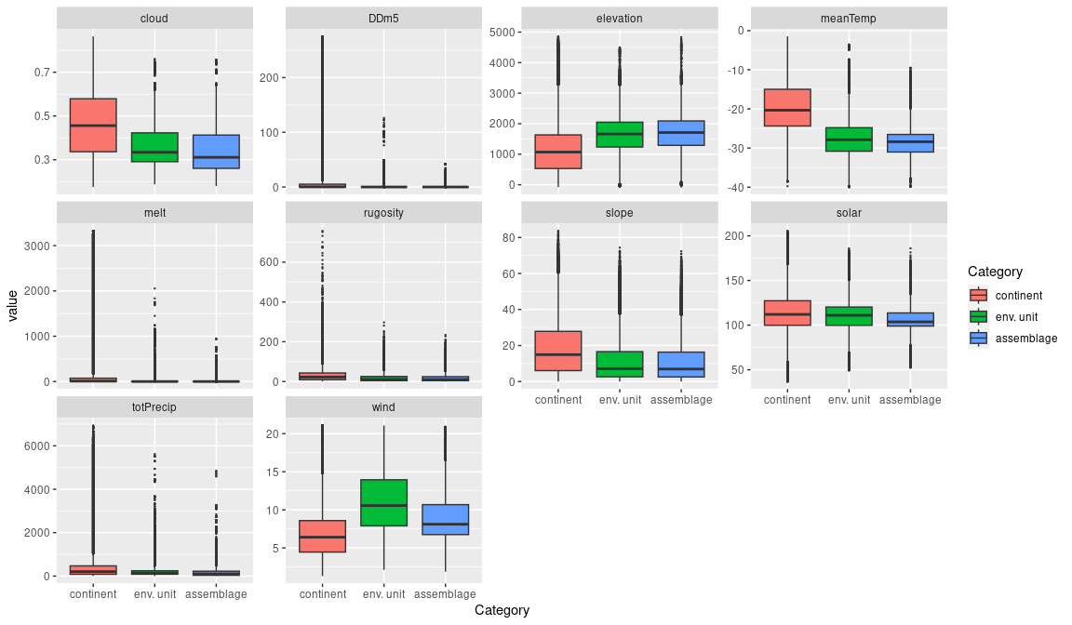

### Biota

Most widely sampled species in the unit (found in most pixels)

|  |  |  |  |  |  |
| --- | --- | --- | --- | --- | --- |
| scientific | Functional group | phylum | restricted | count | percent of samples |
| Rhizocarpon geographicum | Ascomycota_Lecanoromycetes_Not assigned_Rhizocarpaceae | Ascomycota | FALSE | 2 | 6.8966 |
| Umbilicaria decussata | Ascomycota_Lecanoromycetes_Umbilicariales_Umbilicariaceae | Ascomycota | FALSE | 2 | 6.8966 |
| Acarospora williamsii | Ascomycota_Lecanoromycetes_Acarosporales_Acarosporaceae | Ascomycota | TRUE | 1 | 3.4483 |
| Adineta gracilis | Rotifera | Rotifera | FALSE | 1 | 3.4483 |
| Adineta steineri | Rotifera | Rotifera | TRUE | 1 | 3.4483 |
| Adineta vaga | Rotifera | Rotifera | FALSE | 1 | 3.4483 |
| Biatorella cerebriformis | Ascomycota_Lecanoromycetes_Lecanorales_Biatorellaceae | Ascomycota | TRUE | 1 | 3.4483 |
| Buellia pallida | Ascomycota_Lecanoromycetes_Teloschistales_Physciaceae | Ascomycota | TRUE | 1 | 3.4483 |
| Caloplaca citrina | Ascomycota_Lecanoromycetes_Teloschistales_Teloschistaceae | Ascomycota | TRUE | 1 | 3.4483 |
| Candelaria sp. | Ascomycota_Lecanoromycetes_Candelariales_Candelariaceae | Ascomycota | TRUE | 1 | 3.4483 |
| Candelariella flava | Ascomycota_Lecanoromycetes_Candelariales_Candelariaceae | Ascomycota | TRUE | 1 | 3.4483 |
| Carbonea capsulata | Ascomycota_Lecanoromycetes_Lecanorales_Lecanoraceae | Ascomycota | TRUE | 1 | 3.4483 |
| Ceratodon purpureus | Bryophyta_Bryopsida_Dicranales | Bryophyta | FALSE | 1 | 3.4483 |
| Chlorosphaera sp. | Chlorophyta | Chlorophyta | TRUE | 1 | 3.4483 |
| Cymbella helvetica | Ochrophyta | Ochrophyta | FALSE | 1 | 3.4483 |
| Habrotrocha elusa | Rotifera | Rotifera | TRUE | 1 | 3.4483 |
| Lecanora mawsoni | Ascomycota_Lecanoromycetes_Lecanorales_Lecanoraceae | Ascomycota | TRUE | 1 | 3.4483 |
| Macrobiotus ?fuciger | Tardigrada | Tardigrada | TRUE | 1 | 3.4483 |
| Macrobiotus sp. | Tardigrada | Tardigrada | TRUE | 1 | 3.4483 |
| Macrotrachela ambigua | Rotifera | Rotifera | TRUE | 1 | 3.4483 |
| Macrotrachela cf. ligulata | Rotifera | Rotifera | TRUE | 1 | 3.4483 |
| Mniobia sp. | Rotifera | Rotifera | TRUE | 1 | 3.4483 |
| Nostoc commune | Cyanobacteria | Cyanobacteria | TRUE | 1 | 3.4483 |
| Physcia dubia | Ascomycota_Lecanoromycetes_Teloschistales_Physciaceae | Ascomycota | FALSE | 1 | 3.4483 |
| Pseudephebe minuscula | Ascomycota_Lecanoromycetes_Lecanorales_Parmeliaceae | Ascomycota | FALSE | 1 | 3.4483 |
| Schizothrix calcicola | Cyanobacteria | Cyanobacteria | FALSE | 1 | 3.4483 |
| Tydeus erebus | Arthropoda_Arachnida_Trombidiformes | Arthropoda | TRUE | 1 | 3.4483 |

Supergroup E5 is, on average, substantially higher in suitability for no variables functional groups than continental Antarctica. It is substantially lower in suitability for algae_Green, lichens_Bacidiacid, lichens_Lecideacid, mosses_Dicranales, Nematodes, penguins_Adelie and penguins_Chinstrap than the rest of the continent.

Unit E5B4 is higher in suitability for no variables and lower in suitability for no variables than the rest of supergroup E5.

#### Distinctiveness of the unit from the environmental group and the rest of Antarctica

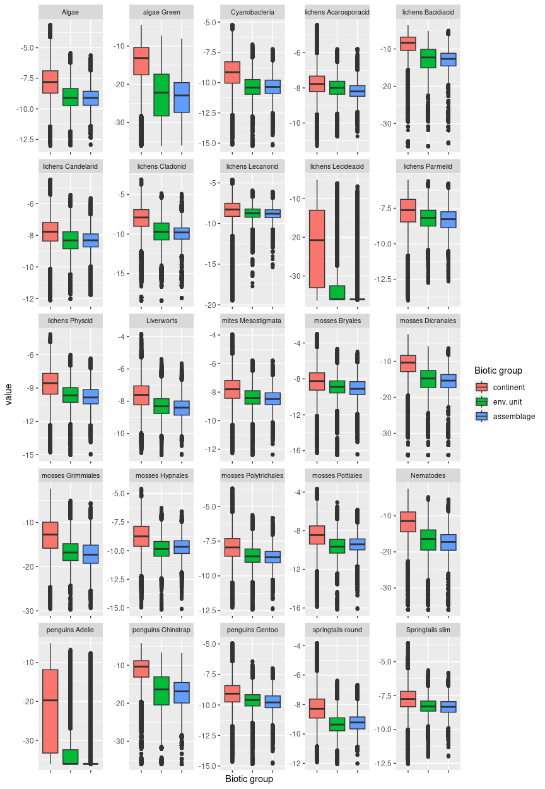

## Ecosystem E5B5

#### Windy xeric plateaus and moraine fields

### Primarily associated flat to undulating terrain at high elevations removed from maritime influence and exposed to strong winds. May include both the top surface of the plateau and the gentle slopes under any escarpments. This unit is closely associated with steep units in E2 and E4 which separate plateau and cliff-foot slopes. It is the coldest unit in the typology (mean annual Temp -30 degrees), and the clearest, and lowest snowfall unit in E5. Several species of Ochrophytes have been sampled but all are singletons. Suitability is lower than continental and group average for all functional groups.

### Photos (if available)

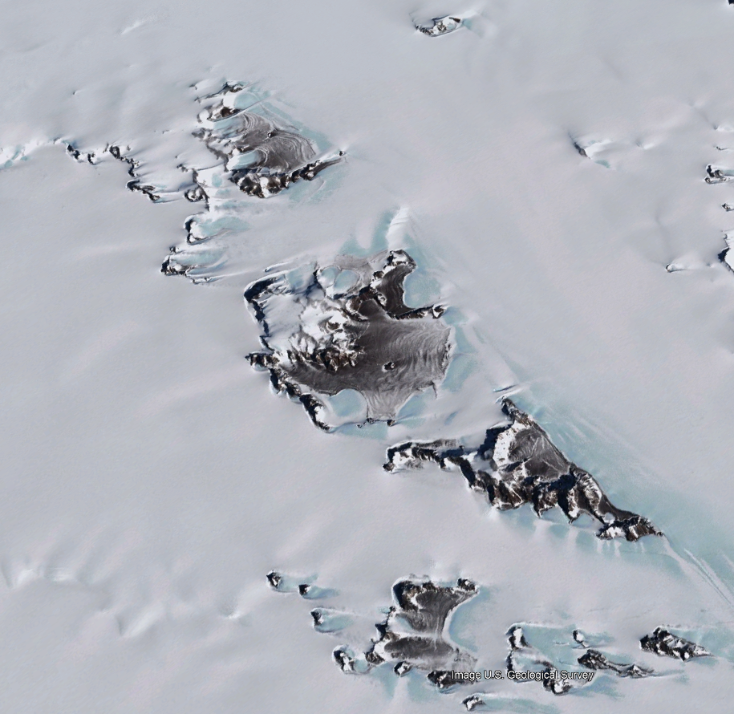

*E5B5 ecosystem in the Prince Charles Mountains (Google Earth)*

### Distribution

Predominantly found in the Prince Charles Mountains, though significant incidence of this unit occurs in the Transantarctic Mountains and Victoria Land.

Full map

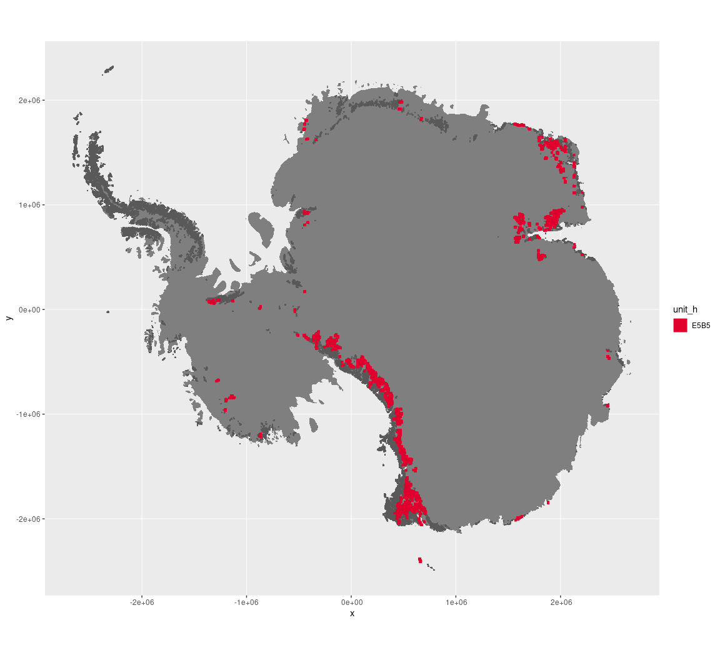

Regional maps

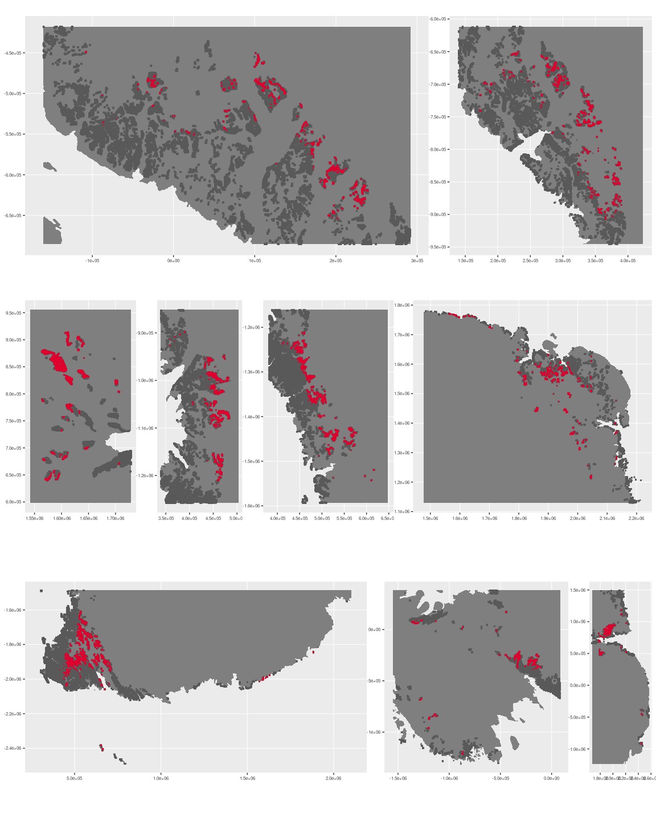

### Environment

The unit E5B5 is part of the environmental supergroup E5.

Supergroup E5 is, on average, substantially higher in elevation and wind than continental Antarctica. It is substantially lower in DDm5, meanTemp, melt, rugosity, slope and totPrecip than the rest of the continent.

The elevation of unit E5B5 ranges from 0 to 3540 metres above sea level, but 90% of its pixels fall above 1070 and below 2428 metres. Its average elevation is 1764 metres.

The unit is higher in no variables and lower in DDm5, melt and totPrecip than the rest of supergroup E5.

#### Distinctiveness of the assemblage from its group and the rest of Antarctica

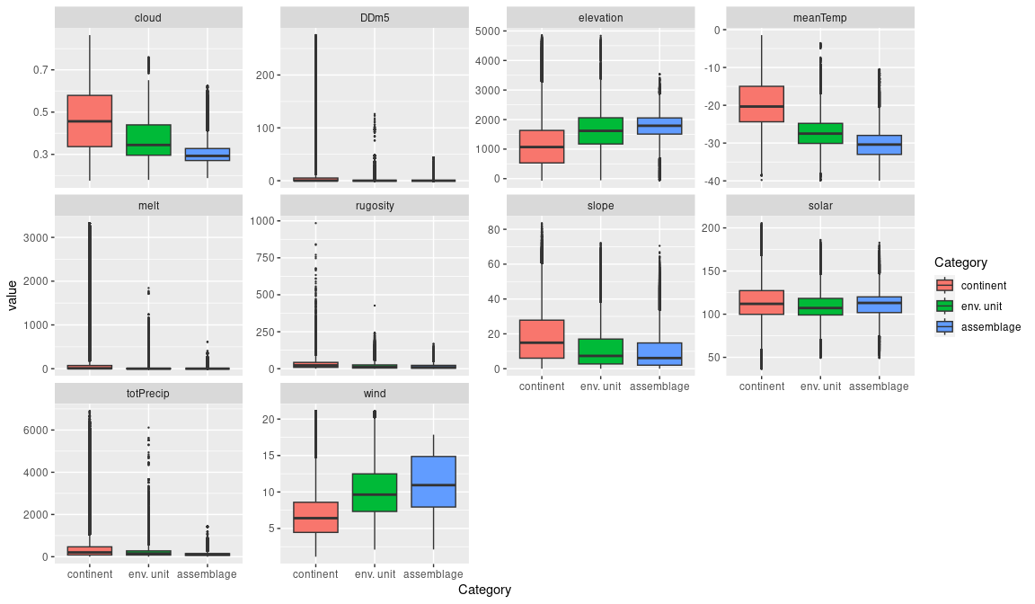

### Biota

Most widely sampled species in the unit (found in most pixels)

|  |  |  |  |  |  |
| --- | --- | --- | --- | --- | --- |
| scientific | Functional group | phylum | restricted | count | percent of samples |
| Stercorarius maccormicki | Chordata_Aves_Charadriiformes | Chordata | FALSE | 10 | 21.7391 |
| Oceanites oceanicus | Chordata_Aves_Procellariiformes | Chordata | TRUE | 9 | 19.5652 |
| Pagodroma nivea | Chordata_Aves_Procellariiformes | Chordata | FALSE | 6 | 13.0435 |
| Buellia frigida | Ascomycota_Lecanoromycetes_Teloschistales_Physciaceae | Ascomycota | TRUE | 3 | 6.5217 |
| Pygoscelis adeliae | Chordata_Aves_Sphenisciformes_Spheniscidae_Pygoscelis_adeliae | Chordata | FALSE | 3 | 6.5217 |
| Pseudephebe minuscula | Ascomycota_Lecanoromycetes_Lecanorales_Parmeliaceae | Ascomycota | FALSE | 2 | 4.3478 |
| Bryum subrotundifolium | Bryophyta_Bryopsida_Bryales | Bryophyta | TRUE | 1 | 2.1739 |
| Caloplaca athallina | Ascomycota_Lecanoromycetes_Teloschistales_Teloschistaceae | Ascomycota | TRUE | 1 | 2.1739 |
| Carbonea vorticosa | Ascomycota_Lecanoromycetes_Lecanorales_Lecanoraceae | Ascomycota | FALSE | 1 | 2.1739 |
| Chaetoceros sp. | Ochrophyta | Ochrophyta | TRUE | 1 | 2.1739 |
| Lecidea cancriformis | Ascomycota_Lecanoromycetes_Lecanorales_Lecideaceae | Ascomycota | TRUE | 1 | 2.1739 |
| Lepraria cacuminum | Ascomycota_Lecanoromycetes_Lecanorales_Stereocaulaceae | Ascomycota | FALSE | 1 | 2.1739 |
| Nitzschia closterium | Ochrophyta | Ochrophyta | FALSE | 1 | 2.1739 |
| Pannaria hookeri | Ascomycota_Lecanoromycetes_Peltigerales_Pannariaceae | Ascomycota | FALSE | 1 | 2.1739 |
| Pleopsidium chlorophanum | Ascomycota_Lecanoromycetes_Acarosporales_Acarosporaceae | Ascomycota | FALSE | 1 | 2.1739 |
| Stephanopyxis turris | Ochrophyta | Ochrophyta | FALSE | 1 | 2.1739 |
| Stereotydeus mollis | Arthropoda_Arachnida_Trombidiformes | Arthropoda | TRUE | 1 | 2.1739 |
| Trachyneis aspera | Ochrophyta | Ochrophyta | FALSE | 1 | 2.1739 |
| Usnea sphacelata | Ascomycota_Lecanoromycetes_Lecanorales_Parmeliaceae | Ascomycota | TRUE | 1 | 2.1739 |

Supergroup E5 is, on average, substantially higher in suitability for no variables functional groups than continental Antarctica. It is substantially lower in suitability for algae_Green, lichens_Bacidiacid, lichens_Lecideacid, mosses_Dicranales, Nematodes, penguins_Adelie and penguins_Chinstrap than the rest of the continent.

Unit E5B5 is higher in suitability for no variables and lower in suitability for no variables than the rest of supergroup E5.

#### Distinctiveness of the unit from the environmental group and the rest of Antarctica

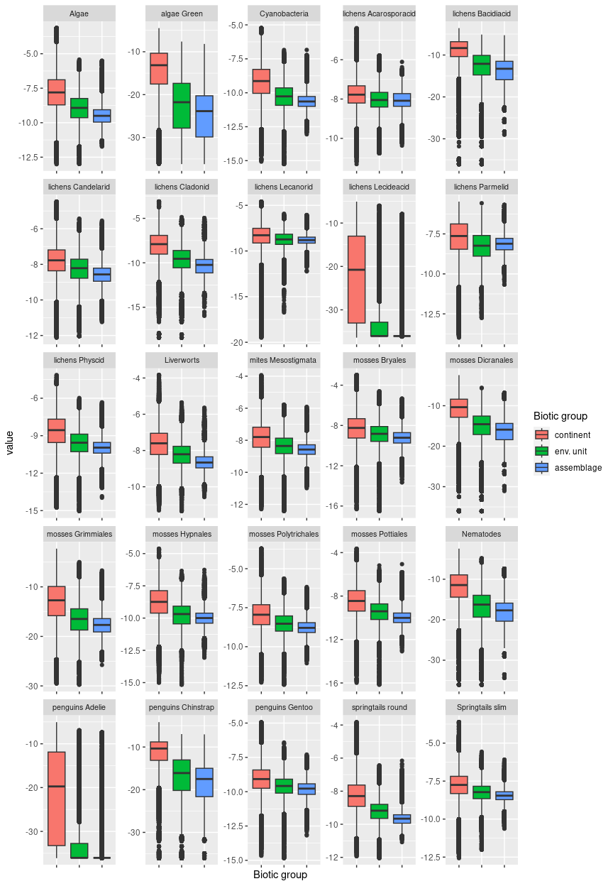

## Ecosystem E5B6

#### Windy highland moraine fields

### This unit typically occurs at high elevations and is usually found tucked in basins and on the fringes of nunataks, particularly in DM Land. It often skirts units from E2 and E4, which form the more rugged nunatak peaks. It has on average higher slope and rugosity than the rest of its group, but still represents quite gentle terrain relative to adjacent peaks. Satellite imagery indicate patterned debris fields left by receding glaciers. Scarce sampled biota includes mostly lichens. Suitability is lower than continental and group average for all functional groups.

### Photos (if available)

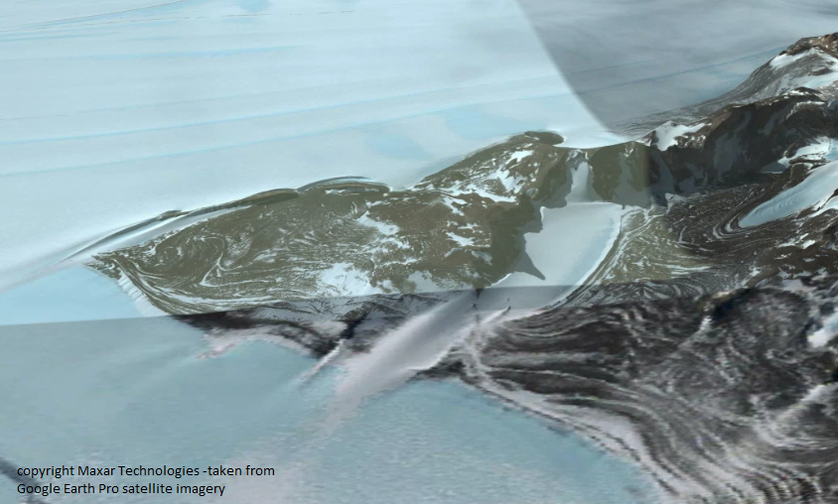

Ecosystem photo

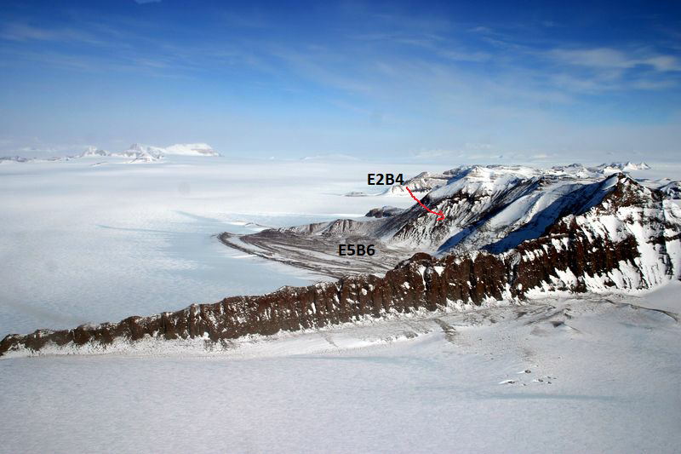

Photo: Mike Willis

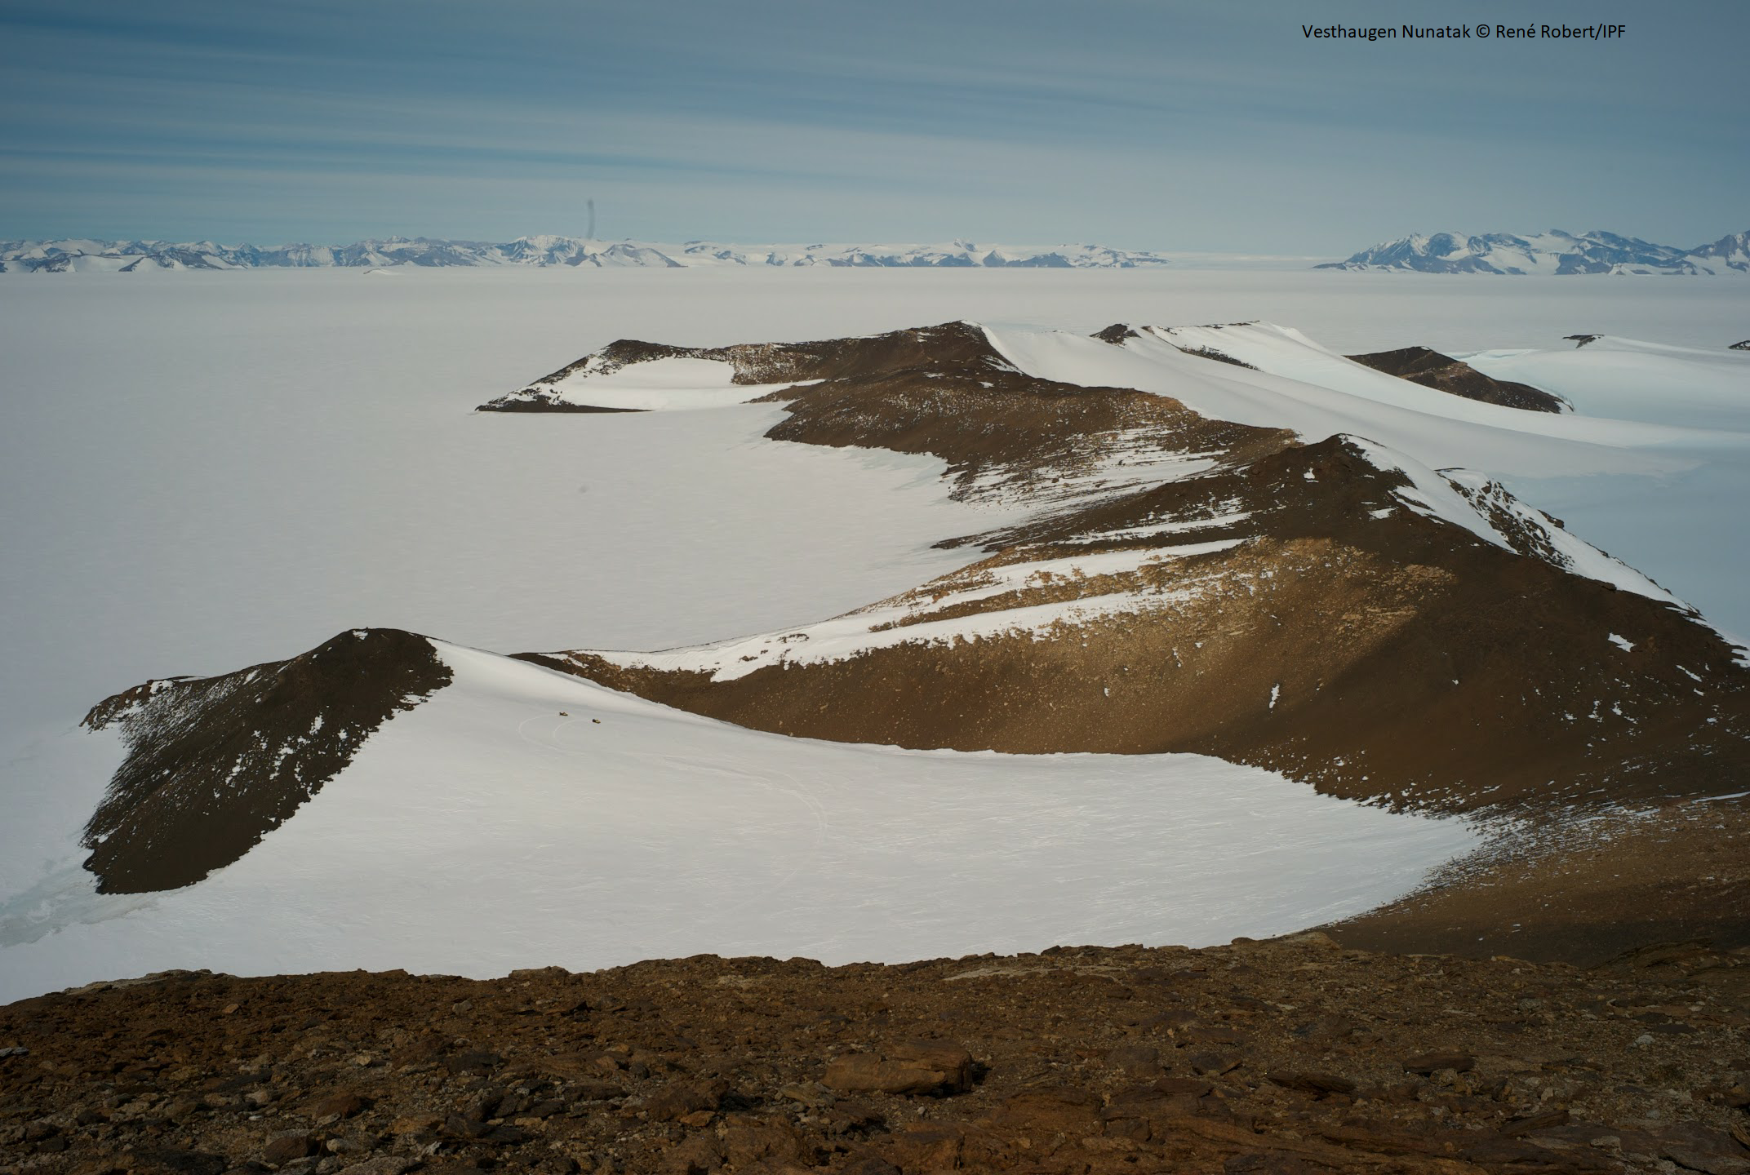

### Distribution

Predominantly found in Dronning Maud Land, and the Transantarctic Mountains, with relatively minor occurrences in Victoria Land and the Prince Charles Mountains.

Full map

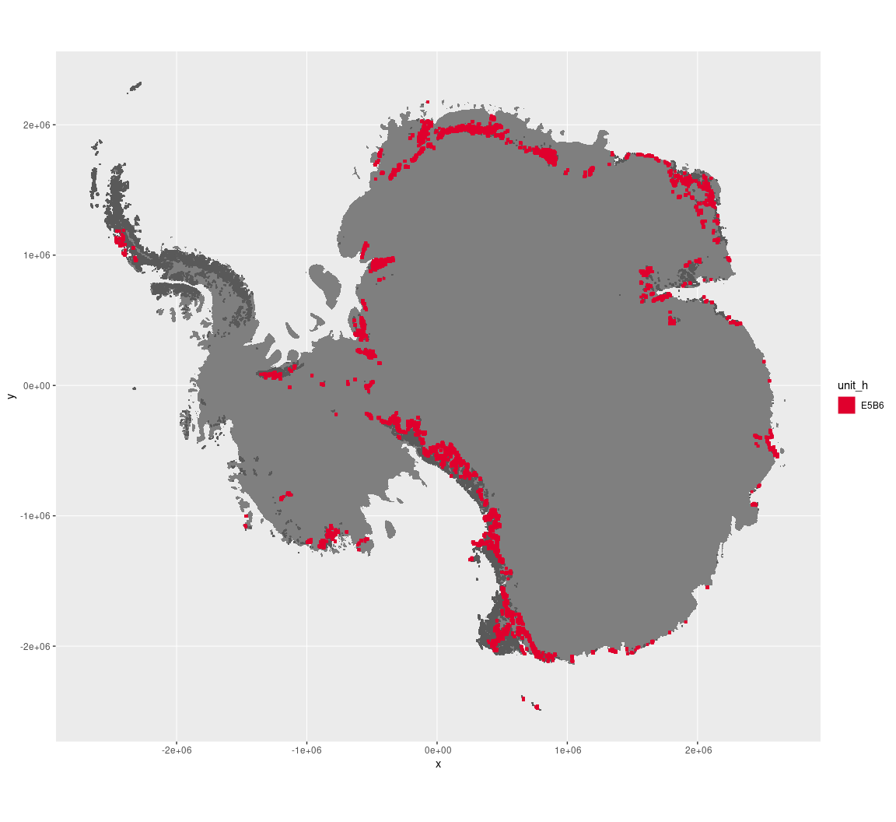

Regional maps

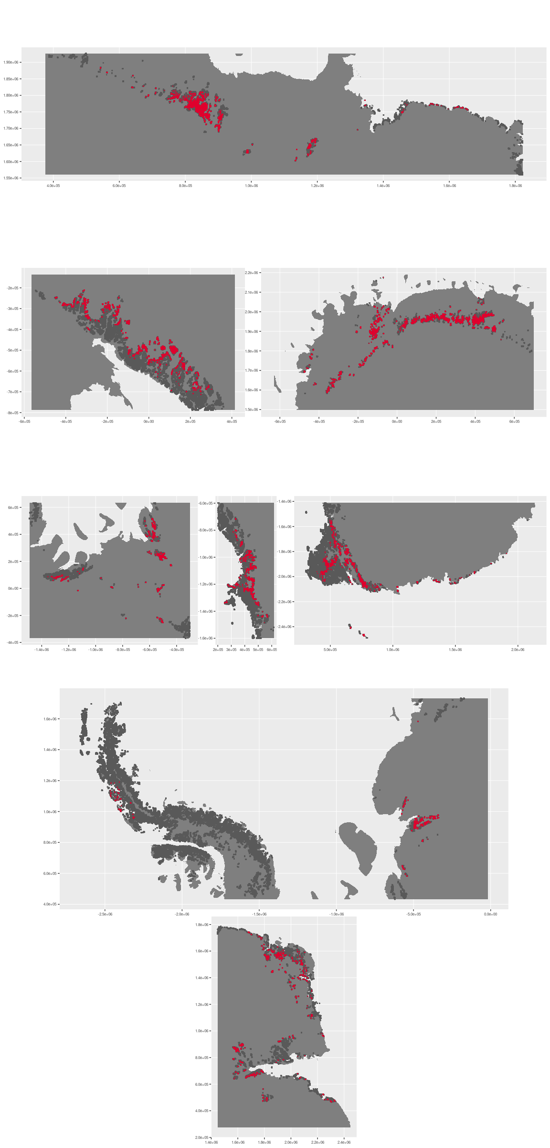



### Environment

The unit E5B6 is part of the environmental supergroup E5.

Supergroup E5 is, on average, substantially higher in elevation and wind than continental Antarctica. It is substantially lower in DDm5, meanTemp, melt, rugosity, slope and totPrecip than the rest of the continent.

The elevation of unit E5B6 ranges from 0 to 4470 metres above sea level, but 90% of its pixels fall above 927 and below 2654 metres. Its average elevation is 1901 metres.

The unit is higher in DDm5 and rugosity and lower in no variables than the rest of supergroup E5.

#### Distinctiveness of the assemblage from its group and the rest of Antarctica

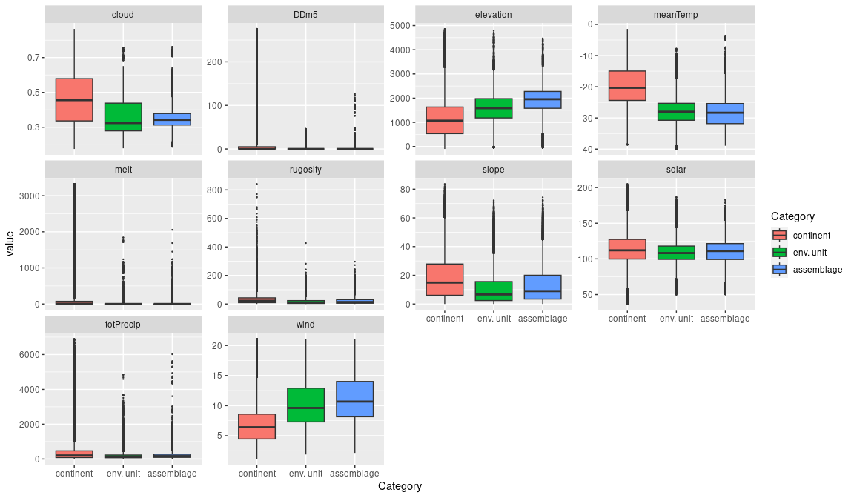

### Biota

Most widely sampled species in the unit (found in most pixels)

The top most widespread species in ecosystem E5B6

|  |  |  |  |  |  |
| --- | --- | --- | --- | --- | --- |
| scientific | Functional group | phylum | restricted | count | percent of samples |
| Candelariella flava | Ascomycota_Lecanoromycetes_Candelariales_Candelariaceae | Ascomycota | TRUE | 3 | 6.1224 |
| Pleopsidium chlorophanum | Ascomycota_Lecanoromycetes_Acarosporales_Acarosporaceae | Ascomycota | FALSE | 3 | 6.1224 |
| Umbilicaria decussata | Ascomycota_Lecanoromycetes_Umbilicariales_Umbilicariaceae | Ascomycota | FALSE | 3 | 6.1224 |
| Acarospora gwynnii | Ascomycota_Lecanoromycetes_Acarosporales_Acarosporaceae | Ascomycota | TRUE | 2 | 4.0816 |
| Bryum pseudotriquetrum | Bryophyta_Bryopsida_Bryales | Bryophyta | FALSE | 2 | 4.0816 |
| Buellia frigida | Ascomycota_Lecanoromycetes_Teloschistales_Physciaceae | Ascomycota | TRUE | 2 | 4.0816 |
| Ceratodon purpureus | Bryophyta_Bryopsida_Dicranales | Bryophyta | FALSE | 2 | 4.0816 |
| Grimmia lawiana | Bryophyta_Bryopsida_Grimmiales | Bryophyta | TRUE | 2 | 4.0816 |
| Physcia caesia | Ascomycota_Lecanoromycetes_Teloschistales_Physciaceae | Ascomycota | FALSE | 2 | 4.0816 |
| Pseudephebe minuscula | Ascomycota_Lecanoromycetes_Lecanorales_Parmeliaceae | Ascomycota | FALSE | 2 | 4.0816 |
| Xanthoria mawsonii | Ascomycota_Lecanoromycetes_Teloschistales_Teloschistaceae | Ascomycota | TRUE | 2 | 4.0816 |

Supergroup E5 is, on average, substantially higher in suitability for no variables functional groups than continental Antarctica. It is substantially lower in suitability for algae_Green, lichens_Bacidiacid, lichens_Lecideacid, mosses_Dicranales, Nematodes, penguins_Adelie and penguins_Chinstrap than the rest of the continent.

Unit E5B6 is higher in suitability for no variables and lower in suitability for no variables than the rest of supergroup E5.

#### Distinctiveness of the unit from the environmental group and the rest of Antarctica

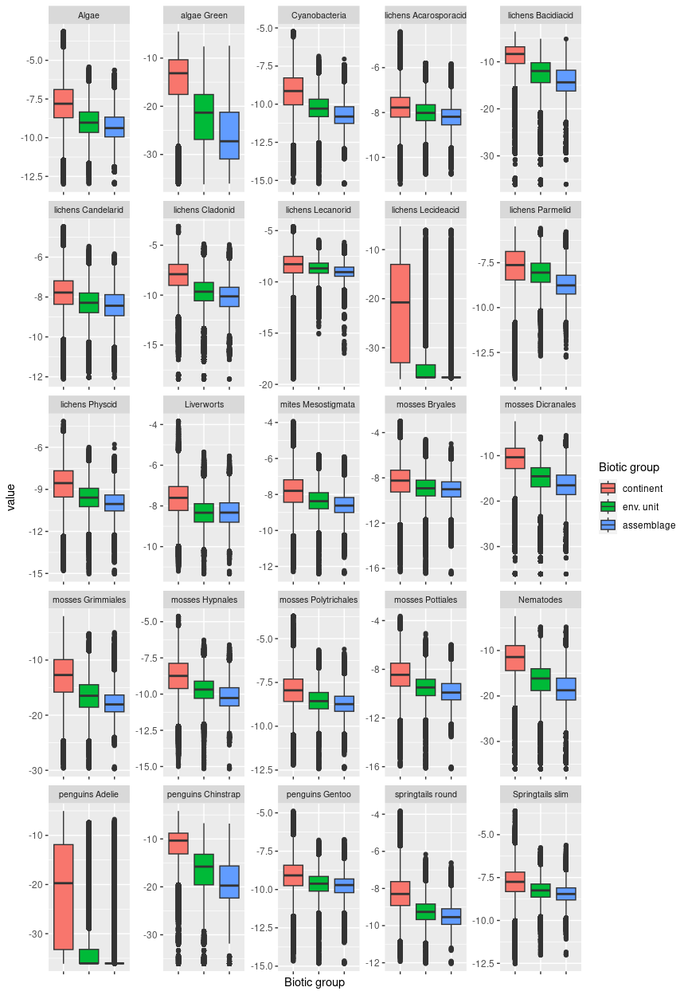

## Ecosystem G1

#### Active Volcanoes

Recent and ongoing volcanic activity associated with active volcanoes is a highly influential ecological driver of ecosystem processes and biota. Active volcanoes that erupted within the last 1,000 years occur only at three restricted sites in the McMurdo volcanic field in northern Victoria Land (Mt Erebus, Mt Melbourne and Mt Rittmann) and one on Deception Island (South Shetlands). Mt Erebus on Ross Island is currently erupting and is closely associated with Mt Terror and Mt Terra Nova, which have been dormant for 800,000 years, but are likely influenced by eruptions of Mt Erebus, and are thus included in Ecosystem type G1. The most recent eruptions of Mt Melbourne and Mt Rittmann were in 1892+/-30 and 1252+/-2, respectively. The Deception Island volcano is less elevated and isolated from the others and last erupted in 1970. All four active volcanoes are characterized by elevated temperatures and ongoing gaseous emissions. Three other volcanoes (Mt Hampton, Mt Kauffman, and Mt Berlin) exhibit some evidence of ongoing geothermal activity, but their status as active or dormant is yet to be resolved (Herbold et al. 2014).

Active volcanoes are polyextremophilic environments. The key physical features of these ecosystems include geothermal heat and steep thermal gradients relative to the surrounding landscape; periodic disturbance by volcanic eruptions, ash deposition or lava flow; emission of volcanic aerosols that contribute to dispersion of microorganisms (Van Eaton et al. 2013) and enrichment of nutrient levels (Garcia-Lopez et al. 2022). These ecosystems also include fumaroles (ice towers) and associated ice caves that form around vents, collapsing and rebuilding over decadal time scales.

### Photos (if available)

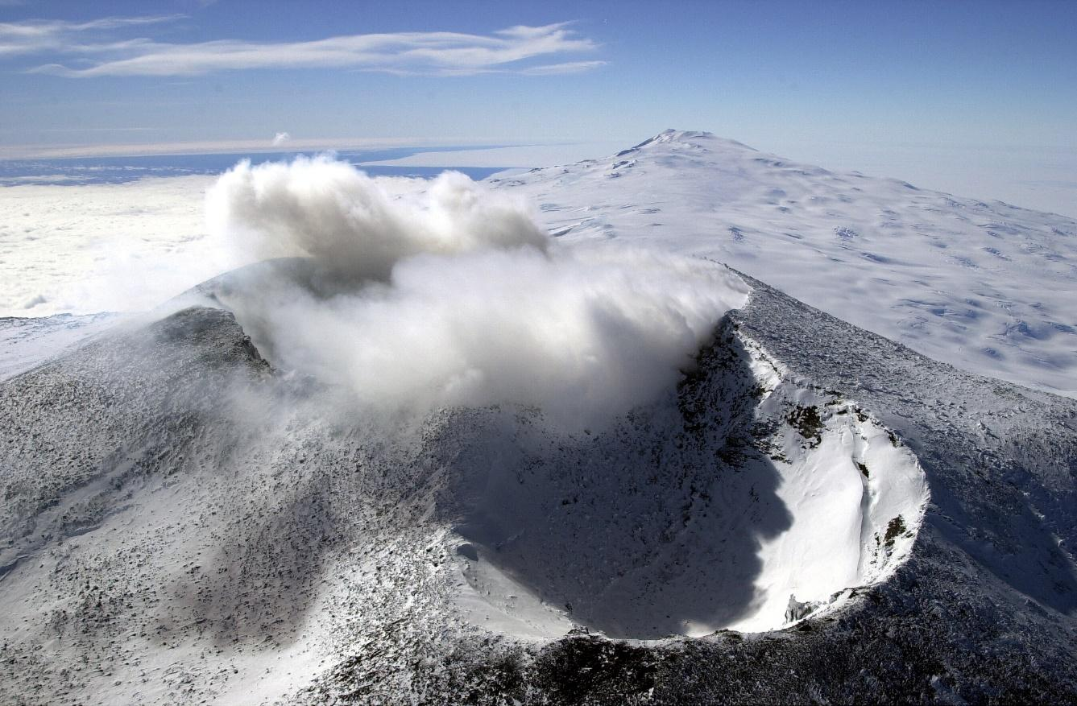

*Ecosystem photo: Active volcano, Mt Erebus on Ross Island, Antarctica. Credit: NSF/Josh Landis, employee 1999-2001 - United States Antarctic Program - Antarctic Photo Library, Public Domain, https://commons.wikimedia.org/w/index.php?curid=3678885*

### Distribution

Northern Antarctic Peninsula and Victoria Land

Full map

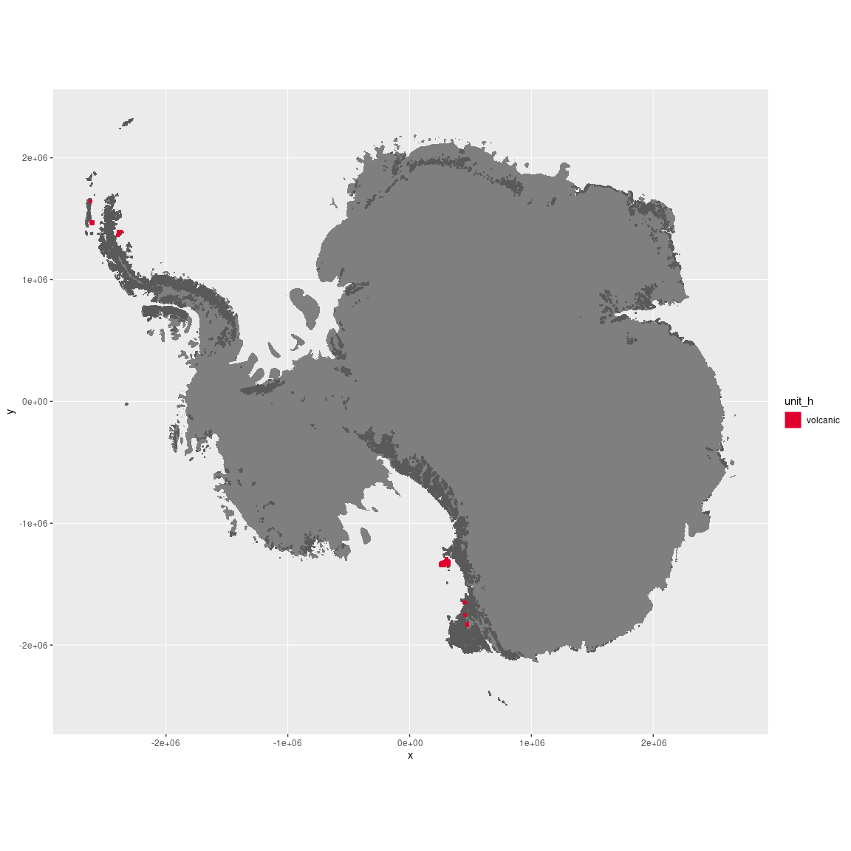

Regional maps

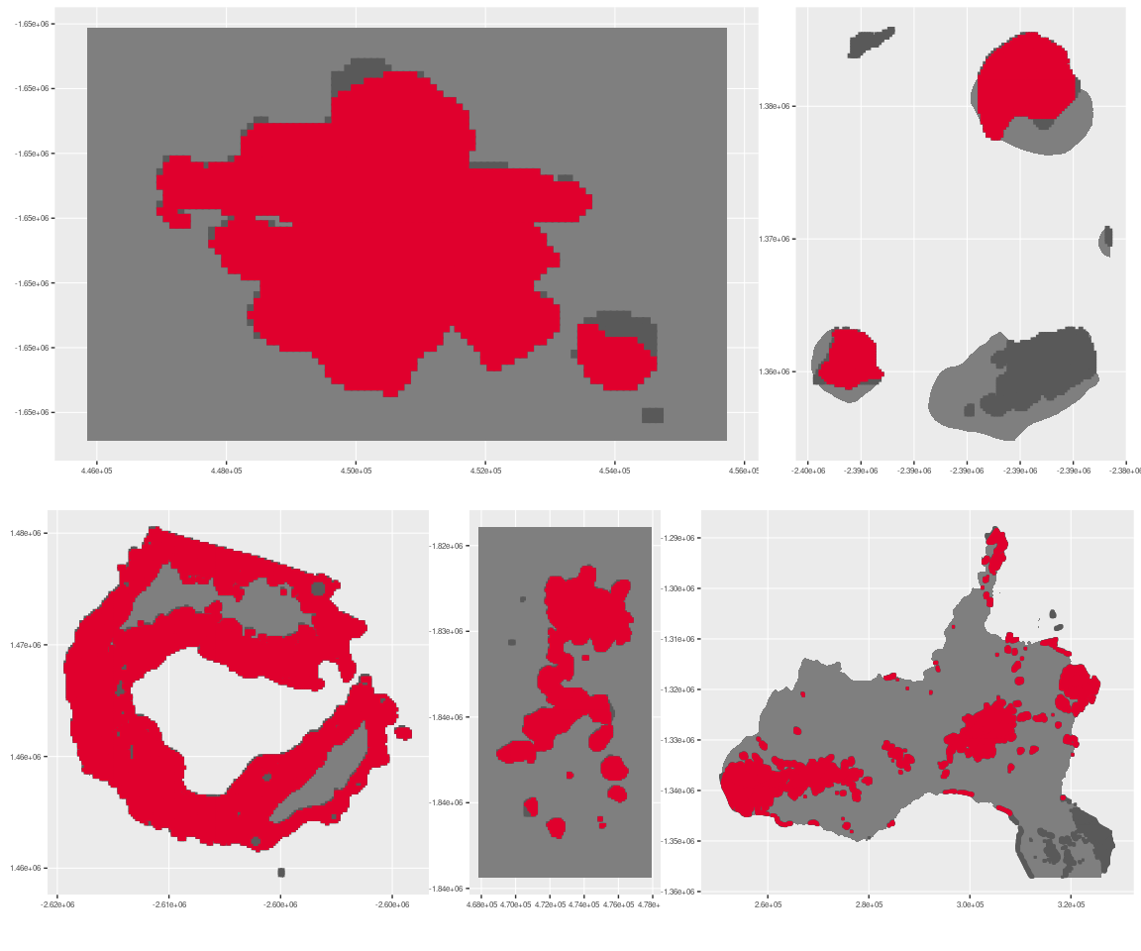

### Environment

The unit volcanic is part of the environmental supergroup G.

This supergroup is, on average, substantially higher in totPrecip than continental Antarctica. It is substantially lower in elevation, rugosity and slope than the rest of the continent.

Elevation varies up to 600 metres above sea level on Deception Island and up to 3,730 metres among the active McMurdo volcanoes. The latter share similar geochemical properties distinct from those of Deception Island. Topography varies in slope and rugosity, and includes specialized elements such as craters, vents and fumaroles.

The unit is higher in DDm5, elevation, rugosity and slope and lower in melt and wind than the rest of its environmental supergroup.

#### Distinctiveness of the assemblage from its group and the rest of Antarctica

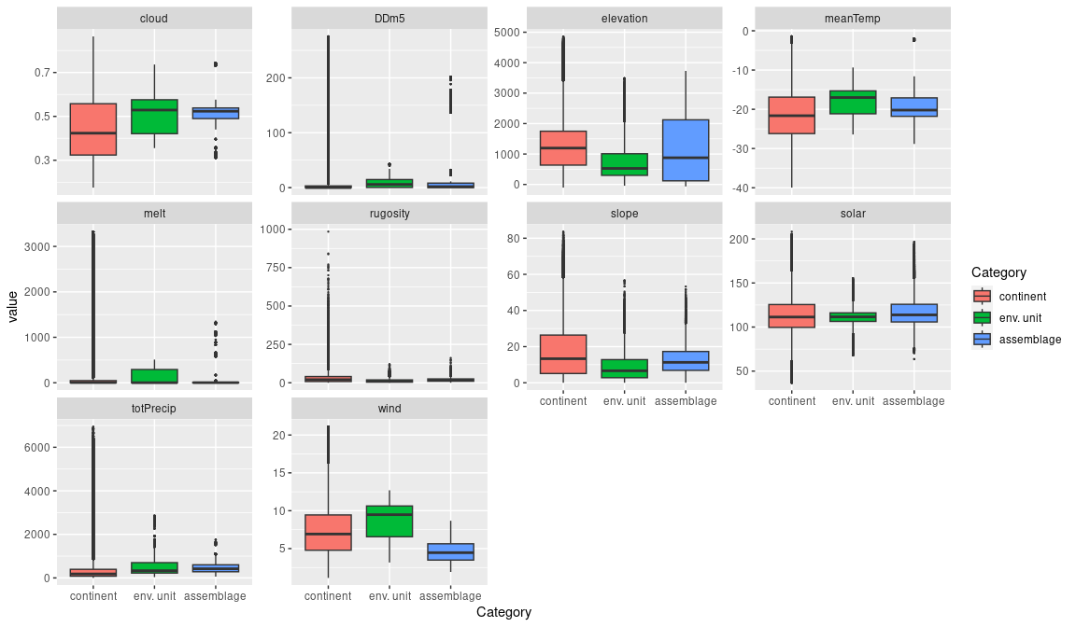

### Biota

Brypohtyes and algae dominate the eukaryotic component of the biota and thrive in mild temperatures and high-nutrient substrates, but are absent where temperatures exceed 40°C due to geothermal heating. Lichens are restricted to cooler peripheral sites. The bryophytes, present as thin films or conspicuous hummocks, include mosses, *Campylopus pyriformis* and *Pohlia nutans*, and the liverwort, *Cephaloziella exiliflora* (Herbold et al. 2014). Green algae (Chlorophyta and Charophyta) are widespread, while yellow-green algae and diatoms (Heterokontophyta) have been observed only at Deception Island.

Heterotrophic eukaryotes, such as protozoa and fungi, are present, but generally in low numbers and possibly limited to specific microhabitats.

The prokaryotic biota includes thermophiles and some psychrophiles. Emissions from the volcanic vents promote microbes with sulphur, iron and carbon metabolism (Garcia-Lopez et al. 2022). Photoautotrophic cyanobacteria are well represented on volcanoes, but exhibit strong local gradients in relation to temperature and pH, and there are far more species on Deception Island than the other active volcanoes (Herbold et al. 2014).

Temperature and pH gradients are important filters of community composition at local scales. Cyanobacteria, followed by algae, and moss, are assembled along gradients from hotter to cooler areas. Local geochemical gradients are also important determinants of microbial community composition, with anionic and cationic constituents each accounting for 25% of microbial compositional variation in ice adjacent to vents on Deception Island (Garcia-Lopez et al. 2022).

Diversity of all taxonomic groups is greater on the maritime Deception Island volcano than the three more elevated continental volcanoes. Differences in elevation, nutrient status, solar radiation, disturbance history, maritime influence and insularity potentially all contribute to the differences in diversity (Herbold et al. 2014). Garcia-Lopez et al. (2022) found the following microbial groups to be common around Deception Island volcanic vents: major phyla were Actinobacteria (27%), Bacteroidetes (23%), Cyanobacteria (20%), and Proteobacteria (most commonly the classes Betaproteobacteria (8%) and Alphaproteobacteria (5%). Abundant genera found in adjacent ice include *Hymenobacter, Pontibacter, Frankia, Cyanobacterium* and *Symploca*, while *Salinibacterium, Flavobacterium* and *Singulisphaera* were distinctive for Antarctica.

The top most sampled species in volcanic ecosystems

|  |  |  |  |  |  |
| --- | --- | --- | --- | --- | --- |
| scientific | Functional group | phylum | restricted | count | percent of samples |
| Gomphiocephalus hodgsoni | Arthropoda_Entognatha_Poduromorpha | Arthropoda | TRUE | 28 | 1.7960 |
| Usnea antarctica | Ascomycota_Lecanoromycetes_Lecanorales_Parmeliaceae | Ascomycota | FALSE | 22 | 1.4112 |
| Schistidium antarctici | Bryophyta_Bryopsida_Grimmiales | Bryophyta | TRUE | 21 | 1.3470 |
| Ceratodon purpureus | Bryophyta_Bryopsida_Dicranales | Bryophyta | FALSE | 20 | 1.2829 |
| Stereotydeus mollis | Arthropoda_Arachnida_Trombidiformes | Arthropoda | TRUE | 19 | 1.2187 |
| Sarconeurum glaciale | Bryophyta_Bryopsida_Pottiales | Bryophyta | TRUE | 17 | 1.0904 |
| Syntrichia princeps | Bryophyta_Bryopsida_Pottiales | Bryophyta | FALSE | 17 | 1.0904 |
| Hennediella heimii | Bryophyta_Bryopsida_Pottiales | Bryophyta | FALSE | 16 | 1.0263 |
| Polytrichastrum alpinum | Bryophyta_Bryopsida_Polytrichales | Bryophyta | FALSE | 16 | 1.0263 |
| Bryum pseudotriquetrum | Bryophyta_Bryopsida_Bryales | Bryophyta | FALSE | 15 | 0.9622 |
| Didymodon brachyphyllus | Bryophyta_Bryopsida_Pottiales | Bryophyta | FALSE | 15 | 0.9622 |

This supergroup is, on average, substantially higher in suitability for lichens_Lecideacid and penguins_Adelie functional groups than continental Antarctica. It is substantially lower in suitability for no variables than the rest of the continent.

Unit volcanic is higher in suitability for lichens_Lecideacid, penguins_Adelie and penguins_Chinstrap and lower in suitability for no variables than the rest of its environmental supergroup.

#### Distinctiveness of the unit from the environmental group and the rest of Antarctica

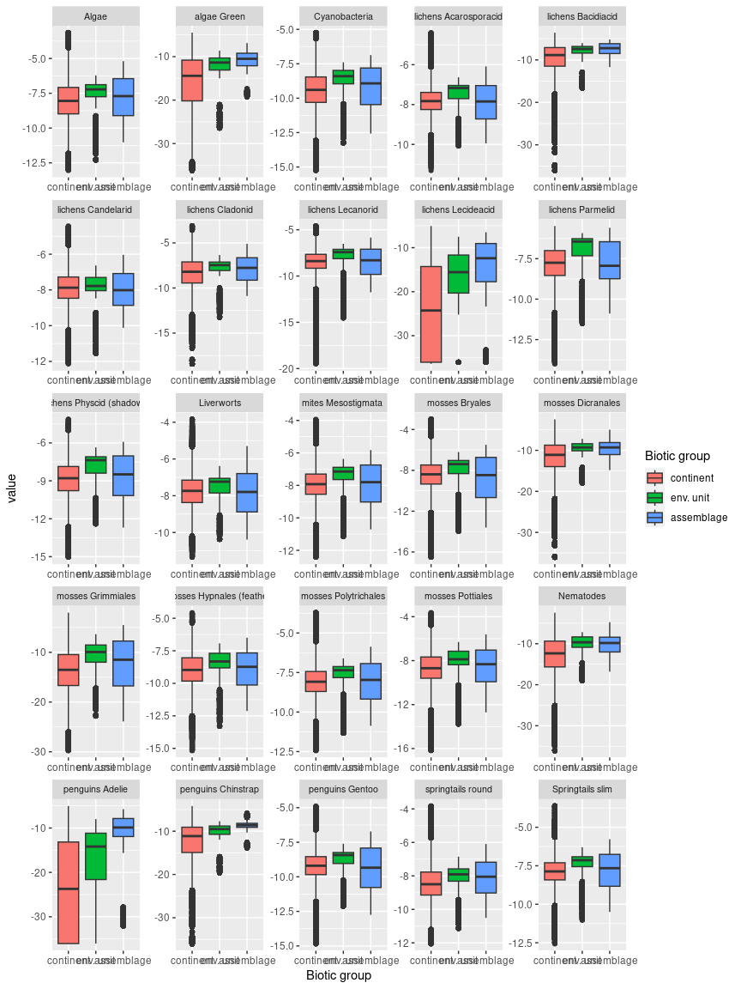

### References

Garcia-Lopez E, Ruiz-Blas F, Sanchez-Casanova S, Peña Perez S, Martin-Cerezo ML and Cid C (2022) Microbial Communities in Volcanic Glacier Ecosystems. Frontiers in Microbiology 13, 825632. [doi: 10.3389/fmicb.2022.825632]

Herbold CW, McDonald IR Cary SC (2014) Microbial ecology of geothermal habitats in Antarctica. In: Antarctic Terrestrial Microbiology, (Ed. DA Cowan), pp 181-215.  Springer-Verlag, Berlin Heidelberg. [doi: 10.1007/978-3-642-45213-0_10].

Van Eaton, A. R., Harper, M. A., and Wilson, C. J. N. (2013). High-flying diatoms: widespread dispersal of microorganisms in an explosive volcanic eruption. *Geology* 41, 1187–1190. [doi: 10.1130/G34829.1]

## Ecosystem G2

#### Dormant volcanoes

Dormant volcanoes last erupted 1,000 - 100,000 years ago. The geophysical and biological legacies of those events are likely to persist to varying degrees, distinguishing these ecosystems from their surrounding landscapes. Their substrates are likely to retain high levels of nutrients. Gaseous emissions may or may not occur (Bargagli et al. 2004), but are generally less abundant than those that characterize active volcanoes (G1). Dormant volcanoes may also function as glacial refugia for unique biota. Older inactive volcanoes, that last erupted more than 100,000 years ago, generally lack these features and were classified with non-volcanic ecosystem types. Examples of dormant volcanoes occur through Marie Byrd Land, Victoria Land and Enderby Land at the Hudson mountains, Mt Berlin, Mt Takahe, Penguin Island and The Pleiades.

### Photos (if available)

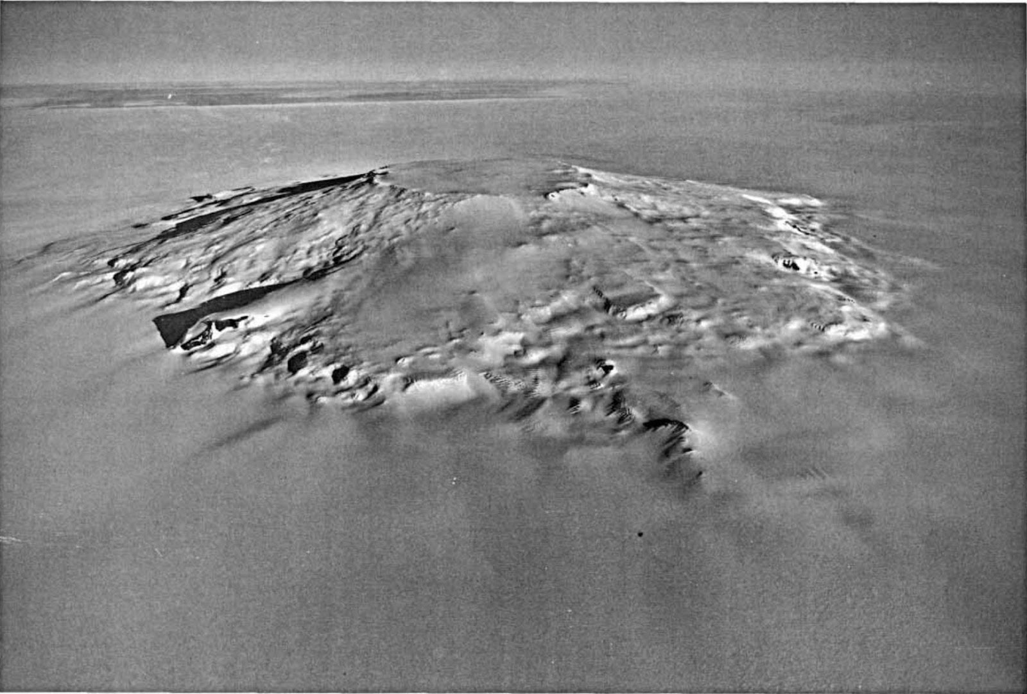

*Ecosystem photo: Mt Takahe. Credit - US Navy - https://pubs.usgs.gov/pp/p1386b/p1386b.pdf Satellite Image Atlas of Glaciers of the World: Antarctica, United States Geological Survey, Professional Paper 1386-B (1988), page B131, Figure 96., Public Domain, https://commons.wikimedia.org/w/index.php?curid=43798*

### Distribution

Marie Byrd Land and Enderby Land, Victoria Land

Full map

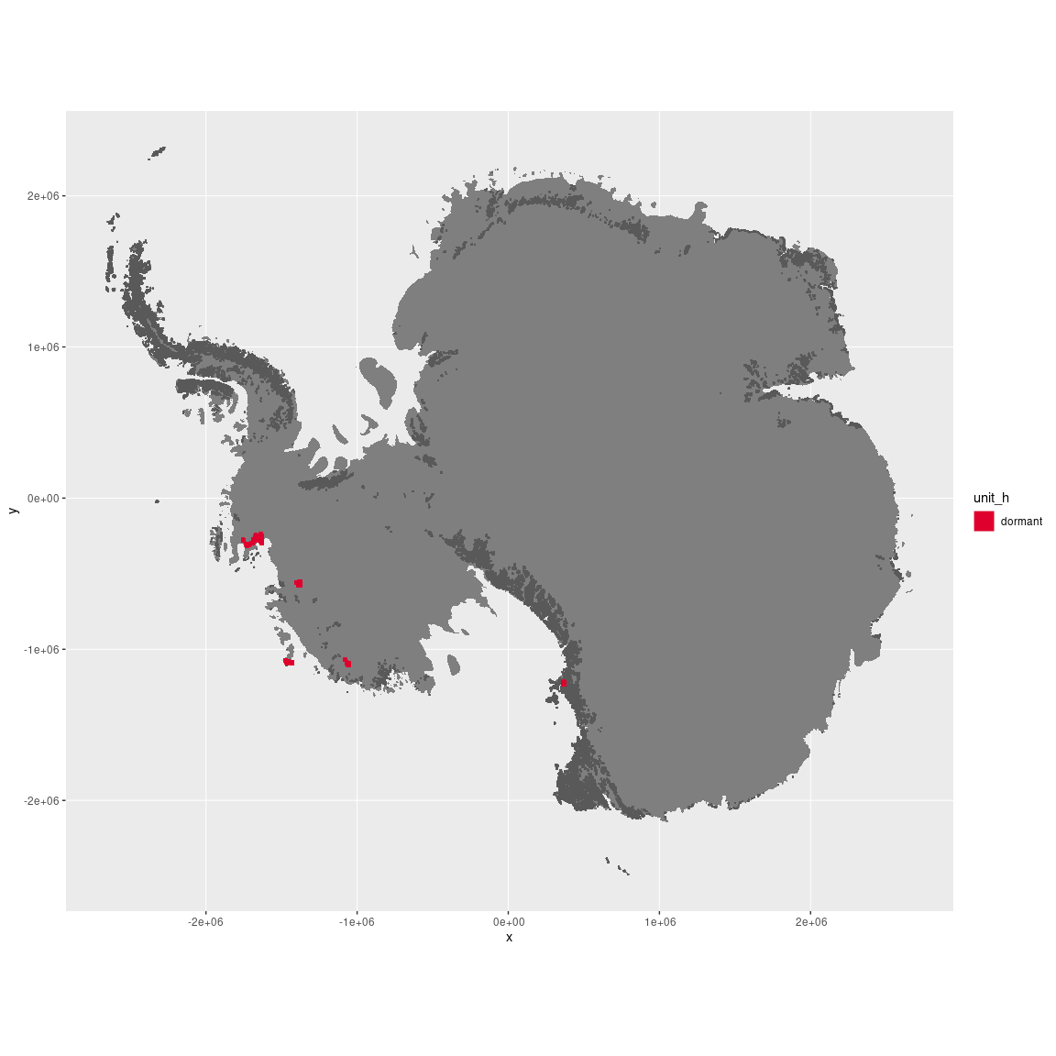

Regional maps

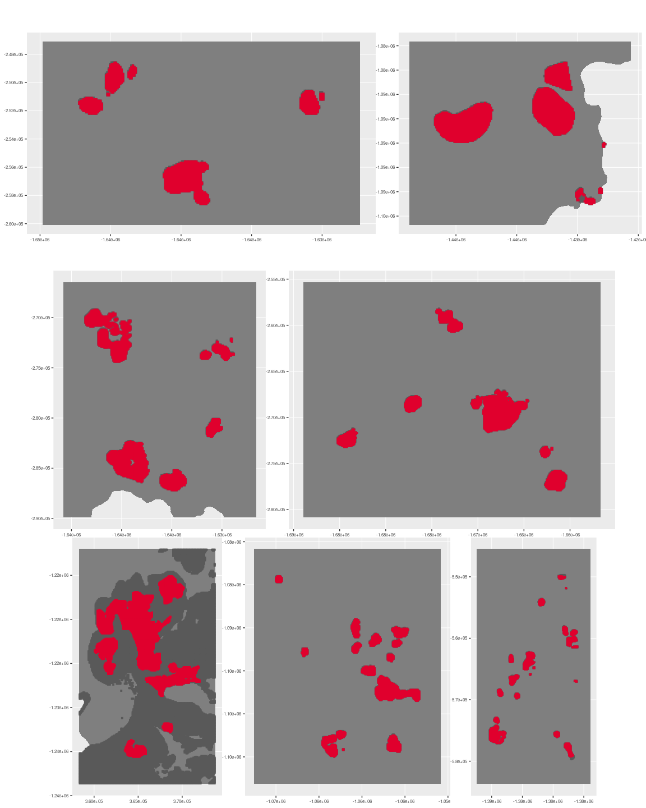



### Environment

Dormant volcanoes are characterized by legacies of past eruptions, including elevated levels of nutrients and geothermal heat, creating and thermal gradients. These ecosystems generally lack active fumaroles (ice towers), and gaseous emissions are absent or more limited than active volcanoes.

Dormant volcanoes are part of the supergroup G. This supergroup is, on average, substantially higher in DDm5 than continental Antarctica. It is substantially lower in melt, rugosity, slope and wind than the rest of the continent.

The elevation of ice-free dormant volcanoes ranges from near sea level to 3485 metres, but 90% of pixels fall below 2756 metres. The average elevation is 858 metres. Dormant volcanoes fall mainly in the E1 and E3 environments.

The unit is higher in melt and wind and lower in DDm5, rugosity and slope than the rest of its environmental supergroup.

#### Distinctiveness of the assemblage from its group and the rest of Antarctica

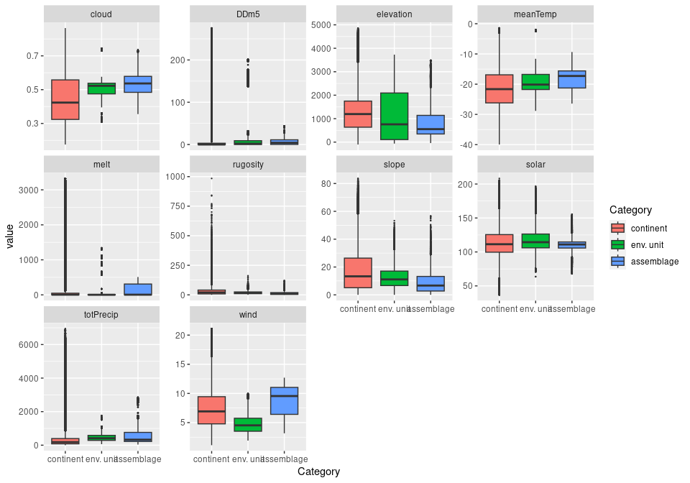

### Biota

The biota of dormant volcanoes is poorly studied but is likely to share some components with active volcanoes (G1). Photoautotrophic eukaryotes are likely to thrive on high nutrient substrates, with bryophytes dominating where substrate moisture levels or humidly are high. Unlike active volcanoes, extreme high temperatures are unlikely to be limiting. Prokaryotic communities are likely to be diverse. Chemoautotrophic bacteria are most likely to be abundant in dark microsites and where there are high residual levels of iron or sulfur in the substrate. Local geochemical gradients are likely influential on spatial organization of the community (Herbold et al. 2014).

The top most sampled species on ice-free areas of dormant volcanoes

|  |  |  |  |  |  |
| --- | --- | --- | --- | --- | --- |
| scientific | Functional group | phylum | restricted | count | percent of samples |
| Gomphiocephalus hodgsoni | Arthropoda_Entognatha_Poduromorpha | Arthropoda | TRUE | 2 | 33.3333 |
| Nanorchestes antarcticus | Arthropoda_Arachnida_Sarcoptiformes | Arthropoda | TRUE | 1 | 16.6667 |
| Pygoscelis adeliae | Chordata_Aves_Sphenisciformes_Spheniscidae_Pygoscelis_adeliae | Chordata | FALSE | 1 | 16.6667 |
| Stereotydeus mollis | Arthropoda_Arachnida_Trombidiformes | Arthropoda | TRUE | 1 | 16.6667 |
| Usnea sphacelata | Ascomycota_Lecanoromycetes_Lecanorales_Parmeliaceae | Ascomycota | TRUE | 1 | 16.6667 |

This supergroup is, on average, substantially higher in suitability for algae_Green, lichens_Bacidiacid, lichens_Lecideacid, Nematodes, penguins_Adelie and penguins_Chinstrap functional groups than continental Antarctica. It is substantially lower in suitability for no variables than the rest of the continent.

Unit dormant is higher in suitability for no variables and lower in suitability for lichens_Lecideacid and penguins_Adelie than the rest of its environmental supergroup.

#### Distinctiveness of the unit from the environmental group and the rest of Antarctica

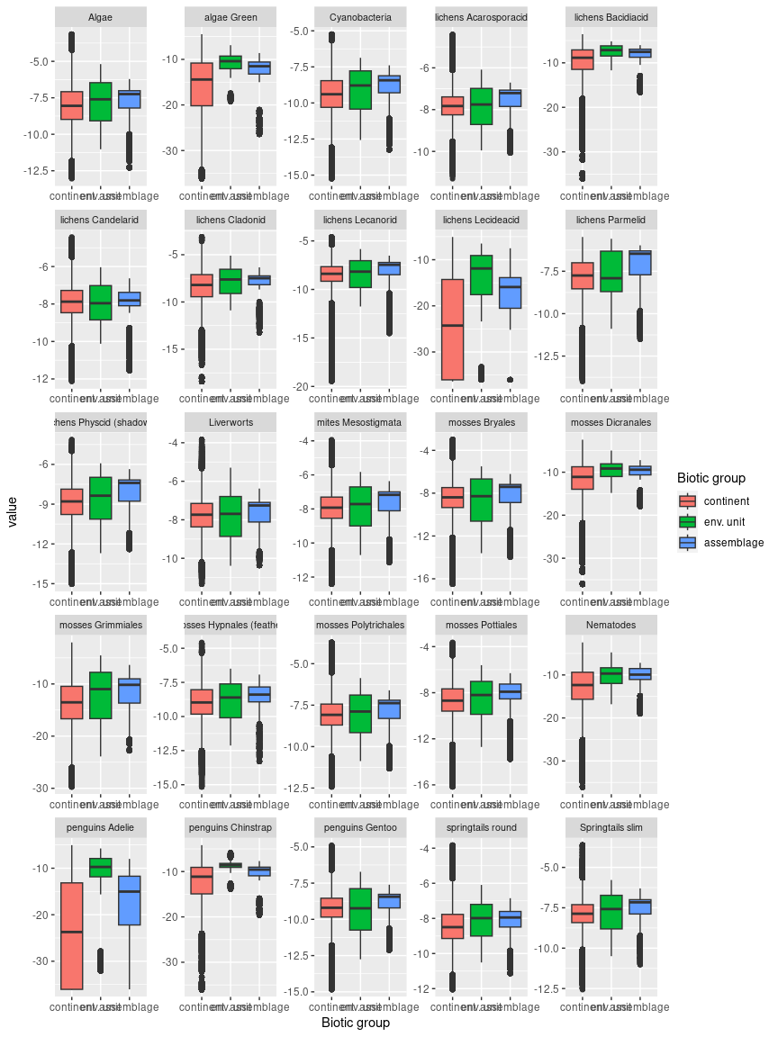

### References

Bargagli, R.; Broady, P.A.; Walton, D.W.H. (2004). Preliminary investigation of the thermal biosystem of Mount Rittmann fumaroles (northern Victoria Land, Antarctica).  *Antarctic Science* 8, 121–126. [doi:10.1017/S0954102096000181]

Garcia-Lopez E, Ruiz-Blas F, Sanchez-Casanova S, Peña Perez S, Martin-Cerezo ML and Cid C (2022) Microbial Communities in Volcanic Glacier Ecosystems. Frontiers in Microbiology 13, 825632. [doi: 10.3389/fmicb.2022.825632]

Herbold CW, McDonald IR Cary SC (2014) Microbial ecology of geothermal habitats in Antarctica. In: Antarctic Terrestrial Microbiology, (Ed. DA Cowan), pp 181-215.  Springer-Verlag, Berlin Heidelberg. [doi: 10.1007/978-3-642-45213-0_10].

## Ecosystem G3

#### Non-volcanic Geothermal ecosystems

Geothermal heating of base rocks and water can result from processes other than vulcanism. Such heating is presently known only from one small area of Antarctica on the Broknes Peninsula in the Larsemann Hills, where Cambrian rocks are heated by radiogenic decay (Fraser et al. 2014). These ecosystems lack gaseous emissions and nutrient release that distinguish volcanic geothermal ecosystems (G1 and G2). They are also characterised by a more moderate range of temperatures than active volcanoes. Radiogenic decay within rocks sustains geothermal heating over hundreds of millions of years. During climate shifts to glacial maxima, this sustained heating is thought to buffer conditions locally, as ice cover advances across the broader landscape. Higher levels of biological diversity at geothermal sites than in non-geothermal sites support the notion that geothermal sites function as ice-free refuges for ice-sensitive biota. while patterns of nestedness with distance from geothermal sites suggest recolonization occurs by dispersal from the refuges during glacial retreat (Fraser et al. 2014).

### Photos (if available)

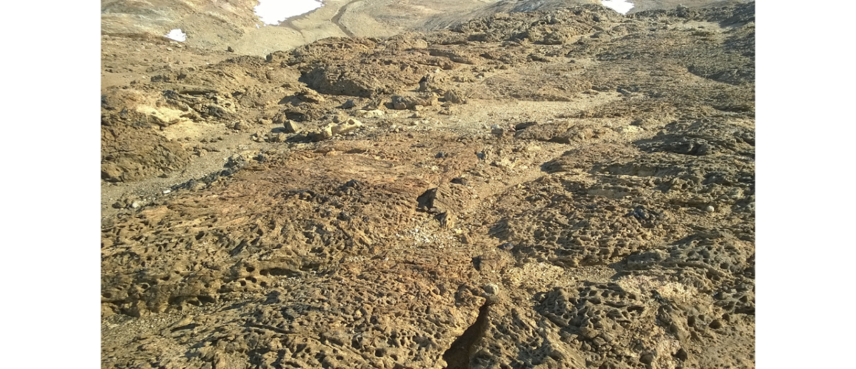

*Ecosystem photo: Larsemann Hills Oasis. Credit: Yurii-A-Dvornikov*

### Distribution

Broknes Peninsula in the Larsemann Hills

Full map

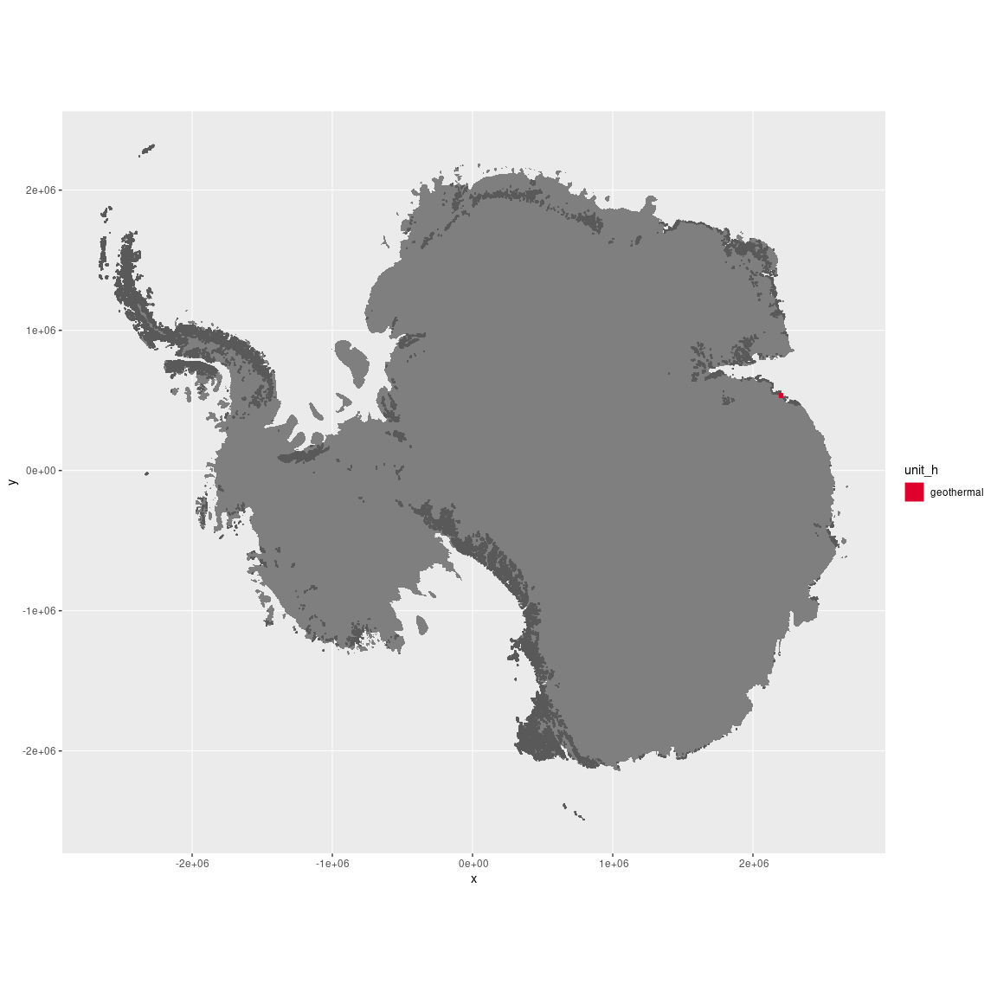

Regional maps

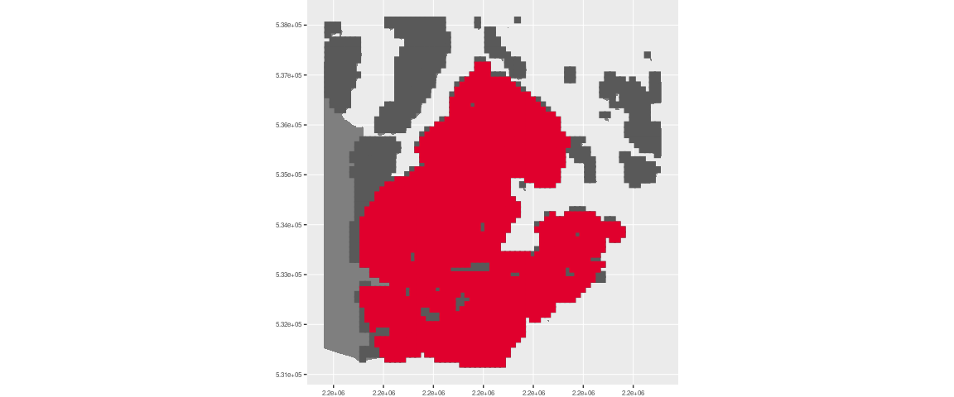

### Environment

Non-volcanic geothermal ecosystems are restricted to geological substrates with rare minerals undergoing radiogenic decay. This maintains mild soil and rock temperatures. Mineral nutrients are derived only from gradual weathering and, unlike volcanic geothermal ecosystems, are not periodically replenished by eruptions or aerosol emissions.

Geothermal areas are part of the environmental supergroup G. This supergroup is, on average, substantially higher in DDm5 than continental Antarctica. It is substantially lower in melt, rugosity and slope than the rest of the continent.

The elevation of the Broknes Peninsula ranges from sea level to 152 metres above sea level. Its average elevation is 71 metres. In the environmental classification, it is represented by units E3B1, E3B4, and E3B6.

The unit is higher in meanTemp and wind and lower in elevation, melt, rugosity, slope and totPrecip than the rest of its environmental supergroup.

#### Distinctiveness of the assemblage from its group and the rest of Antarctica

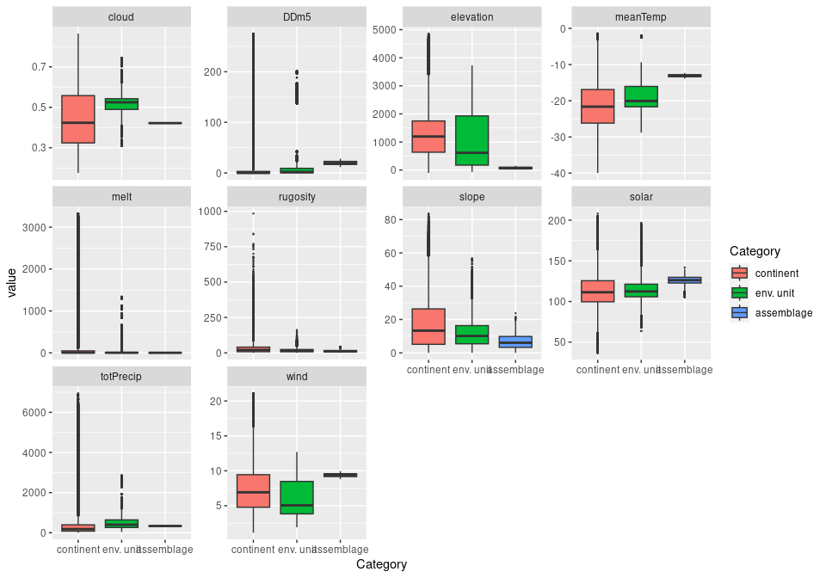

### Biota

The biota of non-volcanic geothermal ecosystems is poorly studied, but exhibits high richness of bryophytes and lichens relative to most non-geothermal sites (Fraser et al. 2014). A range of cold-sensitive species inhabit the surface and subsurface. It also supports a range of soil- and moss-dwelling invertebrates. Herbold et al. (2014) describe the major groups of microbes found in the substrate, including Cyanobacteria, Actinobateria, Bacteroidetes and Proteobacteria.

The top most sampled species in the Broknes Peninsula

|  |  |  |  |  |  |
| --- | --- | --- | --- | --- | --- |
| scientific | Functional group | phylum | restricted | count | percent of samples |
| Bryum pseudotriquetrum | Bryophyta_Bryopsida_Bryales | Bryophyta | FALSE | 9 | 8.4112 |
| Lepadella patella | Rotifera | Rotifera | FALSE | 8 | 7.4766 |
| Notholca sp. | Rotifera | Rotifera | TRUE | 8 | 7.4766 |
| Isohypsibius sp. | Tardigrada | Tardigrada | TRUE | 6 | 5.6075 |
| Daphniopsis studeri | Arthropoda_Branchiopoda_Anomopoda | Arthropoda | TRUE | 4 | 3.7383 |
| Encentrum spatitium | Rotifera | Rotifera | TRUE | 4 | 3.7383 |
| Philodina sp. 2 | Rotifera | Rotifera | TRUE | 4 | 3.7383 |
| Adineta grandis | Rotifera | Rotifera | TRUE | 3 | 2.8037 |
| Buellia frigida | Ascomycota_Lecanoromycetes_Teloschistales_Physciaceae | Ascomycota | TRUE | 3 | 2.8037 |
| Collotheca ornata | Rotifera | Rotifera | FALSE | 3 | 2.8037 |
| Epiphanes senta | Rotifera | Rotifera | FALSE | 3 | 2.8037 |

This supergroup is, on average, substantially higher in suitability for algae_Green, lichens_Lecideacid, Nematodes, penguins_Adelie and penguins_Chinstrap functional groups than continental Antarctica. It is substantially lower in suitability for no variables than the rest of the continent.

Unit geothermal is higher in suitability for lichens_Bacidiacid, lichens_Lecanorid, lichens_Lecideacid, lichens_Parmelid, mosses_Bryales, mosses_Grimmiales and penguins_Adelie and lower in suitability for no variables than the rest of its environmental supergroup.

#### Distinctiveness of the unit from the environmental group and the rest of Antarctica

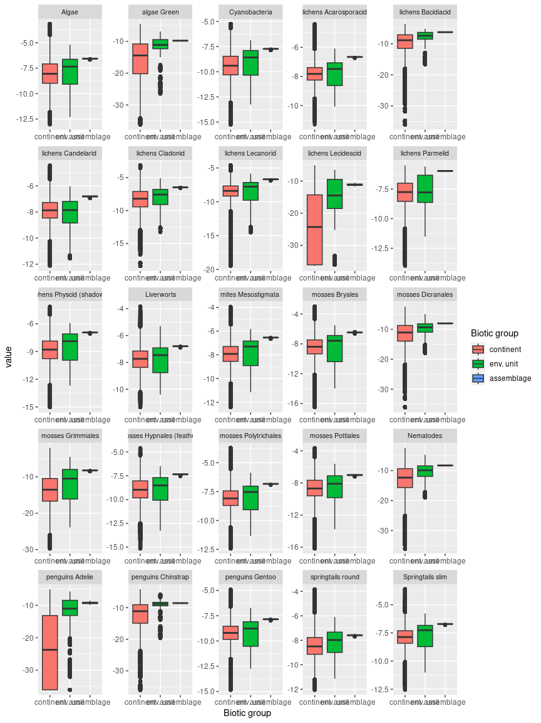

### References

Cromer L, Gibson JAE, Swadling KM, Hodgson DA. 2006. Evidence for a lacustrine faunal refuge in the Larsemann Hills, East Antarctica, during the Last Glacial Maximum. Journal of Biogeography 33: 1314–1323.

Fraser CI, Terauds A, Smellie J, Convey P, Chown SL. 2014. Geothermal activity helps life survive glacial cycles. Proceedings of the National Academy of Sciences of the United States of America 111: 5634–5639.

## Ecosystem L

#### Lakes

NA

### Photos (if available)

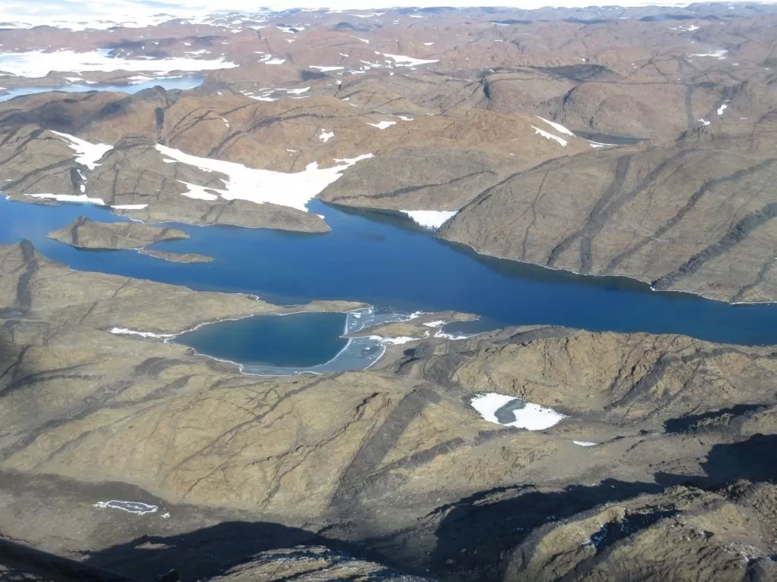

*Lakes in the Vestfold Hills*

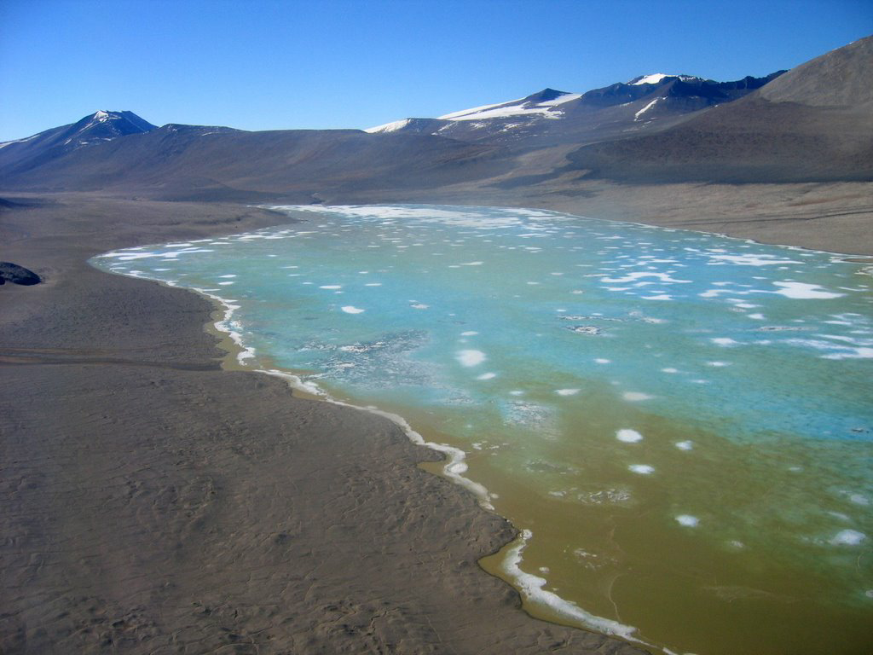

*Photo credit: Hassan Basagic. Lake Vida, Victoria Valley (McMurdo Dry Valleys)*

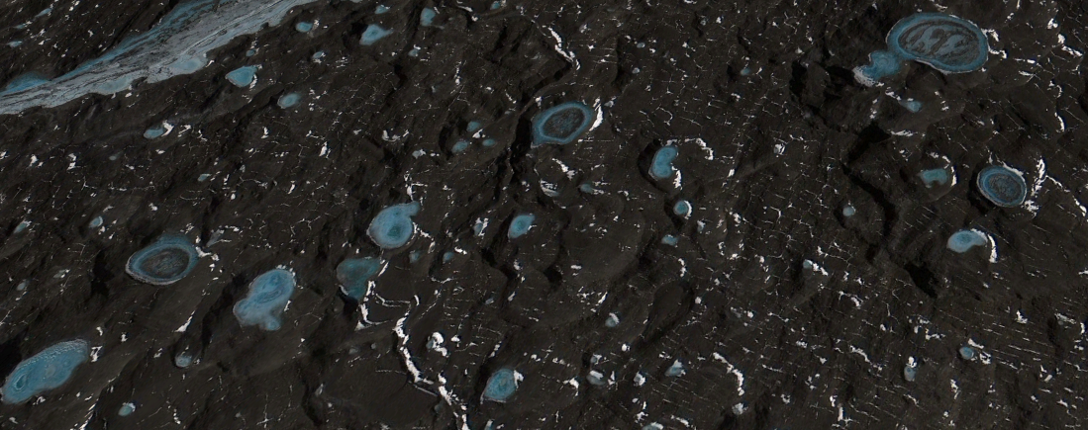

*Google Earth Pro snapshot; Kettle lakes in the McMurdo Dry Valleys*

### Distribution

Current knowledge about the distribution of Antarctic lakes is incomplete, however, over 1,300 terrestrial lakes have been identified in ice-free areas. About 200 lakes have been documented in the northern Antarctic Peninsula, mainly on Deception Island and James Ross Island. Hundreds of lakes ranging from a few metres to a few kilometres across are dotted across the McMurdo Dry Valleys and reach down into North Victoria Land. Lakes are also documented in Marie Byrd Land, Dronning Maud Land, Enterby Land, the Prince Charles Mountains, East Antarctica, and the Transantarctic Mountains. Some areas, such as the Vestfold Hills and the Larsemann Hills, have notably high concentrations of lakes of various sizes, containing hundreds of lakes across a relatively small area.

Full map

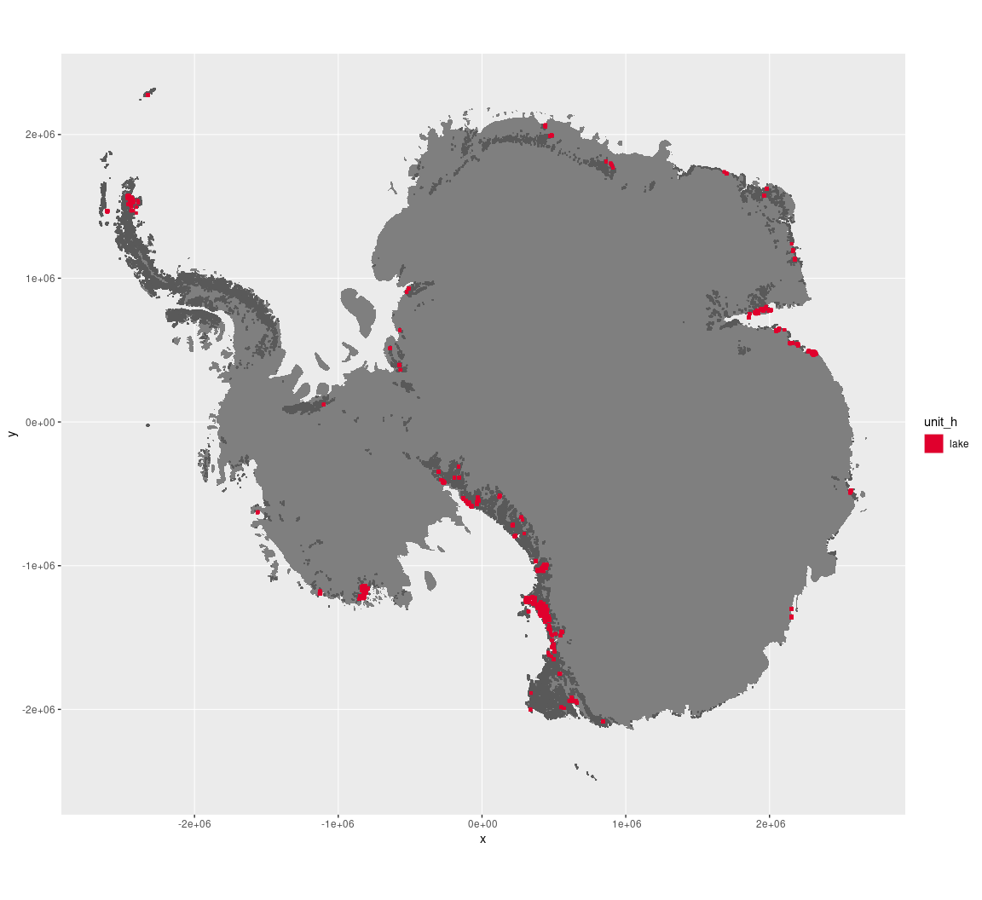

Regional maps

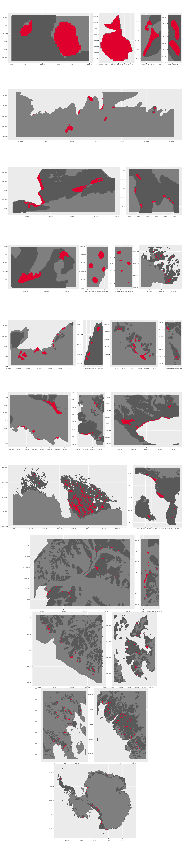

### Environment

The unit lake is part of the environmental supergroup E3.

Supergroup E3 is, on average, substantially higher in DDm5, meanTemp and melt than continental Antarctica. It is substantially lower in elevation, rugosity, slope and totPrecip than the rest of the continent.

The elevation of unit lake ranges from 0 to 1967 metres above sea level, but 90% of its pixels fall above -35 and below 825 metres. Its average elevation is 227 metres.

The unit is higher in no variables and lower in DDm5, elevation, melt, rugosity, slope and totPrecip than the rest of supergroup E3.

#### Distinctiveness of the assemblage from its group and the rest of Antarctica

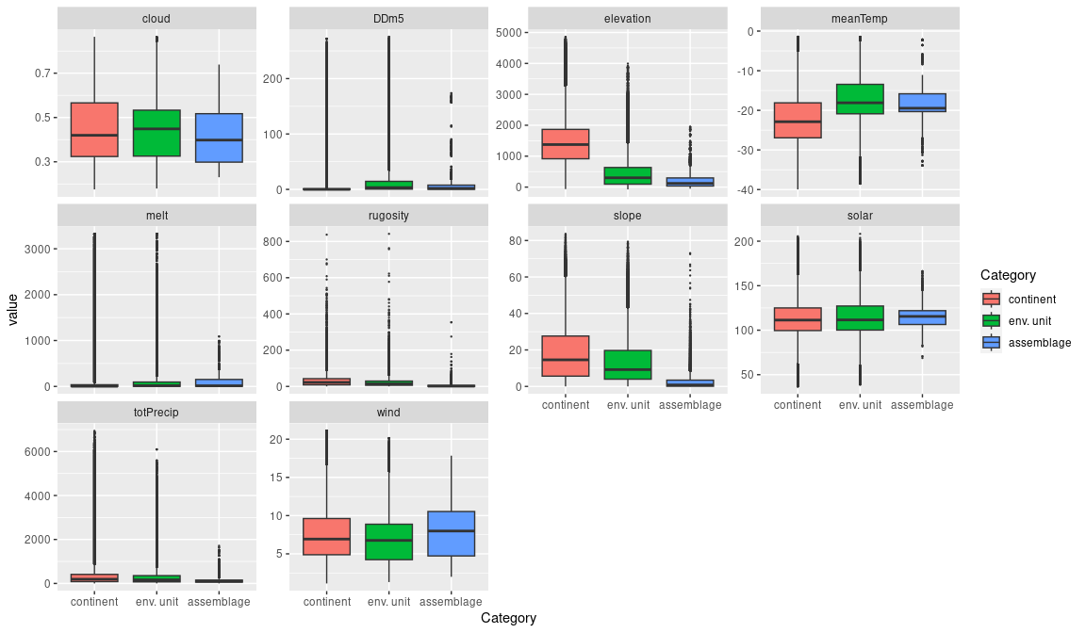

### Biota

Most widely sampled species in the unit (found in most pixels)

The top most widespread species in lakes

|  |  |  |  |  |  |
| --- | --- | --- | --- | --- | --- |
| scientific | Functional group | phylum | restricted | count | percent of samples |
| Notholca sp. | Rotifera | Rotifera | TRUE | 11 | 3.0055 |
| Scottnema lindsayae | Nematoda | Nematoda | TRUE | 11 | 3.0055 |
| Daphniopsis studeri | Arthropoda_Branchiopoda_Anomopoda | Arthropoda | TRUE | 10 | 2.7322 |
| Lepadella patella | Rotifera | Rotifera | FALSE | 10 | 2.7322 |
| Ptygura crystallina | Rotifera | Rotifera | FALSE | 8 | 2.1858 |
| Diacyclops mirnyi | Arthropoda_Maxillopoda_Cyclopoida | Arthropoda | TRUE | 7 | 1.9126 |
| Encentrum mustela | Rotifera | Rotifera | FALSE | 7 | 1.9126 |
| Eudorylaimus antarcticus | Nematoda | Nematoda | TRUE | 7 | 1.9126 |
| Bryum pseudotriquetrum | Bryophyta_Bryopsida_Bryales | Bryophyta | FALSE | 6 | 1.6393 |
| Collotheca ornata | Rotifera | Rotifera | FALSE | 6 | 1.6393 |
| Philodina sp. 1 | Rotifera | Rotifera | TRUE | 6 | 1.6393 |

Supergroup E3 is, on average, substantially higher in suitability for algae_Green, lichens_Bacidiacid, lichens_Cladonid, lichens_Lecideacid, mosses_Dicranales, mosses_Grimmiales, Nematodes, penguins_Adelie and penguins_Chinstrap functional groups than continental Antarctica. It is substantially lower in suitability for no variables than the rest of the continent.

Unit lake is higher in suitability for no variables and lower in suitability for no variables than the rest of supergroup E3.

#### Distinctiveness of the unit from the environmental group and the rest of Antarctica

